IPC Using NetMQ (ZeroMQ)

Contents
Overview 1
Requirements and Setup 2
Example Simio Project 3
Server-Client Pattern 6
Overview 6
Appendix – SimioPacket 8
Version V240301 8

Overview

The IpcNetMq uses an IPC (Inter-Process Communication) mechanism to provide fast communications between separate processes. It employs a Client/Server Request/Response pattern.
The entire project including examples servers is located on GitHub at ???
The use of this technique is simple :
One process acts as a Server and other processes are clients. Each client can request an Action to be executed - along with arguments - to the IPC server. These arguments are implemented as a list of Name-Value pairs. Also included is a list of name-value pairs expected to be filled in by the Response.
This ‘packet’ of Action, along with out argments and in arguments are sent to the IPC Server and the Response packet is awaited. The Server should have code to handle the Action and uses the expressions to fill in the “out” values. This is returned to the IPC client.
The entire round trip mechanism has been clocked at under 90 microseconds.
The communication is facilitated with a common IpcPacket header that contains a Sequence number (to ensure communications integrity), the world (UTC) times (as determined by the Client) and the Request/Response data which are name/value pairs.
It is of course necessary that the Client and Server implicitly agree on the Actions and arguments.
Examples of the external Server are provided in C# and Python.

Requirements and Setup
Operating System: The GitHub repository has been tested on Windows 11. It was built upon Windows but with the intention of ultimately running on Linux using FIFOs.
The version of Python for the sample Server is 3.8 and 3.11
The version of .NET used is .NET 8.
Visual Studio 2022 was employed for the server and client example.
Visual Studio Code 1.90.2 along with Python 3.11 was used for the Python example.

Example Projects

There are several projects in the IpcNetMq repository to benchmark, demonstrate, and test the IpcNetMq.

During development it was decided that the IpcClient should be replaceable, and so it was implemented as an Interface. As of October 2024 client mechanisms for the Open-Source ZeroMQ (0MQ) were implemented.

Error Decoding. If the Python server cannot decode the message, then you might have a schema version mismatch. There is a Version field in the packet that indicates what version of the schema is being used. On a schema mismatch, you may get an error like this:

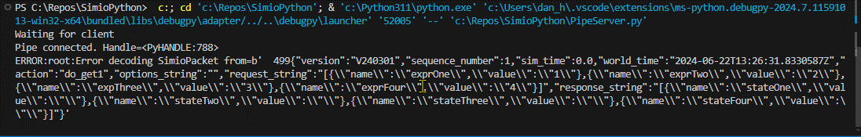

Check the Properties on the Packet to see what the version is, and use the documentation in the appendix to see what the correct Schema is.

Server-Client Pattern
This is the recommended pattern to get up-and-running quickly. This is because
- there are one or more Ipc clients
- there are samples for a Server in Python and C#
- It is tested and benchmarked

Overview
The IpcNetMq can be found on GitHub at batpox\IpcNetMq (as of October 2024 this repository is Private). It includes samples for Server/Client in multiple languages.
The unit of communications is an IpcPacket which is described in the Appendix. One of the most important characteristics is the Action, which the client Step fills in and – by convention – the user-written Server employs to call the appropriate method.
A concrete example should help. The Server will be a Python program (included in the GitHub repository under Examples as Server.py. The meta-logic is:

Create named pipe.
While not Stopped
While connected to the pipe.
While not Stopped
Read IpcPacket from NetMQ
Deserialize the Packet
Handle the Action method, with the Packet as the argument
Serialize the response from the method into a Packet
Write the Packet back to the Client

The entire turnaround time is in the order of 90 microseconds. As you might expect, the Request-Response is handled synchronously. If you don’t care about the Response, you could build logic to just modify the Request to be a “fire and forget” datagram, but you should mind the buffer size of the named pipe and construct logic to prevent overruns.
The Python example included has the Actions in a separate file (UserActions.py).
The Request and Response data portions of the packets are encoded as key-value pairs. These are handled in C# as Dictionary collections, and as name-value pairs via the json.loads method.
These examples are based on .NET 8 and Python 3.11. They were tested on a Windows 11 Pro (23H2) machine with 11th Gen Intel (i9-11900K @3.50Ghz) with 32GB Ram.

When the client (Simio) disconnects, it falls out of the loop and builds the named pipe again and the whole process begins again.

Diagnostics

Appendix – SimioPacket

Version V240301

This is the C# and Python schema for Packet Version V240301

The message is prefixed by a right-aligned (left padded) 5 character field indicating the size of the message in ASCII-8 characters.

Here is a sample of the json serialization:
