# MO01

Vendor Data to SYNC Tables Group 1

Contents

MO01 1

MO01 Vendor Message Overview 2

NS_OPENTRAC_NS_MD01 2

MD01 Message XLSX 3

OpenTrac Database: VENDOR_MASTER_TX 4

## MO01 Vendor Message Overview

The MO01 message is created by Maximo for consumption by OpenTrac.

Maximo will create messages under the following conditions:

* Vendor Type is F or P (ns_vendortype)
* Vendor is not disabled
* Vendor is Approved
* One of the associated attributes has changed, or a new record is approved.

The message from Maximo will be created as NS_OPENTRAC_NS_MO01_*1234*.xml

Attribute Mapping:

|  |  |  |
| --- | --- | --- |
| **From Maximo** | **IN Rxe** | **To OpenTrac** |
| No | RxE magic | **FINANSYS_TRANSACTION_SKEY** |
| No | Literal '10' | **FINANCIAL_ORG_CODE** |
| COMPANY | Map --> | **VENDOR_RECORD_KEY** |
| NS_VENDORTYPE | Map --> | **VENDOR_TYPE_CODE** |
| NAME | Map --> | **NAME** |
| DUNSNUM | Map --> | **VENDOR_CORP_DUNS** |
| DUNSNUM | Map --> | **VENDOR_PLANT_DUNS** |
| No | Literal 'Y' | **REMIT_TO_FLAG** |
| No | Map --> | **REMIT_TO_VENDOR_RECORD_KEY** |
| FOB | Map --> | **FREIGHT_TERMS_CODE** |
| NS_FOB_DESC | Map --> | **FREIGHT_TERMS_TEXT** |
| PAYMENTTERMS | Map --> | **PAYMENT_TERMS_CODE** |
| NS_TERMS_DESC | Map --> | **PAYMENT_TERMS_TEXT** |
| SHIPVIA | Map --> | **SHIP_MODE_CODE** |
| NS_SHIPVIA_DESC | Map --> | **SHIP_MODE_TEXT** |

## NS_OPENTRAC_NS_MD01



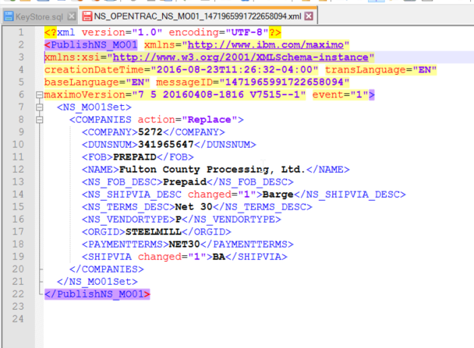

## MD01 Message XLSX

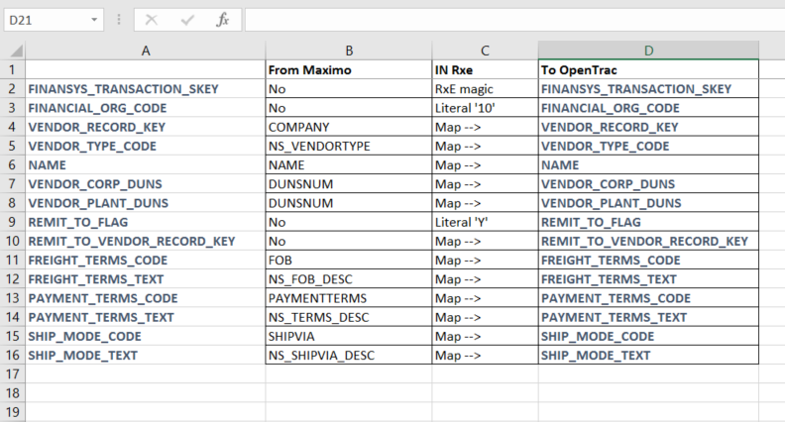

## OpenTrac Database: VENDOR_MASTER_TX

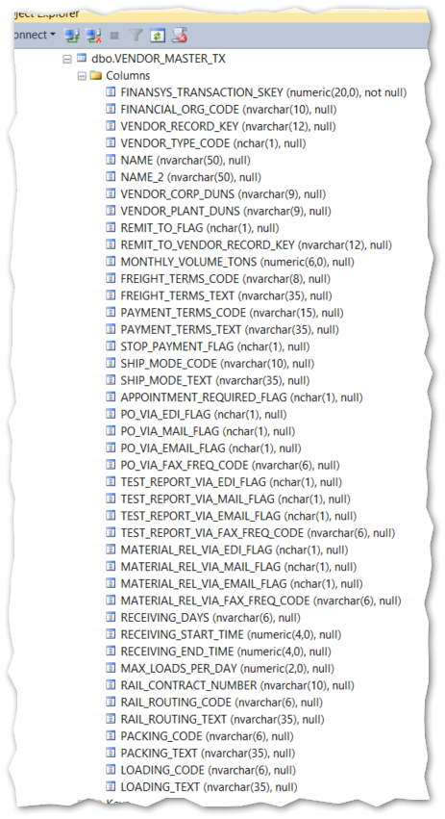

## Sample Data

