DR. ANIKA SHARMA
Scientist E — Atmospheric Instrumentation & Applied AI

✉ anika.sharma@example.org ☎ +91 00000 12345 ⌂ New Delhi, India ➤ linkedin.com/in/anika-sharma-example

PROFESSIONAL SUMMARY  Electronics and avionics engineer with twelve years of airborne-systems integration and qualification testing, followed by ten years leading scientific instrumentation and edge-AI development in government service. Experienced in MIL-STD-1553 test rigs, UAV payload electronics, sensor telemetry, embedded GPU deployment and technical procurement.  AREAS OF EXPERTISE  R&D in avionics systems · 12 years  Twelve years of mission-computer and sensor integration, interface testing (MIL-STD-1553, ARINC 429) and environmental qualification for airborne platforms at Halcyon Avionics Design Bureau.  Upper-air instrumentation · 10 years  Planning, testing and maintenance of radiosonde ground systems and upper-air instruments; division workshop management; technical evaluation of procurements.  Edge AI for aerial imagery · 5 years  Research on super-resolution and model compression (pruning, knowledge distillation) for real-time deployment on NVIDIA Jetson devices; publications and a deployed telemetry prototype.  IoT monitoring systems · 4 years  Design of MQTT, Node-RED, InfluxDB and Grafana pipelines for monitoring ground-station equipment.  CAREER TIMELINE  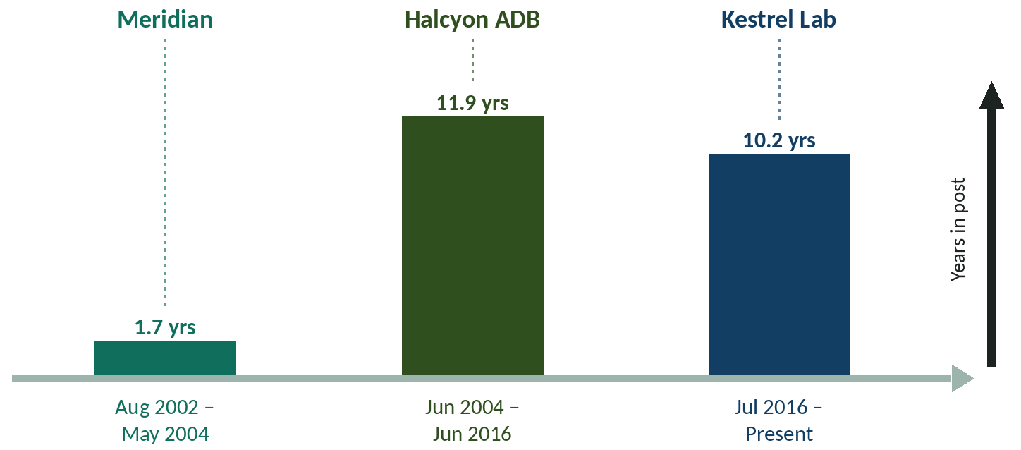  ■ Meridian Electronics Limited — Graduate Engineer (Aug 2002 – May 2004): Automated test equipment for avionics units  ■ Halcyon Avionics Design Bureau — Senior Design Engineer (Jun 2004 – Jun 2016): Mission-computer integration and environmental qualification  ■ Kestrel Atmospheric Instrumentation Laboratory — Scientist E (Jul 2016 – Present): Upper-air instruments, workshop, IoT and edge-AI programmes  Bar height shows time in post, calculated from your recorded dates.  PROFESSIONAL EXPERIENCE  Scientist E Jul 2016 – Present  Upper Air Instrumentation Division, Kestrel Atmospheric Instrumentation Laboratory, New Delhi  Responsible for upper-air observation instruments, the division workshop and the laboratory's IoT and AI/ML activities.  - Lead a four-member AI/ML group developing lightweight super-resolution and detection models for UAV imagery, deployed on NVIDIA Jetson devices with TensorRT.  - Led acceptance testing and commissioning of radiosonde ground-receiving systems at three observing stations, writing the test protocol and the defect-tracking procedure.  - Designed and deployed an IoT monitoring network for laboratory infrastructure (ESP32 sensor nodes, MQTT, Node-RED, InfluxDB and Grafana dashboards) covering temperature, humidity and power quality.  Additional charge: Workshop In-charge, Upper Air Division Workshop Apr 2019 – Present  Additional charge of the division workshop supporting instrument repair, fabrication and calibration.  Nodal officer: Nodal Officer, IoT and AI/ML Initiatives Jan 2021 – Present  Senior Design Engineer Jun 2004 – Jun 2016  Avionics Integration Group, Halcyon Avionics Design Bureau, Bengaluru  Integration and qualification testing of airborne electronics and UAV payloads.  - Developed payload interface electronics for a fixed-wing UAV electro-optical sensor and supported its ground and flight trials.  Graduate Engineer Aug 2002 – May 2004  Test Systems Group, Meridian Electronics Limited, Bengaluru  Built automated test equipment for avionics line-replaceable units.  - Developed LabVIEW test sequences for power-supply and interface boards of avionics units.  PROJECTS EXECUTED  Edge super-resolution pipeline for UAV imagery (Ongoing) Sep 2021 – Present  Principal investigator, Kestrel Atmospheric Instrumentation Laboratory  Research prototype that enhances low-resolution UAV video in real time on embedded GPUs using pruned and distilled deep networks.  - Implemented structured channel pruning and knowledge distillation to shrink the super-resolution network for embedded deployment.  EDUCATION  Ph.D., Electrical and Electronics Engineering 2021 – ongoing  Northfield Institute of Science and Technology  Thesis: Lightweight deep networks for real-time enhancement of aerial imagery  M.Tech., Avionics 2010  Coastal Institute of Aeronautical Engineering, Chennai  Grade: CGPA 8.6/10  Thesis: Fault-tolerant data acquisition for airborne test instrumentation  B.E., Electronics and Communication Engineering 2004  Northfield Institute of Science and Technology, Northfield University, Pune  Grade: First Class with Distinction  PUBLICATIONS  [1] A. Sharma and R. Iyer, “Knowledge-distilled lightweight networks for drone image super-resolution,” accepted for publication in Example Transactions on Aerial Imaging.  [2] A. Sharma, K. Rao and R. Iyer, “Benchmarking embedded GPUs for real-time image enhancement,” Example Symposium on Applied AI, pp. 88-93, Jan 2025.  LEADERSHIP & RESPONSIBILITIES  Supervisor, M.Tech. interns in applied machine learning 2022 – Present  Kestrel Atmospheric Instrumentation Laboratory  Supervise summer and dissertation interns on edge-AI projects.  Chair, Technical Evaluation Committee for radiosonde procurement Apr 2023 – Feb 2024  Kestrel Atmospheric Instrumentation Laboratory  Chaired technical evaluation of bids for upper-air sounding systems.  - Evaluation report accepted by the competent authority.  AWARDS & HONOURS  Best Paper Award 2023  Example Conference on Instrumentation (ECI 2023) | CERTIFICATIONS & TRAINING  Deep Learning for Edge Devices  Example Academy of Applied Computing  Mar 2022  CORE COMPETENCY  Avionics  MIL-STD-1553 / ARINC 429  Avionics integration  Scientific instrumentation  Environmental qualification testing  Sensor calibration  Radiosonde and upper-air systems  Embedded systems  Embedded C  ESP32 / STM32 microcontrollers  Edge AI  NVIDIA Jetson deployment  Bars show my own assessment of proficiency (five steps; five = expert).  LANGUAGES  English  Hindi

