DR. ANIKA SHARMA
Scientist E — Atmospheric Instrumentation & Applied AI
✉ anika.sharma@example.org ☎ +91 00000 12345 ⌂ New Delhi, India ➤ linkedin.com/in/anika-sharma-example

PROFILE  Electronics and avionics engineer with twelve years of airborne-systems integration and qualification testing, followed by ten years leading scientific instrumentation and edge-AI development in government service. Experienced in MIL-STD-1553 test rigs, UAV payload electronics, sensor telemetry, embedded GPU deployment and technical procurement.  AREAS OF EXPERTISE  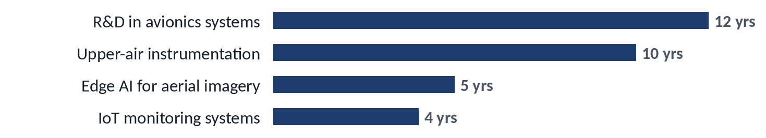  Years of experience in each area, as you recorded them; areas overlap in time.  R&D in avionics systems · 12 years  Twelve years of mission-computer and sensor integration, interface testing (MIL-STD-1553, ARINC 429) and environmental qualification for airborne platforms at Halcyon Avionics Design Bureau.  Upper-air instrumentation · 10 years  Planning, testing and maintenance of radiosonde ground systems and upper-air instruments; division workshop management; technical evaluation of procurements.  Edge AI for aerial imagery · 5 years  Research on super-resolution and model compression (pruning, knowledge distillation) for real-time deployment on NVIDIA Jetson devices; publications and a deployed telemetry prototype.  IoT monitoring systems · 4 years  Design of MQTT, Node-RED, InfluxDB and Grafana pipelines for monitoring ground-station equipment.  CAREER TIMELINE    ■ Meridian Electronics Limited — Graduate Engineer (Aug 2002 – May 2004): Automated test equipment for avionics units  ■ Halcyon Avionics Design Bureau — Senior Design Engineer (Jun 2004 – Jun 2016): Mission-computer integration and environmental qualification  ■ Kestrel Atmospheric Instrumentation Laboratory — Scientist E (Jul 2016 – Present): Upper-air instruments, workshop, IoT and edge-AI programmes  Bar length shows years in each organisation, calculated from your recorded dates.  RESEARCH AT A GLANCE  3 Journal articles · 3 Conference papers · 1 Manuscript under review · 1 Research grant · 1 Talk / presentation · 142 Citations (Google Scholar (fictional example), Oct 2026) · 6 h-index (Google Scholar (fictional example), Oct 2026) · 4 i10-index (Google Scholar (fictional example), Oct 2026)  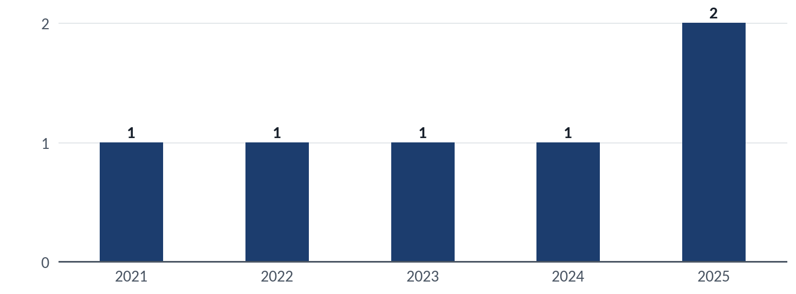  Published and accepted outputs by year (from your publication records).  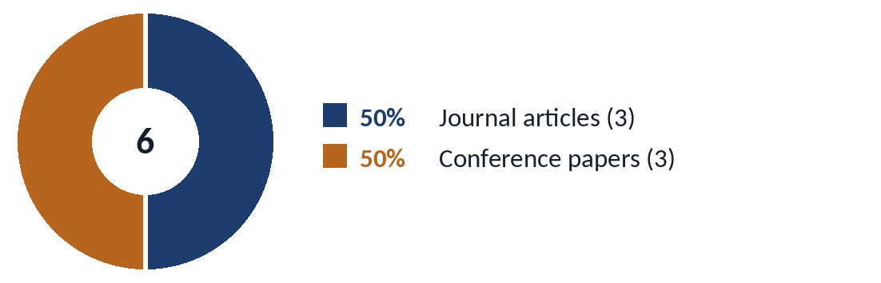  Publications by type: Journal articles: 3; Conference papers: 3.  PROFESSIONAL EXPERIENCE  Scientist E Jul 2016 – Present  Upper Air Instrumentation Division, Kestrel Atmospheric Instrumentation Laboratory, New Delhi  - Lead a four-member AI/ML group developing lightweight super-resolution and detection models for UAV imagery, deployed on NVIDIA Jetson devices with TensorRT.  - Led acceptance testing and commissioning of radiosonde ground-receiving systems at three observing stations, writing the test protocol and the defect-tracking procedure.  - Designed and deployed an IoT monitoring network for laboratory infrastructure (ESP32 sensor nodes, MQTT, Node-RED, InfluxDB and Grafana dashboards) covering temperature, humidity and power quality.  Senior Design Engineer Jun 2004 – Jun 2016  Avionics Integration Group, Halcyon Avionics Design Bureau, Bengaluru  - Developed payload interface electronics for a fixed-wing UAV electro-optical sensor and supported its ground and flight trials.  SELECTED PROJECTS  Edge super-resolution pipeline for UAV imagery (Ongoing) Sep 2021 – Present  Principal investigator, Kestrel Atmospheric Instrumentation Laboratory  Research prototype that enhances low-resolution UAV video in real time on embedded GPUs using pruned and distilled deep networks.  - Implemented structured channel pruning and knowledge distillation to shrink the super-resolution network for embedded deployment.  LEADERSHIP & RESPONSIBILITIES  Supervisor, M.Tech. interns in applied machine learning 2022 – Present  Kestrel Atmospheric Instrumentation Laboratory  PUBLICATIONS  [1] A. Sharma and R. Iyer, “Knowledge-distilled lightweight networks for drone image super-resolution,” accepted for publication in Example Transactions on Aerial Imaging.  EDUCATION  Ph.D., Electrical and Electronics Engineering 2021 – ongoing  Northfield Institute of Science and Technology  M.Tech., Avionics 2010  Coastal Institute of Aeronautical Engineering, Chennai  B.E., Electronics and Communication Engineering 2004  Northfield Institute of Science and Technology, Northfield University, Pune | CORE COMPETENCY  Avionics  MIL-STD-1553 / ARINC 429  Avionics integration  Scientific instrumentation  Environmental qualification testing  Sensor calibration  Radiosonde and upper-air systems  Embedded systems  Embedded C  ESP32 / STM32 microcontrollers  Bars show my own assessment of proficiency (five steps; five = expert).

