Dr. Anika Sharma
Scientist E — Atmospheric Instrumentation & Applied AI
✉ anika.sharma@example.org ☎ +91 00000 12345 ⌂ New Delhi, India ➤ github.com/anika-sharma-example ➤ linkedin.com/in/anika-sharma-example

SKILLS  Avionics  MIL-STD-1553 / ARINC 429  Avionics integration  Scientific instrumentation  Environmental qualification testing  Sensor calibration  Radiosonde and upper-air systems  Embedded systems  Embedded C  ESP32 / STM32 microcontrollers  Computer vision  Image super-resolution  Object detection  Drones & UAV systems  UAV payload integration  Edge AI  NVIDIA Jetson deployment  AI / machine learning  Deep learning  PyTorch  Procurement & administration  Technical procurement (GeM, GFR)  IoT  MQTT and Node-RED  InfluxDB and Grafana  Model optimisation  TensorRT and ONNX  Pruning and knowledge distillation  Software & tools  Python  Docker and Linux  Technical leadership  Team leadership  GPU computing  CUDA / GPU computing  Bars show my own assessment of proficiency (five steps; five = expert).  EDUCATION  Ph.D., Electrical and Electronics Engineering  Northfield Institute of Science and Technology  2021 – ongoing  Thesis: Lightweight deep networks for real-time enhancement of aerial imagery  M.Tech., Avionics  Coastal Institute of Aeronautical Engineering  2010  Grade: CGPA 8.6/10  Thesis: Fault-tolerant data acquisition for airborne test instrumentation  B.E., Electronics and Communication Engineering  Northfield Institute of Science and Technology, Northfield University  2004  Grade: First Class with Distinction | PROFESSIONAL SUMMARY  Electronics and avionics engineer with twelve years of airborne-systems integration and qualification testing, followed by ten years leading scientific instrumentation and edge-AI development in government service. Experienced in MIL-STD-1553 test rigs, UAV payload electronics, sensor telemetry, embedded GPU deployment and technical procurement.  AREAS OF EXPERTISE  R&D in avionics systems · 12 years  Twelve years of mission-computer and sensor integration, interface testing (MIL-STD-1553, ARINC 429) and environmental qualification for airborne platforms at Halcyon Avionics Design Bureau.  Edge AI for aerial imagery · 5 years  Research on super-resolution and model compression (pruning, knowledge distillation) for real-time deployment on NVIDIA Jetson devices; publications and a deployed telemetry prototype.  Upper-air instrumentation · 10 years  Planning, testing and maintenance of radiosonde ground systems and upper-air instruments; division workshop management; technical evaluation of procurements.  IoT monitoring systems · 4 years  Design of MQTT, Node-RED, InfluxDB and Grafana pipelines for monitoring ground-station equipment.  CAREER TIMELINE  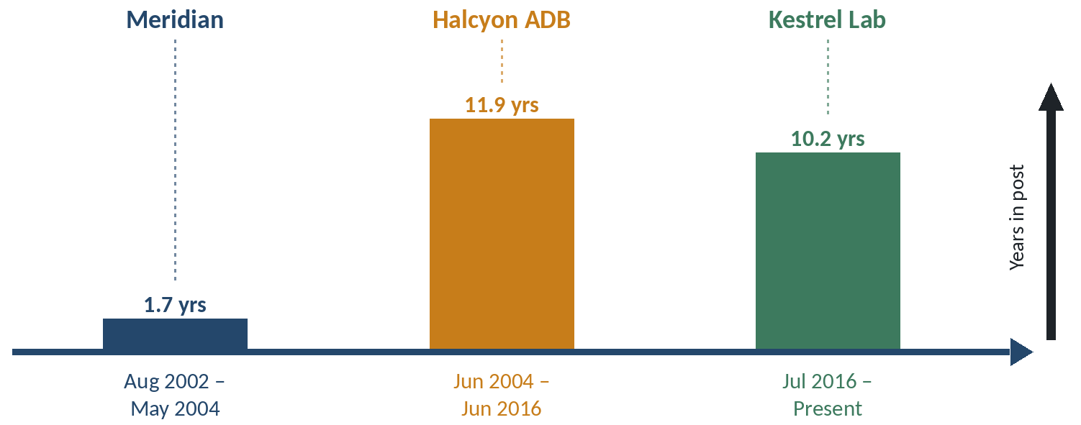  ■ Meridian Electronics Limited — Graduate Engineer (Aug 2002 – May 2004): Automated test equipment for avionics units  ■ Halcyon Avionics Design Bureau — Senior Design Engineer (Jun 2004 – Jun 2016): Mission-computer integration and environmental qualification  ■ Kestrel Atmospheric Instrumentation Laboratory — Scientist E (Jul 2016 – Present): Upper-air instruments, workshop, IoT and edge-AI programmes  Bar height shows time in post, calculated from your recorded dates.  PROFESSIONAL EXPERIENCE  Scientist E Jul 2016 – Present  Upper Air Instrumentation Division, Kestrel Atmospheric Instrumentation Laboratory, New Delhi  Responsible for upper-air observation instruments, the division workshop and the laboratory's IoT and AI/ML activities.  Tools: Python, PyTorch, MQTT, Node-RED, InfluxDB, Grafana, Docker  - Lead a four-member AI/ML group developing lightweight super-resolution and detection models for UAV imagery, deployed on NVIDIA Jetson devices with TensorRT.  - Led acceptance testing and commissioning of radiosonde ground-receiving systems at three observing stations, writing the test protocol and the defect-tracking procedure.  - Designed and deployed an IoT monitoring network for laboratory infrastructure (ESP32 sensor nodes, MQTT, Node-RED, InfluxDB and Grafana dashboards) covering temperature, humidity and power quality.  - Prepared technical specifications and served on bid-evaluation committees for instrument procurement through the Government e-Marketplace in line with the General Financial Rules.  - Authored standard operating procedures for pre-flight checks and calibration of upper-air instruments used across the division.  Additional charge: Workshop In-charge, Upper Air Division Workshop Apr 2019 – Present  Additional charge of the division workshop supporting instrument repair, fabrication and calibration.  - Supervise technicians and plan preventive maintenance for workshop test equipment.  - Introduced a job-card and spares-inventory system for instrument repairs and calibration work.  Nodal officer: Nodal Officer, IoT and AI/ML Initiatives Jan 2021 – Present  Senior Design Engineer Jun 2004 – Jun 2016  Avionics Integration Group, Halcyon Avionics Design Bureau, Bengaluru  Integration and qualification testing of airborne electronics and UAV payloads.  Tools: MIL-STD-1553, ARINC 429, LabVIEW, C, MATLAB  - Developed payload interface electronics for a fixed-wing UAV electro-optical sensor and supported its ground and flight trials.  - Integrated mission-computer and display units on MIL-STD-1553 avionics buses and built the automated test rig used for bench validation.  - Planned environmental qualification (MIL-STD-810 vibration, temperature and humidity) for line-replaceable units and documented the test results.  - Mentored graduate engineer trainees on avionics bus protocols and test documentation.  Graduate Engineer Aug 2002 – May 2004  Test Systems Group, Meridian Electronics Limited, Bengaluru  Built automated test equipment for avionics line-replaceable units.  Tools: LabVIEW, C  - Developed LabVIEW test sequences for power-supply and interface boards of avionics units.  PROJECT PORTFOLIO  Edge super-resolution pipeline for UAV imagery (Ongoing) Sep 2021 – Present  Principal investigator, Kestrel Atmospheric Instrumentation Laboratory  Research prototype that enhances low-resolution UAV video in real time on embedded GPUs using pruned and distilled deep networks.  - Implemented structured channel pruning and knowledge distillation to shrink the super-resolution network for embedded deployment.  - Converted models through ONNX to INT8 TensorRT engines, achieving 3.1× faster inference on Jetson Xavier NX.  Technologies: NVIDIA Jetson Xavier NX, NVIDIA Jetson Orin Nano, PyTorch, TensorRT, ONNX, Docker, Structured pruning, Knowledge distillation, INT8 quantisation  Radiosonde ground-station acceptance test protocol Jan 2018 – Mar 2019  Coordinator  Challenge: Station acceptance testing varied between sites.  Outcome: A common acceptance protocol and checklist adopted for new ground-receiving systems.  IoT monitoring of laboratory infrastructure Feb 2020 – Jun 2022  Project lead  Challenge: Instrument rooms lacked continuous environmental and power-quality monitoring.  Approach: Deployed ESP32 sensor nodes publishing over MQTT to a Node-RED flow, InfluxDB time-series storage and Grafana dashboards with threshold alerts.  Outcome: Continuous monitoring with automated alerts replaced manual twice-daily readings.  Technologies: ESP32, Environmental sensors, MQTT, Node-RED, InfluxDB, Grafana  PUBLICATIONS  [1] A. Sharma and R. Iyer, “Knowledge-distilled lightweight networks for drone image super-resolution,” accepted for publication in Example Transactions on Aerial Imaging.  [2] A. Sharma, K. Rao and R. Iyer, “Benchmarking embedded GPUs for real-time image enhancement,” Example Symposium on Applied AI, pp. 88-93, Jan 2025.  [3] A. Sharma and R. Iyer, “Channel-pruned residual networks for real-time aerial image enhancement on embedded GPUs,” Journal of Embedded Vision Systems, vol. 12, no. 3, pp. 45-58, Mar 2024. doi: 10.5555/jevs.2024.0123  [4] A. Sharma, P. Rao and S. Gill, “An IoT telemetry framework for upper-air ground stations,” Proceedings of the Example Conference on Instrumentation (ECI 2023), pp. 112-117, Sep 2023.  [5] A. Sharma and S. Verma, “Edge telemetry dashboards for upper-air ground stations,” Proceedings of the Example Conference on Instrumentation, Paper 17, Feb 2022.  [6] A. Sharma, P. Menon and R. Iyer, “A low-cost GNSS receiver chain for radiosonde tracking,” Example Journal of Atmospheric Instrumentation, vol. 8, no. 2, pp. 101-112, Jun 2021. doi: 10.5555/ejai.2021.0042  AWARDS & HONOURS  Best Paper Award 2023  Example Conference on Instrumentation (ECI 2023)  REFEREES  Dr. R. Iyer (fictional)  Professor of Electronics, Example Institute of Technology  Research collaborator and co-author  Email: r.iyer@example.org  Telephone: +91 00000 54321

