*Wouter van Battum, Jos Vroegindeweij*

*Radboud University | Comeniuslaan 4, 6525HP Nijmegen*

*seats and more*

Vision and Scope Document

Table of Content

Business Requirements 3

Background 3

Business opportunity 3

Business objectives 3

Success metrics 3

Vision statement 4

Business risks 4

Business assumptions and dependencies 4

Assumptions 4

Dependencies 4

Scope and limitations 5

Major Features 5

Scope of initial release 5

Limitations and exclusions 6

Business context 7

Stakeholder profiles 7

Project priority 8

Deployment considerations 8

# Business Requirements

In this chapter we investigate the business requirements of Seats and More. The background, the business opportunity, the business objectives, the success metrics, the vision statement, the business risks and the business assumptions and dependencies will be investigated.

## Background

This project is about Seats and More. Seats and More is a chain of furniture stores, with 8 physical stores in or near larger cities throughout the Netherlands. The philosophy of Seats and More is that furniture should not be bought online: customers should be able to see, touch and test a chair, sofa, table or bed before deciding whether to buy it or not.

## Business opportunity

The goal of Seats and More with the redevelopment of the stores is to offer their customers a shopping experience that is as pleasant and personalized as possible, with all advantages of a physical store. In addition, Seats and More has the ambition to provide their customers with a digital product information system that will make the shopping visit as pleasant, efficient, effective and informative as possible.

## Business objectives

The main ambition of Seats and More is to create a shopping experience that will please a growing group of returning customers. Seats and More hopes to attract both customers who still buy their furniture at physical stores as well as customers who are already used at buying furniture online. The other objectives are as follows:

* Let the customers be navigated in a personalized manner through the store, focusing on the products that they are interested in, while avoiding congestions due to too many customers in a small area of the store.
* Let the customers be recommended products based on their interests. Should a particular product be sold out, an alternative product should be recommended to the customer.
* Provide the customers with product reviews or let them review a product themselves. These might be the reviews of all customers in the same physical store, or the reviews of all customers of all 8 physical stores.
* Let the customers create a wish list or shopping cart and then take the decision to buy the selected products via the website.

## Success metrics

The success of the changes is measured by an increased number of satisfied customers, customers that have tested the furniture before buying it instead of only having seen a picture. Seats and More also wants that these changes as a result of an increased number of satisfied customers result in a that there will be less returned items.

## Vision statement

For customers who want to buy furniture, the new product information system is an information system that will navigate the customers through the store in a personalized manner. The system also recommends the customers products based on their interests, and should a product be sold out, an alternative product should be recommended. This system should provide product reviews that the customers can read (or listen to) or provide themselves. The system should also have a wish list or shopping cart for customers to add selected products and make the decision to buy them via the website. Unlike the current way customers can buy furniture at online stores, where the customers cannot see, touch and test furniture. Our product will create a shopping experience as pleasant and personalized as possible.

## Business risks

There are a few risks for Seats and More if they implement new the product information system. Due to software errors, Seats and More risk having congestions in the store. If the customers are not navigated the proper way, congestions can occur and that is what Seats and More wants to avoid.

Seats and More risk having smart phones/and or tablet stolen. If the customers picked up a smart phone or tablet at the entrance and they do not return them that could cost Seats and More a lot of money when it happens often.

Another risk is that customers don not want to come to a store and then have to buy their furniture online.

Customers don not want to put in too much of an effort, so they might lose customers over this.

## Business assumptions and dependencies

### Assumptions

Seats and More assumed that customers only want to see products that they are interested in, and not just look around in the store and see everything Seats and More has.

Seats and More assume that customers want to be recommended about other products.

They also assume that customers are willing to travel further distances to see the furniture, because eight stores throughout the Netherlands is not much.

### Dependencies

Seats and More is dependent on customers actually wanting to test and see the furniture they buy. Most web shops these days allow a customer to view a piece of furniture in the relevant room on their smartphone.

Seats and More is also dependent on the software engineers. If the software for the app is implemented wrongly, then for examples congestions can occur or customers could be sent to the wrong furniture in the store.

We have come to conclusion that Seats and More is a company with big opportunities to grow and expand her clientele. Using this chapter, we are able to create the scope and limitations and business context of Seats and More.

# Scope and limitations

In this chapter we investigate the scope and limitations, using the business context. We investigate the major features, the scope of initial release and the limitations of the product information system.

## Major Features

The scope and limitations are given in the following feature tree. All aspects that will be implemented are displayed, left out are the aspects that will not be implemented.

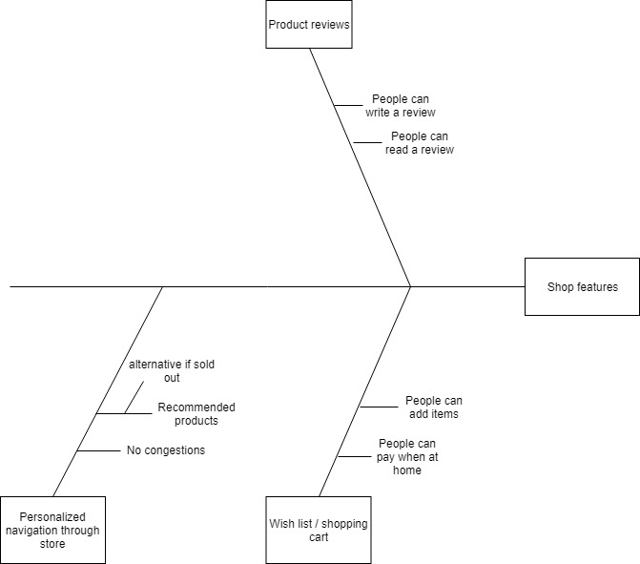

## Scope of initial release

FE-1: Customers will be navigated through the store in a personalized manner, in such a way that there won't be congestions by having too many customers in the same area. Customers are recommended products based on their interests. If products are sold out, alternative products will be proposed.

FE-2: Customers can write and read reviews on different products.

FE-3: Customers can add products to their wish list / shopping cart. They can order and pay for the products on the wish list or in the shopping cart at home.

Features that will not be implemented:

Bringing customers that are interested in the same products together to drink a cup of coffee.

Having the app integrated with in-store physical objects.

## Limitations and exclusions

Using in-store objects to communicate with the app is infeasible and will therefore not be implemented.

To summarize, almost every feature will be implemented. The features that have been listed are the ones that will be implemented. Using this chapter and the previous chapter, we are able to investigate the business context of Seats and More.

# Business context

Using the business requirements chapter and the scope and limitations chapter we are able to create a better and more exact business context. In this chapter we elaborate the profiles of 5 stakeholders using a cross-table. We elaborate the project’s priorities and the deployment considerations.

## Stakeholder profiles

|  |  |  |  |  |
| --- | --- | --- | --- | --- |
| Stakeholder | Major value | Attitudes | Major interests | Constraints |
| Customer | A pleasant shopping experience; time savings; convenience | Enthusiast, but might not be interested | Simplicity of use; quick shopping experience | Able to use the application |
| Management | Less returned items; expand clientele; more satisfied customers | Strong commitment | Create a shopping experience that will please an expanding clientele; expand clientele | Good working internet connection and tablets/smart phones |
| Store Employees | More efficient use of staff time throughout the day; | Concern about possible downsizing | Job preservation | Training for collaboration with the system |
| Software Department | No benefit;  Needs to set up a product information system | Not happy about the software work needed, but recognizes the value to the company and employees | Create a simple but efficient application | Recourses for the changes |
| Marketing Department | Expand clientele | Enthusiast to have a new opportunity to attract new customers | Communicate advantages to potential customers | Exact information about how the system works |

## Project priority

|  |  |  |  |
| --- | --- | --- | --- |
| Dimension | Constraint | Driver | Degree of freedom |
| Features | All features scheduled, must be finished before the initial release. |  |  |
| Quality |  | As few as possible congestions |  |
| Schedule |  |  | The initial release has an overrun of up to two acceptable without sponsor review |
| Cost |  | Reduces the number of returned items; expand the clientele |  |
| Staff |  | The opportunity to help customers better |  |

## Deployment considerations

The internet surfer must be upgraded to handle the increased usage of the internet by all the smartphones or tablets. The app has to be developed for different operating systems, such as iOS, Android or Windows Phone or tablet. Any infrastructure changes must be in place before the initial release. The customer database must have enough storage to store the preferences of the customers and the shopping cart. The store’s staff must get training to help them work with the new system and because of that will be able to help customers better.

We have come to conclusion that there are a lot of things to keep in mind and take into account when making the new product information system.