Task3
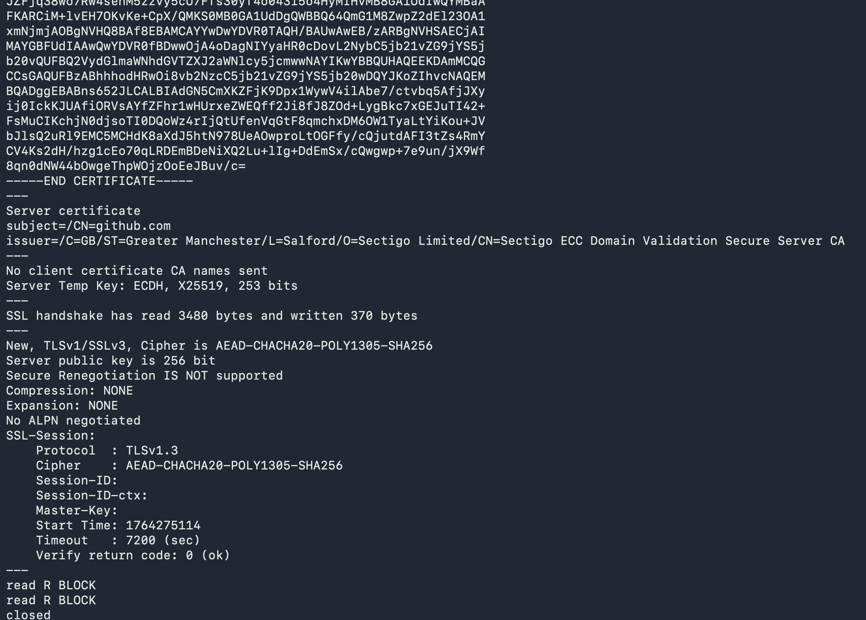

TLS Version: TLS 1.3
Cipher Suite: TLS_CHACHA20_POLY1305_SHA256

Certificate Chain:
Root CA → USERTrust / Sectigo Root CA (trusted locally)
Intermediate CA → Sectigo ECC Domain Validation Secure Server CA
Leaf Certificate → github.com

I found githubt IP using nslookup. Here is the handshake with server
