Fuzzy Logic Control of Ball-Beam System

Gokula Balan Subbiah

Faculty of Engineering and Information Technology

University of Technology Sydney Sydney, Australia [GokulaBalan.Subbiah@student.uts.edu.au](mailto:GokulaBalan.Subbiah@student.uts.edu.au)

***Abstract*—This research paper presents the development and optimization of a Ball and Beam system controlled exclusively by a Fuzzy Logic Controller (FLC), implemented using MATLAB and Simulink. The study begins with a literature review discussing traditional controllers like Proportional-Derivative (PD) and Proportional-Integral- Derivative (PID) controllers to contextualize the use of FLCs in similar systems. The core of the project focuses on the design, testing, and subsequent tuning of an FLC tailored for the Ball and Beam system. Initial results with the FLC showcased its capability to stabilize the system, but with high settling times. By adjusting the membership functions within the controller’s design, the research successfully reduced these settling times, enhancing system responsiveness and stability. The comparative analysis between the initial and tuned configurations of the FLC demonstrates the effectiveness of precise tuning in FLCs, highlighting the importance of optimal controller design in achieving efficient operational performance in dynamic systems.**

1. INTRODUCTION

The concept of the ball and beam system was first introduced for educational purposes in the 1960s and 1970s as a simple yet effective way to demonstrate principles of control theory, such as feedback control and stabilization. It provides a tangible and visually intuitive platform for students and researchers to understand and experiment with various control algorithms and techniques [1].

Ball and beam system is one of the most enduringly popular and important laboratory models for teaching control systems engineering. It is widely used because many important classical and modern design methods can be studied based on it [2]. A ball is placed on a beam, where it is allowed to roll with one degree of freedom along the length of the beam. A lever arm is attached to the beam at one end and a motor at the other. As the motor turns by an angle theta, the lever changes the angle of the beam by alpha. When the angle is changed from the vertical position, gravity causes the ball to roll along the beam. A controller will be designed for this system so that the ball's position can be manipulated [4].

1. *Literature review*

The main topics covered in the literature review are- The design of the ball and beam model, general control techniques, and the implementation of a Fuzzy Logic Controller for the Ball and Beam. The design of the ball and beam system can be of two different types. The motor can be placed in the middle of the beam with no other attachment to the sides, or it can be connected to the beam at one end with a lever attached to the other end or in the centre of the beam. Most of the practical implementation use the latter one [5] [6] [4].

Most Ball and Beam balancing systems use traditional controllers like Proportional-Derivative (PD) or Proportional-Integral-Derivative (PID) controllers. However, Fuzzy Logic Controllers (FLCs) are also employed. Unlike

conventional controllers, FLCs do not depend on a mathematical model of the system. Instead, they utilize a rule-based approach, which can lead to improved performance in systems that are challenging to model accurately or when external disturbances are present [7].

In a comparative study of PID and FLC performance, the PID controller was found to quickly reduce error but with significant overshot and stabilization time, whereas the FLC achieved a steady zero error convergence without overshoot. The PID required a higher initial control input with subsequent spikes, unlike the FLC's gradual and stable input. Similarly, while the PID output overshot before stabilizing, the FLC maintained a smooth and consistent setpoint. Despite similar settling times, the FLC exhibited a smoother and more stable response, suggesting its superiority in applications like the ball and beam system where steady control is crucial [7].

1. *Motivation*

The Ball and Beam project captivates me due to its multidisciplinary nature, merging dynamic system modeling and advanced control systems—essential areas in robotics. Utilizing MATLAB and Simulink, this project demands a robust understanding of control theory and provides a practical platform to apply these concepts. By focusing on the Ball and Beam system, I aim to showcase my proficiency in system modeling, feedback control, and implementing a fuzzy logic controller.

1. *Objectives*
   * Design a Ball and Beam System:

Develop a comprehensive Ball and Beam system using MATLAB and Simulink, ensuring accurate representation of dynamic behaviors and system responses.

* + Select Inputs to and Outputs from the Ball-Beam and Fuzzy System:

Identify and define the critical inputs and outputs for both the Ball and Beam system and the fuzzy logic controller, facilitating effective control and feedback mechanisms.

* + Design a Fuzzy Logic Controller:
    1. *Fuzzification:*

Develop membership functions for input variables, transforming crisp inputs into fuzzy values suitable for processing by the fuzzy logic controller.

* + 1. *Inference - Rule-Base:*

Construct a robust rule-base consisting of logical IF- THEN rules that dictate the controller's actions based on the fuzzy inputs.

* + 1. *Defuzzification:*

Implement a defuzzification method to convert the fuzzy output from the inference engine into a precise control action for the system.

* + Test the System:

Conduct comprehensive testing of the Ball and Beam system with the fuzzy logic controller, analyzing system performance and stability under various conditions.

* + Additional Improvements by Tuning:

Fine-tune the fuzzy logic controller parameters to enhance system performance, ensuring optimal control accuracy and responsiveness.

1. METHODS

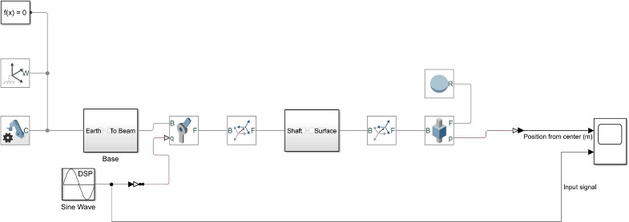

*Fig 1: Physical representation of the ball-beam model*

1. *System Considerations*

We have 2 inputs, Error and change in Error and single output, motor angle. There are 3 common membership functions. Triangular Membership Function is characterized by a linear rise and fall around a central point. Trapezoidal membership function is characterized by a flat top, which can represent uncertainty about the membership of an element to a set. Gaussian membership function has a bell-shaped curve described by two parameters: mean (m) and standard deviation (σ), providing a smooth and natural representation of uncertainty. This function is more computationally intensive but can be more representative of naturally occurring phenomena. We chose Triangular membership function for simplicity.

“Min-Max method” is a common inference method used in fuzzy logic systems. During the inference process, this method is utilized to evaluate the rules in the rule base by applying the minimum (min) operator for the 'AND' condition and the maximum (max) operator for the 'OR' condition within fuzzy logic rules. Min-Max is a simple inference method that doesn't involve complex mathematical operations so we went with this.

The “Rule Base” refers to a set of if-then rules that define how the fuzzy system should make decisions. Each rule correlates fuzzy inputs with fuzzy outputs based on expert knowledge or data-driven methods.

The “Centre of Gravity” (also known as the Centroid) method calculates the center of the area under the curve of the aggregated fuzzy set, yielding a single output value. We chose this for couple of reasons.

*Smooth Control Action:* The centroid method takes into account the entire area under the curve of the aggregated membership function. This typically results in a control action

that is smooth and doesn’t lead to abrupt changes, which is essential for precisely balancing the ball on the beam.

*Continuous Systems:* Ball and beam systems are continuous control problems where small changes in the beam's angle can have a significant effect on the ball's position. The centroid method provides a single crisp output value that ensures continuous control action.

1. *Implementation*

The implementation of the system was executed in several stages. Initially, the physical model was designed using SIMULINK. Upon completion, the physical model appeared as follows,

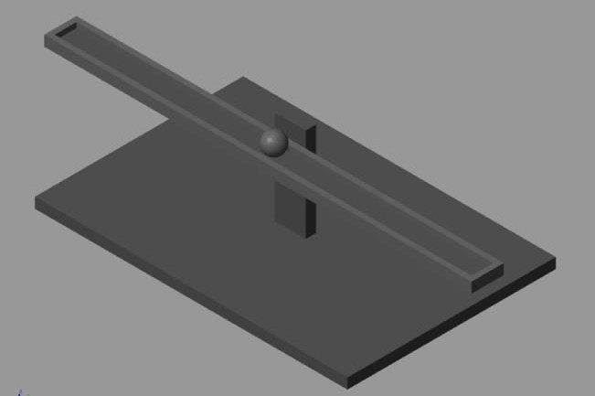

*Fig 2: Ball and beam model*

The physical model comprises three distinct components: the base, beam, and ball. The base is anchored to the ground. The beam is linked to the base using a prismatic joint, and the ball is connected to the beam through another prismatic joint. The system accepts the input motor angle via the rotational joint, while the ball's position and velocity outputs are extracted from the prismatic joint. The physical model illustrated in Fig. 2 is integrated into a single block, with the motor angle serving as the input (applied to the rotational joint) and the ball's position as the output (sourced from the prismatic joint).

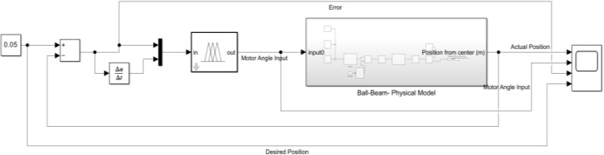

*Fig 3: Functional Block Diagram*

The functional block diagram of the designed system is shown in Fig. 3. It includes a Fuzzy Logic Controller (FLC) with two inputs—error and change in error—and one output, the motor angle. The error is calculated as the difference between the desired and actual ball positions, while the change in error is determined using a derivative function. Parameters such as ball position, error, and desired position are visualized using a scope.

The input and output comprised of seven triangular membership functions: NL, NM, NS, Z, PS, PM, and PL. The FLC structure is as follows.

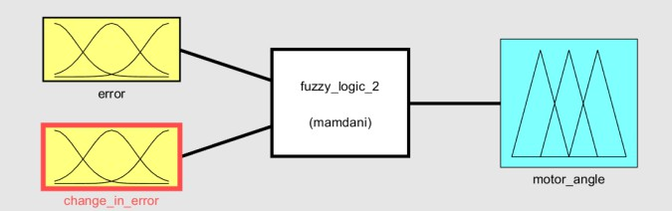

*Fig 4: Fuzzy Logic Controller*

The range of the inputs was fixed at -0.18 to 0.18 for error (based on the length of the beam), -12 to 12 for change in error (based on experiments) and -0.3 to 0.3 for motor angle (based on experiments). The distribution of the membership functions is as follows.

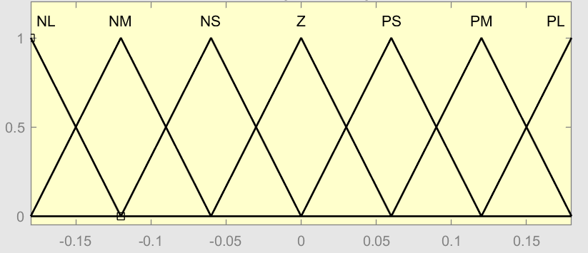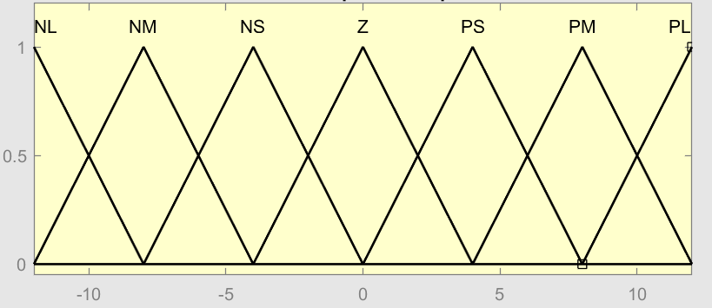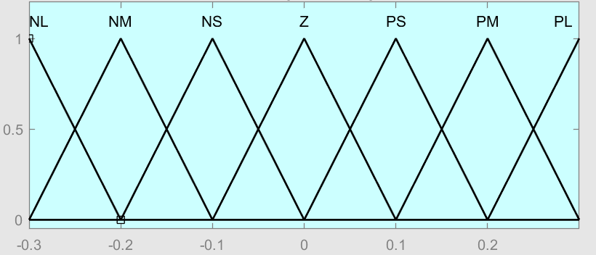

*Fig 5: Error, Change in Error, and Motor angle (top to bottom)*

When the error is positive the ball is on the right side of the beam and negative means it is on left side of the beam. If the change in error is positive, then the ball is moving left and rolling to the right side when the change in error is negative.

The inference mechanism used was the min-max method, and the defuzzification method was the centroid method. The rule base used is shown below,

*Fig 6: Rule Base*

1. 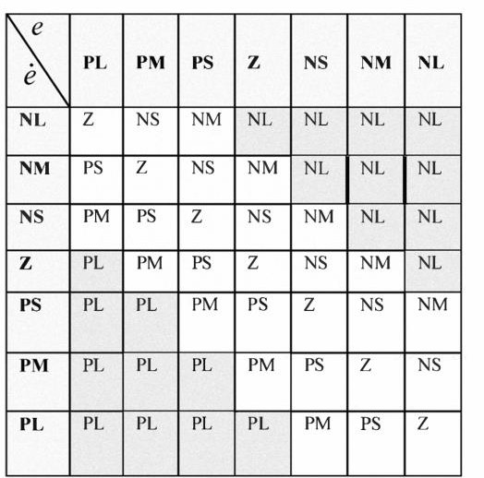EXPERIMENTS AND RESULTS

The desired position is defined as the measurement from the center of the beam to the respective position at either end of the beam. We have tested the model on only one side as the beam is symmetrical and will yield the same result if conducted on either side. The desired positions are set at 3 different positions from the center of the beam at 5cm, 10cm and 15cm. note: the total length of the beam is 20 cm.



20 cm

Desired Position

15cm 10 cm 5 cm

 Symmetrical 

*Fig 7:Ball and Beam setup*

With the initial configuration of the membership functions the settling time for desired positions set are high as we can see from the graphs below. The settling time when the desired position or error at 5cm is around 18 seconds, close to 20 seconds for 20cm and about 14 seconds for 15 cm.

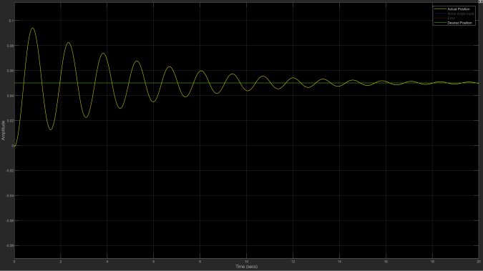

*Fig 8: Initial configuration result at 5cm*

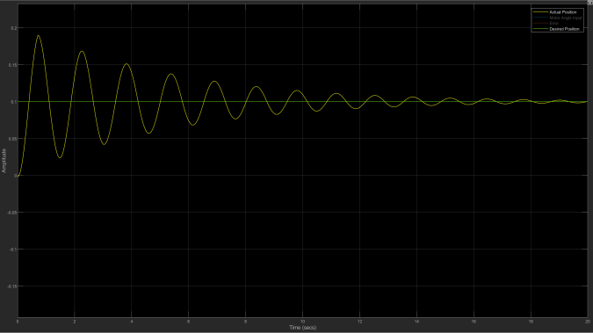 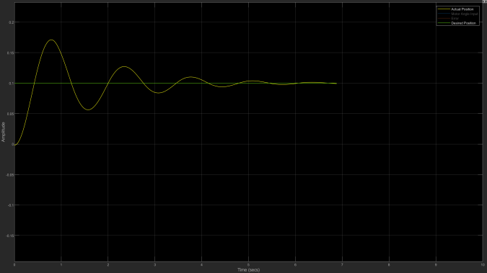

*Fig 9: Initial configuration result at 10cm*

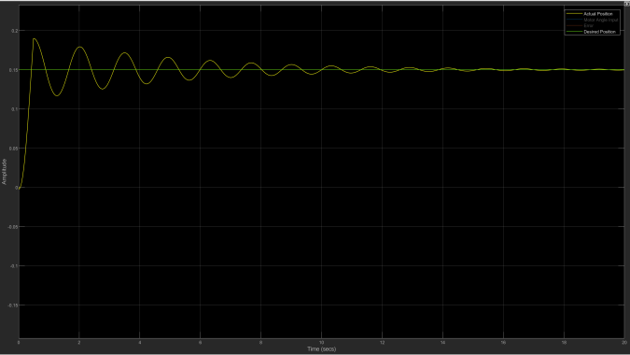

*Fig 10: Initial configuration result at 15cm*

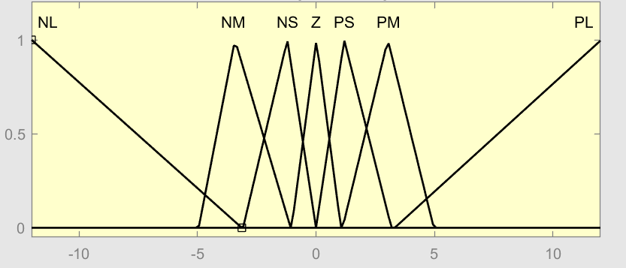

*Fig 11: tuned membership fuction for change in error*

The membership functions are then tuned inorder to achieve quick settling time. Membership functions are tightly packed and centered around the zero point, with overlap between adjacent sets. This configuration allows for more precise adjustments to the control output as changes in error occur, contributing to a more responsive control system.

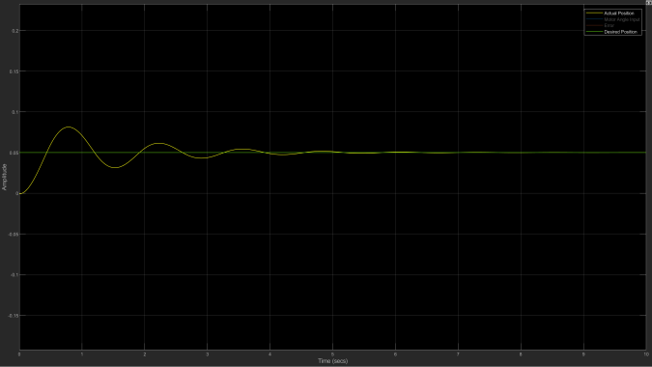

*Fig 12: Tuned configuration result at 5cm*

*Fig 13: Tuned configuration result at 10cm*

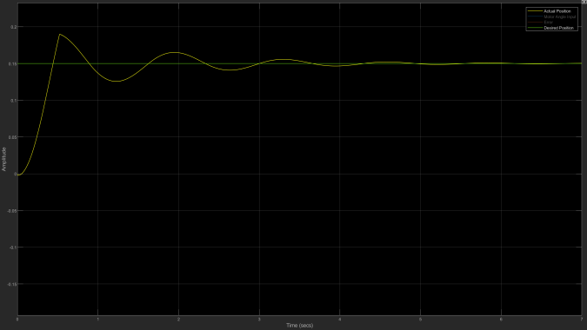

*Fig 14: Tuned configuration result at 15cm*

1. ANALYSIS AND DISCUSSION

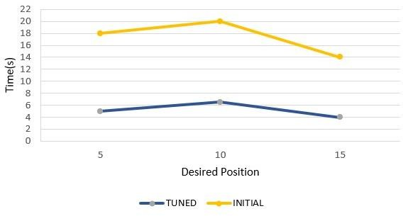

*Fig 15: Initial vs tuned configuration*

|  |  |  |
| --- | --- | --- |
| Desired Positions (cm) | Initial config (s) | Tuned config (s) |
| 5 | ~18 | ~5 to 5.5 |
| 10 | ~20 | ~6 to 6.5 |
| 15 | ~14 | ~ 4 to 4.5 |

The initial configuration features wider triangular membership functions. This design tends to smooth out the control actions because changes in the error need to be larger to significantly shift the degree of membership between different fuzzy sets. Therefore, the system reacts more slowly

to changes in error, which can lead to slower adjustments and consequently longer settling times.

In contrast, the narrower bases of tuned triangular functions mean that even small changes in the error will move the system from one membership function to another more rapidly than the broader bases seen in the second graph. This responsiveness results in quicker reactions to changes, hence reducing the settling time—the time it takes for the system to stabilize within a desired error range after a disturbance.

As obserbed from the table the settling time are high when the desired position is 10cm which is the middle point on one side from the center of the beam. One possible reason for this might be the beam's midpoint often represents a critical balance point. Control sensitivity is higher here because small deviations in the ball's position can lead to significant changes in the control requirements. The control system needs to exert more effort to maintain or reach equilibrium at this midpoint, which can naturally lead to longer settling times.

1. CONCLUSION

In this study, a Ball and Beam system was intricately modeled in MATLAB and controlled via a Fuzzy Logic Controller toolbox designed in SIMULINK. The model was adeptly set up with specific inputs and outputs—motor angle and ball position respectively. The control strategy was meticulously developed using two primary inputs: error and rate of change in error, each managed by seven triangular membership functions. Initial settings of the FLC were refined through systematic tuning, leading to optimized performance where steady state conditions were swiftly reached within 4 to 6 seconds across various positional targets. This fine-tuning process underscored the potential for further reductions in response time and provided a foundational approach for potential comparative analysis with conventional control methods in future studies.

1. REFERENCES
2. Olmstead, C. W., & Kuhlmann, J. C. (1965). The Use of Electromechanical Analogies in the Teaching of Linear Control Systems. IEEE Transactions on Education, 8(1), 3-6.
3. Yu, W. (2009). Nonlinear PD Regulation for Ball and Beam System. *International Journal of Electrical Engineering & Education*, *46*(1), 59–73. <https://doi.org/10.7227/IJEEE.46.1.5>
4. [https://www.mstarlabs.com/control/fuzzypid.html#:~:tex](https://www.mstarlabs.com/control/fuzzypid.html) [t=The%20simple%20fuzzy%20logic%20controller%20is](https://www.mstarlabs.com/control/fuzzypid.html)

[%20based%20on%20three%20heuristic,is%20no%20mo](https://www.mstarlabs.com/control/fuzzypid.html) [re%20mathematically%20complex.](https://www.mstarlabs.com/control/fuzzypid.html)

1. [https://ctms.engin.umich.edu/CTMS/index.php?example](https://ctms.engin.umich.edu/CTMS/index.php?example=BallBeam&section=SystemModeling)

[=BallBeam&section=SystemModeling](https://ctms.engin.umich.edu/CTMS/index.php?example=BallBeam&section=SystemModeling)

1. Acharya, Manoj & Bhattarai, Manish & Poudel, Bikash. (2014). Real Time Motion Assessment for Positioning in Time and Space Critical Systems Authors. International Journal of Applied Research and Studies (iJARS). 3. 2278-9480.
2. Lv, Xiao & Liu, Yongxin & Liu, Yu & Huang, Hai. (2011). Design of Ball-Beam Control System Based on Machine Vision. Applied Mechanics and Materials. 71-

78. 10.4028/[www.scientific.net/AMM.71-78.4219.](http://www.scientific.net/AMM.71-78.4219)

1. Amjad, M., Kashif, M. I., Abdullah, S. S., & Shareef, Z. (2010). Fuzzy logic control of ball and beam system. *2010 2nd International Conference on Education Technology and Computer*, *3*, V3-489-V3-493. <https://doi.org/10.1109/ICETC.2010.5529494>
2. E. P. Dadios, R. Baylon, R. De Guzman, A. Florentino, R.

M. Lee and Z. Zulueta, "Vision guided ball-beam balancing system using fuzzy logic," 2000 26th Annual Conference of the IEEE Industrial Electronics Society. IECON 2000. 2000 IEEE International Conference on Industrial Electronics, Control and Instrumentation. 21st Century Technologies, Nagoya, Japan, 2000, pp. 1973- 1978 vol.3, doi: 10.1109/IECON.2000.972578.\

1. [https://codecrucks.com/what-is-fuzzy-membership-](https://codecrucks.com/what-is-fuzzy-membership-function-complete-guide/) [function-complete-guide/](https://codecrucks.com/what-is-fuzzy-membership-function-complete-guide/)
2. [https://au.mathworks.com/videos/defining-rigid-bodies-](https://au.mathworks.com/videos/defining-rigid-bodies-68845.html?s_tid=vid_pers_recs) [68845.html?s_tid=vid_pers_recs](https://au.mathworks.com/videos/defining-rigid-bodies-68845.html?s_tid=vid_pers_recs)
3. [https://ctms.engin.umich.edu/CTMS/index.php?example](https://ctms.engin.umich.edu/CTMS/index.php?example=BallBeam&section=SimulinkSimscape)

[=BallBeam&section=SimulinkSimscape](https://ctms.engin.umich.edu/CTMS/index.php?example=BallBeam&section=SimulinkSimscape)

1. C. Osinski, A. L. R. Silveira, C. Stiegelmaier, M. G. Bergamini and G. V. Leandro, "Control of Ball and Beam System Using Fuzzy PID Controller," 2018 13th IEEE International Conference on Industry Applications (INDUSCON), Sao Paulo, Brazil, 2018, pp. 875-880, doi: 10.1109/INDUSCON.2018.8627251.