Calculus

<https://www.mathsisfun.com/calculus/derivatives-introduction.html>

<https://www.youtube.com/watch?v=cT4pQT5Da0Q>

Calculus – math of change

## History:

Full name is infinitesimal calculus. In olden days, “calculus” simply meant “math”.

Calculus ~ in latin means “small pebble”. Math in the olden days was done with pebbles and thus came to be called Calculus.

Isaac Newton wanted to understand how gravity worked.

Gravitational force between two object worked like below. The lower the distance between the two, greater is the gravitational force/attraction. But Newton could not mathematically define the curve which was not uniform and the rate of change is different in different spots of graph.

To first identify the relation between y and x, Newton assumed a tangential line at a point and so now the goal was to find the slope/gradient of the tangential line which in turn gave the relation of y and x at this point.

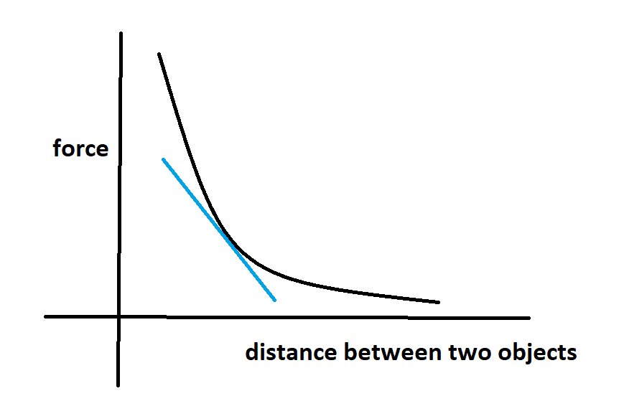

Since tangent had only one point on curve, calculating or representing gradient was not possible.

Newton then imagined a parallel line that cut the curve in two points (secant). like below:

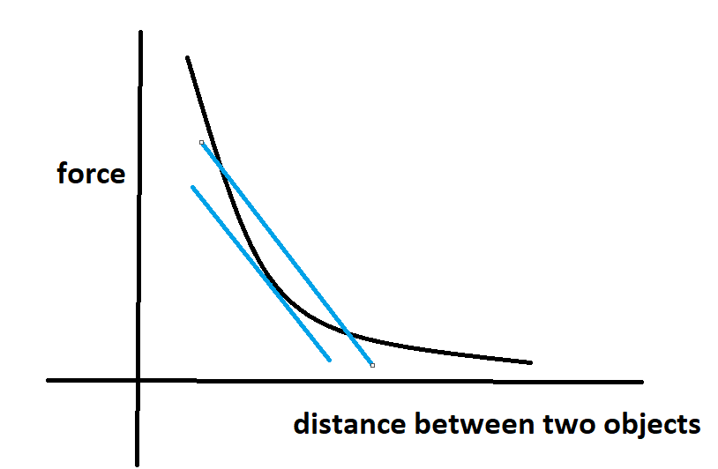

The slope of the secant should be close to slope of the tangent.

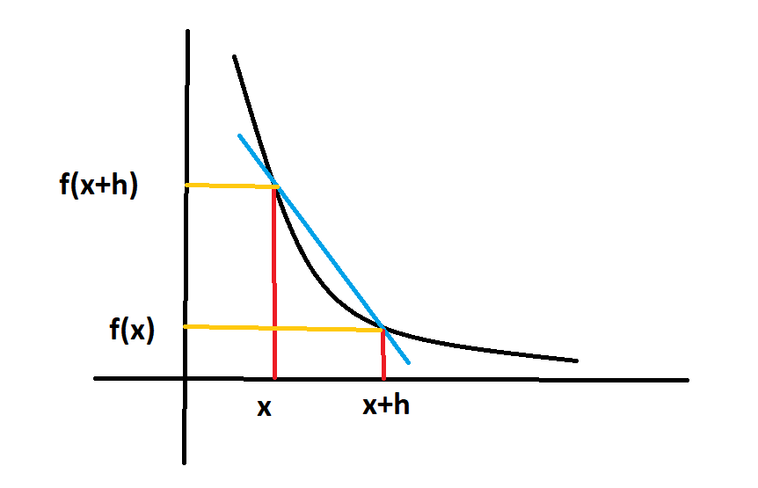

The idea of limits was introduced and this allowed mathematical expression of the relation.

gradient, msecant = rise/ run

To get expression for tangent, lets introduce limits, that in the expression h tends towards becoming 0 but not x = 0. Thus an expression for tangent was made possible.

mtangent = limh->0 f(x+h)-f(x) / h

Note: If h = 0 is considered, the eqn becomes invalid since division by 0 is not possible.

When you remove limh->0 then the formula becomes gradient of secant and not the tangent. limits in a eqn simply means we are interested in the tangent and not the secant.

limh->0 f(x+h)-f(x) / h is called first principle of calculus

the eqn. limh->0 f(x+h)-f(x) / h allows us to

Derivative function:

In calculus change in variables is indicated by ‘d’

If a function explained the relation between y and x variables, the derivativbe function can be simply noted as : dy/dx

dy/dx is used a lot in calculus to indicate change in y and x.

**Slope vs Derivative**

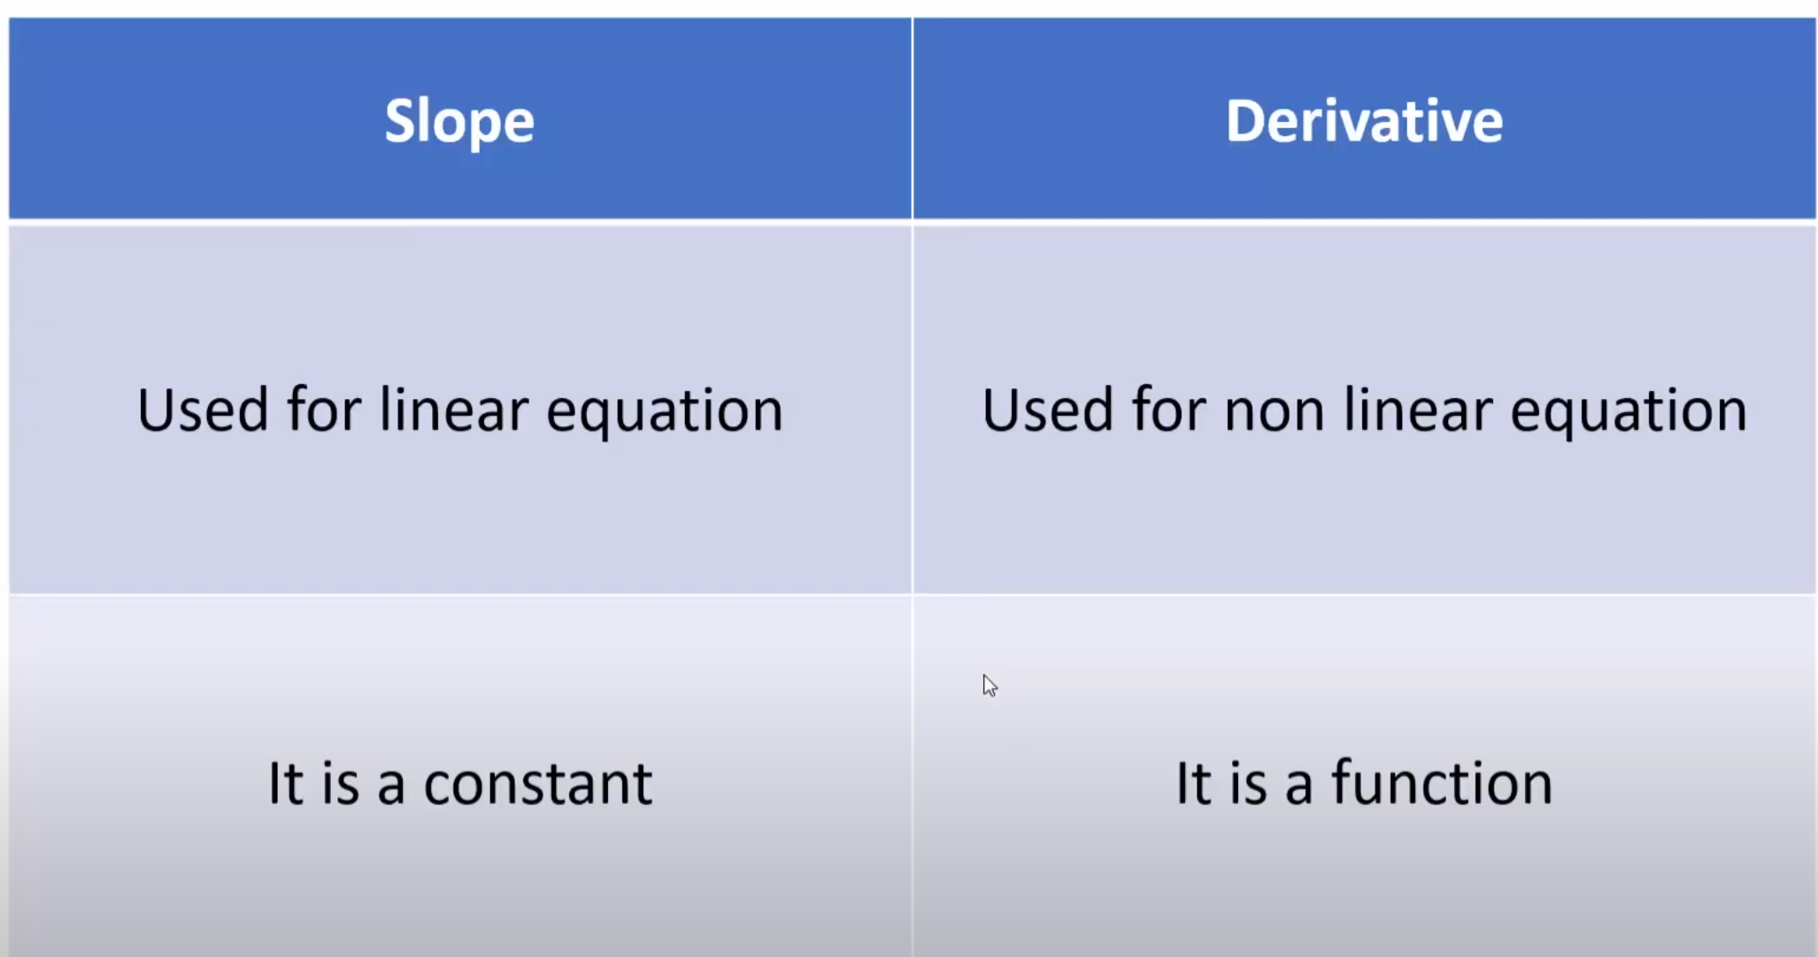

**Partial Derivative:**

A Partial Derivative is a [derivative](https://www.mathsisfun.com/calculus/derivatives-introduction.html) where we hold some variables constant. Like in this example:

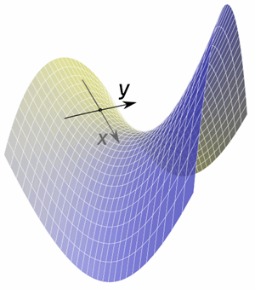

Example: a function for a surface that depends on two variables **x** and **y**

 When we find the slope in the **x** direction (while keeping **y** fixed) we have found a partial derivative.

 Or we can find the slope in the **y** direction (while keeping **x** fixed).