Desi Battle

CPE301 – SPRING 2016

Design Assignment 0

**DO NOT REMOVE THIS PAGE DURING SUBMISSION:**

The student understands that all required components should be submitted in complete for grading of this assignment.

|  |  |  |  |
| --- | --- | --- | --- |
| **NO** | **SUBMISSION ITEM** | **COMPLETED (Y/N)** | **MARKS**  **(/MAX)** |
| 0. | COMPONENTS LIST AND CONNECTION BLOCK DIAGRAM w/ PINS |  |  |
| 1. | INITIAL CODE OF TASK 1/A |  |  |
| 2. | INCREMENTAL / DIFFERENTIAL CODE OF TASK 2/B |  |  |
| 3. | INCREMENTAL / DIFFERENTIAL CODE OF TASK 3/C |  |  |
| 4. | INCREMENTAL / DIFFERENTIAL CODE OF TASK 4/D |  |  |
| 5. | INCREMENTAL / DIFFERENTIAL CODE OF TASK 5/E |  |  |
| 6. | SCHEMATICS |  |  |
| 7. | SCREENSHOTS OF EACH TASK OUTPUT |  |  |
| 8. | SCREENSHOT OF EACH DEMO |  |  |
| 9. | VIDEO LINKS OF EACH DEMO |  |  |
| 10. | GOOGLECODE LINK OF THE DA |  |  |
|  |  |  |  |
|  |  |  |  |

|  |  |  |  |
| --- | --- | --- | --- |
| 0. | COMPONENTS LIST AND CONNECTION BLOCK DIAGRAM w/ PINS |  |  |

|  |  |  |  |
| --- | --- | --- | --- |
| 1. | INITIAL CODE OF TASK 1/A |  |  |

;CpE 301 Design Assignment 0

; DA0.asm

; Created: 2/15/2016 6:25:14 PM

; Author : DJ

start:

ldi r16, 0 ;initialize rsum to 0

ldi r17, 60 ;store random number in r17

ldi r18, 60 ;store random number in r18

ldi r19, 60 ;store random number in r19

ldi r20, 60 ;store random number in r20

ldi r21, 15 ;store random number in r21

;Add "random" numbers to r16, only check for carry flag

;after 5th addition due to problem constraints that random

;values are between 30 and 60. Therefore carry may only be

;generated following the 5th addition

add r16, r17

add r16, r18

add r16, r19

add r16, r20

add r16, r21

brcs carrySet ;if the carry flag set break to carrySet label

rjmp done ;if carry flag not send jump to done

carrySet:

ldi r22, 4 ;load 4 or 0b00000100 into r22

out PORTB, r22 ;set port b to 0b00000100 if carry flag was set. (set portb.2 = 1)

done: ;infinite loop denoting end of program

rjmp done

|  |  |  |  |
| --- | --- | --- | --- |
| 6. | SCHEMATICS |  |  |

|  |  |  |  |
| --- | --- | --- | --- |
| 7. | SCREENSHOTS OF EACH TASK OUTPUT |  |  |

TASK 1: Screenshot showing initial contents of sum register (r16), portb.2, and the carry flag register prior to adding a total of 255.

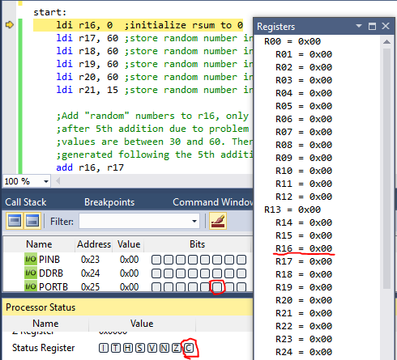

Screenshot showing final contents of sum register (r16), portb.2 and the carry flag. Portb.2 is still 0 as the sum did not generate a carry bit.

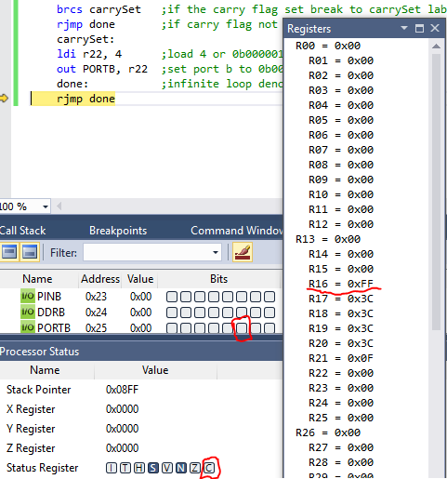

Screenshot of a second example (adding 300 to r16 rather than 255). Note the Carry flag is set and remains set until another arithmetic instruction alters it. Portb.2 is also set to HIGH per assignment instructions.

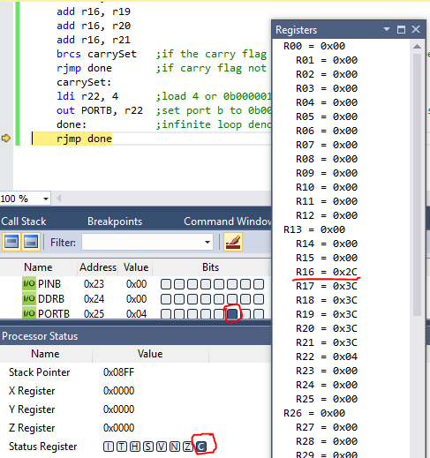

B.) The algorithm I chose uses 13 clock cycles and 1.63 us at 8.000 MHz is no carry is generated. If a carry is generated the algorithm uses 14 clock cycles and 1.75 us at 8.000 MHz. This includes the time it takes to initialize the registers.

|  |  |  |  |
| --- | --- | --- | --- |
| 8. | SCREENSHOT OF EACH DEMO |  |  |

|  |  |  |  |
| --- | --- | --- | --- |
| 9. | VIDEO LINKS OF EACH DEMO |  |  |
|  | | | |
| 10. | GOOGLECODE LINK OF THE DA |  |  |
| https://github.com/battled/DA0.git | | | |

**Student Academic Misconduct Policy**

<http://studentconduct.unlv.edu/misconduct/policy.html>

“This assignment submission is my own, original work”.

Desi Battle