Desi Battle

CPE301 – SPRING 2016

Design Assignment 5

**DO NOT REMOVE THIS PAGE DURING SUBMISSION:**

The student understands that all required components should be submitted in complete for grading of this assignment.

|  |  |  |  |
| --- | --- | --- | --- |
| **NO** | **SUBMISSION ITEM** | **COMPLETED (Y/N)** | **MARKS**  **(/MAX)** |
| 0. | COMPONENTS LIST AND CONNECTION BLOCK DIAGRAM w/ PINS |  |  |
| 1. | INITIAL CODE OF TASK 1/A |  |  |
| 2. | INCREMENTAL / DIFFERENTIAL CODE OF TASK 2/B |  |  |
| 3. | INCREMENTAL / DIFFERENTIAL CODE OF TASK 3/C |  |  |
| 4. | SCHEMATICS |  |  |
| 5. | FlOW CHARTS FOR EACH TASK |  |  |
| 8. | SNAPSHOTS OF BOARD WITH CONNECTED COMPONENTS |  |  |
| 9. | VIDEO LINKS OF EACH DEMO |  |  |
| 10. | GOOGLECODE LINK OF THE DA |  |  |
|  |  |  |  |
|  |  |  |  |

|  |  |  |  |
| --- | --- | --- | --- |
| 0. | COMPONENTS LIST AND CONNECTION BLOCK DIAGRAM w/ PINS |  |  |

TASK 1 components

* Atmega328p
* ILD74 Optoisolator
* 1N4004 Diode
* TIP120 Transistor
* 100k, 10k resistors
* 25k potentiometer

TASK 2 components

* Atmega328p
* ULN2003 driver
* Unipolar Stepper Motor
* 25k potentiometer

TASK 3 components

* Atmega328p
* Servo Motor
* 25k potentiometer

|  |  |  |  |
| --- | --- | --- | --- |
| 1. | INITIAL CODE OF TASK 1/A |  |  |

/*

* DA5.c

* Created: 4/19/2016 12:21:33 PM

* Author : desi.battle

*/

#define F_CPU 8000000UL

#include <avr/io.h>

#include <util/delay.h>

int main(void)

{

int ctr =0; //counter to do software timer

DDRB = 0XFF;

DDRD = 0XFF;

ADCSRA = 0X87; //10000111 Enable ADC, divide clock by 128

ADMUX = 0X40; //internal 1.1v voltage reference

while(1)

{

ADCSRA |= (1<< ADSC)|(1<<ADIF); //read adc

while ((ADCSRA & (1<<ADIF)) ==0); //wait for adc to finish

ctr = 1024 - ADC; //set first part of duty cycle

while (ctr != 0)

{

ctr --;

_delay_us(10);

}

PORTB ^= 0x04; //flip output bit

ctr = ADC; //set second half of duty cycle

while (ctr != 0)

{

ctr--;

_delay_us(10);

}

PORTB ^= 0X04; //flip output bit

}

}

|  |  |  |  |
| --- | --- | --- | --- |
| 2. | INITIAL CODE OF TASK 2/B |  |  |

/*

* DA5.c

* Created: 4/19/2016 12:21:33 PM

* Author : desi.battle

*/

#define F_CPU 8000000UL //XTAL = 8MHZ

#include <avr/io.h>

#include <util/delay.h>

void my_delay(int x) //delay function

{

int i;

for(i= 0; i < x*2.5; i++)

{

_delay_us(1);

}

}

int main()

{

int del; //holds potentiometer value

DDRB = 0xFF; //make PORTB outputs

DDRB |= (1<<PB0); //make PB0 an output

ADCSRA = 0x80; //use AREF, internal Vref turned off, ck/2

ADMUX=0; //ADC single ended input

while(1)

{

ADCSRA |= (1<<ADSC); //start conversion

while((ADCSRA&(1<<ADIF))==0); //wait for conversion to finish

del = 1024 - ADC; //store adc

PORTB = 0X06;

my_delay(del);

PORTB = 0x0A;

my_delay(del);

PORTB = 0x09;

my_delay(del);

PORTB = 0x05;

my_delay(del);

}

return 0;

}

|  |  |  |  |
| --- | --- | --- | --- |
| 3. | INITIAL CODE OF TASK 3/C |  |  |

/*

* DA5.c

* Created: 4/19/2016 12:21:33 PM

* Author : desi.battle

*/

#include <util/delay.h>

#include <avr/io.h>

#define F_CPU 8000000UL

int main()

{

//PORTD pins as input

DDRD = 0xFF;

//Enable internal pull ups

PORTD = 0xFF;

//Set PORTB1 pin as output

DDRB = 0xFF;

ADCSRA = 0x80; //use AREF, internal Vref turned off, ck/2

ADMUX=0; //ADC single ended input

//TOP = ICR1;

//output compare OC1A 8 bit non inverted PWM

//Clear OC1A on Compare Match, set OC1A at TOP

//Fast PWM

//ICR1 = 20000 defines 50Hz pwm

float adcConv;

ICR1 = 20000;

TCCR1A|=(0<<COM1A0)|(1<<COM1A1)|(0<<COM1B0)|(0<<COM1B1)|(0<<FOC1A)|(0<<FOC1B)|(1<<WGM11)|(0<<WGM10); //TCCR1A = 0x82

TCCR1B|=(0<<ICNC1)|(0<<ICES1)|(1<<WGM13)|(1<<WGM12)|(0<<CS12)|(1<<CS11)|(0<<CS10);

//TCCR1B = 0x1A

//start timer with prescaler 8

OCR1A = 500;

while(1)

{

ADCSRA |= (1<<ADSC); //start conversion

while((ADCSRA&(1<<ADIF))==0); //wait for conversion to finish

adcConv =1024-ADC;

adcConv /=1024; //convert ADC value (0->1024 as a ratio by dividing by 1024)

adcConv *=1800; //convert ADC value to scale of our servo by multiplying by 1800

adcConv += 500; //add constant 500 as 0 degrees ==500

OCR1A =(int)adcConv; //store adc

_delay_ms(250);

}

}

|  |  |  |  |
| --- | --- | --- | --- |
| 4. | SCHEMATICS |  |  |

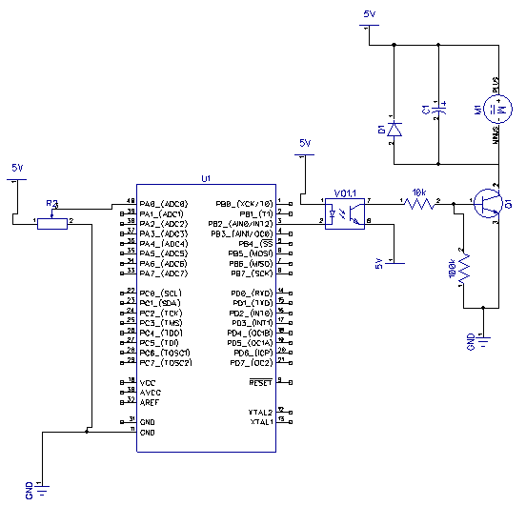

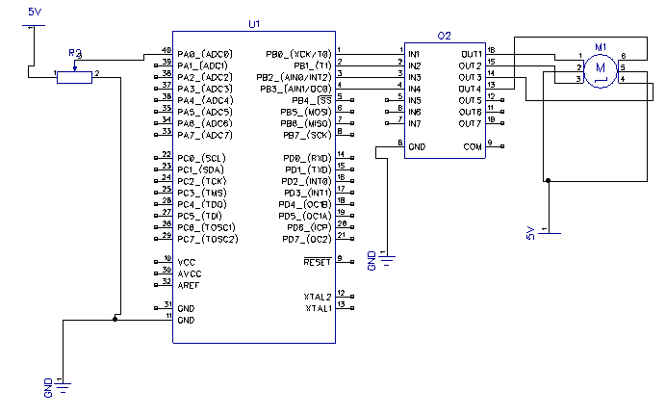

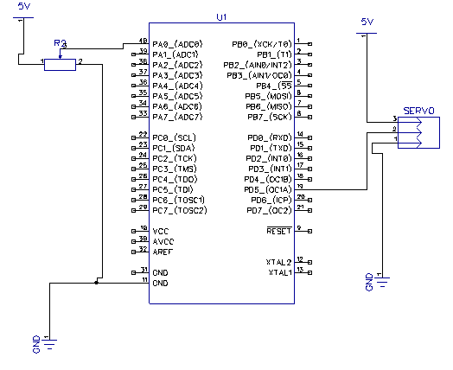

|  |  |  |  |
| --- | --- | --- | --- |
| 5. | FLOW CHARTS FOR EACH TASK |  |  |

Task1:

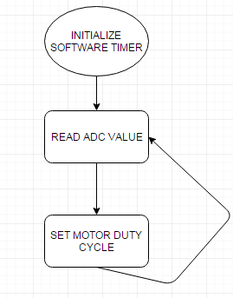

Task 2:

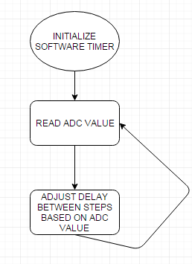

TASK 3:

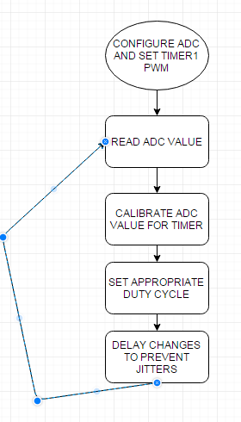

|  |  |  |  |
| --- | --- | --- | --- |
| 7. | SNAPSHOTS OF BOARD WITH CONNECTED COMPONENTS |  |  |

TASK 1/A:

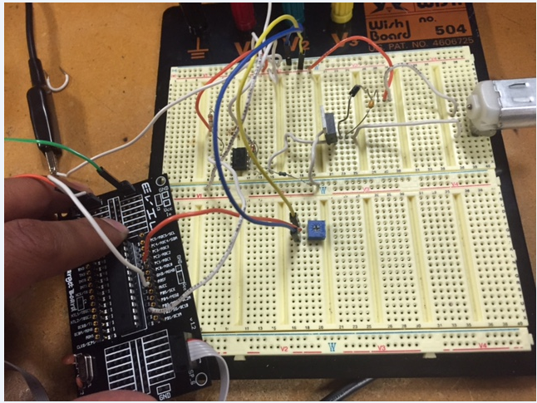

TASK 2/B:

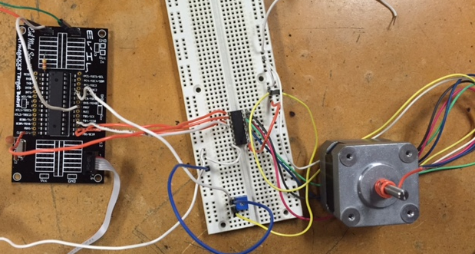

TASK 3/C

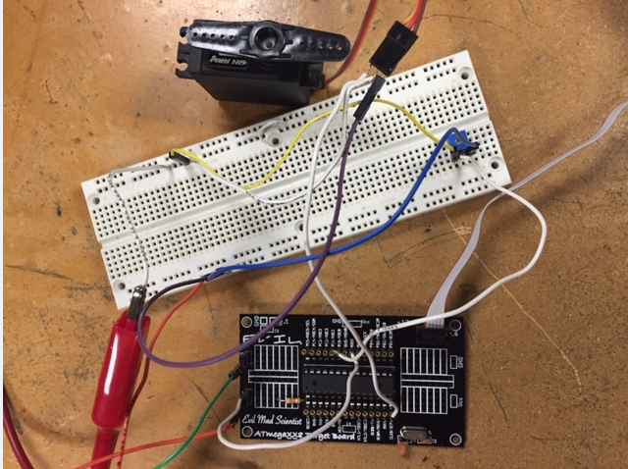

|  |  |  |  |
| --- | --- | --- | --- |
| 9. | VIDEO LINKS OF EACH DEMO |  |  |
| https://www.youtube.com/watch?v=lkFHhOstVIo&spfreload=5 | | | |
| https://www.youtube.com/watch?v=scR-B9wwgxM | | | |
| https://www.youtube.com/watch?v=NLks-1GPMUc | | | |
| 10. | GOOGLECODE LINK OF THE DA |  |  |
| https://github.com/battled/DA0 | | | |

**Student Academic Misconduct Policy**

<http://studentconduct.unlv.edu/misconduct/policy.html>

“This assignment submission is my own, original work”.

Desi Battle