Title: Testing the temperature

Goal:

* Read LM34 temperature sensor with Atmega328p over SPI
* Transfer data to ESP8266 module through UART
* Push reading onto Thingspeak.com account
* Create graph comparing current temperature to forecasted temperature

Deliverables:

The main deliverable of this assignment is a graph plotting both current room temperature as well as a forecasted temperature.

Literature Survey:

Having the ability to plot the current temperature over time from a sensor can help in maintaining a desired temperature. By integrating this device with a homes heating system it could accomplish that goal.

Components:

Atmega328p –Microcontroller (SPI, UART interface)

LM34 - Temperature Sensor

ESP8266 – WiFi module (3.3v)

USB FTDI – 3.3 V adapter

USB cable – 5 V power

Schematics: 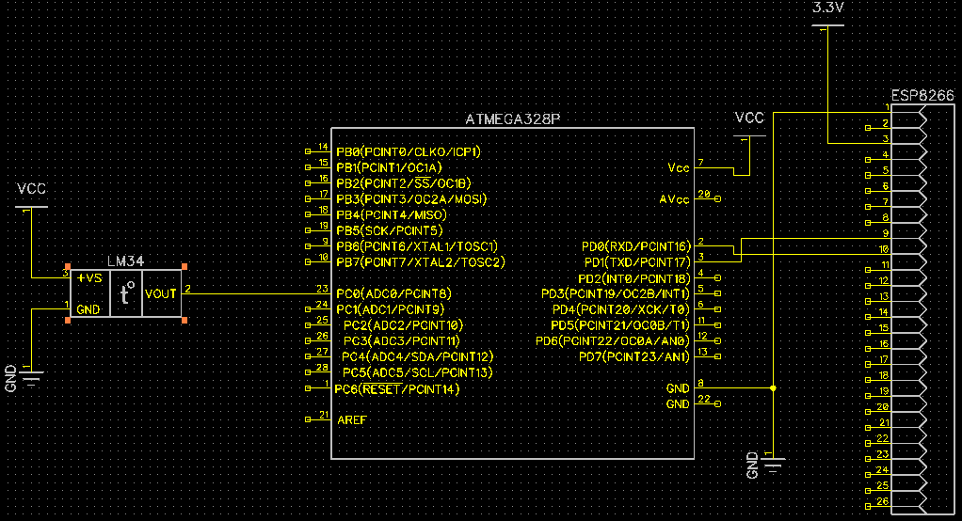

Initial PCB:

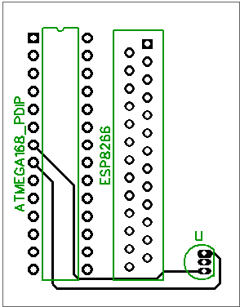

Implementation:

* ATMega328P connected through SPI to Temperature sensor
* ATMega328P connected through UART to ESP8266
* Every 15 minutes ESP8266 pushes temperature data to web server (Thingspeak.com)
* Web server compares current temperature read with forecasted value

Snapshots/Screenshots:

CODE: (with comments) \*\*omitted in PreFinal)

Reference:

<http://nodemcu.readthedocs.io/en/dev/en/upload/>

<https://github.com/nodemcu/nodemcu-firmware>

<https://www.mathworks.com/help/thingspeak/examples.html>

<https://sites.google.com/a/unlv.edu/unlvcpe301/projects>