Nicholas Robertson, Michael Weaver, Rose Marie Lizama, and Charles Whitten

Charles Lively

CST-135

April 15, 2017

Vending Machine Application Storyboard

Main Screen

This is the first screen that displays when the application is run. The **Customer Mode** button will take the user to the main vending machine GUI, where the user can purchase items from the vending machine. The **Boss Mode** button opens a list of tools related to management of the vending machine.

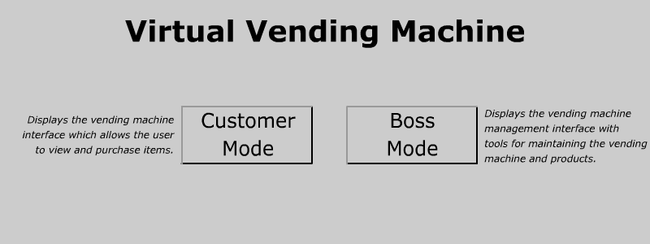

Customer Mode

This is the interface which allows the customer to enter a selection, insert money, and purchase an item from the vending machine. It will verify that the selection matches a valid item number, as well as confirm sufficient funds. Afterwards, the change due will be displayed at the bottom, and one item will be deducted from the inventory. A blank image signifies that particular location is out of stock.

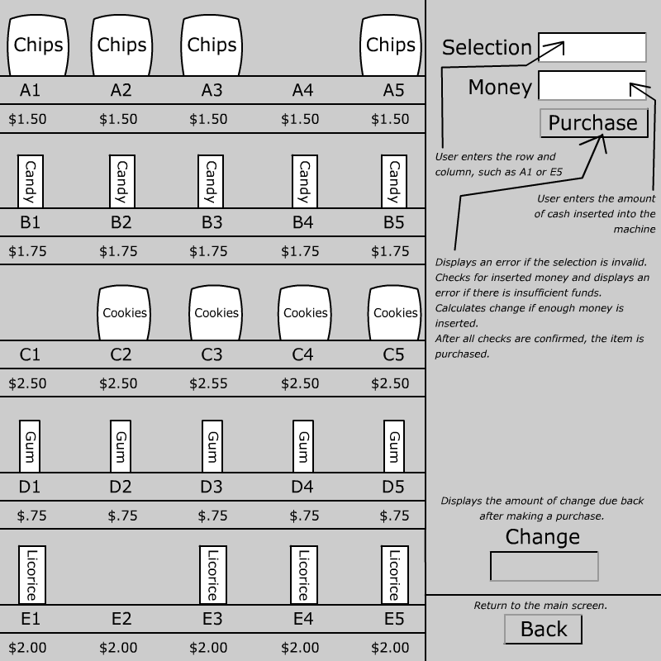

Boss Mode

This interface presents three options for managing the vending machine. Items may be restocked, moved into new locations, and have their attributes modified such as name and price. Additionally, inventory can be checked by searching for a particular product’s attributes.

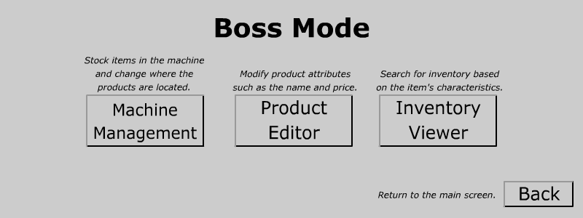

Machine Management

This is the interface which allows the boss to pick which items go where and how much stock is available. The user first selects the radio button, which then automatically selects the current item and displays the quantity. Both values can be changed, and the changes are saved after clicking the **Save** button.

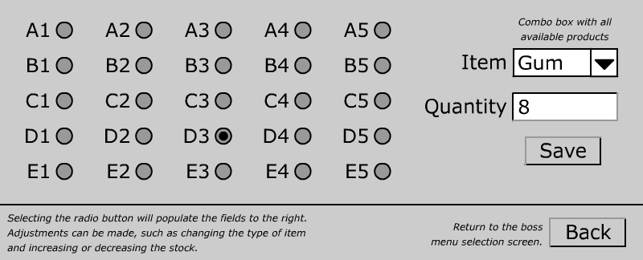

Product Editor

This is the interface which allows the boss to make changes to items in the inventory. The **Save** button will save any changes made, and these changes will be reflected within Customer Mode.

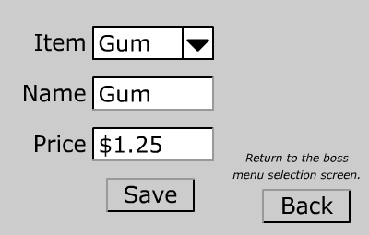

Inventory Viewer

This interface allows the boss to search for an item based on its name, quantity, or price.

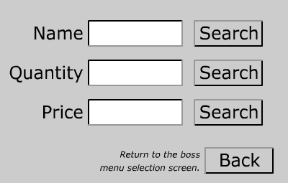

After clicking the **Search** button, a pop-up window will display the search results. The query may return zero results or several as shown below.

