**CST-361 Design Patterns in Java**

**Student** **Name**: Michael Weaver

**Project** **Title**: Presentation Layer Patterns

**Date**: 12/23/2018

Activity Log

|  |  |  |
| --- | --- | --- |
| **User stories** | **Team Member** | **Hours Worked** |
| Red Hat Development Studio Instillation and Configuration | Michael | 4 |
| Login Page and Model Research and Development | Michael | 4 |
| Documentation | Michael | 1 |
| JBoss EAP Server and Configuration | Michael | 1 |

Screenshots

Login Page Screenshot

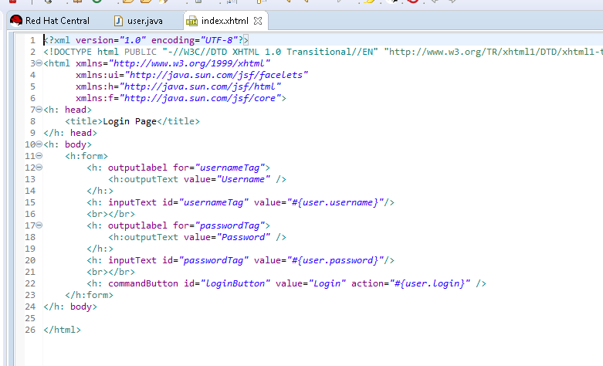

User Managed Bean Screenshot

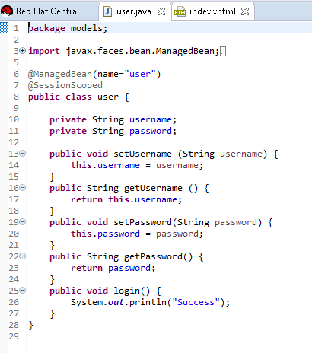

Design Pattern

For this project I used the MVC design pattern. Creating a view to display the login page, a controller to handle page submissions and a model to store user data.

Other options for this project would have been the MVVM or the MVP design patterns, as they would have worked just as effectively as MVC. MVC is the one that I am most familiar with which is why it is my first pick when designing a project.

What went Well

* I managed to get the RedHat Developer Studio installed after a few tries.
* I also managed to install the JBoss EAP application server
* I also managed to successfully launch the Hello World demo without issue.

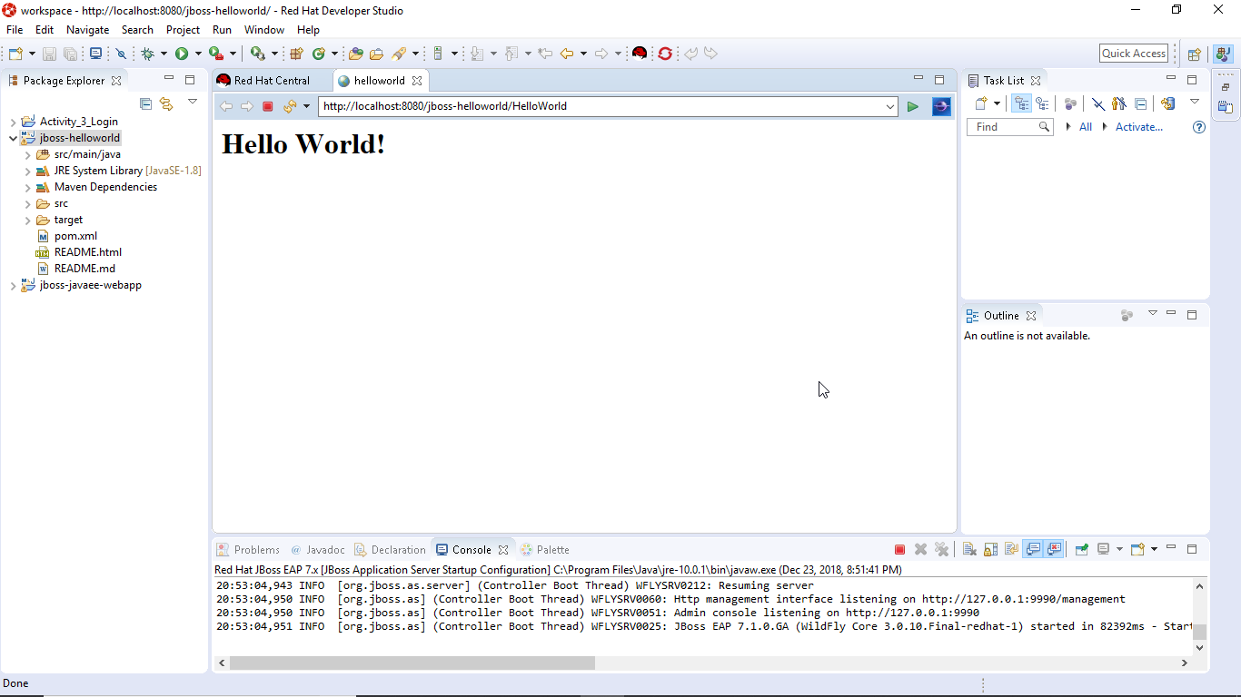

What Went Wrong

* Installing the workspace took 3-4 tries
* I think I installed 2-3 versions of JBOSS EAP before it connected to the RedHat Developer Studio
* Time is never on my side
* Also have a version of WildFly 10.1 installed as a secondary server (unsure if that is a problem or remains from past projects)

GitHub Link

<https://github.com/battousairurik/CST361_Design_Patterns_In_Java>