**Q1. configure git in control machine user name is 'gituser', user email id 'gituser@example.com' push default method is 'simple'.**

**Git is not installed by default in exam. We need to install Git and then proceed with the Git config.**

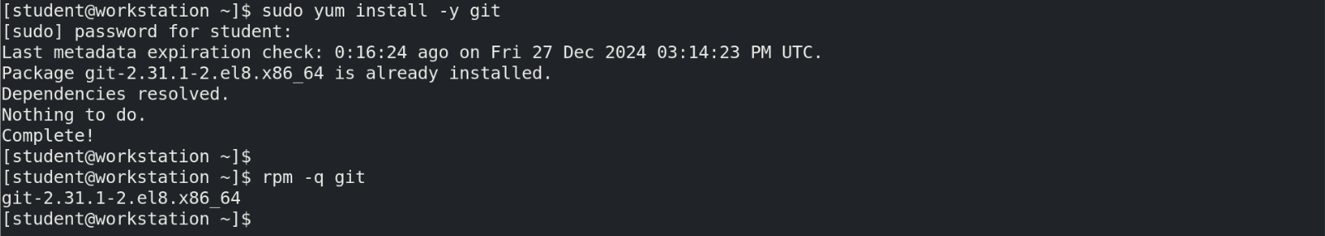

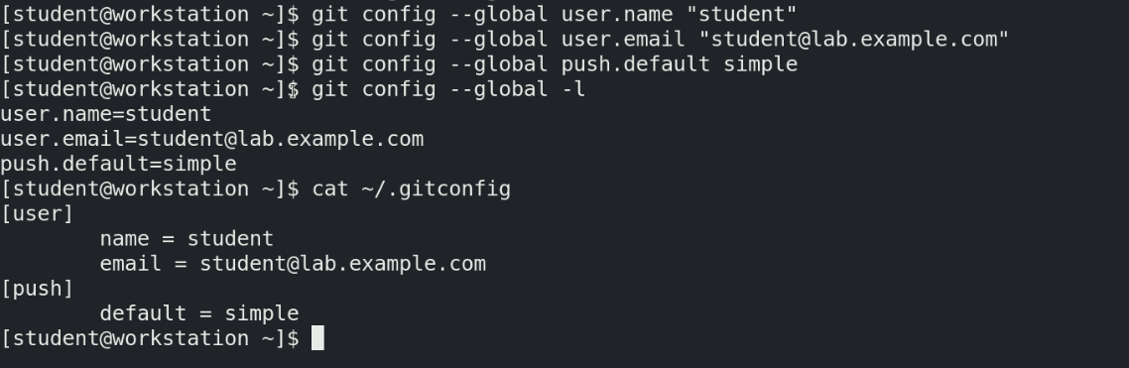

**Configure .vimrc file for auto indentation**

