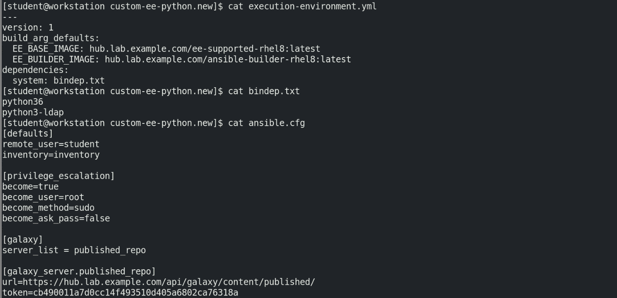

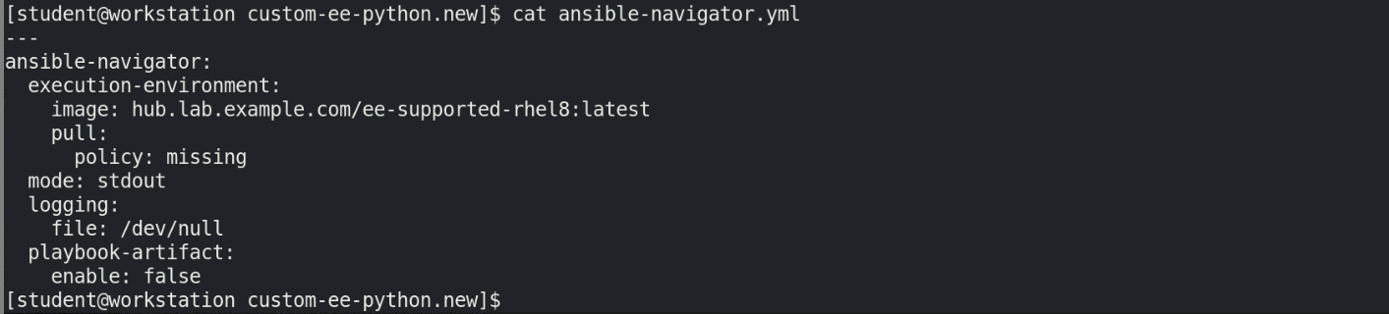

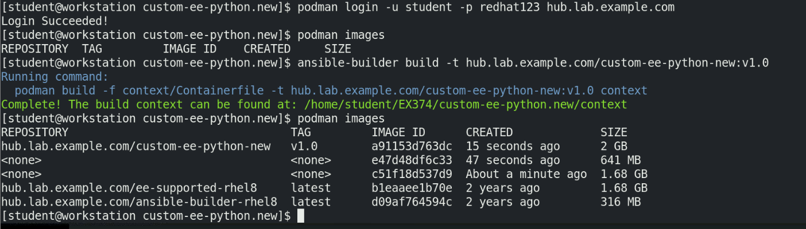



Validate the image before pushing to private automation hub.

**Validation:**

In order to validate the python and OS packages in the image, you can use ansible-navigator command as below and selecting the menu driven options

Esc to go back or :q to come out of the menu

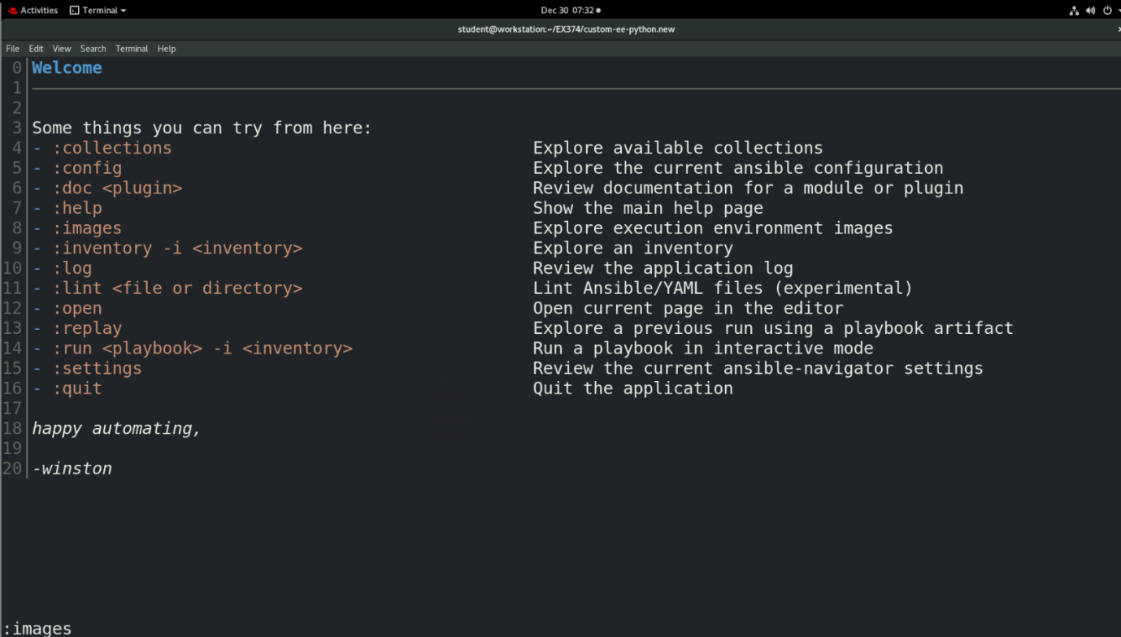

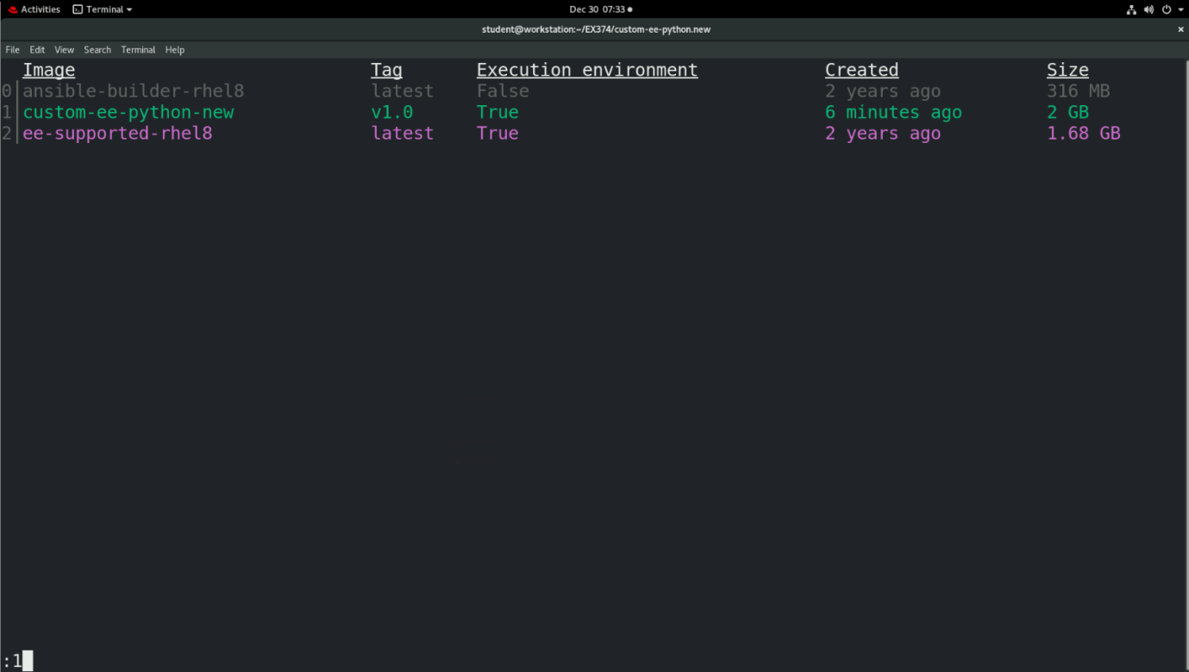

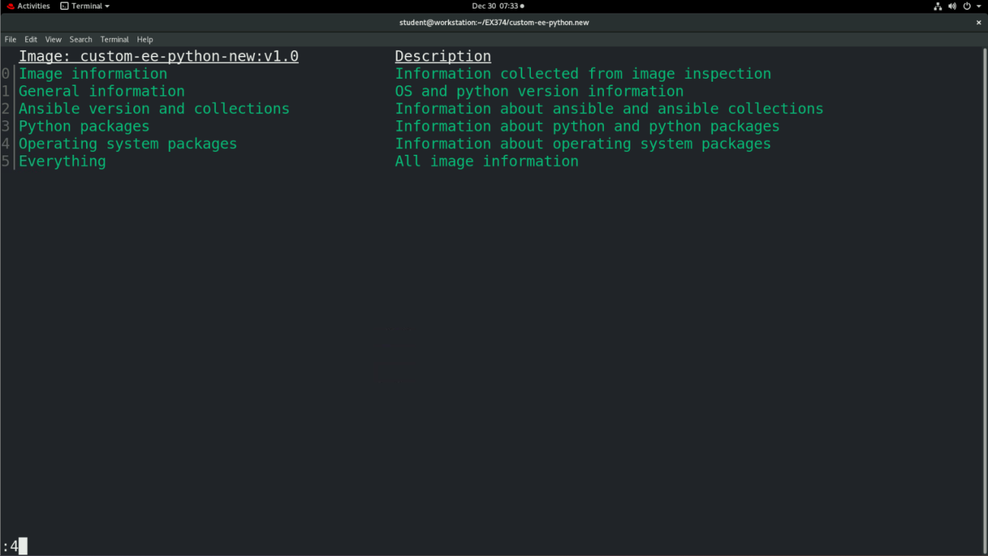

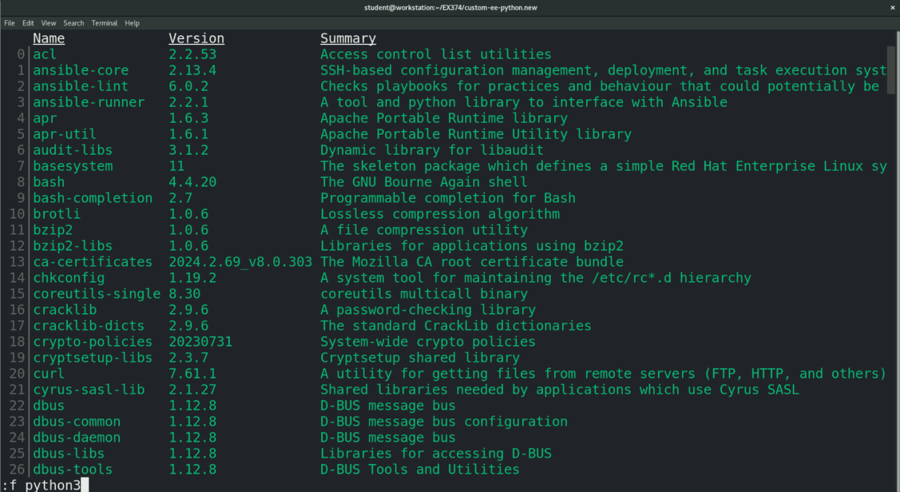

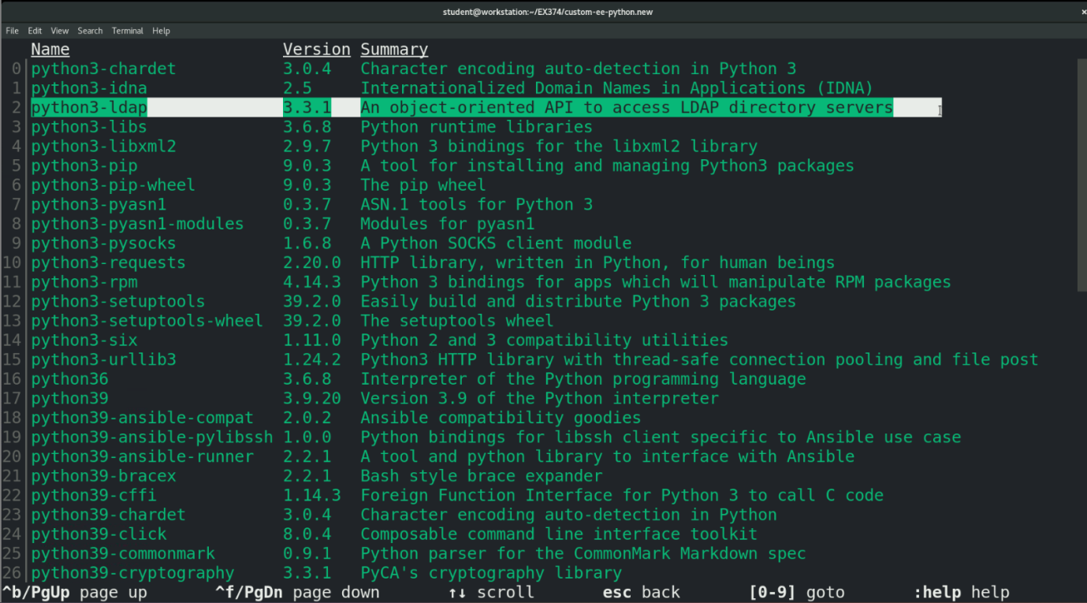

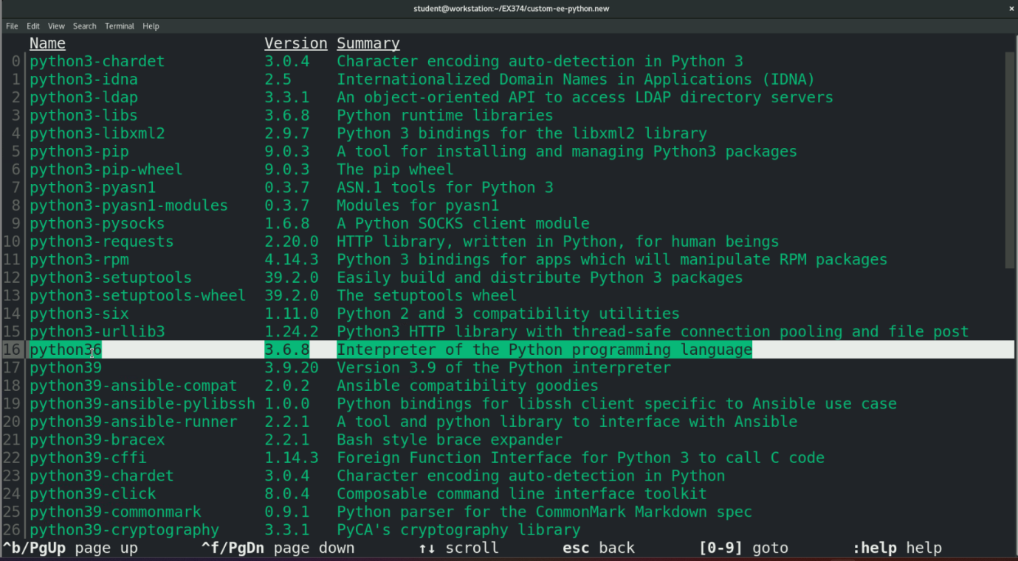

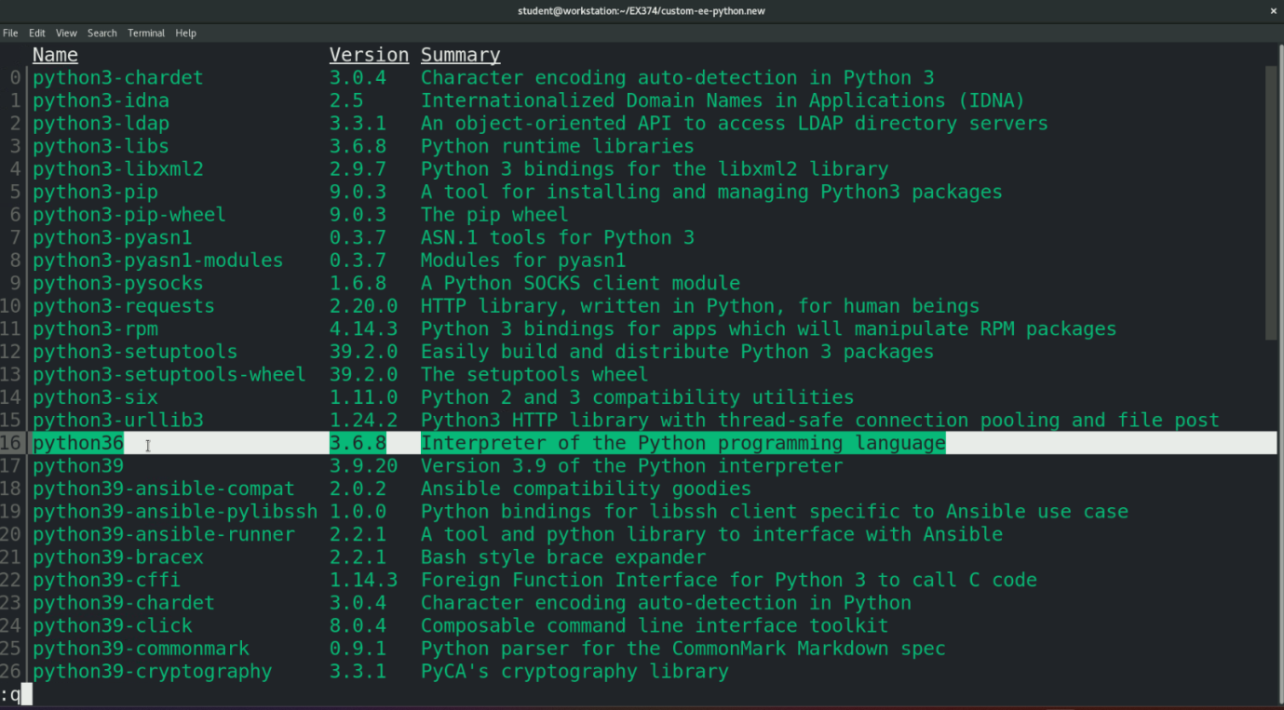



After pushing the image to private automation hub, verify it by refreshing the “execution environments” page in private automation hub.

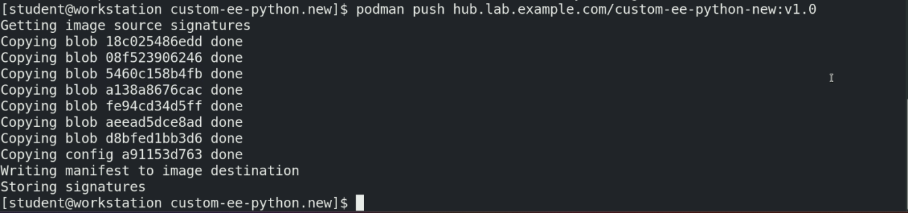

Go to private automation hub and then go to execution-environments

Reload the page and observe that there is a new image created with “custom-ee-python-new”

Below is the screenshot for reference.

