**Q11. Run playbook in an execution environment (created in 10 ques)by script.**

1. Git project need to clone.
2. **A config file and dynamic inventory script there.**
3. **Create playbook with copy content task and run using above eei.**
4. Push to git.

(page no =181)

# 

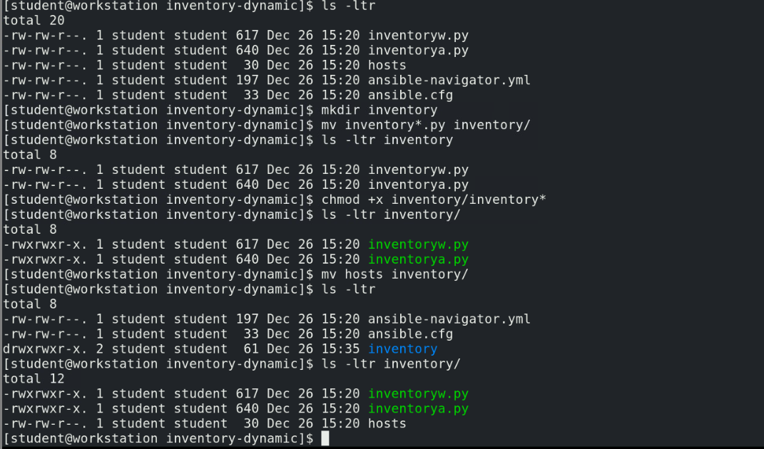

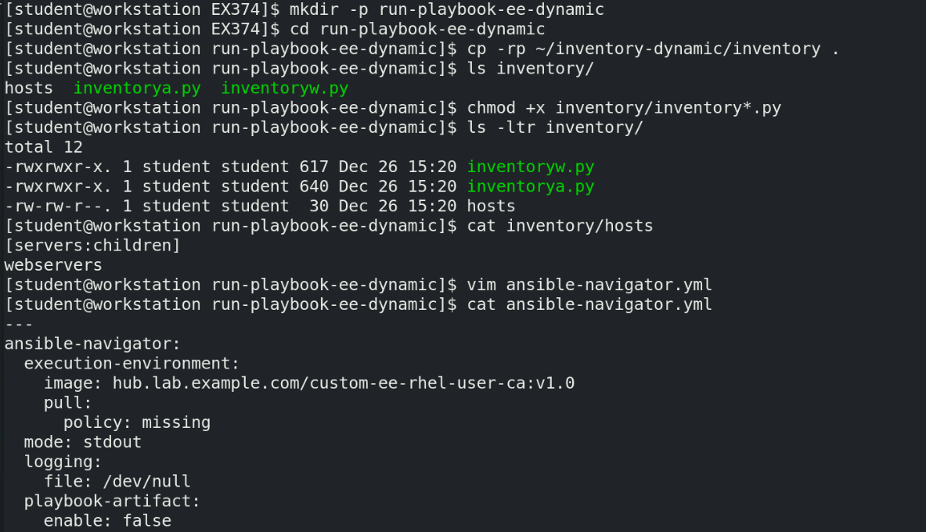

**Note: ansible-navigator.yml is required to be created in the project directory as we need to use script.sh to run the playbook**

**You need to give execution environment image while running ansible-navigator inventory command to list the server list from dynamic inventory**

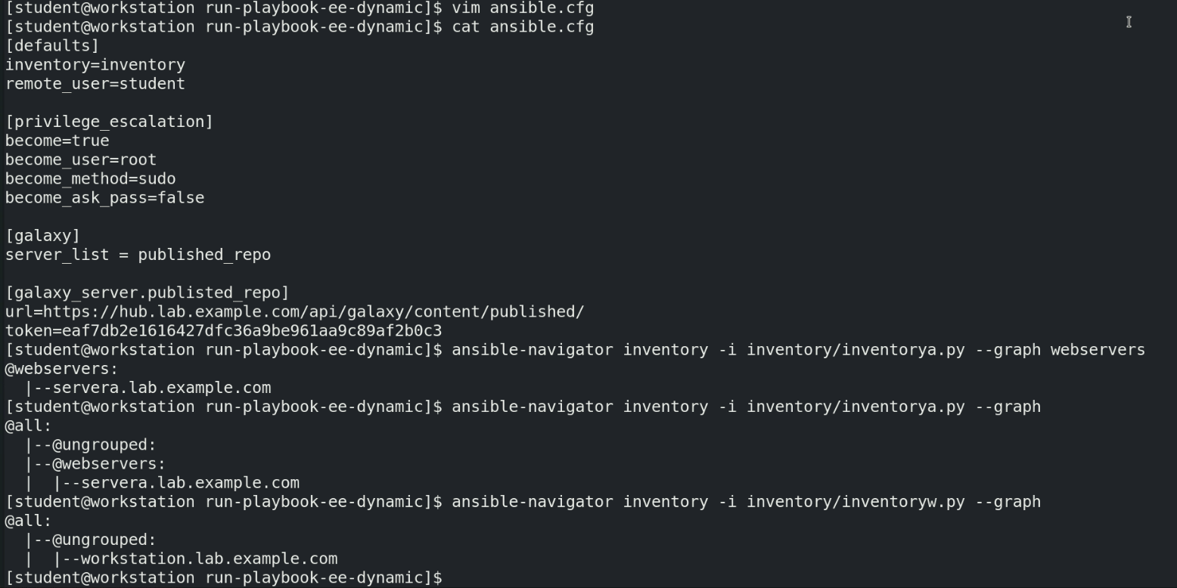

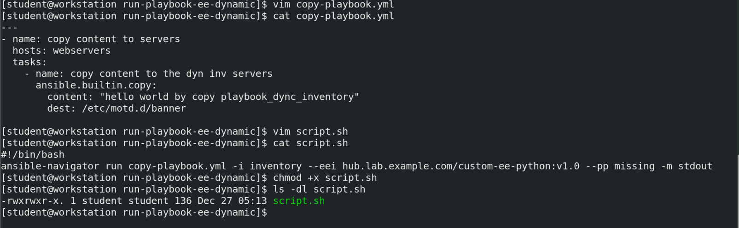

**Note: we can check syntax by using the below commands manually**

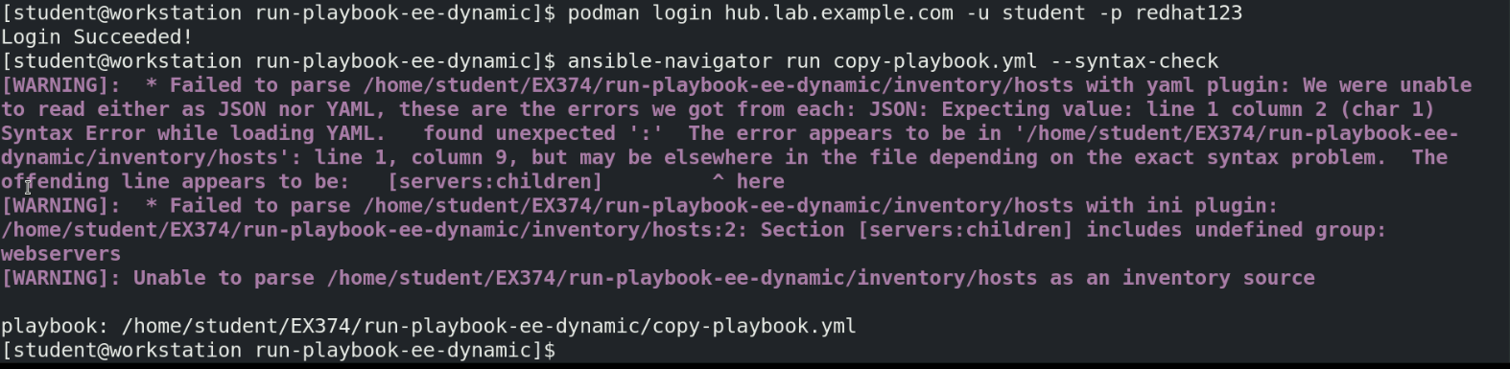

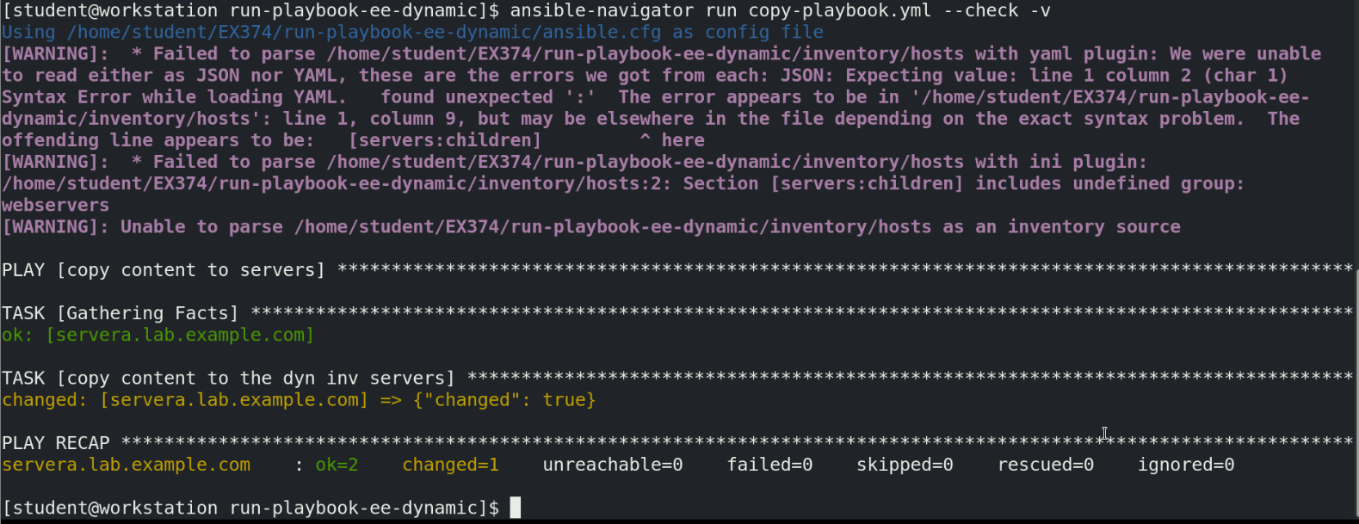

**Finally run script.sh to check if the playbook is running and copying the content to the server defined in dynamic inventory.**

