**Q13. Use custom collection role.**

1. Clone git project from url.
2. Config file and dynamic inventory.
3. Use custom role from rhel.user collection in a playbook.

# 

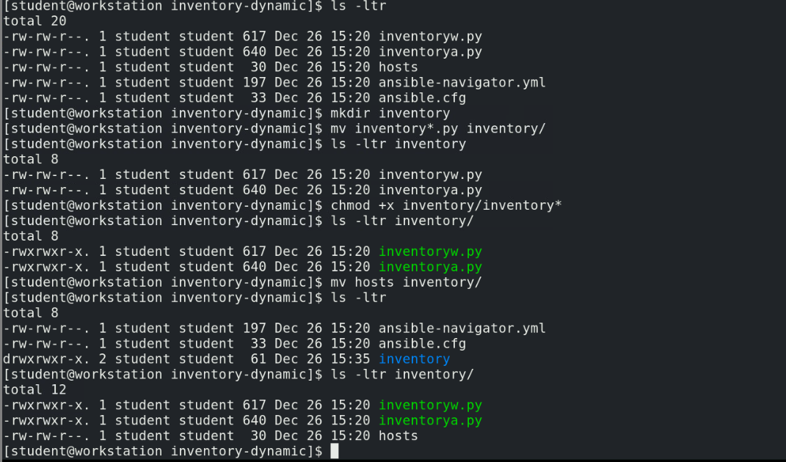

# 

# Check and update ansible-navigator.yml to use custom execution environment with role mymotd in rhel.user created in previous question-10

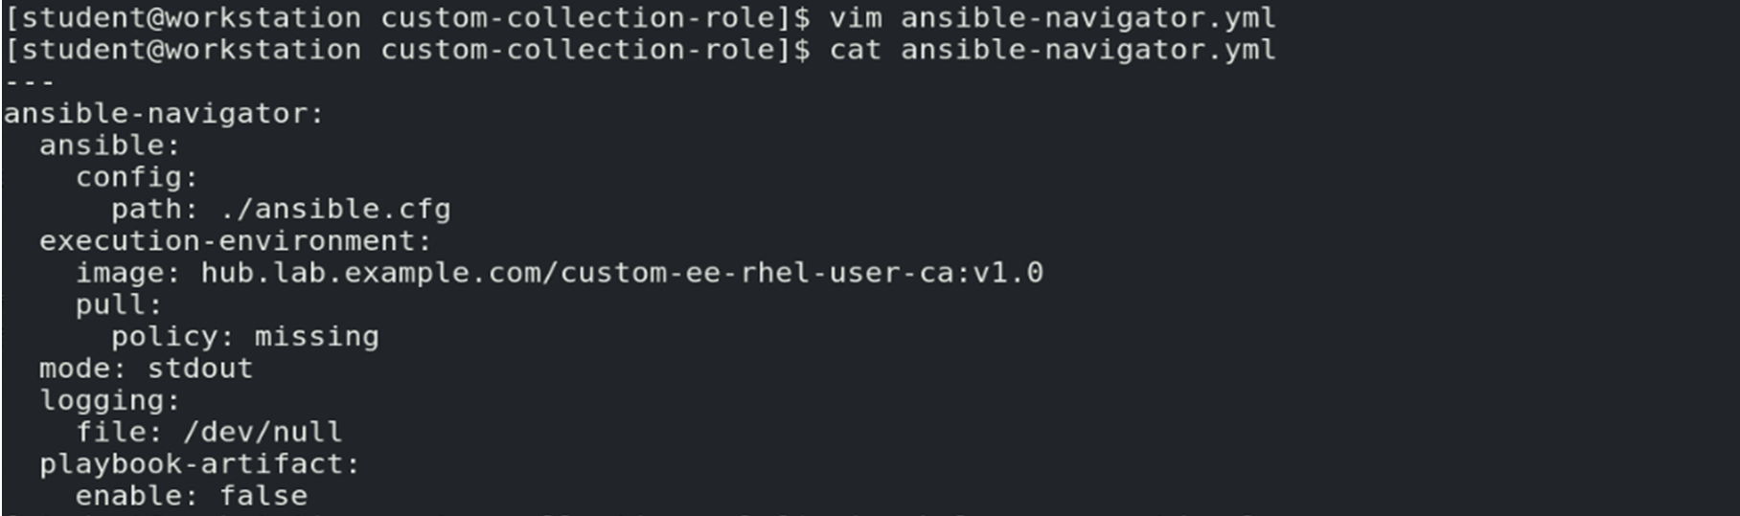

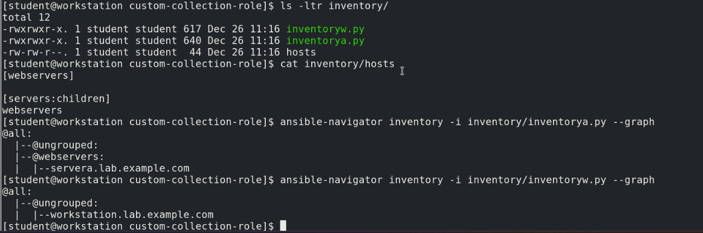



Note: You should take the hosts information from the above command output

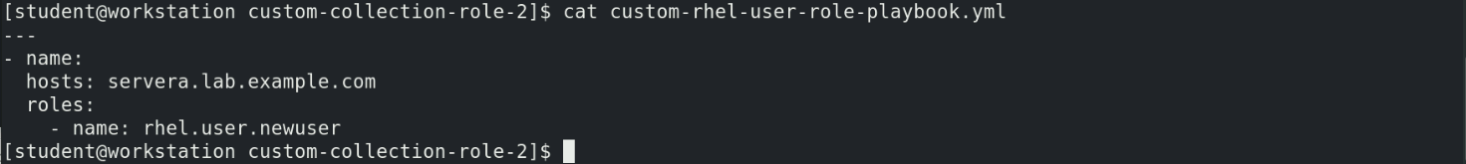

Note: you can also specify the role in playbook as below.

