**Q14. Run playbook.**

1. **Clone project from git url.**
2. **Copy a file to /var/www/html/.**
3. **Dynamic inventory and config file available.**

**Ans:-**

1. **Clone the git project into git-repos directory.**
2. **Provide execute permission to dynamic inventory.**
3. **Create playbook and add copy task on it and execute.**

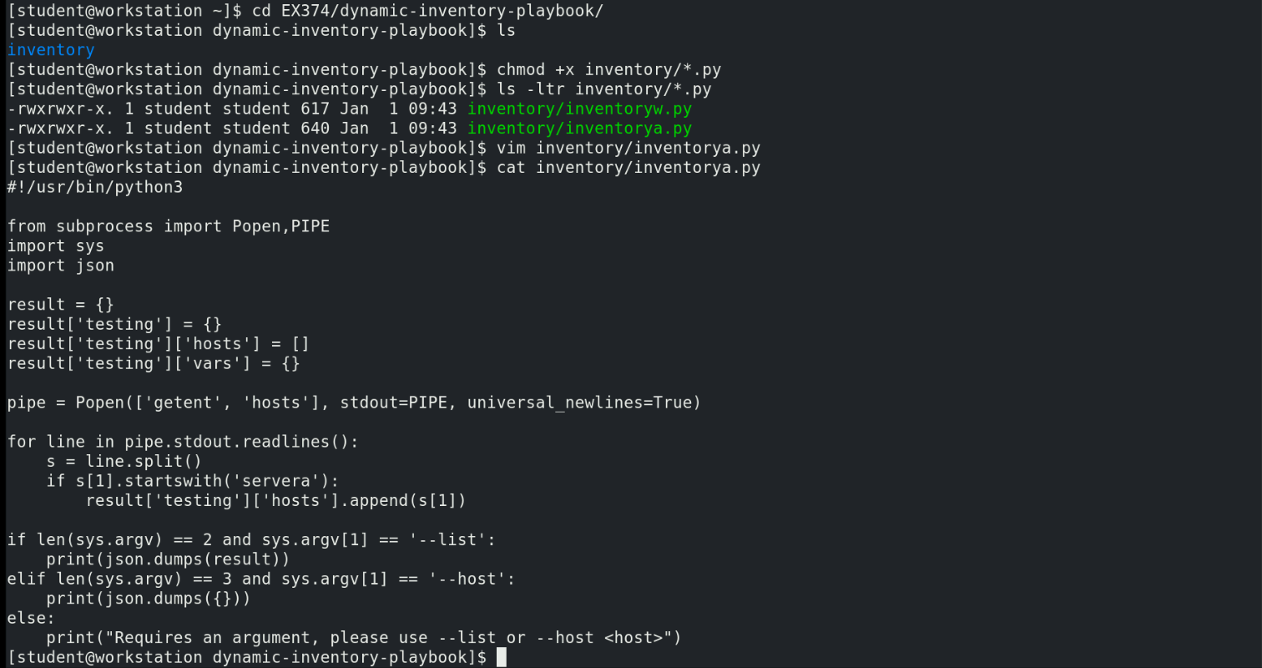

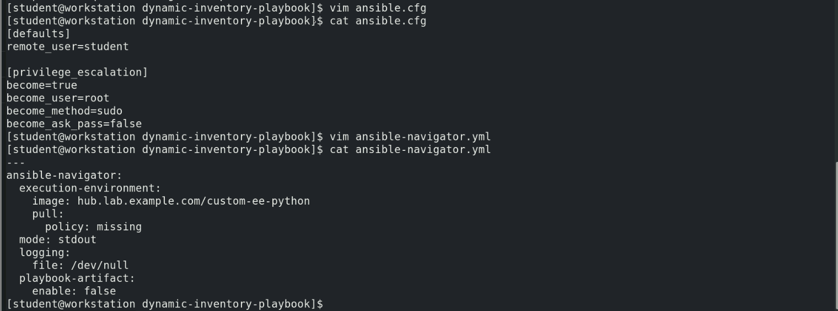

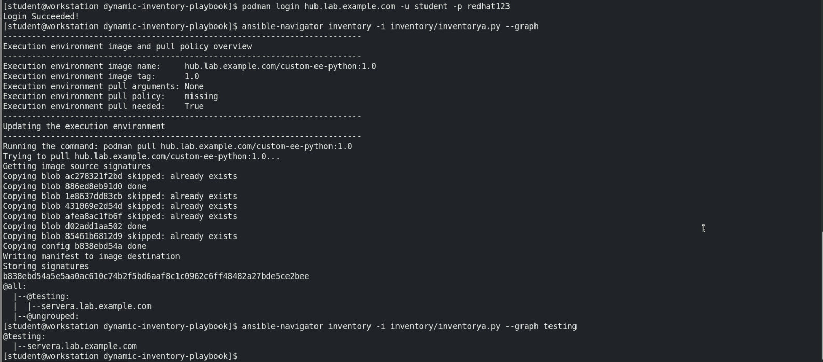

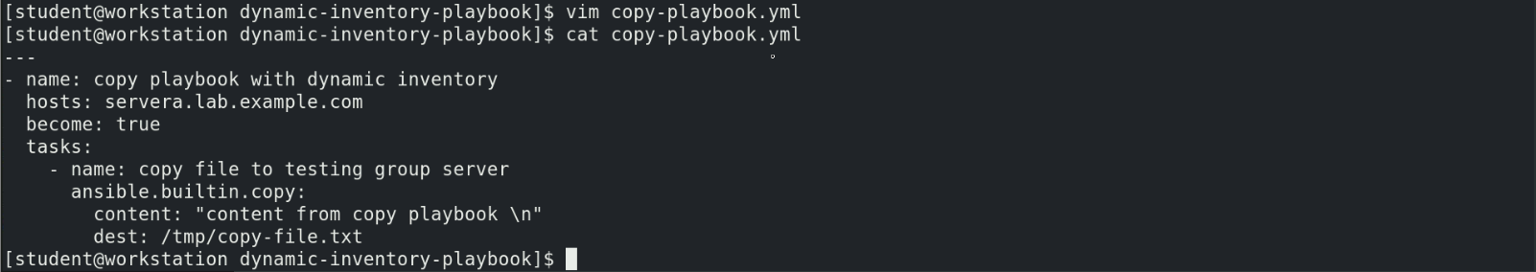

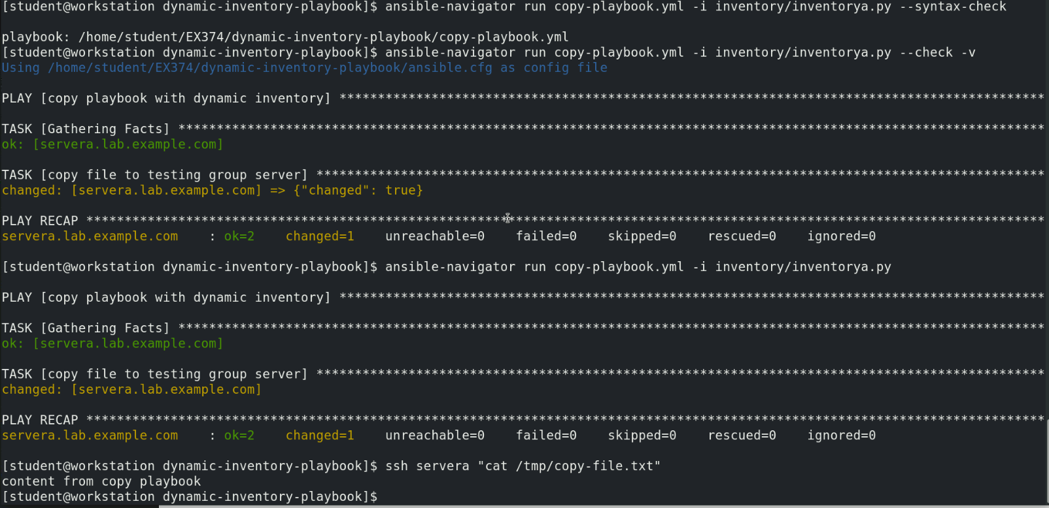i