**Q2. create a project user_project from http://git.lab.example.com:8081/git/user-project.git .**

playbook created there name create_user.yml with some task.users will create from a file user_list.yml where some user names are there with a group.

Add greg user to a group developer.add node3 to a group prod inside the inventory and run the playbook.

after done push to git remote repo.

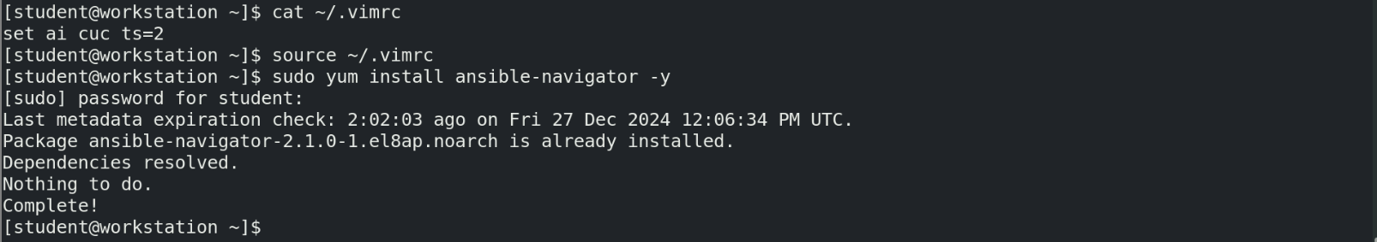

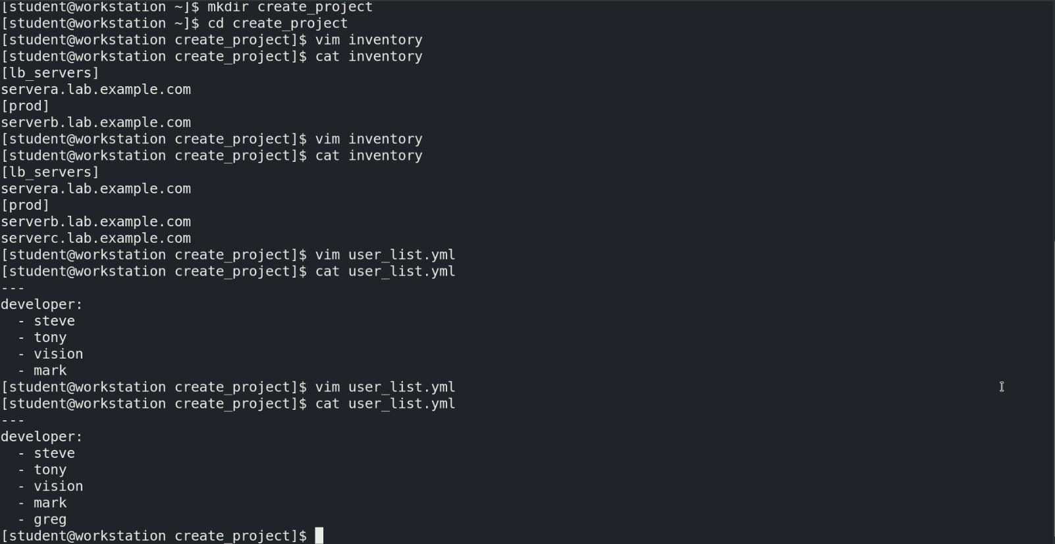

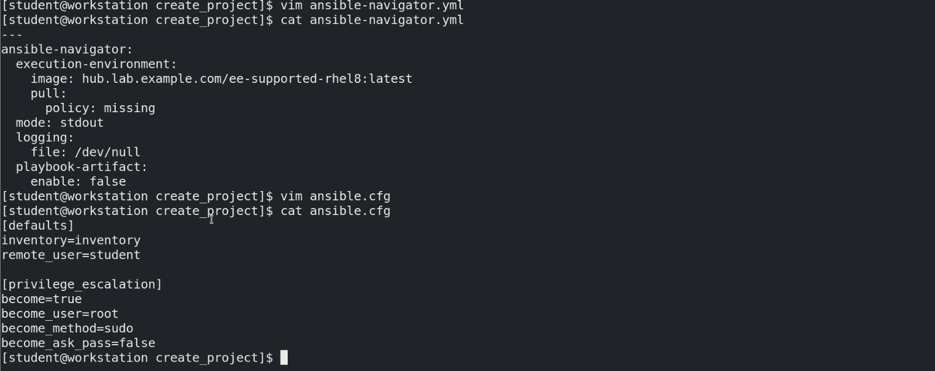

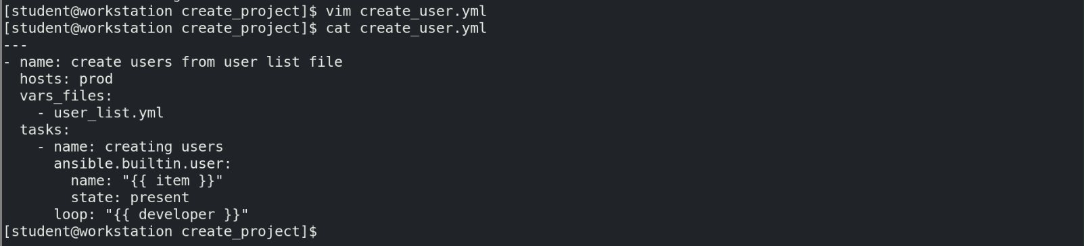



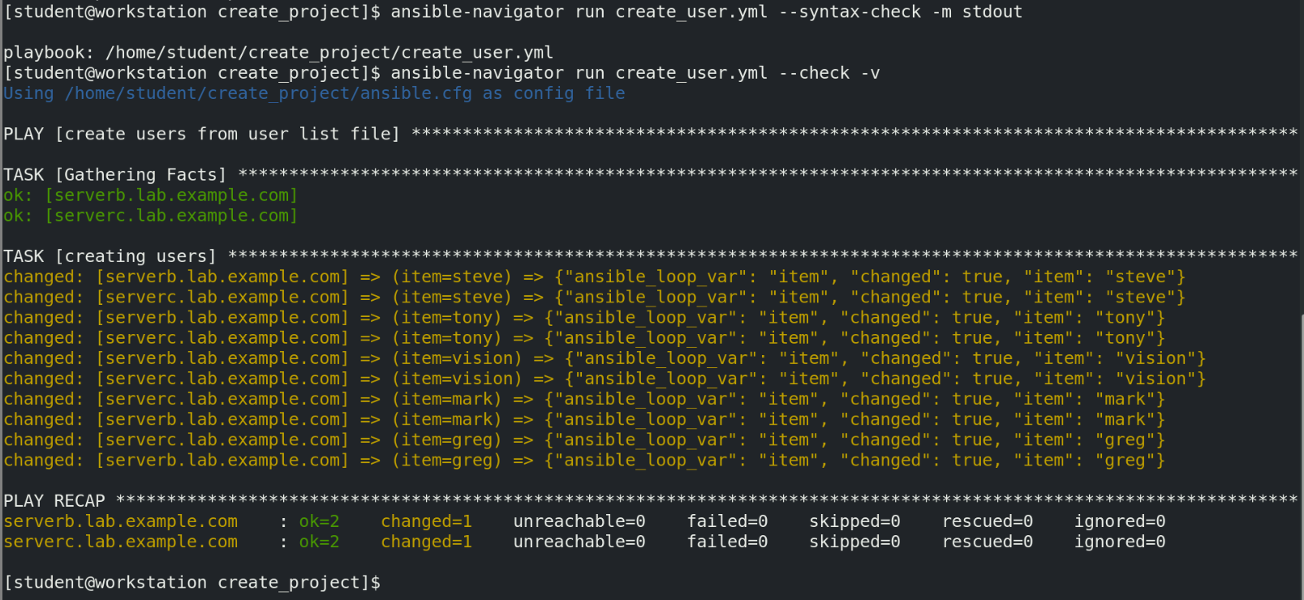

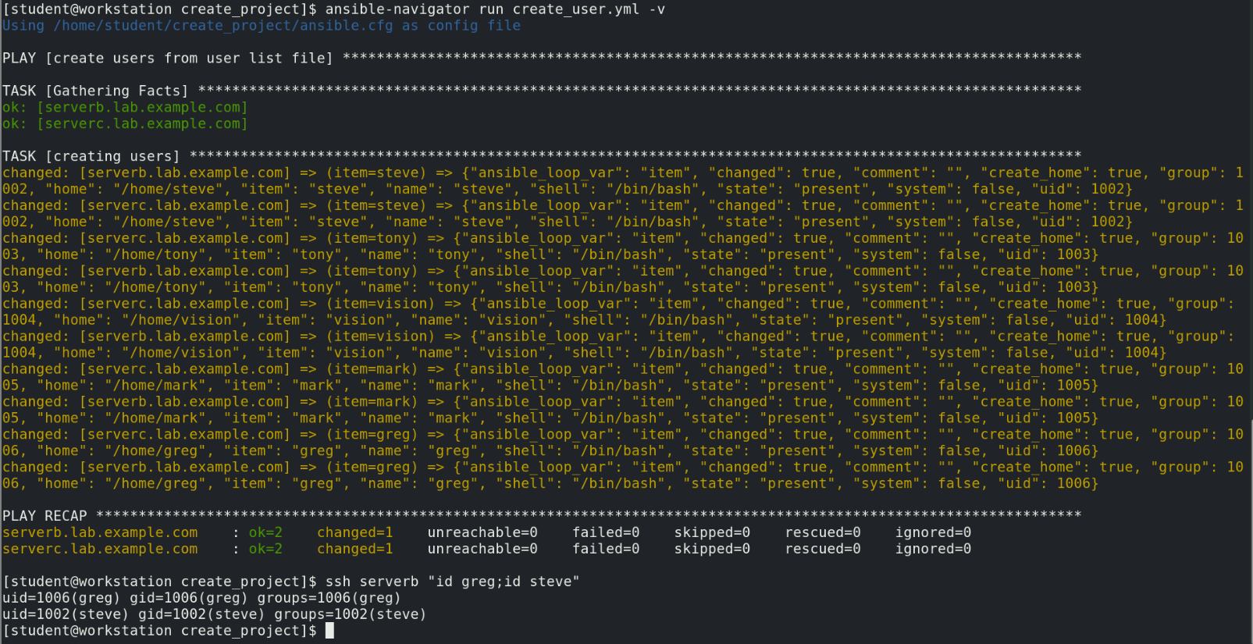

Note:

In exam, we need to install ansible-navigator, ansible-galaxy, ansible-builder packages

Podman package exist aleready, if not we can install podman package as well

Check the packages using the command below command

# rpm -qi ansible-navigator ansible-galaxy ansible-builder podman

In lab, found that ansible-galaxy is part of ansible-core package. Below are the outputs for reference.

