**Q4. create a tag based playbook.**

**playbook name tags.yml pull from http://git.lab.example.com:8081/git/tag-project.git.**

**Add 'hello' to /var/www/html/index.html in 'dev' host group with tag 'alpha'.**

**Add 'by by' to /var/www/html/index.html in same 'dev' host group with tag 'beta'.**

**if any tag not given playbook should not execute any task.**

**After done everything push to git server.**

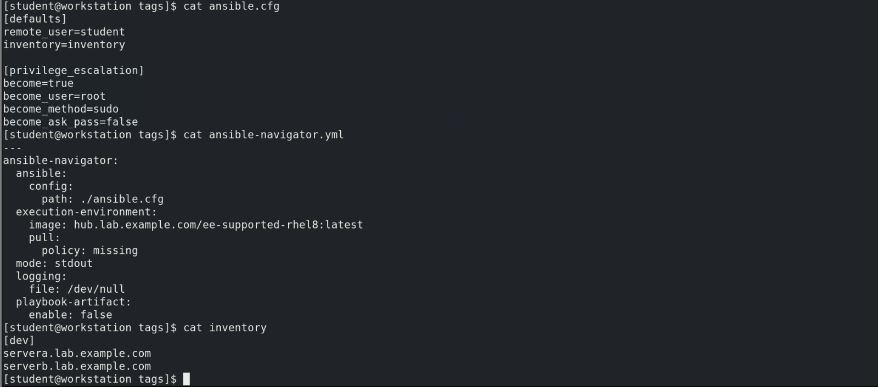

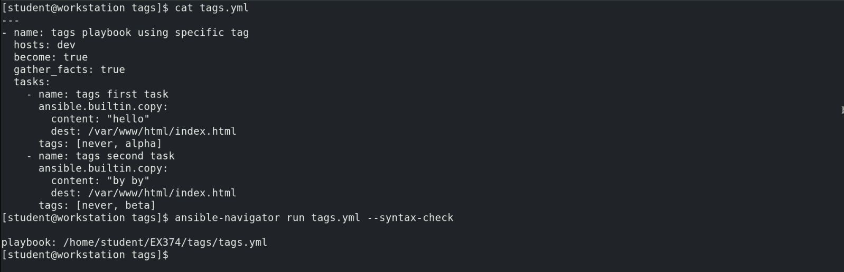

**As no tag is provided for the below command, it does not take any action on the target servers.**

