**Q5. Tune ansible configuration file.**

**pull git project from http://git.lab.example.com:8081/git/fork-project.git**

**modify ansible.cfg file with parallelization size is 45 and gather facts no.**

**push to git server.**

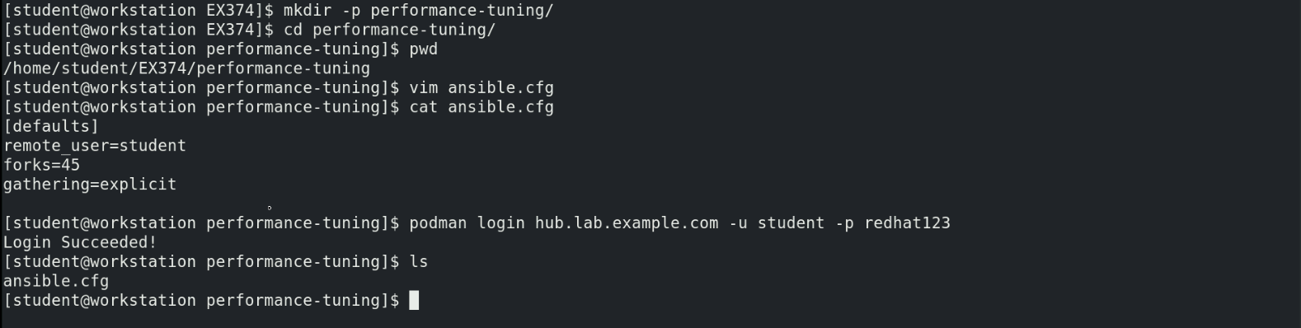



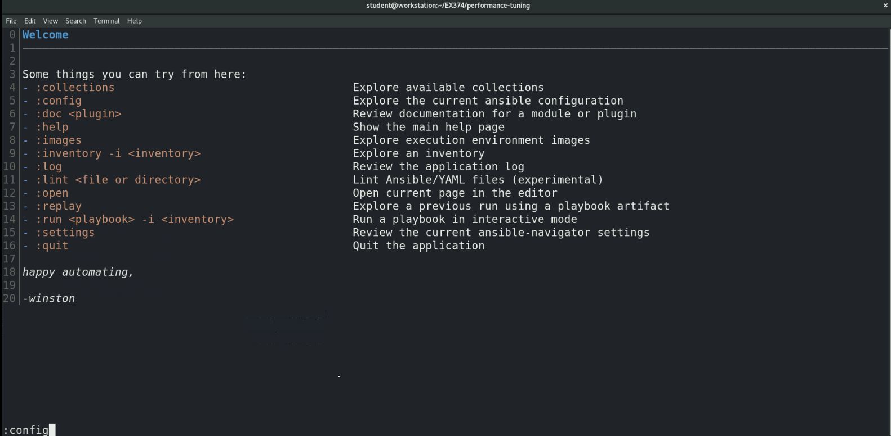

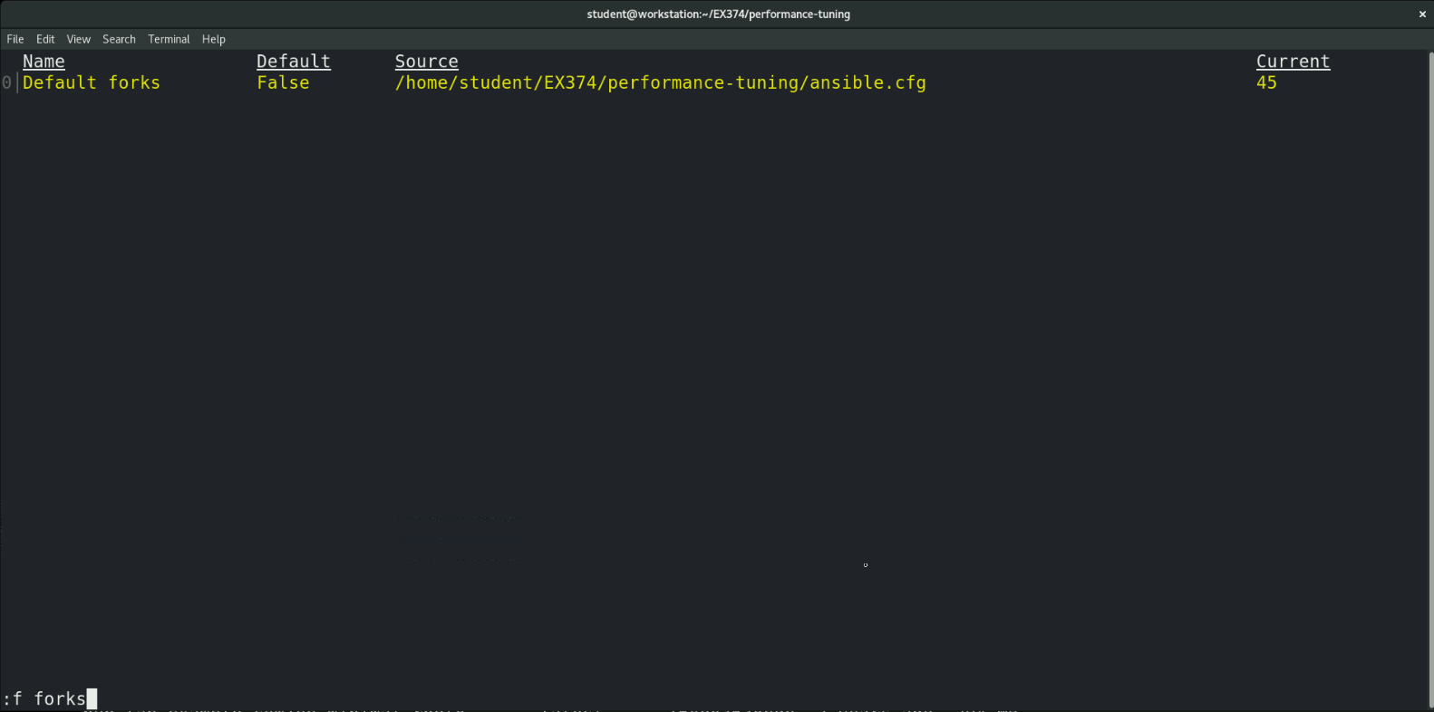

**Escape to go back to previous screen**

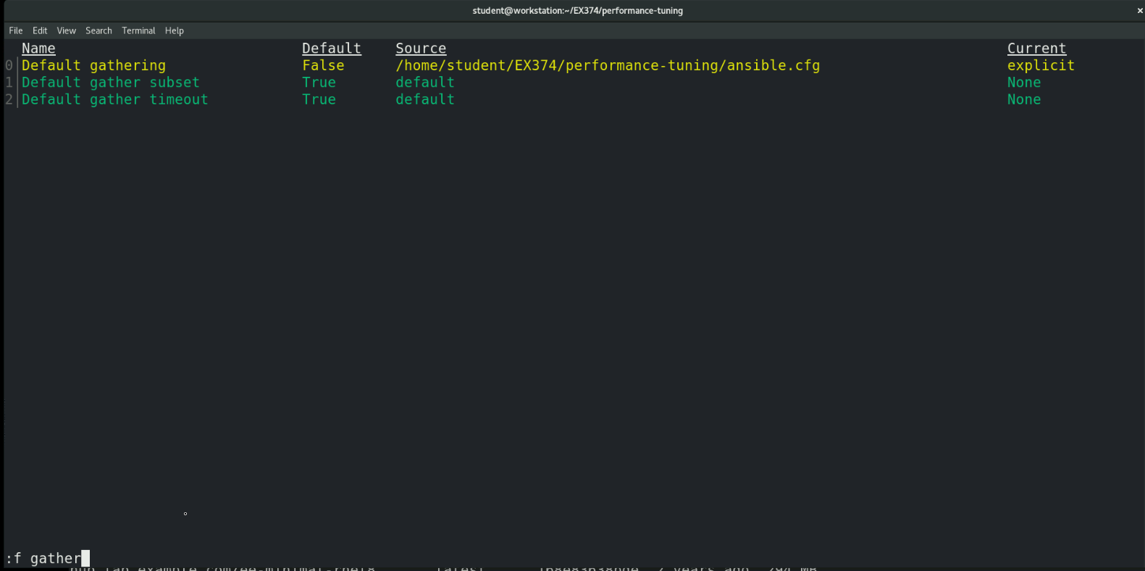

**Escape to go to back the main screen and exit**



**The other method is to use ansible-navigator config dump command as below and just type “forks” when you get the output, it will search for the forks value and gathering and shows the output as below.**



