**Q9. Create a custom execution environment .**

1. **Base image: hub.lab.example.com/ee-minimal-rhel8:latest**
2. **Build image : hub.lab.example.com/ansible-builder-rhel8:latest**
3. Use rhel.user custom collection create in previous question.
4. **TLS certificate available in /etc/pki/tls/certs/classroom-ca.pem**

(Guided Exercise – chapter -9 ,page num – 458)

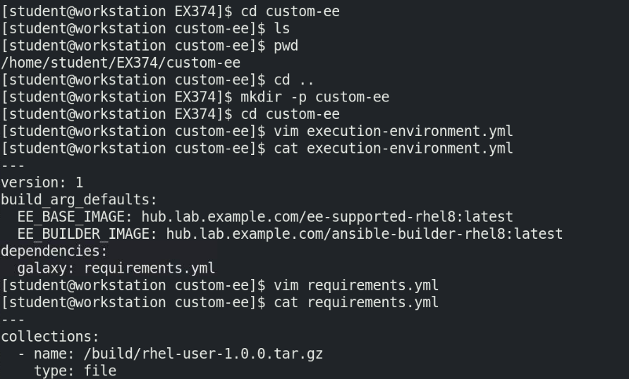

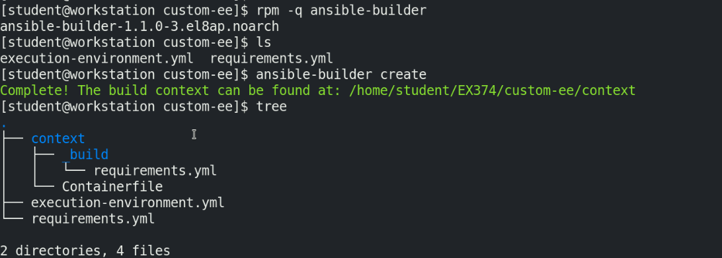

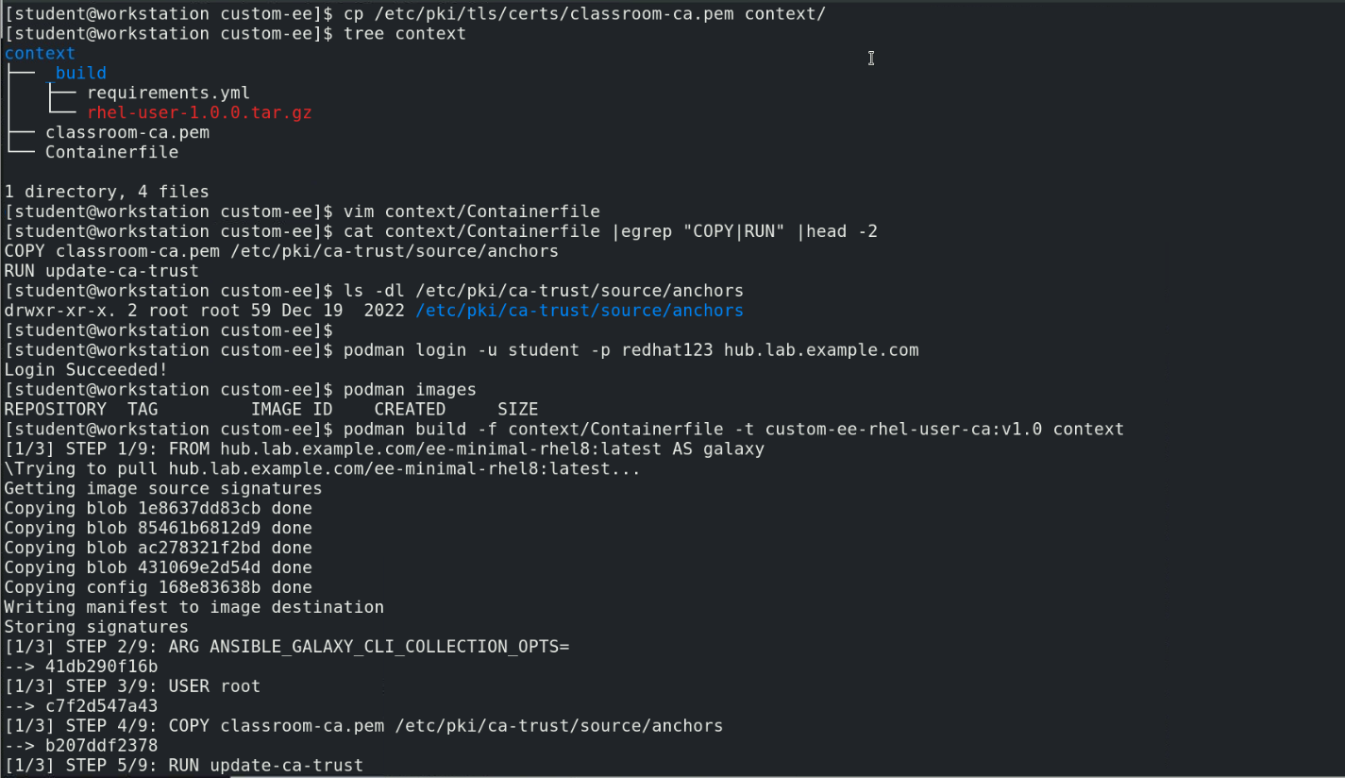

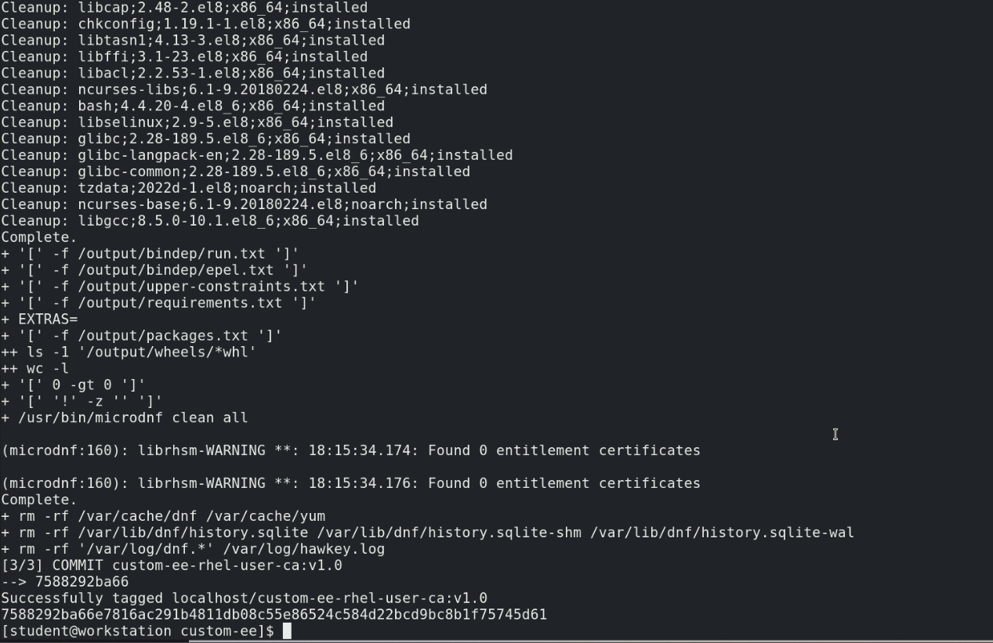

**Note:**

You can also build the custom execution environment image using “ansible-builder build -t hub.lab.example.com/custom-ee-rhel-user-ca:v1.0” and then push the image to private automation hub.

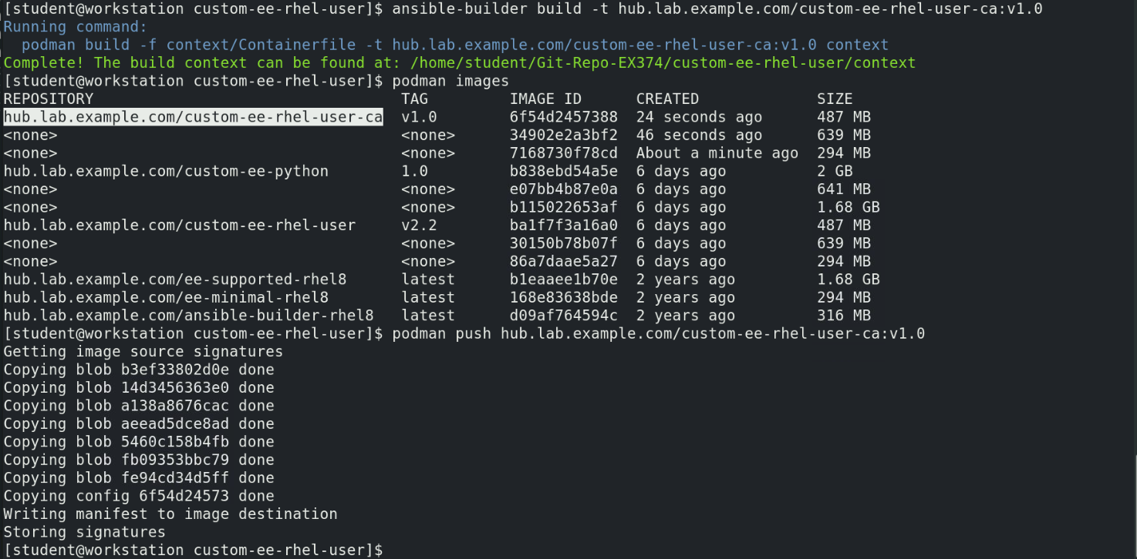

Custom execution environment image is created locally as “localhost/custom-ee-rhel-user-ca:v1.0”

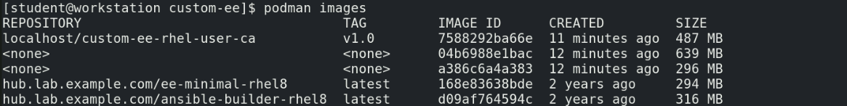

Before pushing the image to private automation hub

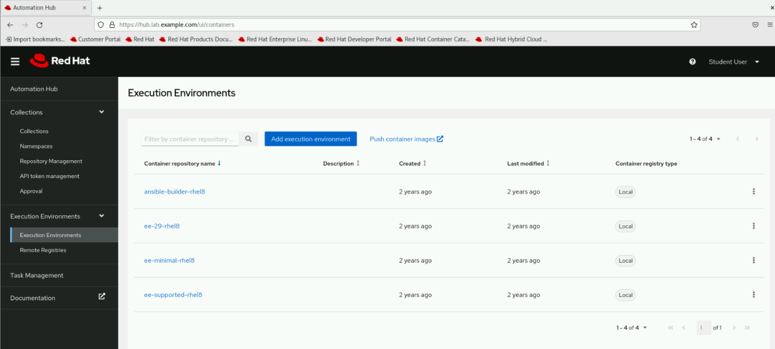

Change the custom execution environment image tag and push the image to private automation hub

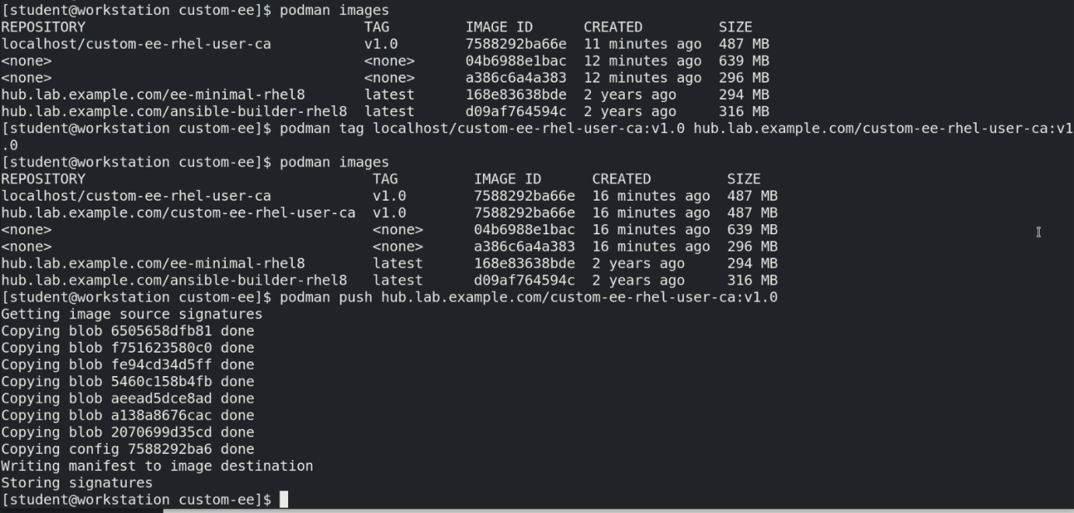

After pushing the custom execution environment image to private automation hub

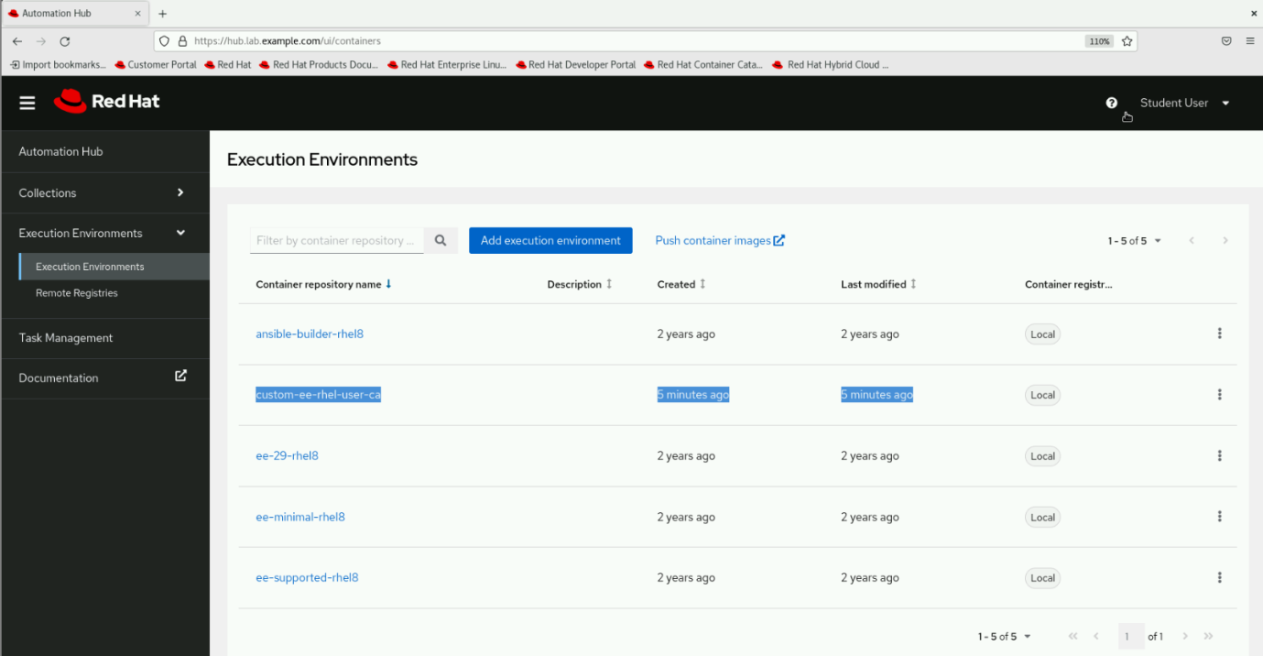

Building custom execution environment using ansible-builder build command

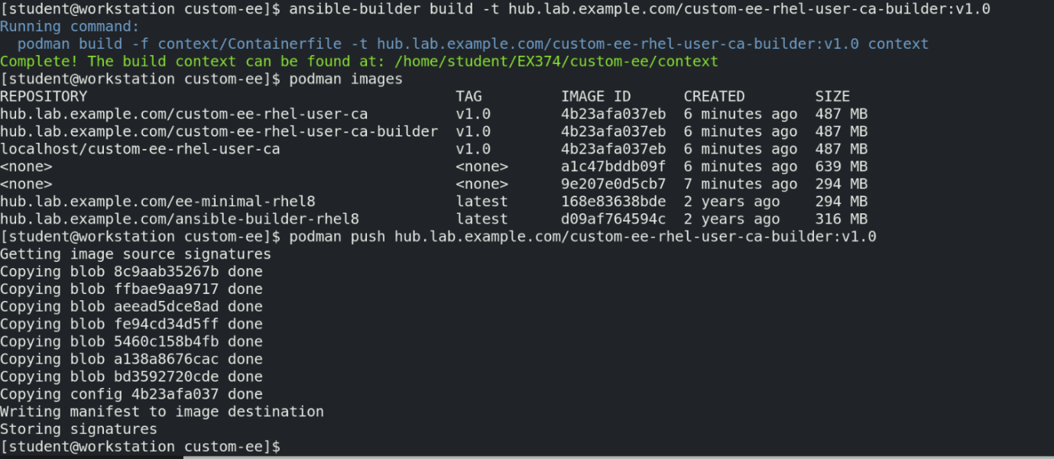

After pushing the image to private automation hub, refresh the “execution environments” page. Now you will find the custom execution environment image that is built by ansible-builder build command

