1 Perform the following DB operations using MongoDB.

1. Create a database “Student” with the following attributes Rollno, Age, ContactNo, Email-Id. AND 2. Insert appropriate values

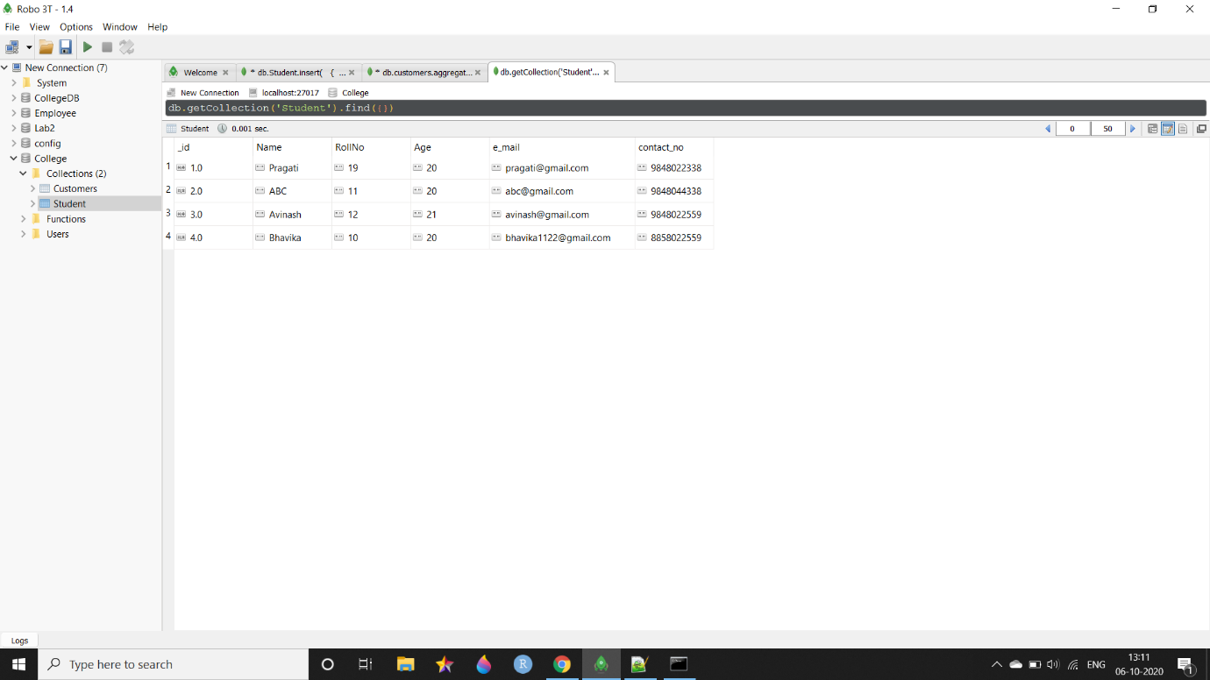

3. Write query to update Email-Id of a student with rollno 10. AND 4. Replace the student name from “ABC” to “FEM” of rollno 11.

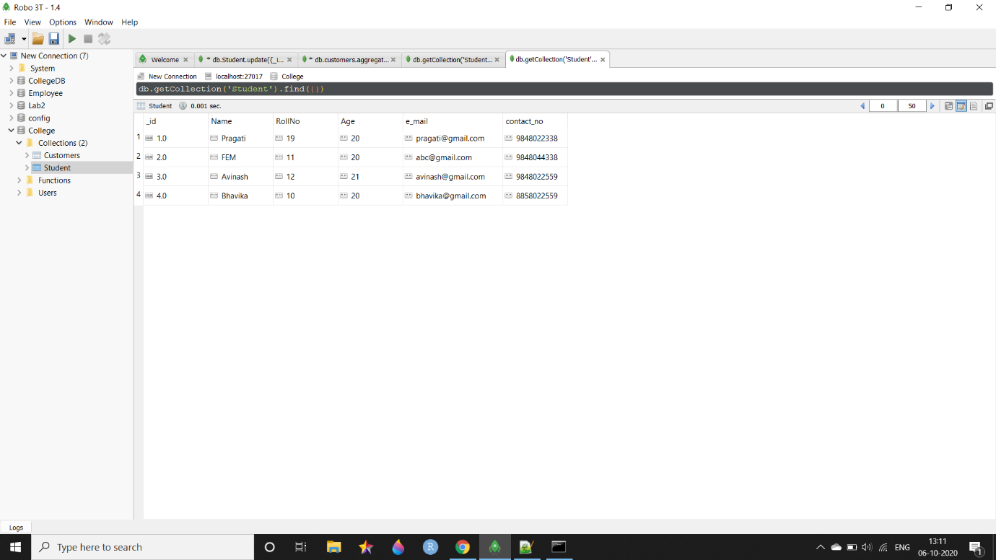

5. Export the created table into local file system

6. Drop the table

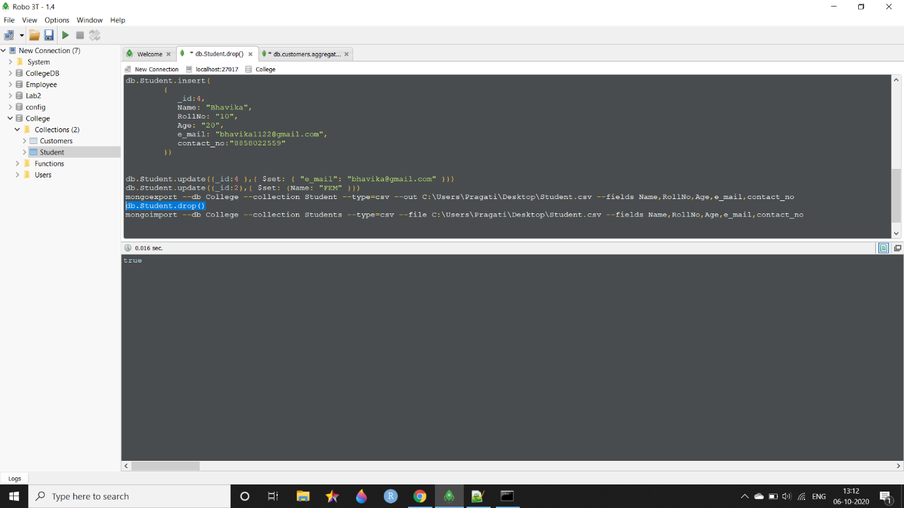

7. Import a given csv dataset from local file system into mongodb collection

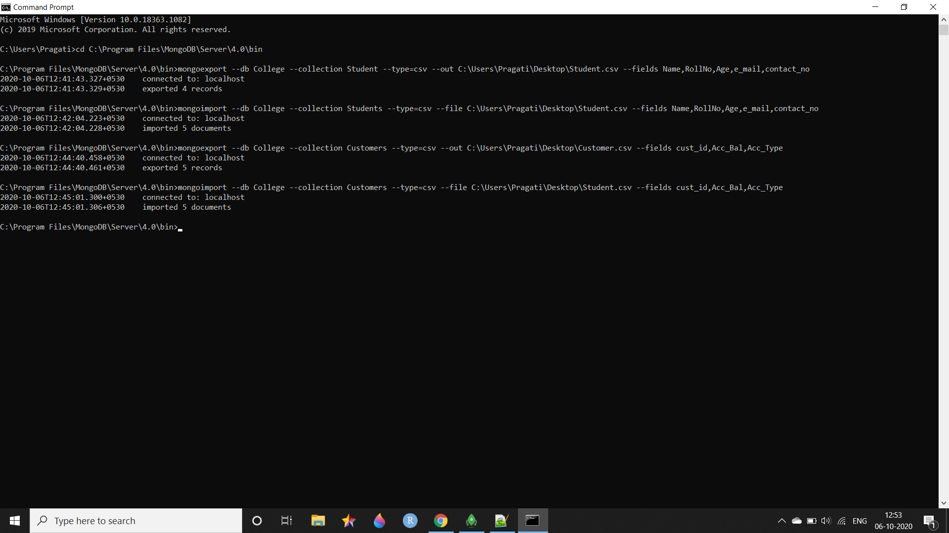

2 Perform the following DB operations using MongoDB.

1. Create a collection by name Customers with the following attributes. Cust_id, Acc_Bal, Acc_Type 2. Insert at least 5 values into the table

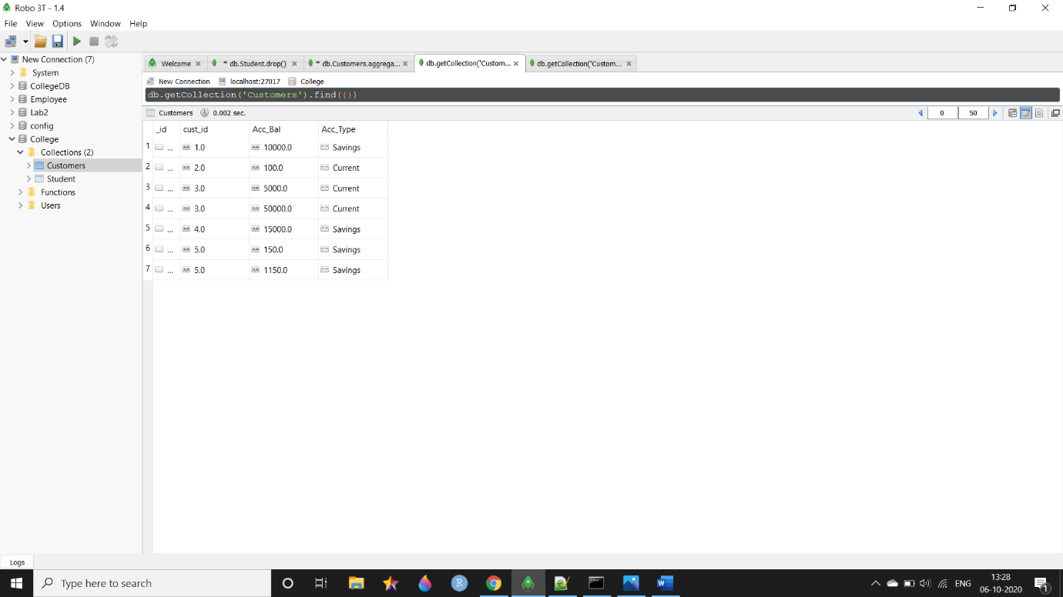

3. Write a query to display those records whose total account balance is greater than 1200 of account type ‘Z’ for each customer_id.

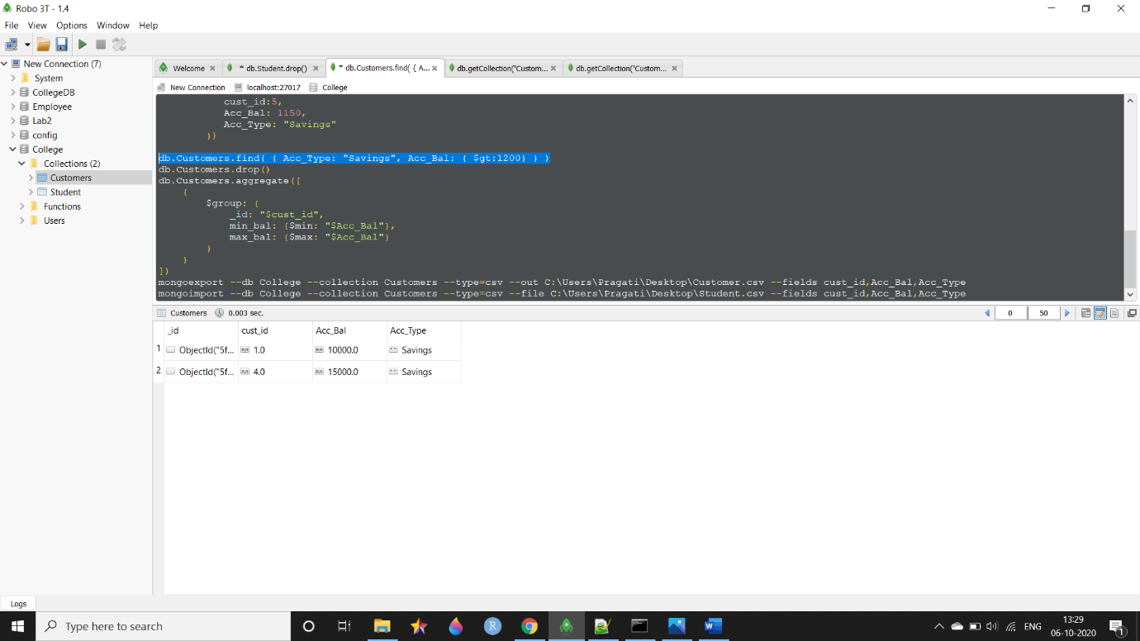

4. Determine Minimum and Maximum account balance for each customer_id.

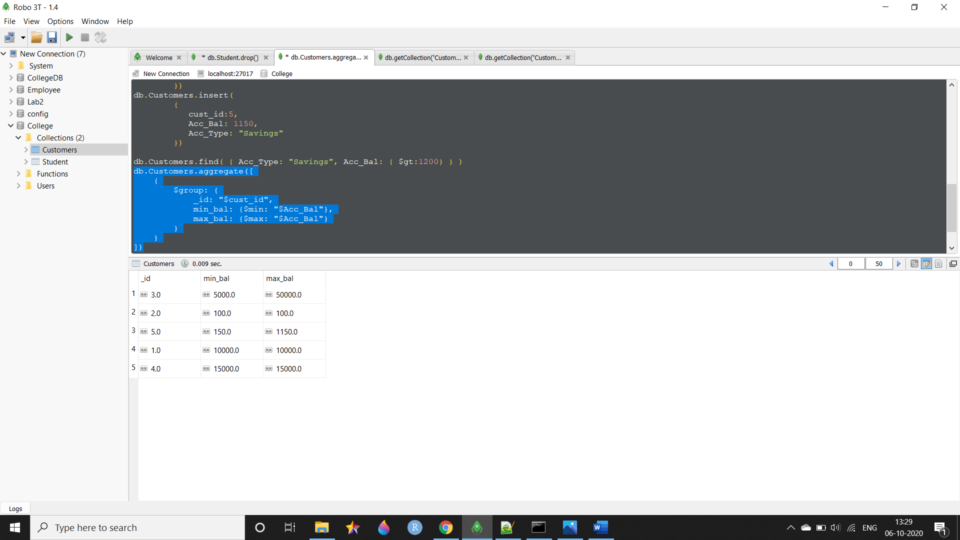

5. Export the created collection into local file system

6. Drop the table

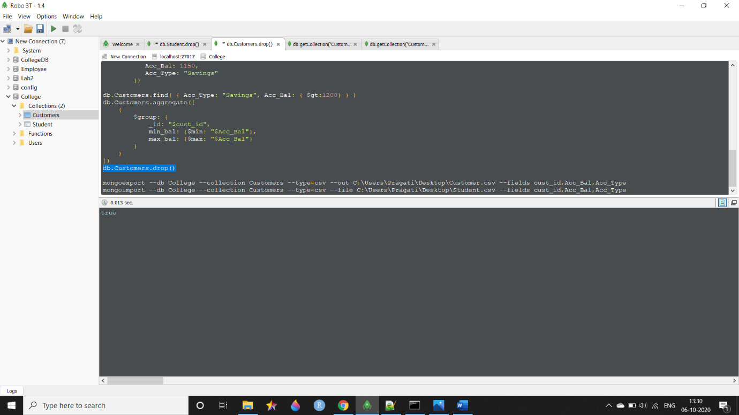

7. Import a given csv dataset from local file system into mongodb collection.



WRITEUP:

