# Final Exam Scheduler Implementation

3 versions of final exam scheduler are implemented:

1. FinalSchedule.java – Uses the algorithm described in the homework assignment.
2. OptimalFinalScheduleOne – Uses greedy coloring algorithm explained at <https://www.youtube.com/watch?v=vGjsi8NIpSE>.
3. OptimalFinalScheduleTwo – Uses backtracking greedy coloring algorithm explained at <https://www.youtube.com/watch?v=miCYGGrTwFU>.

I added a few informative messages to the program output:

* Name of the program that just ran;
* Name of the file that was used;
* Content of the file;
* Possible pairs from student’s enrollment data;

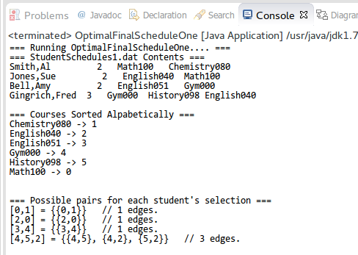

*Picture 1. Few additions/improvements to the program output.*

## Class Diagram

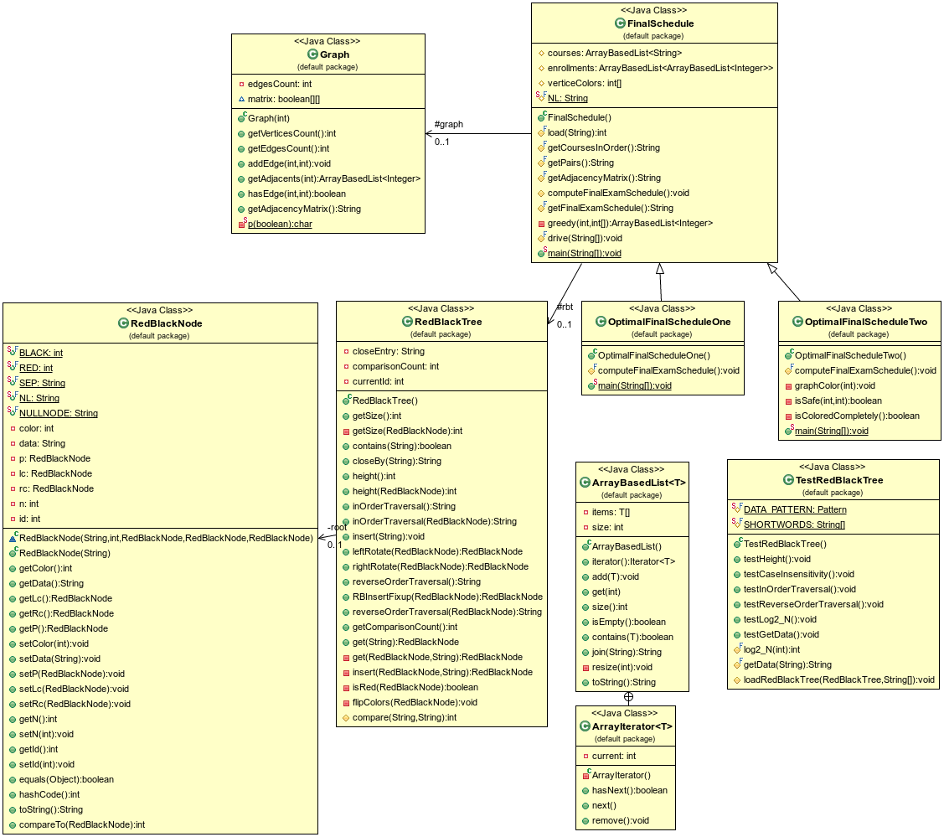

*Picture 2. Class diagram of the project.*

FinalSchedule is a parent class to OptimalFinalScheduleOne and OptimalFinalScheduleTwo classes. The child classes override parent’s ***computeFinalExamSchedule()*** method, thus the child class implemtations are very short. For example, OptimalFinalScheduleOne program consists of just 63 lines of code:

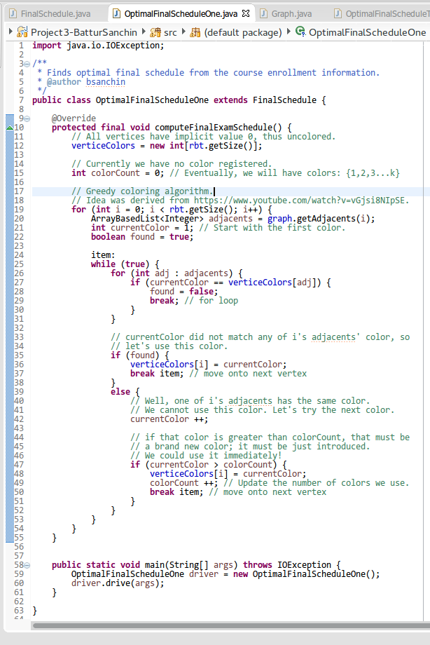

*Picture 3. Complete source code of OptimalFinalScheduleOne program.*

## 1. Program Output for FinalSchedule

### Output for StudentSchedules1.dat

**=== Running FinalSchedule.... ===**

**=== StudentSchedules1.dat Contents ===**

Smith,Al 2 Math100 Chemistry080

Jones,Sue 2 English040 Math100

Bell,Amy 2 English051 Gym000

Gingrich,Fred 3 Gym000 History098 English040

=== Courses Sorted Alpabetically ===

Chemistry080 -> 1

English040 -> 2

English051 -> 3

Gym000 -> 4

History098 -> 5

Math100 -> 0

=== Possible pairs for each student's selection ===

[0,1] = {{0,1}} // 1 edges.

[2,0] = {{2,0}} // 1 edges.

[3,4] = {{3,4}} // 1 edges.

[4,5,2] = {{4,5}, {4,2}, {5,2}} // 3 edges.

=== Adjacency Matrix ===

* 0 1 2 3 4 5

0 . 1 1 . . .

1 1 . . . . .

2 1 . . . 1 1

3 . . . . 1 .

4 . . 1 1 . 1

5 . . 1 . 1 .

=== Recommended Schedule of Final Exams ===

Final Exam Period 1

Math100

English051

History098

Final Exam Period 2

Chemistry080

English040

Final Exam Period 3

Gym000

### Output for StudentSchedules2.dat

**=== Running FinalSchedule.... ===**

**=== StudentSchedules2.dat Contents ===**

Jones,Andy 3 English100 Psychology050 Math220

Hein,Peter 4 Math010 Chemistry230 CompSci401 History080

Miller,Kyle 5 Math010 Chemistry230 History080 Econ110 Psychology100

Williams,Ann 5 Math010 English100 Psychology050 CompSci401 History080

Kim,Jenny 3 English100 Chemistry230 History080

Carter,Herb 5 Psychology050 Chemistry230 CompSci401 English100 Psychology100

Popov,Dimitri 3 Psychology050 Psychology100 Math010

Smith,Kellie 3 Psychology050 History080 Econ110

=== Courses Sorted Alpabetically ===

Chemistry230 -> 4

CompSci401 -> 5

Econ110 -> 7

English100 -> 0

History080 -> 6

Math010 -> 3

Math220 -> 2

Psychology050 -> 1

Psychology100 -> 8

=== Possible pairs for each student's selection ===

[0,1,2] = {{0,1}, {0,2}, {1,2}} // 3 edges.

[3,4,5,6] = {{3,4}, {3,5}, {3,6}, {4,5}, {4,6}, {5,6}} // 6 edges.

[3,4,6,7,8] = {{3,4}, {3,6}, {3,7}, {3,8}, {4,6}, {4,7}, {4,8}, {6,7}, {6,8}, {7,8}} // 10 edges.

[3,0,1,5,6] = {{3,0}, {3,1}, {3,5}, {3,6}, {0,1}, {0,5}, {0,6}, {1,5}, {1,6}, {5,6}} // 10 edges.

[0,4,6] = {{0,4}, {0,6}, {4,6}} // 3 edges.

[1,4,5,0,8] = {{1,4}, {1,5}, {1,0}, {1,8}, {4,5}, {4,0}, {4,8}, {5,0}, {5,8}, {0,8}} // 10 edges.

[1,8,3] = {{1,8}, {1,3}, {8,3}} // 3 edges.

[1,6,7] = {{1,6}, {1,7}, {6,7}} // 3 edges.

=== Adjacency Matrix ===

* 0 1 2 3 4 5 6 7 8

0 . 1 1 1 1 1 1 . 1

1 1 . 1 1 1 1 1 1 1

2 1 1 . . . . . . .

3 1 1 . . 1 1 1 1 1

4 1 1 . 1 . 1 1 1 1

5 1 1 . 1 1 . 1 . 1

6 1 1 . 1 1 1 . 1 1

7 . 1 . 1 1 . 1 . 1

8 1 1 . 1 1 1 1 1 .

=== Recommended Schedule of Final Exams ===

Final Exam Period 1

English100

Econ110

Final Exam Period 2

Psychology050

Final Exam Period 3

Math220

Math010

Final Exam Period 4

Chemistry230

Final Exam Period 5

CompSci401

Final Exam Period 6

History080

Final Exam Period 7

Psychology100

## 2. Program Output for OptimalFinalScheduleOne

### Output for StudentSchedules1.dat

**=== Running OptimalFinalScheduleOne.... ===**

**=== StudentSchedules1.dat Contents ===**

Smith,Al 2 Math100 Chemistry080

Jones,Sue 2 English040 Math100

Bell,Amy 2 English051 Gym000

Gingrich,Fred 3 Gym000 History098 English040

=== Courses Sorted Alpabetically ===

Chemistry080 -> 1

English040 -> 2

English051 -> 3

Gym000 -> 4

History098 -> 5

Math100 -> 0

=== Possible pairs for each student's selection ===

[0,1] = {{0,1}} // 1 edges.

[2,0] = {{2,0}} // 1 edges.

[3,4] = {{3,4}} // 1 edges.

[4,5,2] = {{4,5}, {4,2}, {5,2}} // 3 edges.

=== Adjacency Matrix ===

* 0 1 2 3 4 5

0 . 1 1 . . .

1 1 . . . . .

2 1 . . . 1 1

3 . . . . 1 .

4 . . 1 1 . 1

5 . . 1 . 1 .

=== Recommended Schedule of Final Exams ===

Final Exam Period 1

Math100

English051

History098

Final Exam Period 2

Chemistry080

English040

Final Exam Period 3

Gym000

### Output for StudentSchedules2.dat

**=== Running OptimalFinalScheduleOne.... ===**

**=== StudentSchedules2.dat Contents ===**

Jones,Andy 3 English100 Psychology050 Math220

Hein,Peter 4 Math010 Chemistry230 CompSci401 History080

Miller,Kyle 5 Math010 Chemistry230 History080 Econ110 Psychology100

Williams,Ann 5 Math010 English100 Psychology050 CompSci401 History080

Kim,Jenny 3 English100 Chemistry230 History080

Carter,Herb 5 Psychology050 Chemistry230 CompSci401 English100 Psychology100

Popov,Dimitri 3 Psychology050 Psychology100 Math010

Smith,Kellie 3 Psychology050 History080 Econ110

=== Courses Sorted Alpabetically ===

Chemistry230 -> 4

CompSci401 -> 5

Econ110 -> 7

English100 -> 0

History080 -> 6

Math010 -> 3

Math220 -> 2

Psychology050 -> 1

Psychology100 -> 8

=== Possible pairs for each student's selection ===

[0,1,2] = {{0,1}, {0,2}, {1,2}} // 3 edges.

[3,4,5,6] = {{3,4}, {3,5}, {3,6}, {4,5}, {4,6}, {5,6}} // 6 edges.

[3,4,6,7,8] = {{3,4}, {3,6}, {3,7}, {3,8}, {4,6}, {4,7}, {4,8}, {6,7}, {6,8}, {7,8}} // 10 edges.

[3,0,1,5,6] = {{3,0}, {3,1}, {3,5}, {3,6}, {0,1}, {0,5}, {0,6}, {1,5}, {1,6}, {5,6}} // 10 edges.

[0,4,6] = {{0,4}, {0,6}, {4,6}} // 3 edges.

[1,4,5,0,8] = {{1,4}, {1,5}, {1,0}, {1,8}, {4,5}, {4,0}, {4,8}, {5,0}, {5,8}, {0,8}} // 10 edges.

[1,8,3] = {{1,8}, {1,3}, {8,3}} // 3 edges.

[1,6,7] = {{1,6}, {1,7}, {6,7}} // 3 edges.

=== Adjacency Matrix ===

* 0 1 2 3 4 5 6 7 8

0 . 1 1 1 1 1 1 . 1

1 1 . 1 1 1 1 1 1 1

2 1 1 . . . . . . .

3 1 1 . . 1 1 1 1 1

4 1 1 . 1 . 1 1 1 1

5 1 1 . 1 1 . 1 . 1

6 1 1 . 1 1 1 . 1 1

7 . 1 . 1 1 . 1 . 1

8 1 1 . 1 1 1 1 1 .

=== Recommended Schedule of Final Exams ===

Final Exam Period 1

English100

Econ110

Final Exam Period 2

Psychology050

Math220

Final Exam Period 3

Math010

Final Exam Period 4

Chemistry230

Final Exam Period 5

CompSci401

Final Exam Period 6

History080

Final Exam Period 7

Psychology100

## 3. Program Output for OptimalFinalScheduleTwo

### Output for StudentSchedules1.dat

**=== Running OptimalFinalScheduleTwo.... ===**

**=== StudentSchedules1.dat Contents ===**

Smith,Al 2 Math100 Chemistry080

Jones,Sue 2 English040 Math100

Bell,Amy 2 English051 Gym000

Gingrich,Fred 3 Gym000 History098 English040

=== Courses Sorted Alpabetically ===

Chemistry080 -> 1

English040 -> 2

English051 -> 3

Gym000 -> 4

History098 -> 5

Math100 -> 0

=== Possible pairs for each student's selection ===

[0,1] = {{0,1}} // 1 edges.

[2,0] = {{2,0}} // 1 edges.

[3,4] = {{3,4}} // 1 edges.

[4,5,2] = {{4,5}, {4,2}, {5,2}} // 3 edges.

=== Adjacency Matrix ===

* 0 1 2 3 4 5

0 . 1 1 . . .

1 1 . . . . .

2 1 . . . 1 1

3 . . . . 1 .

4 . . 1 1 . 1

5 . . 1 . 1 .

=== Recommended Schedule of Final Exams ===

Final Exam Period 1

Math100

English051

History098

Final Exam Period 2

Chemistry080

English040

Final Exam Period 3

Gym000

### Output for StudentSchedules2.dat

**=== Running OptimalFinalScheduleTwo.... ===**

**=== StudentSchedules2.dat Contents ===**

Jones,Andy 3 English100 Psychology050 Math220

Hein,Peter 4 Math010 Chemistry230 CompSci401 History080

Miller,Kyle 5 Math010 Chemistry230 History080 Econ110 Psychology100

Williams,Ann 5 Math010 English100 Psychology050 CompSci401 History080

Kim,Jenny 3 English100 Chemistry230 History080

Carter,Herb 5 Psychology050 Chemistry230 CompSci401 English100 Psychology100

Popov,Dimitri 3 Psychology050 Psychology100 Math010

Smith,Kellie 3 Psychology050 History080 Econ110

=== Courses Sorted Alpabetically ===

Chemistry230 -> 4

CompSci401 -> 5

Econ110 -> 7

English100 -> 0

History080 -> 6

Math010 -> 3

Math220 -> 2

Psychology050 -> 1

Psychology100 -> 8

=== Possible pairs for each student's selection ===

[0,1,2] = {{0,1}, {0,2}, {1,2}} // 3 edges.

[3,4,5,6] = {{3,4}, {3,5}, {3,6}, {4,5}, {4,6}, {5,6}} // 6 edges.

[3,4,6,7,8] = {{3,4}, {3,6}, {3,7}, {3,8}, {4,6}, {4,7}, {4,8}, {6,7}, {6,8}, {7,8}} // 10 edges.

[3,0,1,5,6] = {{3,0}, {3,1}, {3,5}, {3,6}, {0,1}, {0,5}, {0,6}, {1,5}, {1,6}, {5,6}} // 10 edges.

[0,4,6] = {{0,4}, {0,6}, {4,6}} // 3 edges.

[1,4,5,0,8] = {{1,4}, {1,5}, {1,0}, {1,8}, {4,5}, {4,0}, {4,8}, {5,0}, {5,8}, {0,8}} // 10 edges.

[1,8,3] = {{1,8}, {1,3}, {8,3}} // 3 edges.

[1,6,7] = {{1,6}, {1,7}, {6,7}} // 3 edges.

=== Adjacency Matrix ===

* 0 1 2 3 4 5 6 7 8

0 . 1 1 1 1 1 1 . 1

1 1 . 1 1 1 1 1 1 1

2 1 1 . . . . . . .

3 1 1 . . 1 1 1 1 1

4 1 1 . 1 . 1 1 1 1

5 1 1 . 1 1 . 1 . 1

6 1 1 . 1 1 1 . 1 1

7 . 1 . 1 1 . 1 . 1

8 1 1 . 1 1 1 1 1 .

=== Recommended Schedule of Final Exams ===

Final Exam Period 1

English100

Econ110

Final Exam Period 2

Psychology050

Final Exam Period 3

Math220

Math010

Final Exam Period 4

Chemistry230

Final Exam Period 5

CompSci401

Final Exam Period 6

History080

Final Exam Period 7

Psychology100

## Sample Screenshot

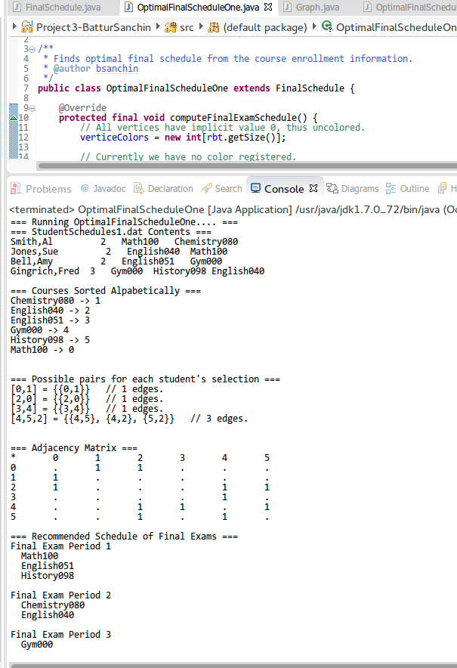

*Picture 4. OptimalFinalScheduleOne in Action.*