# Part 1. Using an approximation algorithm to solve TSP

Graph, LinkedList, MinHeap, and Tree are implemented for this part.

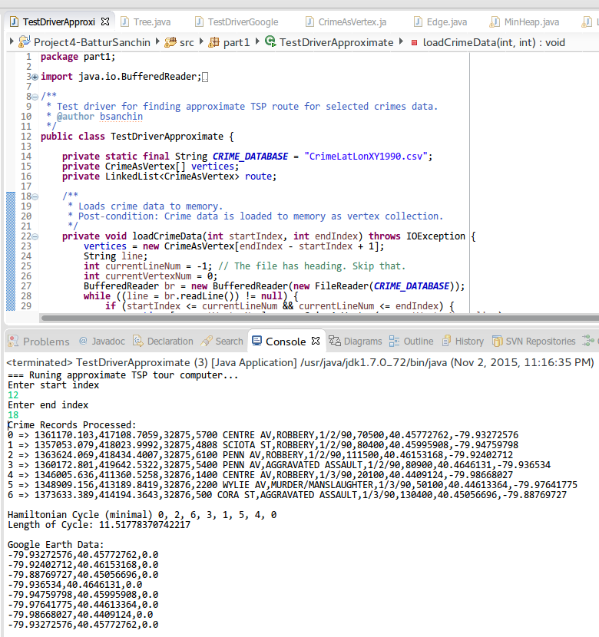

*Picture 1. TSP tour finder using approximation algorithm.*

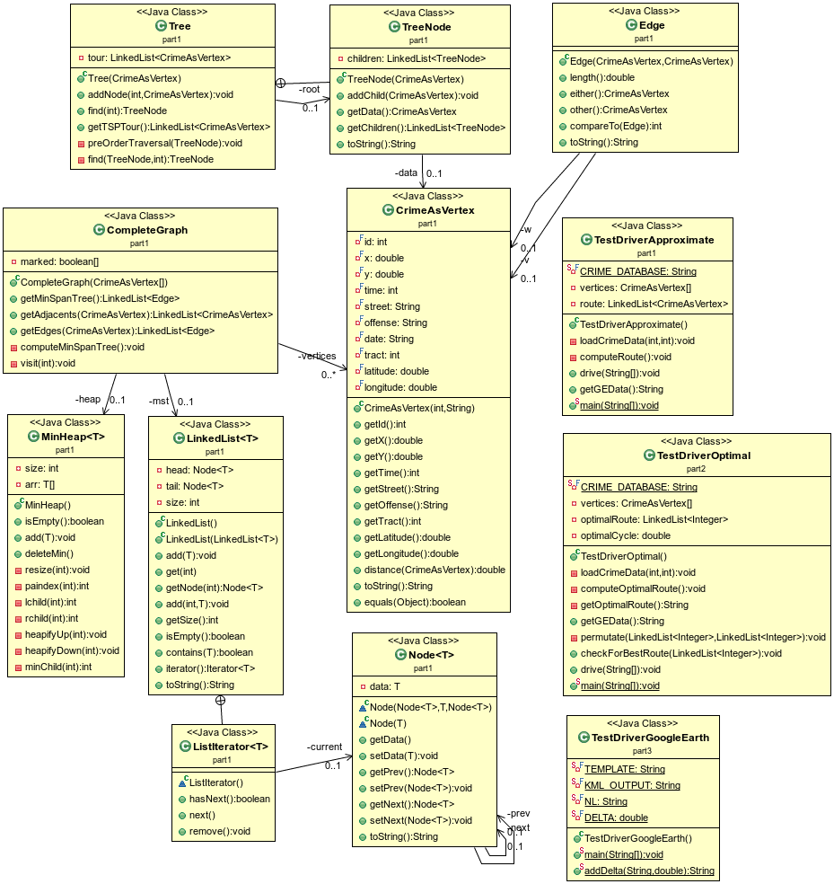

*Picture 2. Overview of the class diagram (auto-generated by* [*Object Aid UML Explorer*](http://www.objectaid.com/)*).*

# Part 2. Finding Optimal Solution to TSP

Uses brute-force approach for finding best tour on TSP.

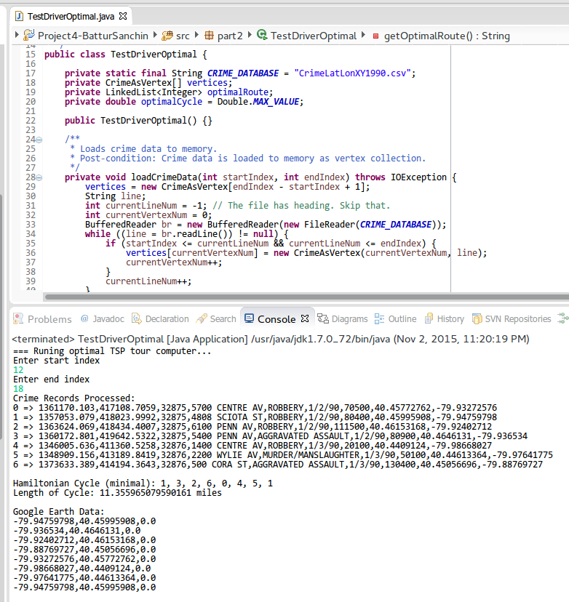

*Picture 3. Optimal TSP tour finder—Uses brute-force approach, thus very slow.*

# Part 3. Displaying the output to Google Earth

TestDriverGoogleEarth invokes solutions from part 1 and 2 and renders the results. It writes KML file content to PGHCrimes.kml and to console output. To avoid overlapping of two different routes, it modifies longitude and lattitude of part 2 output.

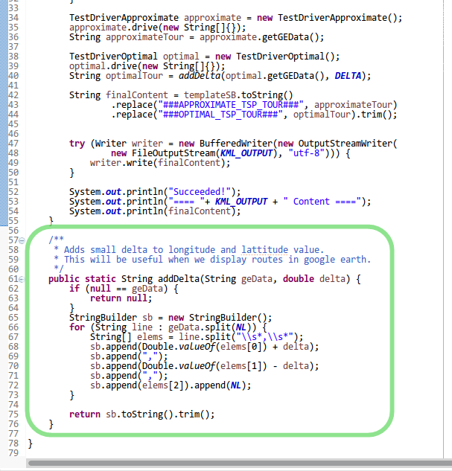

*Picture 4. Avoiding overlapped shapes.*

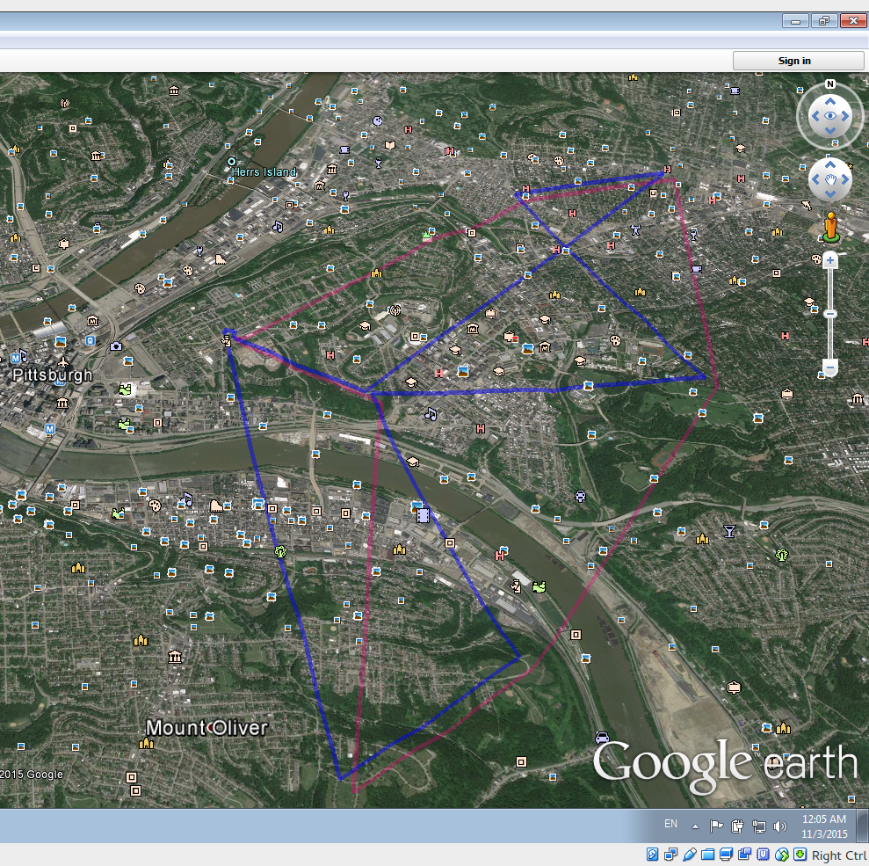

*Picture 5. Two routes displayed in Google Earth. Crime records from 0 to 10 were included.*

**Program Output:**

=== Running part3.TestDriverGoogleEarth...

Enter start index

0

Enter end index

10

=== Runing approximate TSP tour computer...

Crime Records Processed:

0 => 1348656.471,399538.5342,32874,100 BONIFAY ST,ROBBERY,1/1/90,160600,40.40865518,-79.9760891

1 => 1359951.481,410726.1273,32874,320 SCHENLEY RD,ROBBERY,1/1/90,140100,40.44013011,-79.93653583

2 => 1357049.25,418429.9175,32874,4779 LIBERTY AV,ROBBERY,1/1/90,80900,40.46107271,-79.94764804

3 => 1361745.729,419343.2848,32874,5600 PENN AV,AGGRAVATED ASSAULT,1/1/90,111500,40.46389868,-79.93085611

4 => 1353029.519,402359.7471,32875,3247 ARLINGTON AV,ROBBERY,1/2/90,160400,40.4166985,-79.96064401

5 => 1351340.433,410399.55,32875,183 BURROWS ST,AGGRAVATED ASSAULT,1/2/90,51000,40.43864462,-79.96743325

6 => 1351174.047,410440.8089,32875,220 BURROWS ST,ROBBERY,1/2/90,40200,40.43874637,-79.96803454

7 => 1348102.398,412548.4207,32875,2017 CENTRE AV,ROBBERY,1/2/90,50100,40.44431764,-79.97925733

8 => 1348176.524,412807.903,32875,2100 WYLIE AV,RAPE,1/2/90,50100,40.44503482,-79.97901462

9 => 1348176.524,412807.903,32875,2100 WYLIE AV,ROBBERY,1/2/90,50100,40.44503482,-79.97901462

10 => 1347891.491,412839.7694,32875,18 DAVENPORT ST,AGGRAVATED ASSAULT,1/2/90,50100,40.44510252,-79.98004129

Hamiltonian Cycle (minimal) 0, 4, 5, 1, 2, 3, 6, 7, 9, 8, 10, 0

Length of Cycle: 12.590524535417849

Google Earth Data:

-79.9760891,40.40865518,0.0

-79.96064401,40.4166985,0.0

-79.96743325,40.43864462,0.0

-79.93653583,40.44013011,0.0

-79.94764804,40.46107271,0.0

-79.93085611,40.46389868,0.0

-79.96803454,40.43874637,0.0

-79.97925733,40.44431764,0.0

-79.97901462,40.44503482,0.0

-79.97901462,40.44503482,0.0

-79.98004129,40.44510252,0.0

-79.9760891,40.40865518,0.0

=== Runing optimal TSP tour computer...

Crime Records Processed:

0 => 1348656.471,399538.5342,32874,100 BONIFAY ST,ROBBERY,1/1/90,160600,40.40865518,-79.9760891

1 => 1359951.481,410726.1273,32874,320 SCHENLEY RD,ROBBERY,1/1/90,140100,40.44013011,-79.93653583

2 => 1357049.25,418429.9175,32874,4779 LIBERTY AV,ROBBERY,1/1/90,80900,40.46107271,-79.94764804

3 => 1361745.729,419343.2848,32874,5600 PENN AV,AGGRAVATED ASSAULT,1/1/90,111500,40.46389868,-79.93085611

4 => 1353029.519,402359.7471,32875,3247 ARLINGTON AV,ROBBERY,1/2/90,160400,40.4166985,-79.96064401

5 => 1351340.433,410399.55,32875,183 BURROWS ST,AGGRAVATED ASSAULT,1/2/90,51000,40.43864462,-79.96743325

6 => 1351174.047,410440.8089,32875,220 BURROWS ST,ROBBERY,1/2/90,40200,40.43874637,-79.96803454

7 => 1348102.398,412548.4207,32875,2017 CENTRE AV,ROBBERY,1/2/90,50100,40.44431764,-79.97925733

8 => 1348176.524,412807.903,32875,2100 WYLIE AV,RAPE,1/2/90,50100,40.44503482,-79.97901462

9 => 1348176.524,412807.903,32875,2100 WYLIE AV,ROBBERY,1/2/90,50100,40.44503482,-79.97901462

10 => 1347891.491,412839.7694,32875,18 DAVENPORT ST,AGGRAVATED ASSAULT,1/2/90,50100,40.44510252,-79.98004129

Hamiltonian Cycle (minimal): 0, 4, 1, 3, 2, 8, 9, 10, 7, 6, 5, 0

Length of Cycle: 10.583858944347563 miles

Google Earth Data:

-79.9760891,40.40865518,0.0

-79.96064401,40.4166985,0.0

-79.93653583,40.44013011,0.0

-79.93085611,40.46389868,0.0

-79.94764804,40.46107271,0.0

-79.97901462,40.44503482,0.0

-79.97901462,40.44503482,0.0

-79.98004129,40.44510252,0.0

-79.97925733,40.44431764,0.0

-79.96803454,40.43874637,0.0

-79.96743325,40.43864462,0.0

-79.9760891,40.40865518,0.0

Succeeded!

==== PGHCrimes.kml Content ====

<?xml version="1.0" encoding="UTF-8" ?>

<kml xmlns="http://earth.google.com/kml/2.2">

<Document>

<name>Pittsburgh TSP</name><description>TSP on Crime</description><Style id="style6">

<LineStyle>

<color>73FF0000</color>

<width>5</width>

</LineStyle>

</Style>

<Style id="style5">

<LineStyle>

<color>507800F0</color>

<width>5</width>

</LineStyle>

</Style>

<Placemark>

<name>TSP Path</name>

<description>TSP Path</description>

<styleUrl>#style6</styleUrl>

<LineString>

<tessellate>1</tessellate>

<coordinates>

-79.9760891,40.40865518,0.0

-79.96064401,40.4166985,0.0

-79.96743325,40.43864462,0.0

-79.93653583,40.44013011,0.0

-79.94764804,40.46107271,0.0

-79.93085611,40.46389868,0.0

-79.96803454,40.43874637,0.0

-79.97925733,40.44431764,0.0

-79.97901462,40.44503482,0.0

-79.97901462,40.44503482,0.0

-79.98004129,40.44510252,0.0

-79.9760891,40.40865518,0.0

</coordinates>

</LineString>

</Placemark>

<Placemark>

<name>Optimal Path</name>

<description>Optimal Path</description>

<styleUrl>#style5</styleUrl>

<LineString>

<tessellate>1</tessellate>

<coordinates>

-79.9752891,40.40785518,0.0

-79.95984401,40.415898500000004,0.0

-79.93573583,40.43933011,0.0

-79.93005611,40.46309868,0.0

-79.94684804,40.460272710000005,0.0

-79.97821462,40.44423482,0.0

-79.97821462,40.44423482,0.0

-79.97924129,40.44430252,0.0

-79.97845733,40.44351764,0.0

-79.96723454,40.43794637,0.0

-79.96663325,40.43784462,0.0

-79.9752891,40.40785518,0.0

</coordinates>

</LineString>

</Placemark>

</Document>

</kml>