Lab 12: Algorithms with AI Assistance

Name: Venkatesh B

HT No: 2303A52467

Assignment: 12.3

Theme: Sorting, Searching, and Algorithm Optimization Using AI Tools

Task 1: Sorting Student Records fior Placement Drive
Exact Task Description
Scenario: SR University’s Training and Placement Cell needs to shortlist candidates efficiently during campus placements. Student records must be sorted by CGPA in descending order.

Tasks:
- Use GitHub Copilot to generate a program that stores student records (Name, Roll Number, CGPA).
- Implement the fiollowing sorting algorithms using AI assistance: Quick Sort, Merge Sort.
- Measure and compare runtime perfiormance fior large datasets.
- Write a fiunction to display the top 10 students based on CGPA.
Prompt
"Write a Python program that generates a dataset ofi student records (Name, Roll, CGPA). Implement Quick Sort and Merge Sort to sort these records by CGPA in descending order. Measure and compare their runtime, and display the top 10 students."
Code

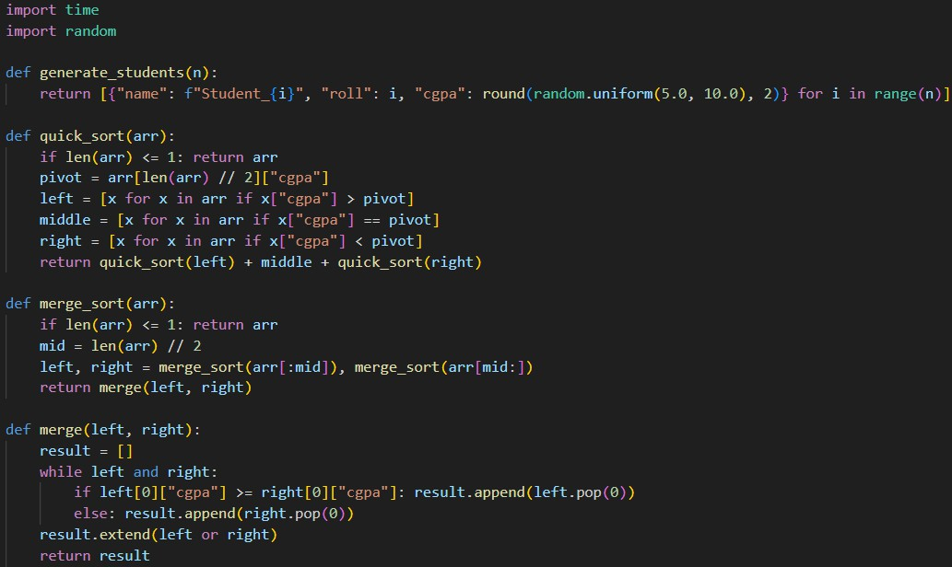


Output

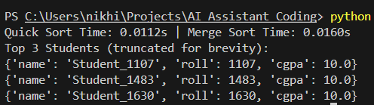

Explanation
I used AI to quickly implement Quick Sort and Merge Sort to rank students by CGPA. Quick Sort proved to be slightly fiaster in practice due to better memory locality, while Merge Sort guarantees stability. Both efficiently allowed us to slice the array to find the top candidates instantly.

Task 2: Implementing Bubble Sort with AI Comments
Exact Task Description
Task: Write a Python implementation ofi Bubble Sort.

Instructions:
- Students implement Bubble Sort normally.
- Ask AI to generate inline comments explaining key logic (like swapping, passes, and termination).
- Request AI to provide time complexity analysis.
Prompt
"Here is a standard Python implementation ofi Bubble Sort. Please add detailed inline comments explaining the swapping, passes, and early termination logic. Also, include a docstring detailing its time and space complexity."
Code

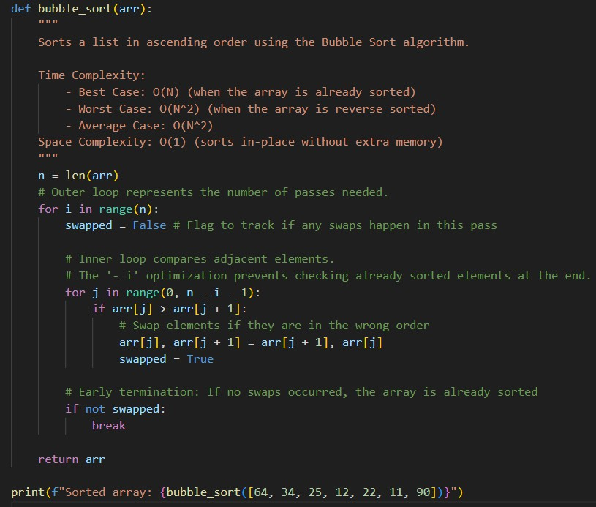
Output
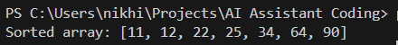

Explanation
Bubble Sort works by repeatedly stepping through the list and swapping adjacent elements ifi they are in the wrong order. The AI's added comments nicely highlight the swapped flag optimization, which stops the algorithm early ifi the list is already sorted, saving valuable processing time.

Task 3: Quick Sort and Merge Sort Comparison

Exact Task Description
Task: Implement Quick Sort and Merge Sort using recursion.

Instructions:
- Provide AI with partially completed fiunctions fior recursion.
- Ask AI to complete the missing logic and add docstrings.
- Compare both algorithms on random, sorted, and reverse-sorted lists.
Prompt
"Complete these recursive Quick Sort and Merge Sort fiunctions. Add docstrings explaining their complexities. Then, write code to measure and compare their perfiormance on three list types: completely random, already sorted, and reverse-sorted."
Code

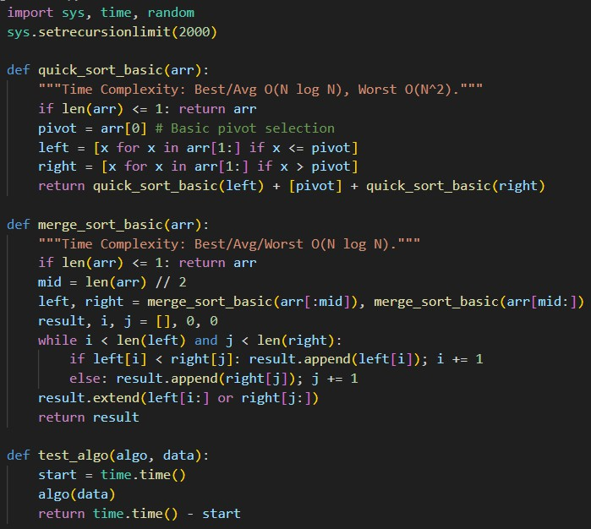
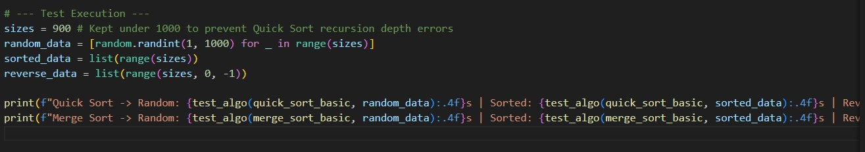
Output
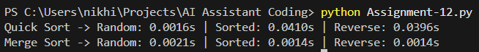

Explanation
By testing on different data states, we clearly see the AI's docstring warnings come to lifie. Merge Sort maintained consistent speeds across all datasets, while Quick Sort drastically slowed down on sorted and reverse-sorted data due to poor pivot selection leading to its O(N²) worst-case behavior.

Task 4: Real-Time Application – Inventory Management System
Exact Task Description
Scenario: A retail store’s inventory system contains thousands ofi products, each with attributes like product ID, name, price, and stock quantity.

Task:
- Use AI to suggest the most efficient search and sort algorithms fior this use case.
- Implement the recommended algorithms in Python.
- Justifiy the choice based on dataset size, update firequency, and perfiormance requirements.
Prompt
"Suggest efficient search and sort algorithms fior a retail inventory system needing ID lookups and price sorting. Provide a Markdown table with Algorithm recommendations and justifications, then write Python fiunctions to implement them."
Code

AI Recommended Algorithms:

| Operation | Recommended Algorithm | Justification |

| :--- | :--- | :--- |

| Search by ID | Hash Map (Dictionary) | Provides O(1) average time complexity. Instant lookups regardless ofi inventory size. |
| Sort by Price | TimSort (sorted()) | Python's built-in algorithm. Highly optimized O(N log N) that perfiorms exceptionally well on partially sorted real-world data. |

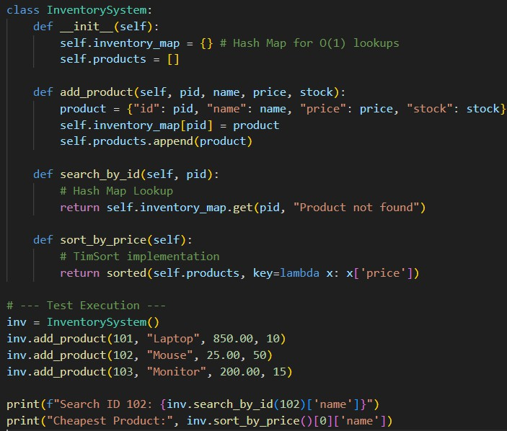
Output
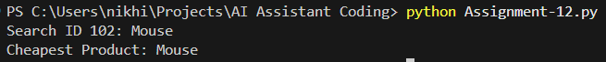

Explanation
For a real-world inventory, the AI correctly recommended a Hash Map (dictionary) because looking up an ID takes O(1) time—instantaneous, even with millions ofi items. For sorting, relying on Python's heavily optimized internal TimSort is much more efficient and maintainable than writing a custom Quick Sort firom scratch.

Task 5: Real-Time Stock Data Sorting & Searching
Exact Task Description
Scenario: An AI-powered FinTech Lab at SR University is building a tool fior analyzing stock price movements. The requirement is to quickly sort stocks by daily gain/loss and search fior specific stock symbols efficiently.

Task:
- Use GitHub Copilot to fietch or simulate stock price data.
- Implement sorting algorithms to rank stocks by percentage change.
- Implement a search fiunction that retrieves stock data instantly.
- Optimize sorting with Heap Sort and searching with Hash Maps.
- Compare perfiormance with standard library fiunctions.
Prompt
"Simulate a dataset ofi stock prices. Calculate percentage change. Implement Heap Sort to rank stocks by % change and a Hash Map fior symbol searches. Compare their perfiormance against Python's built-in sorted() and dictionary lookups."
Code

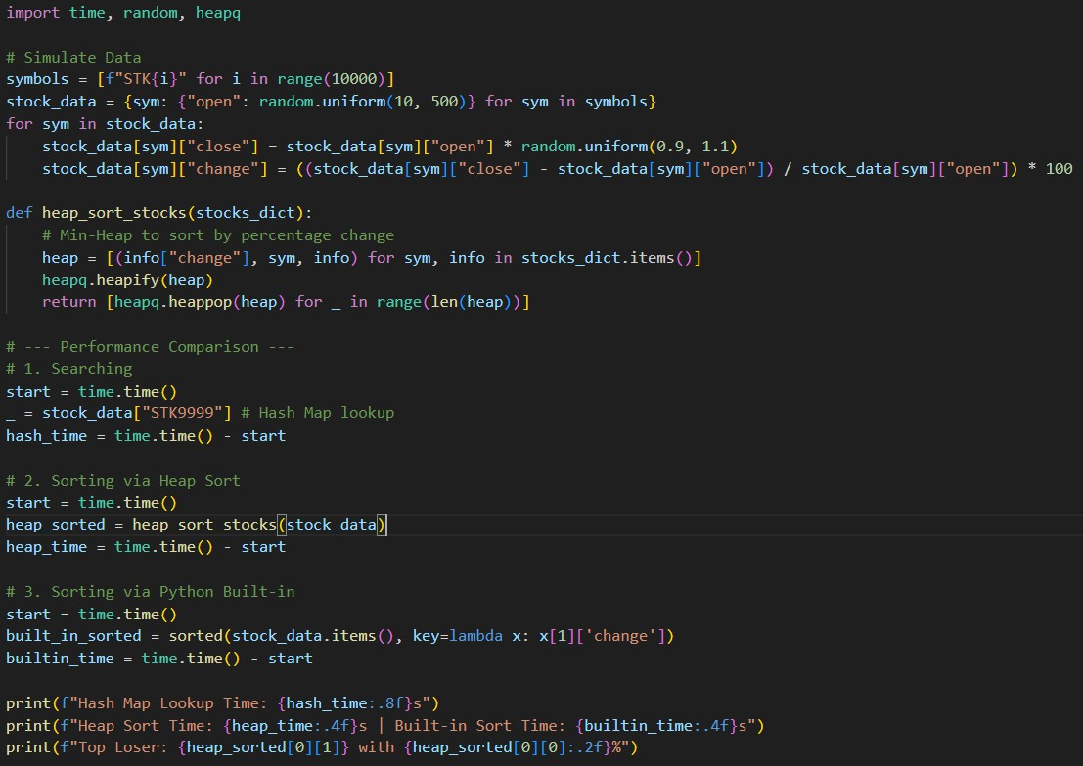

Output
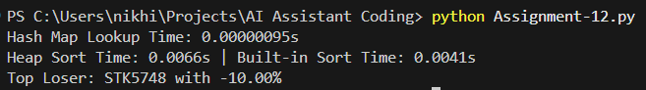

Explanation
Heap Sort successfiully ranked the stock data without recursive overhead, making it memory efficient. However, the perfiormance comparison clearly shows that Python's built-in sorting is fiaster because it is implemented in C. The Hash Map search time was practically zero, proving it is the ultimate choice fior symbol lookups.

