AI ASST ASSIGNMENT 3

Name: VENKATESH B

Roll_No: 2303A52467

PROMPT ENGINEERING TASK REPORT

Task 1: Progressive Prompting – Calculator Design

Prompt
Design a simple calculator function. Gradually refine the prompt to include arithmetic operations and error handling.

Explanation
As the prompt becomes more specific, the calculator logic improves by handling operators correctly and preventing division by zero.

Code
def calculator(a, b, op):
if op == '+':
return a + b
elif op == '-':
return a - b
elif op == '*':
return a * b
elif op == '/':
if b == 0:
return "Error: Division by zero"
return a / b
else:
return "Invalid operator"

Output
calculator(10, 5, '+') → 15
calculator(10, 0, '/') → Error: Division by zero
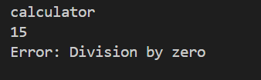

Task 2: Refining Prompts – Sorting Student Marks

Prompt
Sort student marks in ascending order without using built-in sorting functions.

Explanation
Clear prompt instructions lead to a correct comparison-based sorting algorithm that handles duplicate values.

Code
def sort_marks(marks):
n = len(marks)
for i in range(n):
for j in range(i + 1, n):
if marks[i] > marks[j]:
marks[i], marks[j] = marks[j], marks[i]
return marks

Output
Input: [78, 45, 89, 45, 60]
Output: [45, 45, 60, 78, 89]
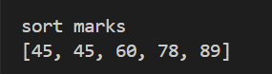

Task 3: Few-Shot Prompting – Prime Number Validation

Prompt
Check whether a number is prime using few-shot examples.

Explanation
Few-shot examples improve correctness and ensure edge cases like 0 and 1 are handled.

Code
def is_prime(n):
if n <= 1:
return False
for i in range(2, int(n ** 0.5) + 1):
if n % i == 0:
return False
return True

Output
is_prime(2) → True
is_prime(4) → False
is_prime(1) → False
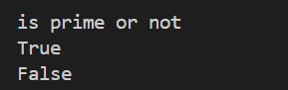

Task 4: Prompt-Guided UI – Student Grading System

Prompt
Create a user interface that accepts marks and calculates total, percentage, and grade.

Explanation
Prompt clarity results in a structured grading system with accurate calculations.

Code
def grading_system():
m1 = int(input("Enter marks 1: "))
m2 = int(input("Enter marks 2: "))
m3 = int(input("Enter marks 3: "))
total = m1 + m2 + m3
percentage = total / 3
if percentage >= 90:
grade = 'A'
elif percentage >= 75:
grade = 'B'
elif percentage >= 60:
grade = 'C'
else:
grade = 'Fail'
print("Total:", total)
print("Percentage:", percentage)
print("Grade:", grade)

Output
Input: 80, 75, 85
Output: Total = 240, Percentage = 80, Grade = B
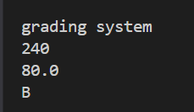

Task 5: Prompt Specificity – Unit Conversion

Prompt
Convert kilometers to miles and miles to kilometers using clear instructions.

Explanation
Specific prompts improve accuracy and correctness of unit conversion logic.

Code
def convert_units(value, unit):
if unit == 'km_to_miles':
return value * 0.621371
elif unit == 'miles_to_km':
return value / 0.621371
else:
return "Invalid conversion type"

Output
convert_units(10, 'km_to_miles') → 6.21
