AI Assistant Coding
Assignment-6.2

Name of Student : Venkatesh B
Enrollment No. : 2303A52467
Batch : 37

Task Description-1 (Classes – Data Validation)
• Prompt AI to generate a Student class with attributes: name,
roll_no, and marks. Add a method is_pass() that returns whether
the student has passed (marks ≥ 40).
Expected Output-1
• Python class with constructor and validation logic
• Clear method implementation returning pass/fail status
• Students analyze correctness and clarity of class design

Prompt:
generate a Student class with attributes: name, roll_no, and marks. Add a method is_pass() that returns whether the student has passed (marks ≥ 40)

Code:
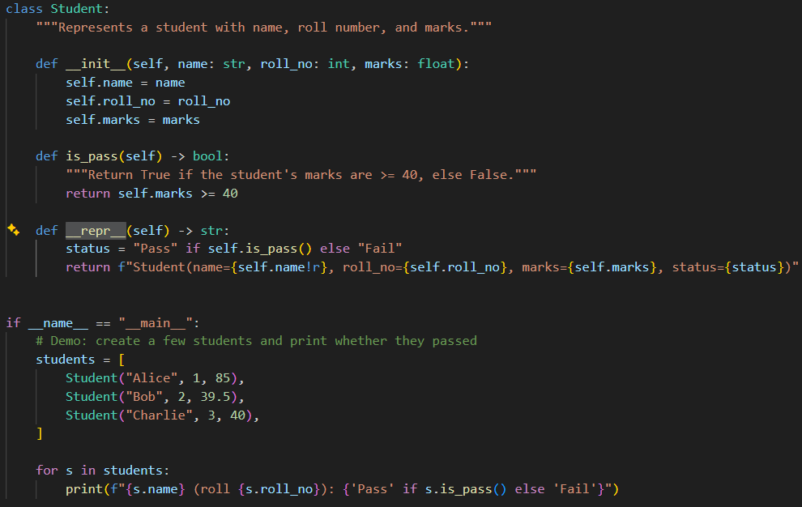

Output:

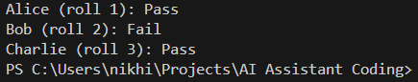
Explanation:
Defines a Student class with attributes name, roll_no, and marks, plus a readable __repr__. Provides is_pass() (returns True when marks ≥ 40)
that prints each student's pass/fail.

Task Description-2 (Loops – Pattern Generation)
• Ask AI to generate a function that prints a right-angled triangle
star pattern using a for loop. Then regenerate the same pattern
using a while loop.
Expected Output-2
• Correct pattern output using both loop types
• Logical loop structure with proper conditions

Prompt:
generate a function that prints a right angled triangle star pattern
1. using a for loop
2. using a while loop
Code:
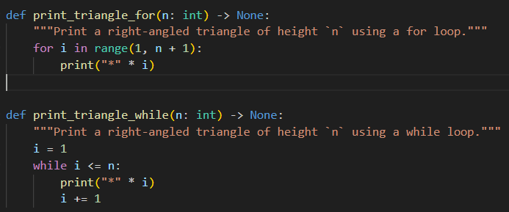
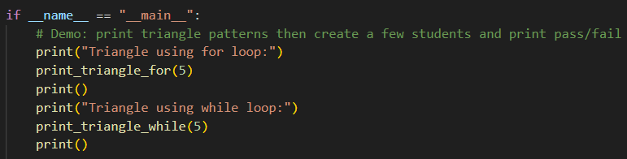

Output:
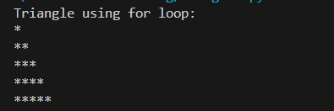
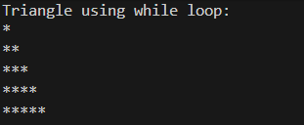

Explanation:
generated print_triangle_for(n) and print_triangle_while(n) to print a right-angled star triangle of height n using a for loop and a while loop respectively.

Task Description-3 (Conditional Statements – Number Analysis)
• Ask AI to write a function that checks whether a given number
is positive, negative, or zero using if-elif-else. Test the function
with multiple inputs.
Expected Output-3
• Function correctly classifies numbers
• Proper handling of all conditions
• Students analyze decision logic

Prompt:
Write a function that checks whether a given number
is positive, negative, or zero using conditional statements. Test the function
with multiple inputs..

Code:
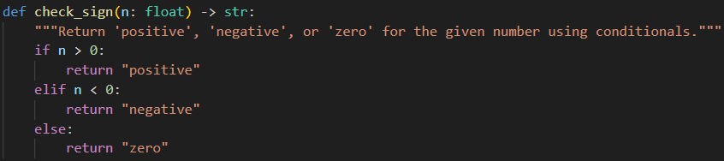

Output:
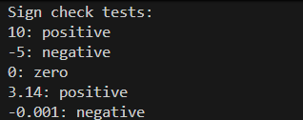
Explanation:
This function simply checks whether the number is greater than, less than, or equal to zero. Based on that comparison, it returns "positive", "negative", or "zero" accordingly.

Task Description-4 (Nested Conditionals)
• Generate a function check_discount(age, is_member) that
determines discount eligibility:
• Age ≥ 60 → Senior discount
• Member → Additional discount
Use nested if statements.
Expected Output-4
• Python code using nested conditionals
• Clear explanation of decision flow
Prompt:
Write a function check_discount(age, is_member) that uses nested if statements to decide discounts.
If age is 60 or above, give a Senior discount.
If the person is also a member, give an Additional discount.
Code:
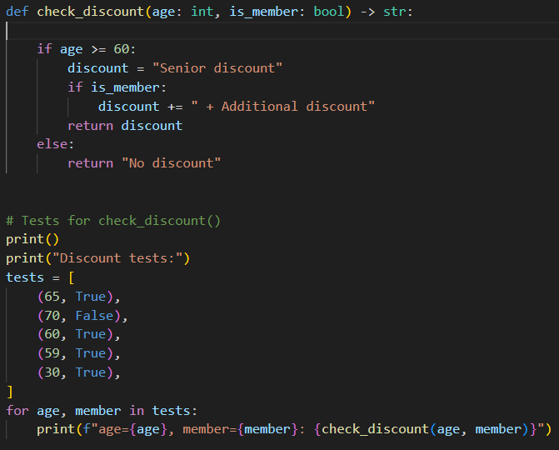

Output:
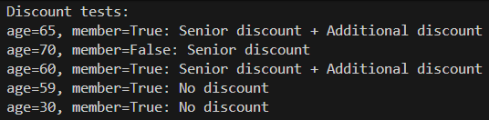

Explanation:
The function first checks if the age is 60 or above to apply a senior discount.
Inside that, it uses another if to add an extra discount if the person is also a member; otherwise, no discount is given.

Task Description-5 (Class – Mathematical Opera)
• Ask AI to create a Circle class with methods to calculate area ()
and circumference () given the radius.
Expected Output-5
• Correct mathematical computation
• Well-structured class with methods
• Code explanation provided

Prompt:
Create a Circle class that takes a radius as input and has two methods:
one to calculate the area and another to calculate the circumference of the circle.
Ensure the calculations are correct

Code:
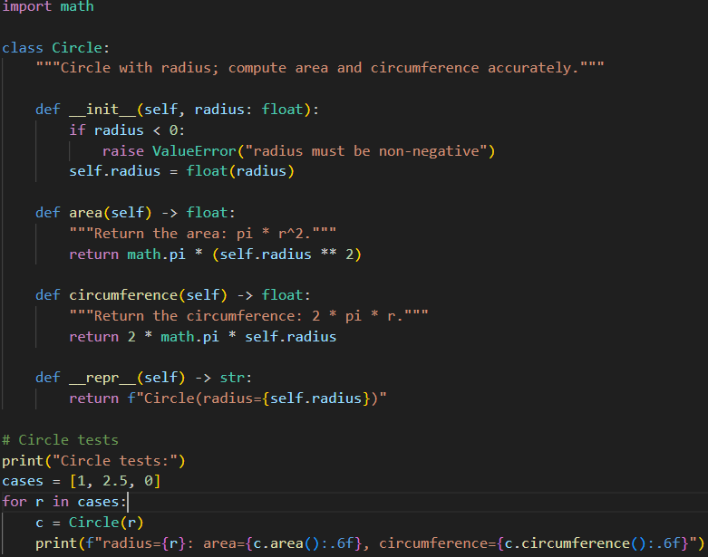

OUTPUT:
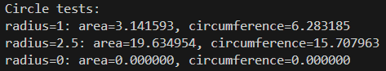

Explanation:
This class stores the radius of a circle and provides methods to calculate its area and circumference using standard formulas.
It also validates the radius and uses Python’s math.pi to ensure accurate mathematical results.

