METADATA
Socioeconomic and Solar Information
The table geos.csv stores socioeconomic information such as population and median household income and solar-related information such as solar potential and net solar potential at various geography levels for the years of 2010 and 2014. For example, you can filter the data for the total population of the city of Santa Monica in 2014. Note: Solar potential is limited to LA County geographies only.
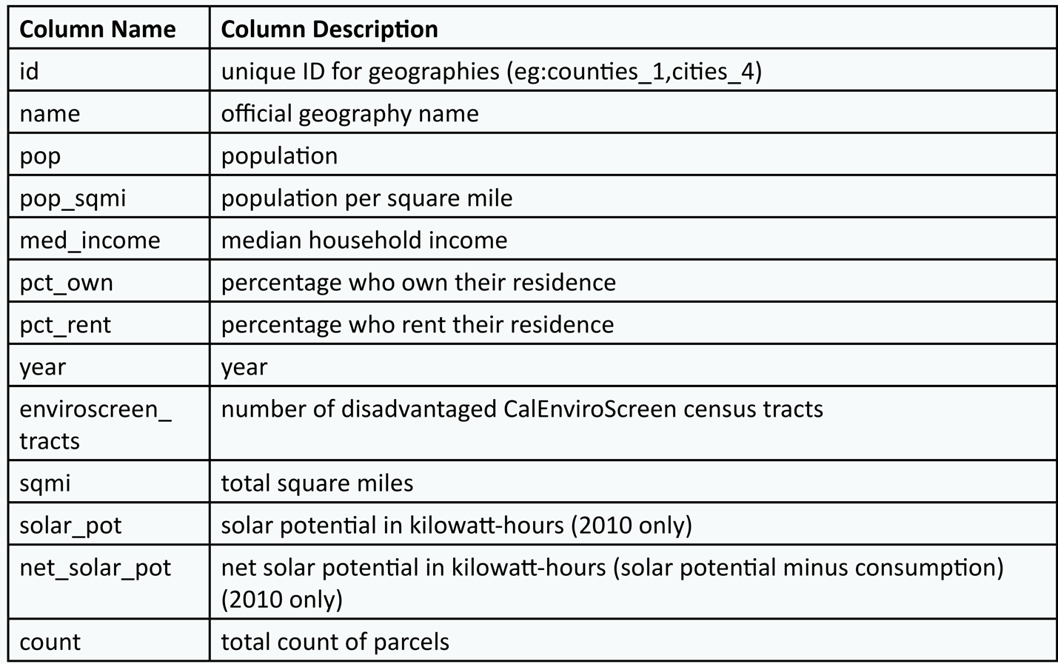

Parcel Information Summary
The table sqft_bld.csv includes parcel information such as the number of parcels, total square footage, and parcel use-type for each geography.
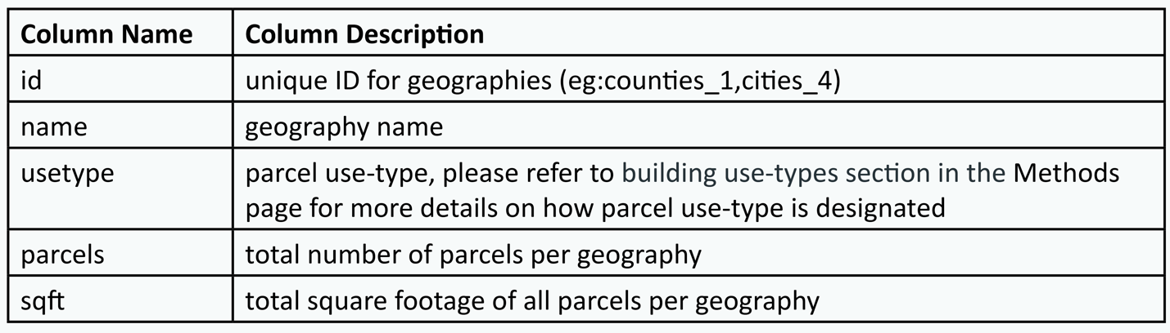
The following tables all pertain to consumption data, and each category contains a series of tables based on four units: kilowatt-hours (kWh), therms (thm), British thermal units (BTU), and metric tons of carbon for greenhouse gas (MTCO2) emissions.
Consumption Information by Parcel Use-Type
The CSV files are consequently named usage_bld_kwh, usage_bld_therms, usage_bld_btu, and usage_bld_ghg. Additional columns for solar information are included in the table usage_bld_kwh.
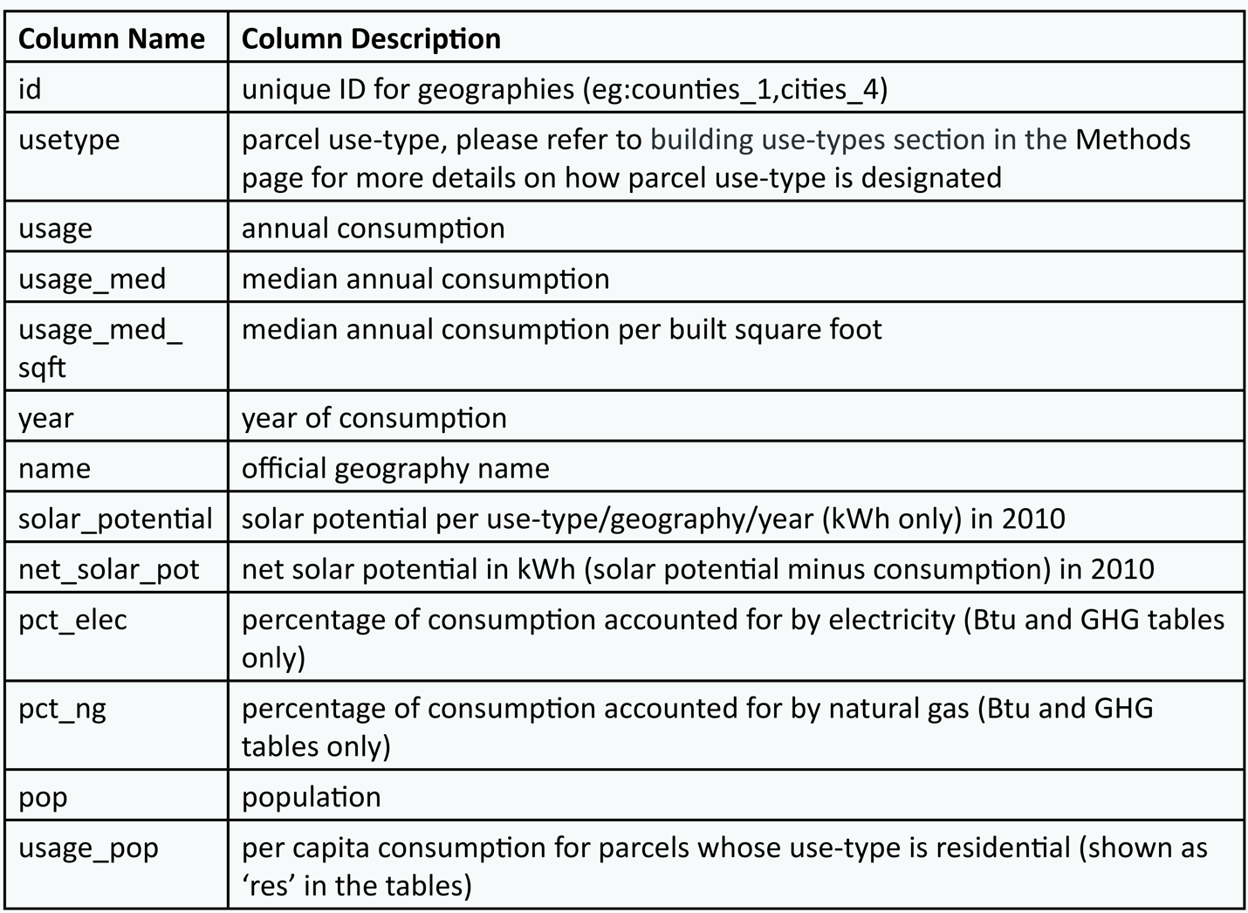

Consumption Information by Income Quintile for Residential Parcels
This series of tables is describing consumption information based on income levels for residential parcels. The CSV files are named by unit type as usage_income_kwh, usage_income_therms, usage_income_btu, and usage_income_ghg.
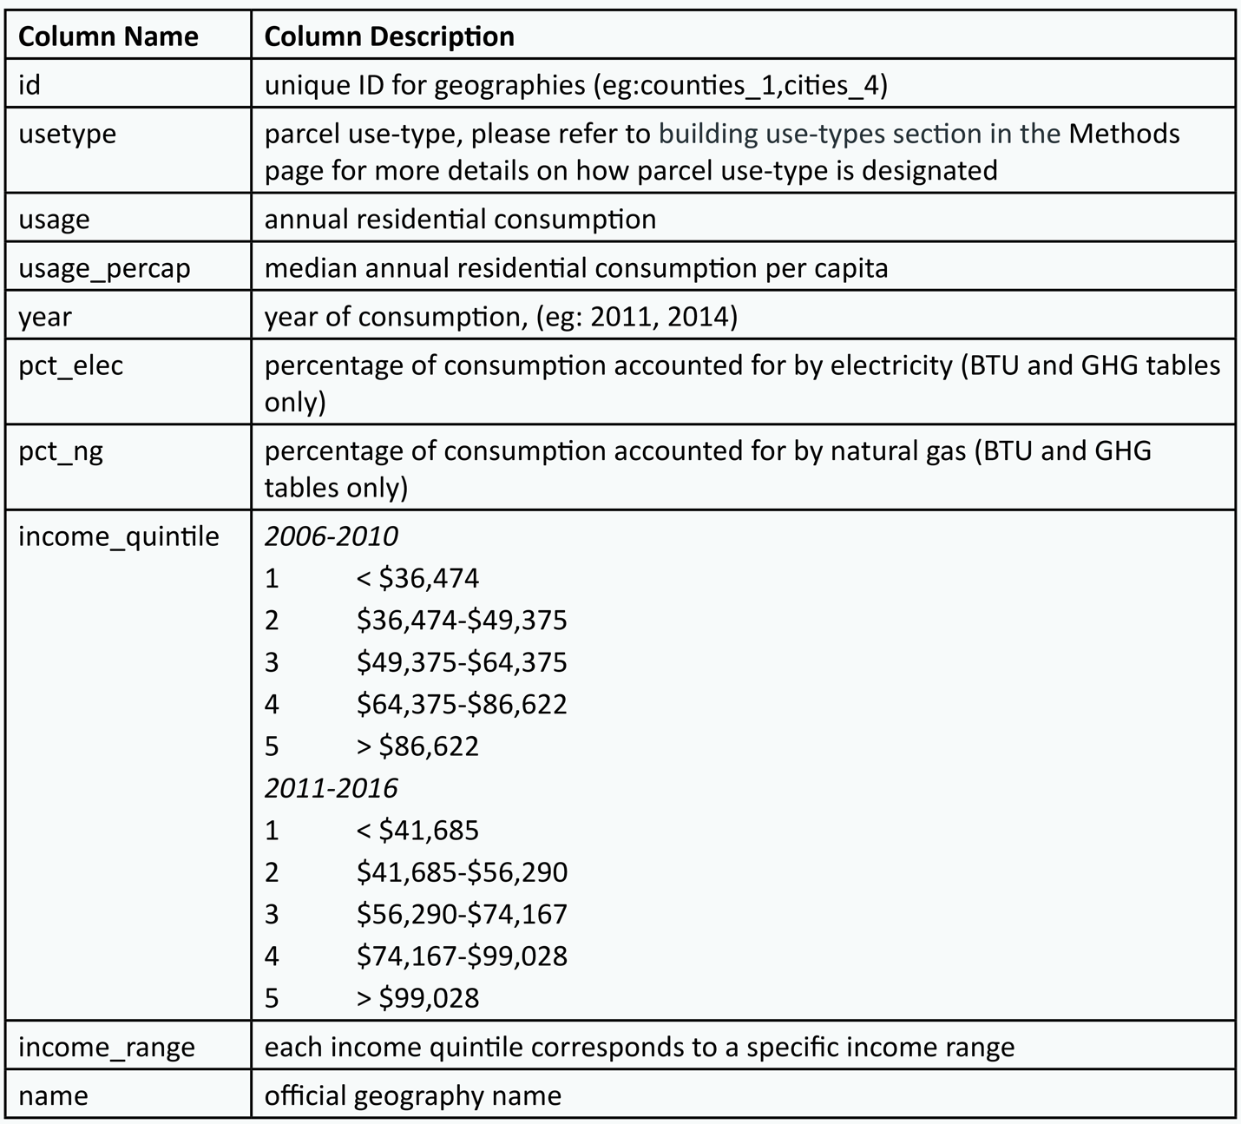

Consumption Information by Different Square Footage Intervals
This series of tables is only applicable for parcels where use-types are non-residential and multi-family. The names for these tables are usage_sqft_kwh, usage_sqft_therms, usage_sqft_btu and usage_sqft_ghg.
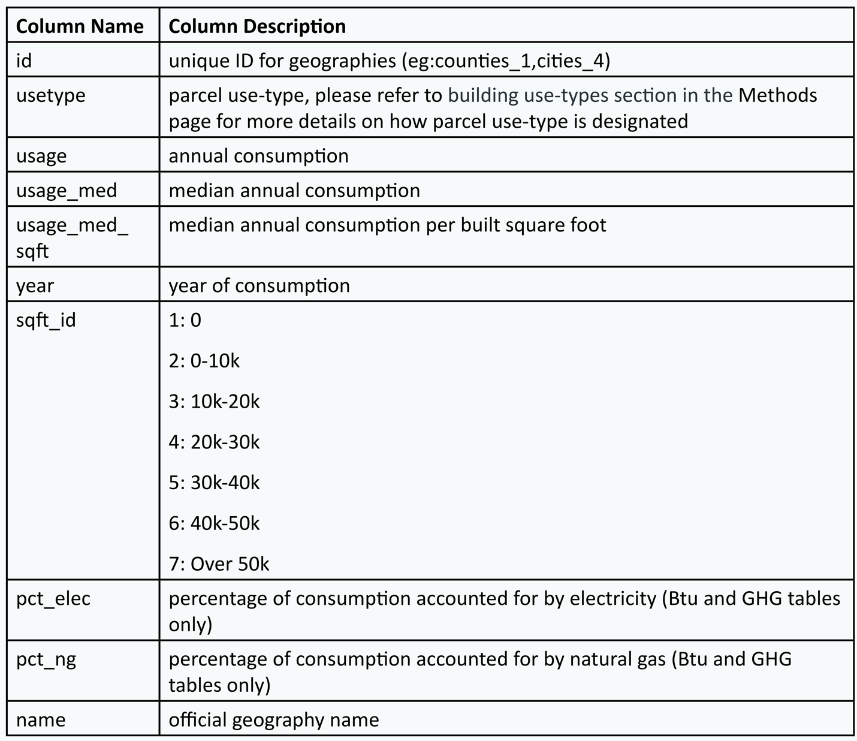

Consumption Information by Different Building Vintages
This series of tables is meant to provide consumption information for buildings based on year built. The CSV files are named according to unit as usage_vintage_kwh, usage_vintage_therms, usage_vintage_btu and usage_vintage_ghg.
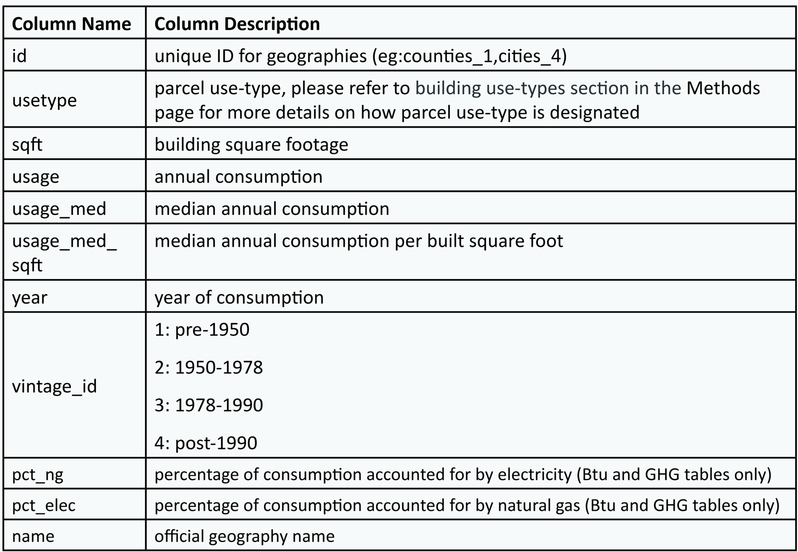

CalEnviroScreen Census Tracts
The download package also includes detailed consumption information regarding CalEnviroScreen census tracts. CalEnviroScreen compiles data for sociodemographic factors and environmental risk assessments to identify Disadvantaged Communities (DACs) throughout the state. At the Census Tract level, communities are ranked according to a summary index of indicators, such as income and proximity to environmental hazards. Different percentile buckets are given to each census tract -- census tracts above the 75th percentile are considered disadvantaged communities.
