max角本自动提示补全方法

来源：

http://www.scriptspot.com/blog/nik/autocomplete-in-the-maxscript-editor

http://andyeee.blogspot.com/2010/12/max-script-2.html

步骤：

1、启动MAX，新建一个编辑窗口（需要管理员身份）

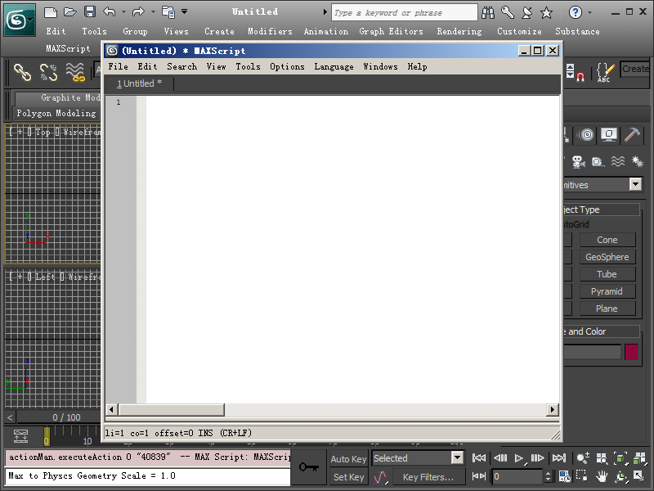

2、把下面那段红色的代码copy到窗口中，按Ctrl+E 执行，会自动生成一个maxscript.api文件，这个文件的位置看标题栏上的路径。（没有什么是一下Ctrl+E解决不了的，如果有，那就两下！）

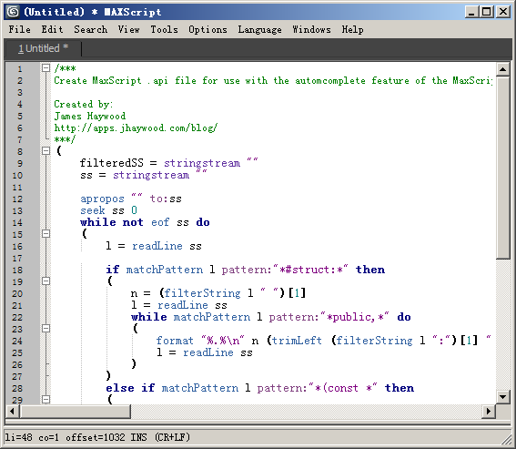 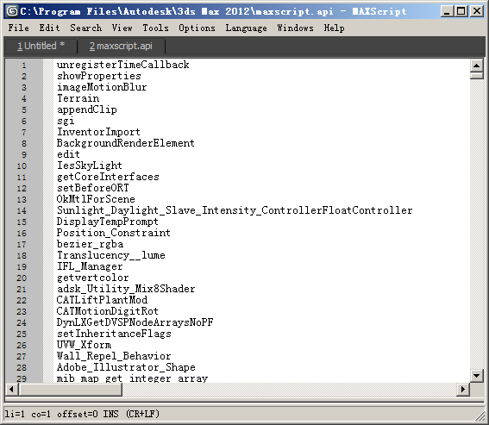

3、打开Tools->OpenGlobalOptionsFile

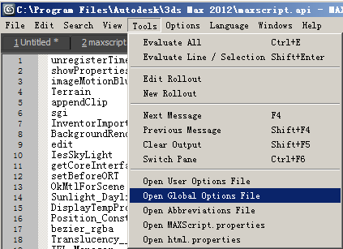

4、找到文件末尾，把下面蓝色代码贴进来, save!

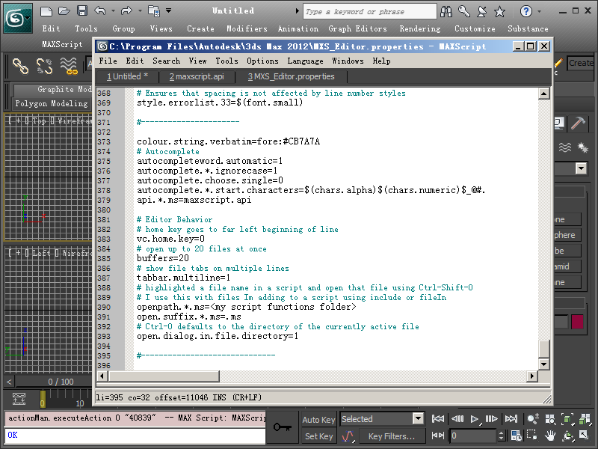

5、重起MAX，更多内容看图2中第7、8、9条

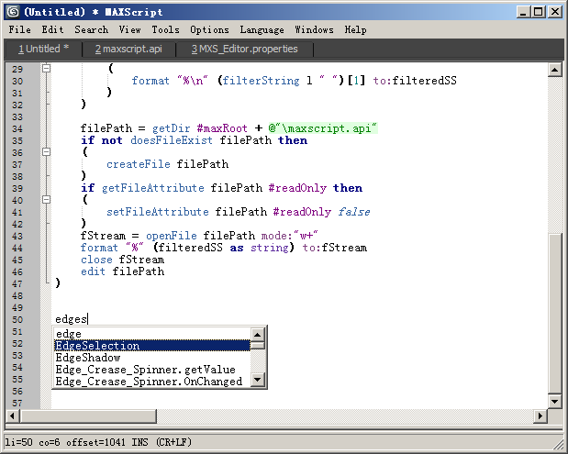

(

filteredSS = stringstream ""

ss = stringstream ""

apropos "" to:ss

seek ss 0

while not eof ss do

(

l = readLine ss

if matchPattern l pattern:"*#struct:*" then

(

n = (filterString l " ")[1]

l = readLine ss

while matchPattern l pattern:"*public,*" do

(

format "%.%\n" n (trimLeft (filterString l ":")[1] " ") to:filteredSS

l = readLine ss

)

)

else if matchPattern l pattern:"*(const *" then

(

format "%\n" (filterString l " ")[1] to:filteredSS

)

)

filePath = getDir #maxRoot + @"\maxscript.api"

if not doesFileExist filePath then

(

createFile filePath

)

if getFileAttribute filePath #readOnly then

(

setFileAttribute filePath #readOnly false

)

fStream = openFile filePath mode:"w+"

format "%" (filteredSS as string) to:fStream

close fStream

edit filePath

)

#----------------------

colour.string.verbatim=fore:#CB7A7A

# Autocomplete

autocompleteword.automatic=1

autocomplete.*.ignorecase=1

autocomplete.choose.single=0

autocomplete.*.start.characters=$(chars.alpha)$(chars.numeric)$_@#.

api.*.ms=maxscript.api

# Editor Behavior

# home key goes to far left beginning of line

vc.home.key=0

# open up to 20 files at once

buffers=20

# show file tabs on multiple lines

tabbar.multiline=1

# highlighted a file name in a script and open that file using Ctrl-Shift-O

# I use this with files Im adding to a script using include or fileIn

openpath.*.ms=<my script functions folder>

open.suffix.*.ms=.ms

# Ctrl-O defaults to the directory of the currently active file

open.dialog.in.file.directory=1

#------------------------------