BATUAN NATIONAL HIGH SCHOOL
SUPREME SECONDARY LEARNER GOVERNMENT (SSLG)
AUTOMATED VOTING & MANAGEMENT SYSTEM
Comprehensive System Architecture & Flowchart Documentation
System Name: | Batuan National High School — SSLG Voting System (batuan-voting)
Architecture: | React 18 (Vite SPA) + Node.js Express REST API + MySQL / Supabase
Target Roles: | Student Voters (Grades 7–12), SSLG Commission on Elections, System Administrators
Document Version: | Version 1.0 (Official Specification & Customizable Thesis Appendix)

1. System Overview and Flowchart Architecture
The Batuan National High School SSLG Voting System is an automated web-based election and voter governance platform. The system provides complete end-to-end election workflows including voter credential management, candidate profiling, secure real-time ballot casting with atomic transaction safeguards, grade-level representation filtering, live tally broadcasting via WebSockets, official tally sheet generation, and past election archiving.
This document presents the complete system flowcharts structured in full accordance with the academic reference standard (matching the layout and decomposed off-page connector architecture of CargoExpressFlowchart.docx). Each figure is accompanied by an in-depth breakdown of user decisions, state transitions, validation trappings, and database mutations.

2. Flowchart Conventions and Symbol Key
Flowchart Shape | ANSI / ISO Name | Functional Role in Batuan Voting System
Oval / Stadium | Terminal Node | Represents the absolute system entry (START) and session termination (END).
Parallelogram | Input / Output / Choices | Represents user interface menu choices, form input data (e.g. LRN, Password, Candidate forms), and filters.
Diamond | Decision Gate | Evaluates boolean conditions (e.g. valid credentials, role=='admin', must_change_password, election ongoing, has_voted).
Rectangle | Process / Action | Represents internal calculations, password hashing, SQL database transactions, CSV parsing, and state updates.
Rounded Bullet | Display Output | Represents user-facing rendered UI screens, toast alerts, statistical summaries, charts, and print dialogs.

3. Public Landing Page and Authentication Module
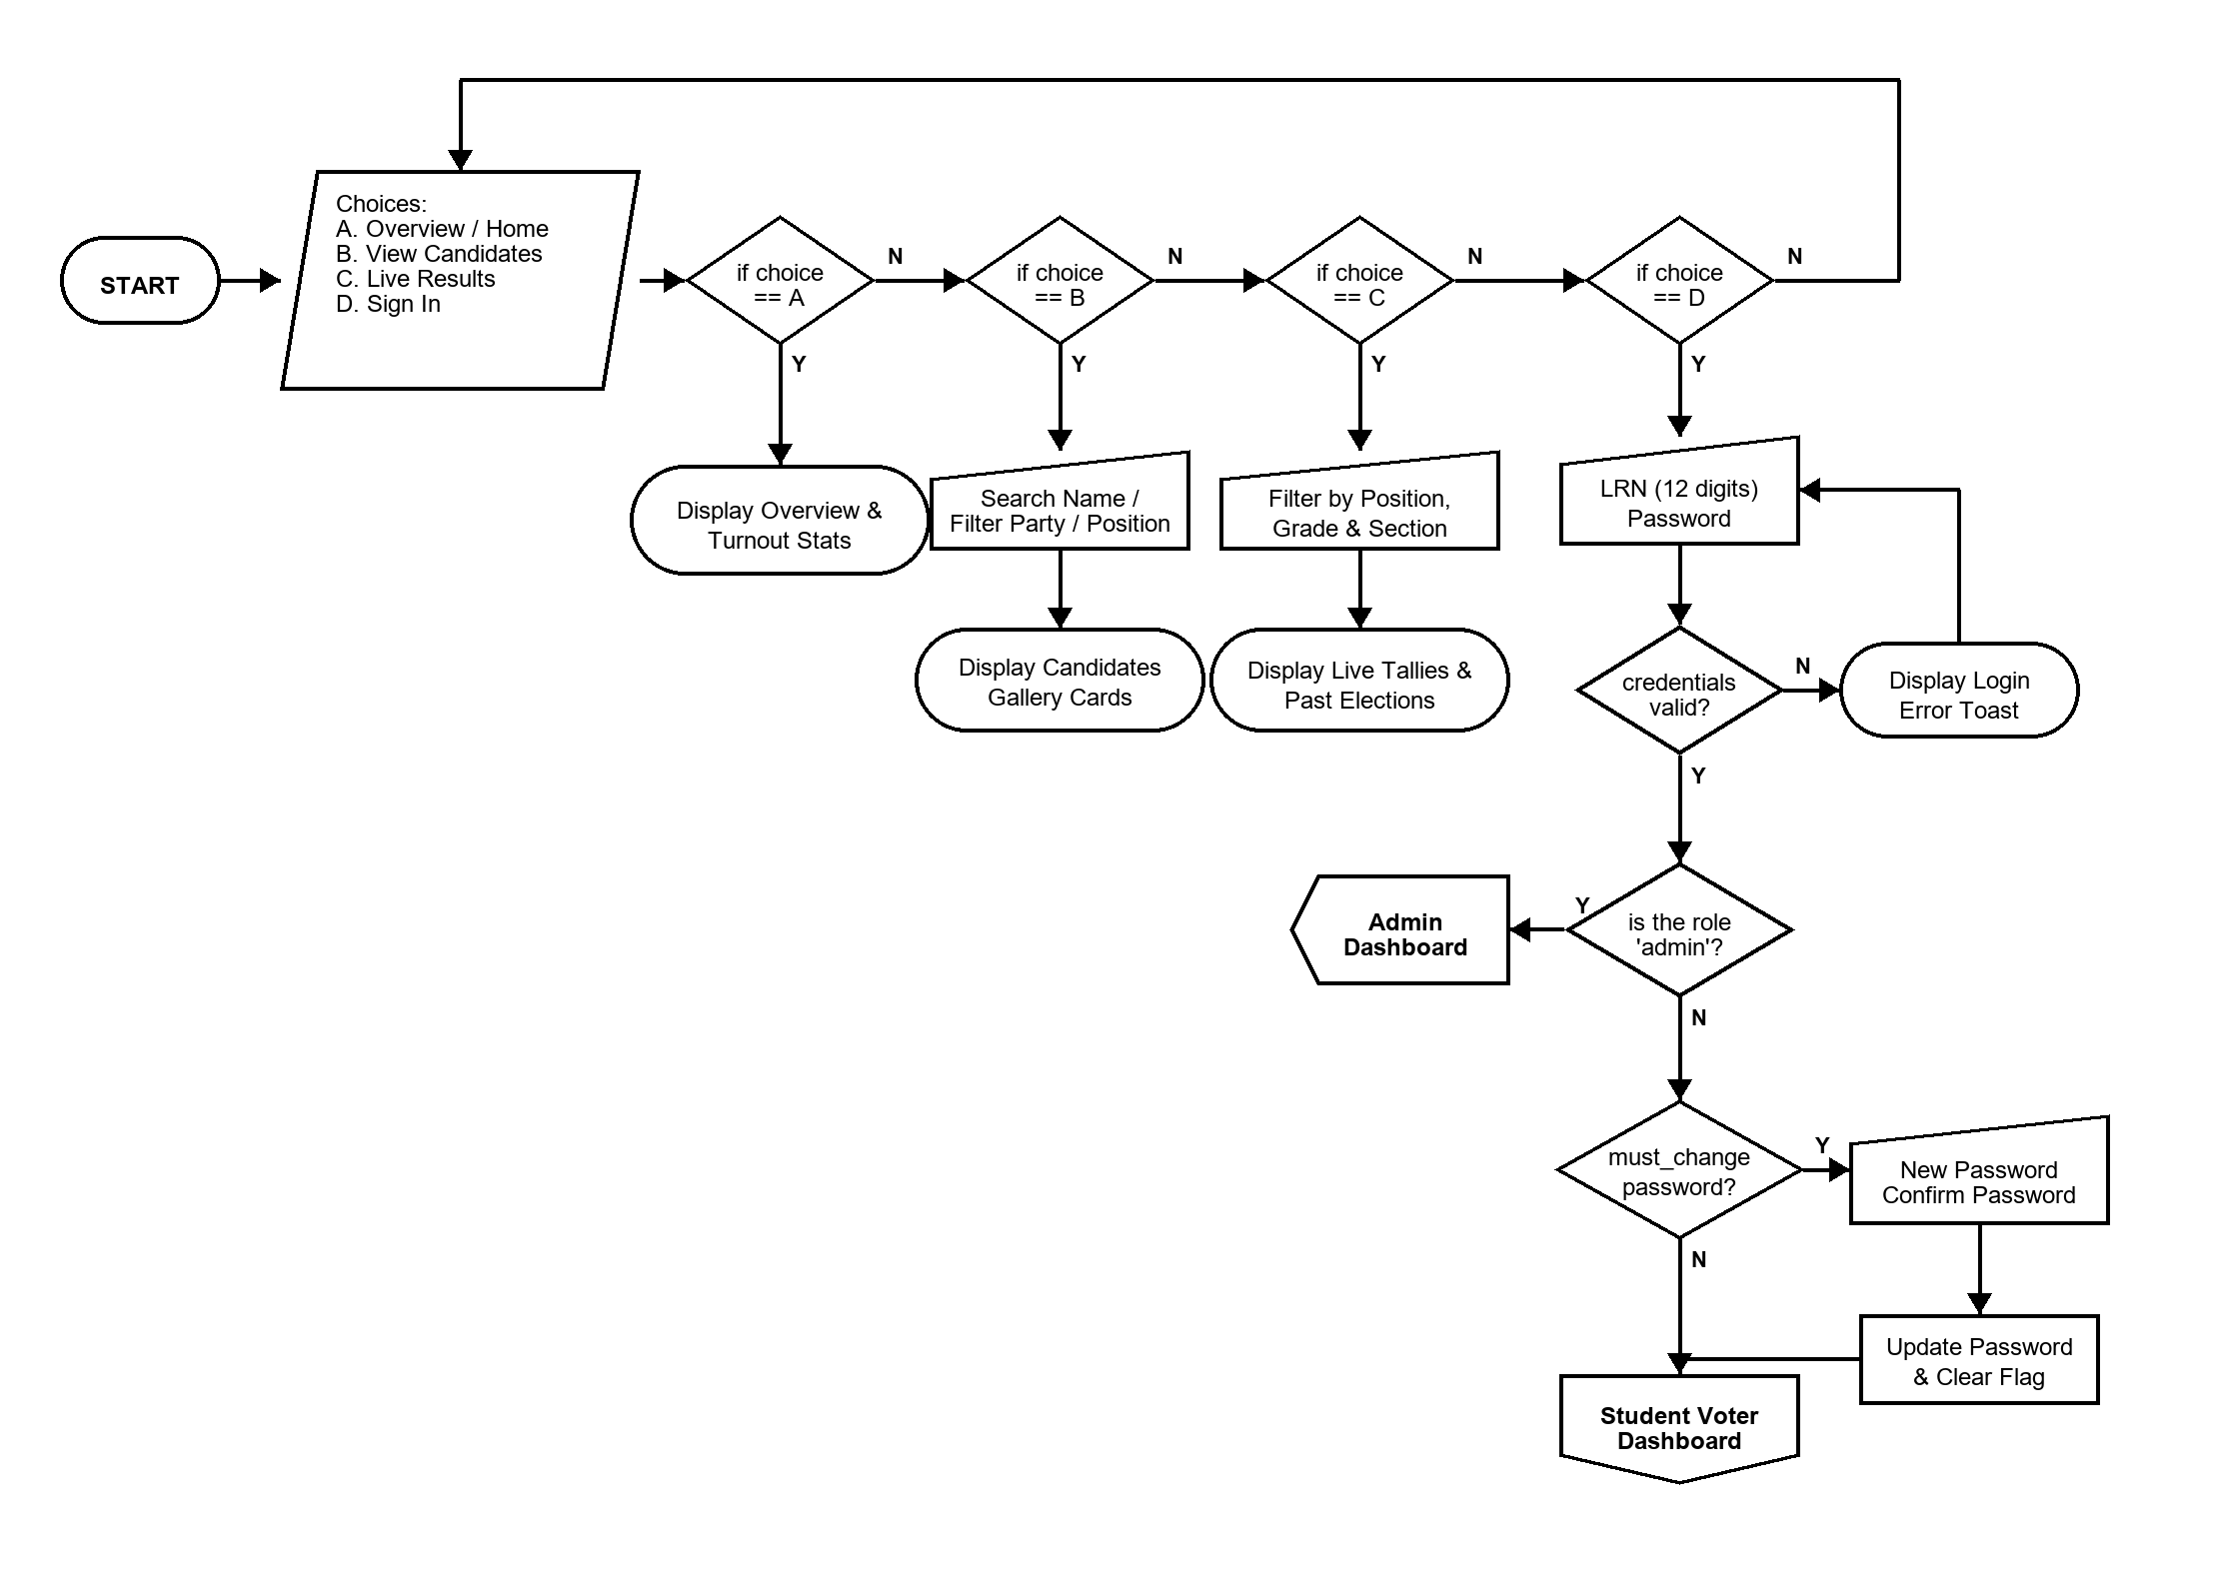
Figure 2. Landing Page & Authentication Flowchart
Figure 2 illustrates the entry gateway and public navigation for the Batuan Voting System. Upon loading the system at the root URL (/), users are presented with four primary choices (A through D):
- Choice A (Overview / Home): Displays the election hero banner, countdown timer, real-time voter turnout percentage, total registered voters, and the top 5 leading candidates leaderboard.
- Choice B (View Candidates): Provides a public candidate directory where students can search candidates by full name or party list, and filter by position.
- Choice C (Live Results): Renders the live election analytics tab with position, voter grade level, and section drilldowns, as well as archived past elections.
- Choice D (Sign In Gate): Accepts 12-digit Learner Reference Number (LRN) and password credentials. Submits to POST /api/auth/login.
Authentication Logic Trapping:
1. Credentials Validation: If credentials are invalid, an error toast is rendered and user loops back.
2. Role Check: If user role is 'admin', user is immediately routed to the Admin Dashboard (Connector 4).
3. Forced Password Change Check: If user is a student voter with must_change_password == true (e.g. newly imported voter whose default password equals their LRN), the system intercepts the session and forces a redirect to /change-password. Once a valid password (minimum 6 characters) is set, the flag is cleared and the voter enters the Student Voter Dashboard.

4. Student Voter Portal and Ballot Casting Module
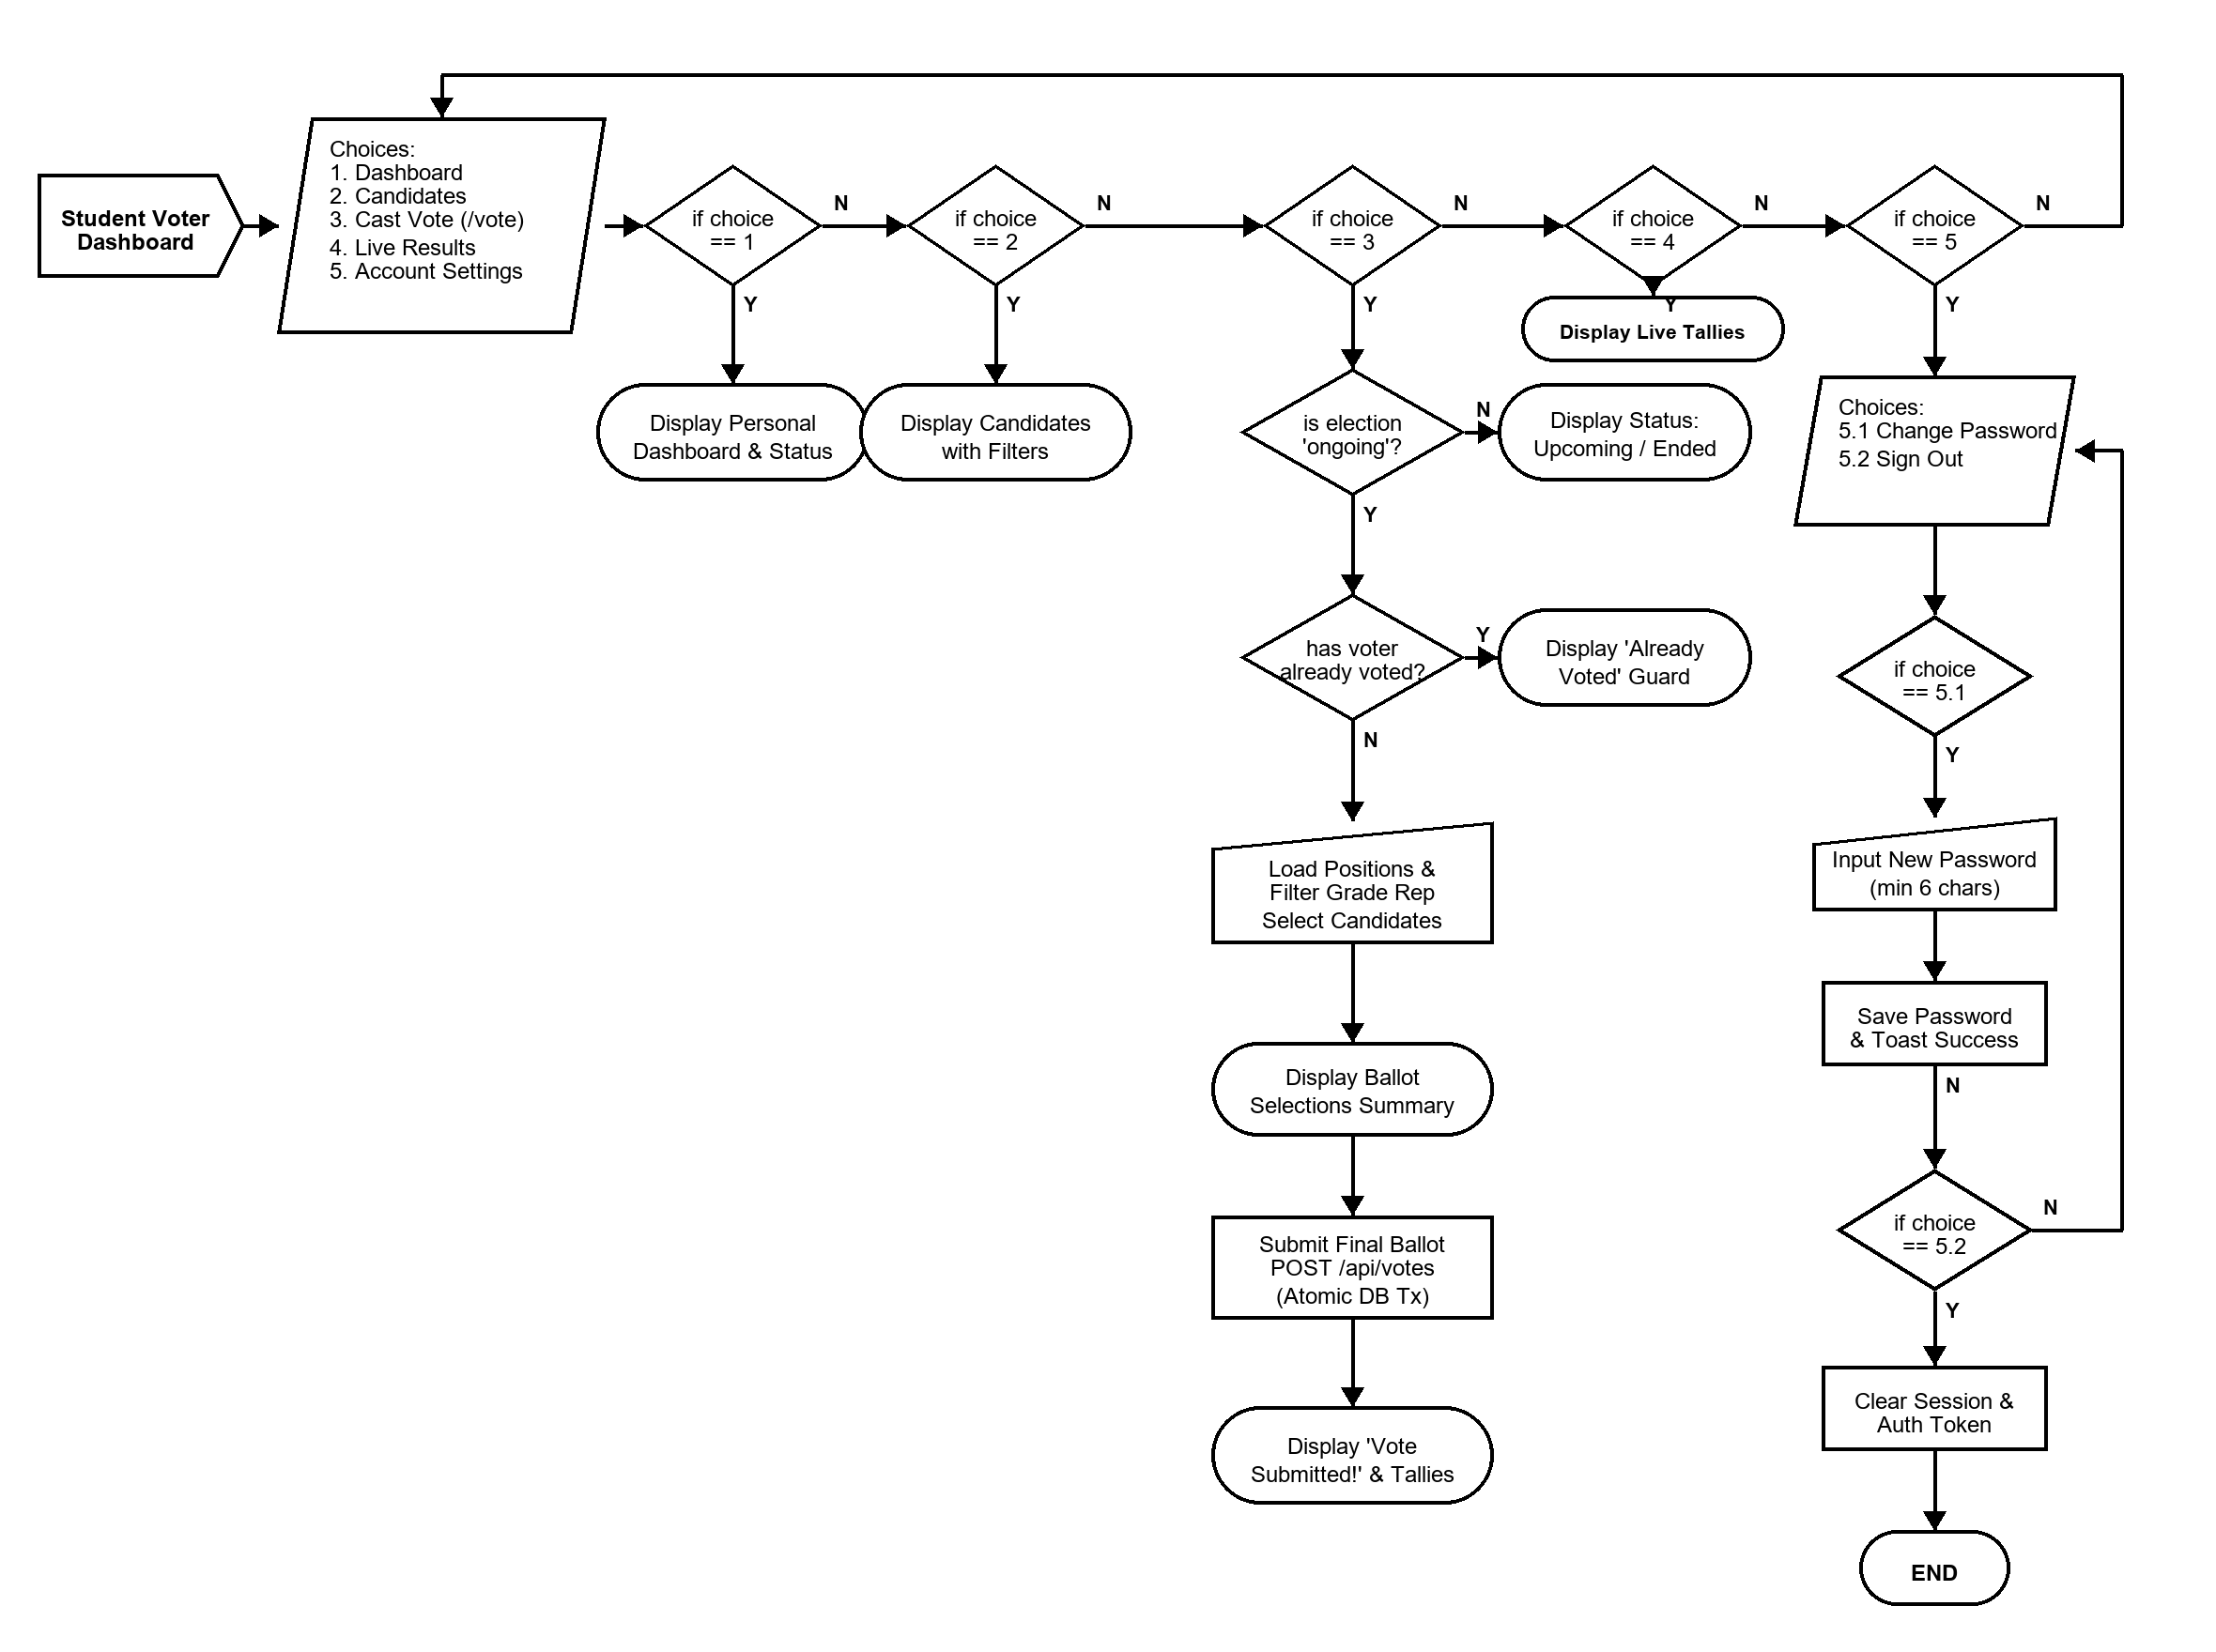
Figure 3. Student Voter Dashboard Flowchart
Figure 3 details the student voter's journey from landing on their dashboard to casting an immutable electronic ballot. The Voter Dashboard exposes choices 1 through 5:
- Choice 1 (Dashboard): Displays personalized voting status badge ('Voted' or 'Not Yet Voted') and election status countdown.
- Choice 2 (Candidates Directory): Allows exploring candidate platforms, party affiliations, and mottos.
- Choice 3 (Cast Vote /vote): Initiates the ballot casting engine with rigorous pre-conditions and validation.
- Choice 4 (Live Results): Provides voter access to real-time election statistics.
- Choice 5 (Account Settings): Sub-menu containing Choice 5.1 (Change Password) and Choice 5.2 (Sign Out with session invalidation).
Detailed Ballot Casting Validation Trappings (Choice 3):
• Election State Guard: Verifies that election_status == 'ongoing'. If 'upcoming' or 'completed', casting is blocked.
• Duplicate Vote Prevention: Checks if voter profile has_voted == true. If already voted, a security guard screen blocks further submission.
• Grade Representative Constraint: Candidates for grade-level representative positions (Grade 7, 8, 9, 10, 11, 12) are dynamically filtered so a student only sees and votes for candidates in their own grade level.
• Max Votes Enforcement: Each position enforces max_votes (e.g. 1 for President, 1 for Representative). Exceeding max_votes requires deselecting a prior candidate.
• Atomic Database Transaction: On submission, POST /api/votes begins an ACID database transaction that inserts records into votes, sets profiles.has_voted = true, and commits. The backend then broadcasts a WebSocket event to update all live screens.

5. System Administrator Dashboard & Navigation Hub
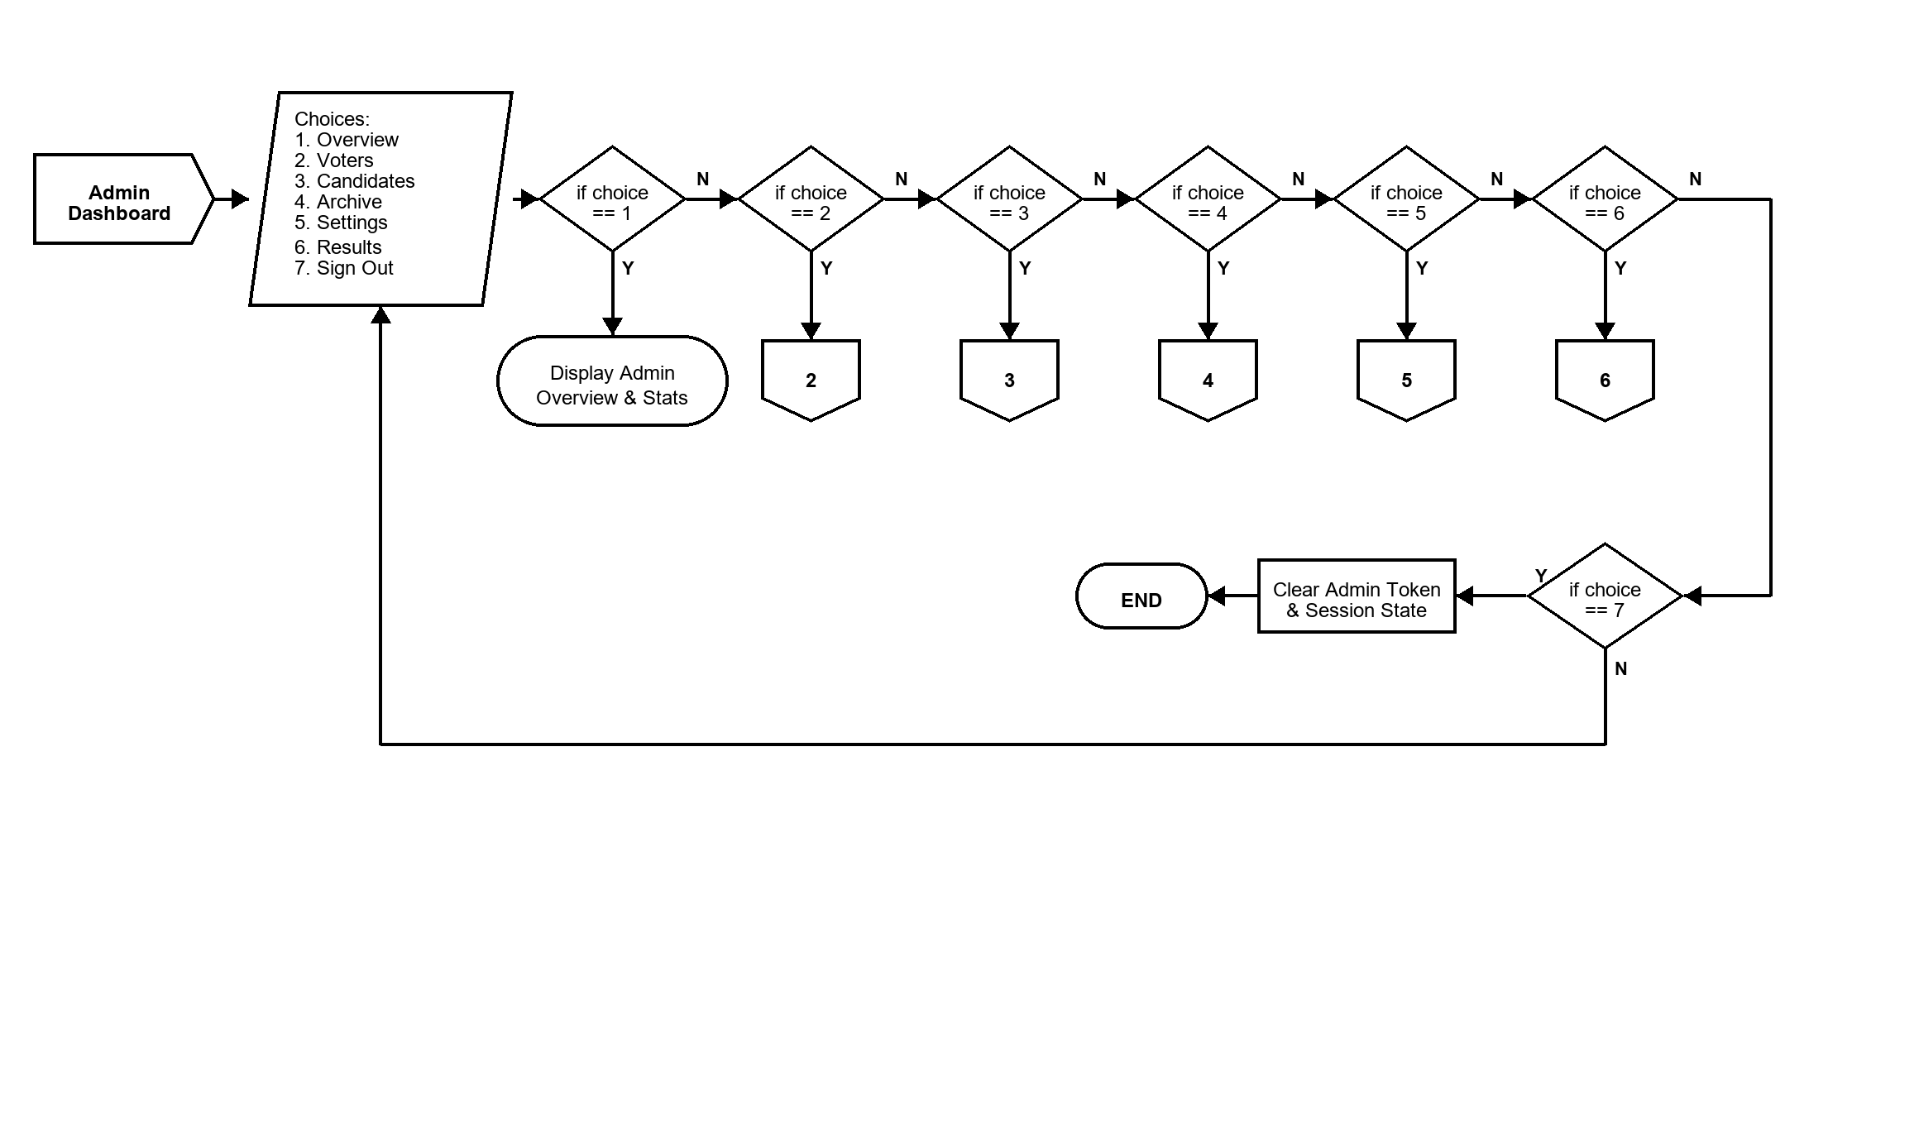
Figure 4. Admin Dashboard Flowchart
Figure 4 outlines the Master Admin Navigation Hub. Administrators authenticated with administrative role permissions gain access to centralized election governance tabs mapped directly to specialized sub-flowchart connectors:
- Choice 1 (Overview Tab): Renders high-level KPIs: Total Registered Voters, Total Votes Cast, Voter Turnout Percentage, and Active Candidates.
- Choice 2 (Voters Tab -> Connector 2): Directs to full Voter Management, single registration, CSV bulk upload, and password reset operations.
- Choice 3 (Candidates Tab -> Connector 3): Directs to Candidate Management, photo uploads, position assignments, and party list configuration.
- Choice 4 (Archive Tab -> Connector 4): Directs to Soft-Delete Archive Management for restoring or permanently deleting archived voters and candidates.
- Choice 5 (Settings Tab -> Connector 5): Directs to Election Lifecycle Control, scheduling, automated end crons, and historical snapshots.
- Choice 6 (Results Tab -> Connector 6): Directs to Real-time Results, multi-filter analytics drilldowns, and official printable tally sheets.
- Choice 7 (Sign Out): Prompts confirmation modal, destroys JWT token in browser storage, and terminates admin session (END).

6. Voters and Candidates Management Modules (Connectors 2 & 3)
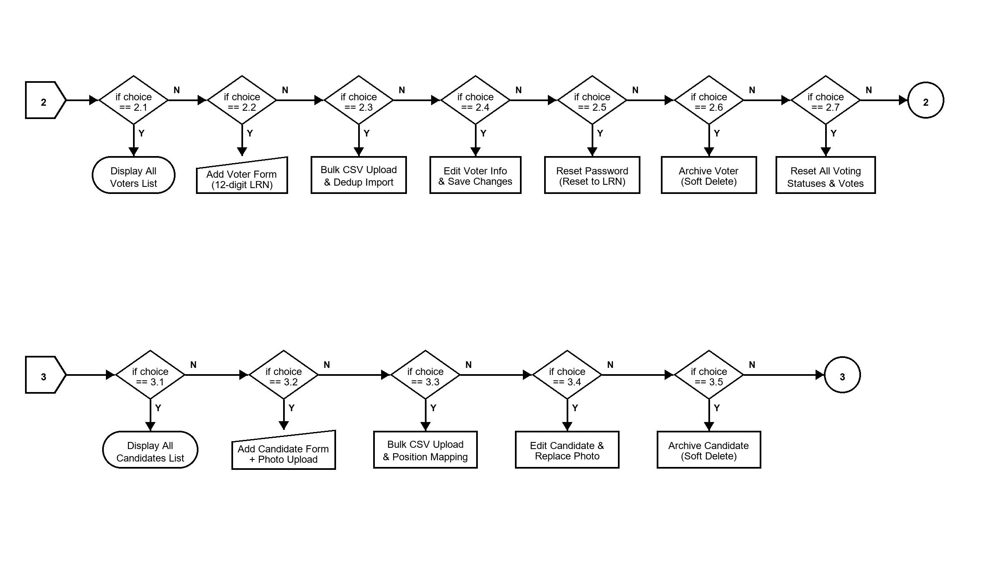
Figure 5. Voters and Candidates Management Flowchart
Figure 5 decomposes off-page Connectors 2 and 3 into detailed administrative sub-flows:
Part A: Connector 2 (Voters Management Operations):
• Choice 2.1: View and search voters table by LRN, full name, or section.
• Choice 2.2: Add single voter (validates 12-digit numeric LRN format; initializes password to LRN with must_change_password=true).
• Choice 2.3: Bulk upload voters via CSV/JSON (parses file, validates LRN format, checks for duplicates, renders preview modal, batch inserts).
• Choice 2.4: Edit voter details (name, grade level, section).
• Choice 2.5: Reset password (resets voter hash to LRN and sets must_change_password=true).
• Choice 2.6: Archive voter (performs soft-delete, archiving the record with archived_at timestamp).
• Choice 2.7: Reset all voting statuses (prompts safety modal, resets all has_voted flags to false, truncates votes table for new election).
Part B: Connector 3 (Candidates Management Operations):
• Choice 3.1: View candidates table filtered by position or party list.
• Choice 3.2: Add candidate with photo file upload (uploads to Supabase Storage / Multer backend; stores photo_url and metadata).
• Choice 3.3: Bulk upload candidates via CSV/JSON (maps position names, verifies grade requirements, batch inserts).
• Choice 3.4: Edit candidate details or replace campaign photo.
• Choice 3.5: Archive candidate (soft-delete, instantly removing candidate from student ballots while preserving audit trail).

7. Archive and Recovery Management Module (Connector 4)
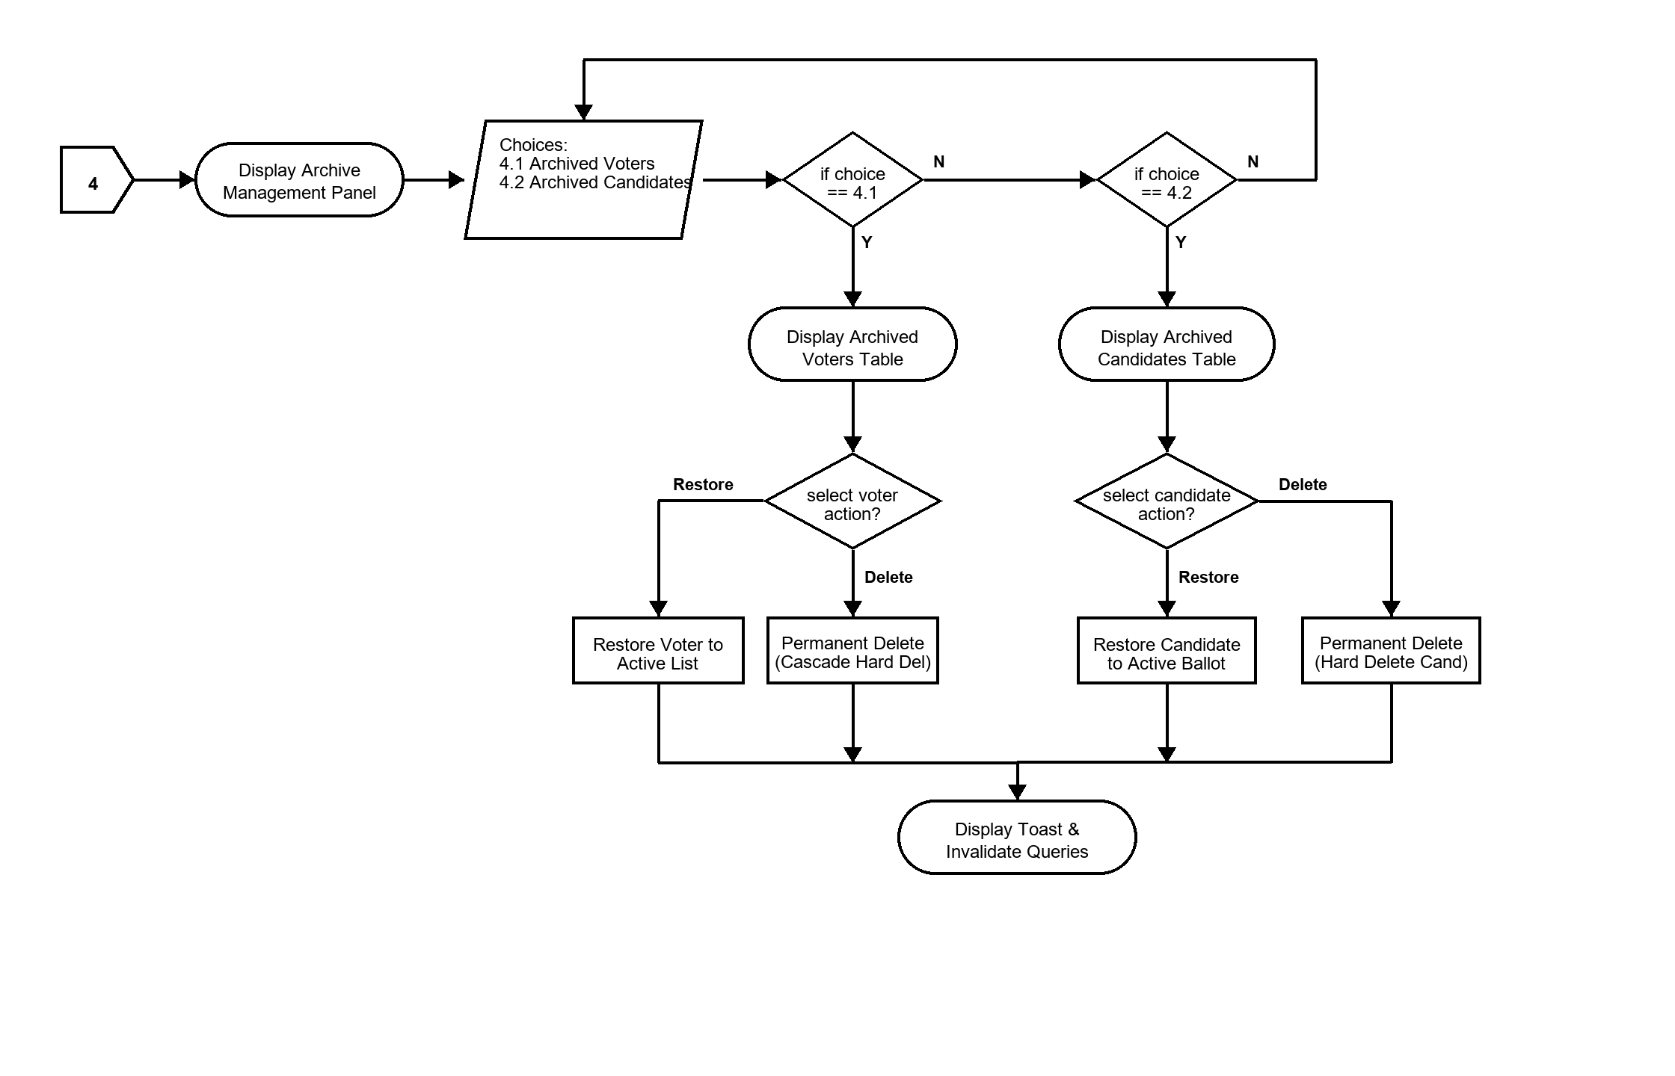
Figure 6. Archive and Recovery Management Flowchart
Figure 6 specifies the soft-delete safety architecture managed under off-page Connector 4. Accidental deletions in critical school election environments can disrupt ongoing tallies. The system segregates active and deleted entities into two sub-tabs:
- Choice 4.1 (Archived Voters Sub-tab): Displays list of soft-deleted voters. Admin can 'Restore' (resets archived=false, restoring voter to active roster) or 'Permanent Delete' (triggers hard SQL DELETE with foreign key cascade).
- Choice 4.2 (Archived Candidates Sub-tab): Displays archived candidates. Admin can 'Restore' (resumes candidacy on ballots) or 'Permanent Delete' (removes record permanently).

8. Election Settings, Schedule, and History Module (Connector 5)
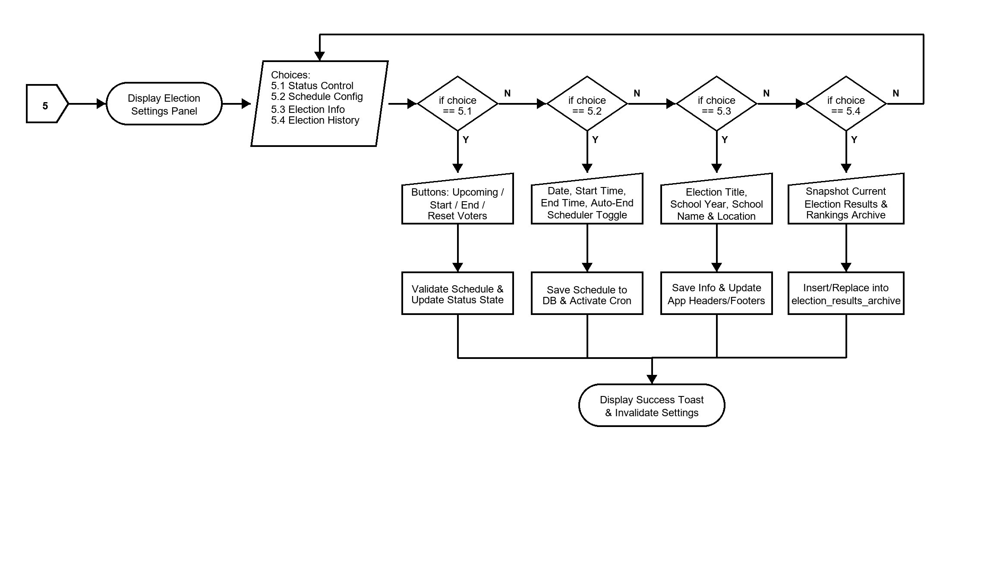
Figure 7. Election Settings, Schedule, and History Flowchart
Figure 7 details the election lifecycle state machine under off-page Connector 5, structured into four core functional areas:
• Choice 5.1 (Election Status Control): Controls live election states (Upcoming, Ongoing, Completed). Includes intelligent time trapping (e.g. prompt to extend end time if attempting to start after scheduled end).
• Choice 5.2 (Schedule Configuration): Sets Election Date, Start Time (e.g. 08:00 AM), End Time (e.g. 04:00 PM), and enables the automated background scheduler (periodic daemon checking every 10 seconds to auto-start and auto-end elections).
• Choice 5.3 (Election Info): Sets School Year (e.g. 2025-2026), Election Title (e.g. SSLG General Election 2026), and School Location for system-wide branding.
• Choice 5.4 (Election History Archive): Captures full result snapshots into election_results_archive with candidate ranks, vote tallies, and declared winners. Supports historical review and deletion of past records.

9. Election Results, Analytics, and Official Tally Module (Connector 6)
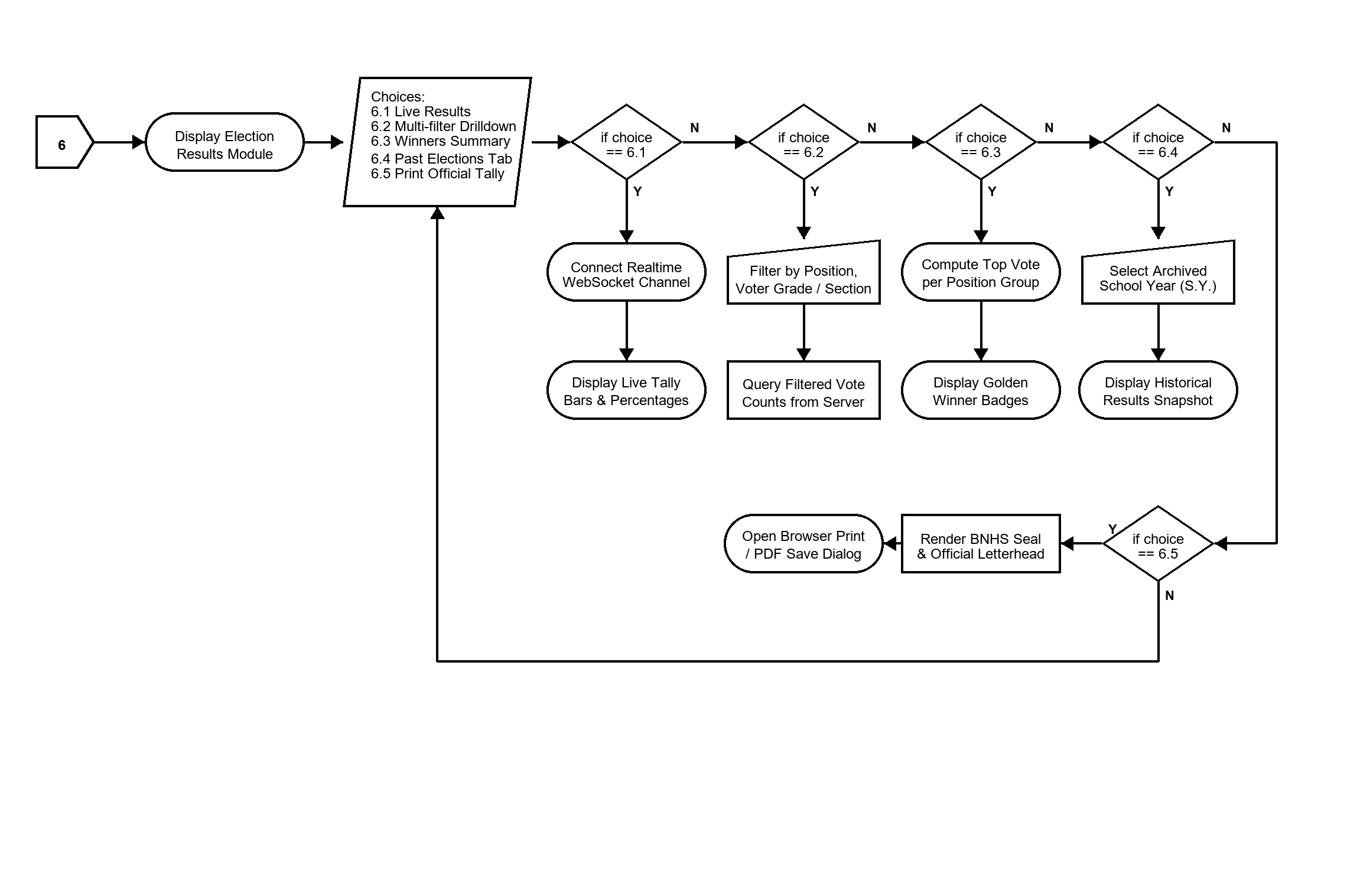
Figure 8. Election Results and Analytics Flowchart
Figure 8 outlines the election results visualization and official DepEd reporting engine under off-page Connector 6:
• Choice 6.1 (Live Results): Subscribes to Supabase Realtime WebSocket channel ('live-votes'), dynamically updating vote count progress bars and percentages as ballots are submitted across the campus.
• Choice 6.2 (Multi-Filter Drilldown): Allows administrators and election officers to filter results by Position, Voter Grade Level (Grades 7 to 12), and Section to analyze voter participation by class.
• Choice 6.3 (Winners Summary): Automatically identifies and highlights the candidate with the highest votes per position with official Golden Winner badges.
• Choice 6.4 (Past Elections Tab): Allows selecting past school years to retrieve immutable historical election outcomes.
• Choice 6.5 (Official Print Layout): Generates a printable DepEd-standard Results Tally Sheet complete with Batuan National High School seal, official letterhead, position breakdowns, and certification signature lines for COMELEC advisers and the School Principal.

10. Database Schema and API Endpoint Architecture Reference
To facilitate technical development, customization, and academic defense, the table below maps the core flowchart entities to their underlying database tables and REST API endpoints:
Flowchart Component | HTTP Route | Method | Underlying Database Table & Actions
Authentication Gate (Fig 2) | /api/auth/login | POST | users, profiles, user_roles (Validates bcrypt hash, issues JWT)
Change Password (Fig 2 & 3) | /api/auth/change-password | POST | users (Updates password_hash, clears must_change_password)
Ballot Submission (Fig 3) | /api/votes | POST | votes, profiles (Atomic transaction: inserts votes & sets has_voted=true)
Voters CRUD & Bulk (Fig 5) | /api/voters, /bulk-upload | GET/POST/PUT | users, profiles, user_roles (Manages student accounts & LRNs)
Candidates CRUD (Fig 5) | /api/candidates | GET/POST/PUT | candidates (Stores photo URLs, positions, party lists, mottos)
Archive & Restore (Fig 6) | /api/voters/:id/archive, /restore | PUT/DELETE | profiles, candidates (Toggles archived column or hard cascades)
Settings & Schedule (Fig 7) | /api/election-settings | GET/PUT | election_settings, election_results_archive (Status, timer, history)

11. Human Customization and Adaptation Guide
To ensure that this documentation and its diagrams are 100% customizable by human teachers, students, and thesis panelists, multiple editing pathways are provided:
1. Microsoft Word (.docx) Customization:
• All narrative text, decision tables, step numbers, and bullet points in this Word document are fully editable.
• You can modify position names (e.g. changing 'SSLG' to 'SPG' or 'Supreme Student Council'), grade levels, and school years directly in this document.
2. Diagram Editing via Draw.io (diagrams.net):
• The companion file 'Batuan_Voting_Flowcharts.drawio' can be opened directly in any web browser at https://app.diagrams.net or using the Draw.io Desktop app.
• You can drag, drop, recolor, add new decision diamonds, or alter text on any shape across all 7 figures.
• Once edited, export the updated diagram to PNG or PDF and replace the figure in this document.
3. Programmatic Generation (Python Scripts):
• The python scripts in 'c:\batuan-voting\flowchart_build\' can be re-run at any time to regenerate ultra-high-resolution (300 DPI) diagrams automatically with custom dimensions or styles.

