SIM卡号加载流程

1. com.android.internal.telephony.RadioIndication#simStatusChanged(Modem上报)
2. com.android.internal.telephony.uicc.UiccController#handleMessage(EVENT_ICC_STATUS_CHANGED)
3. com.android.internal.telephony.RIL#getIccCardStatus
4. com.android.internal.telephony.uicc.UiccController#handleMessage(EVENT_GET_ICC_STATUS_DONE)
5. com.android.internal.telephony.uicc.UiccController#onGetIccCardStatusDone
6. com.android.internal.telephony.uicc.UiccSlot#update(com.android.internal.telephony.CommandsInterface, com.android.internal.telephony.uicc.IccCardStatus, int, int)
7. com.android.internal.telephony.uicc.UiccCard#update
8. com.android.internal.telephony.uicc.UiccProfile#update
9. com.android.internal.telephony.uicc.UiccCardApplication#update
10. com.android.internal.telephony.uicc.UiccCardApplication#notifyReadyRegistrantsIfNeeded
11. com.android.internal.telephony.uicc.IccRecords#IccRecords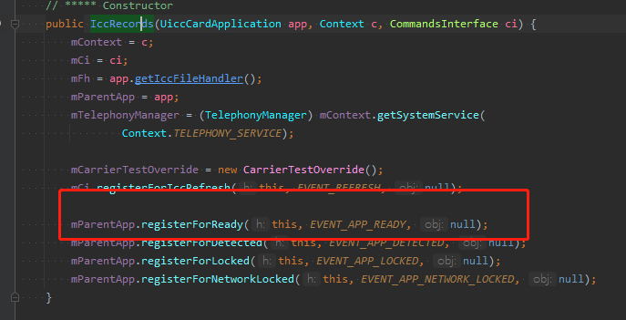
12. com.android.internal.telephony.uicc.IccRecords#handleMessage(EVENT_APP_READY)
13. com.android.internal.telephony.uicc.SIMRecords#onReady
14. com.android.internal.telephony.uicc.SIMRecords#fetchSimRecords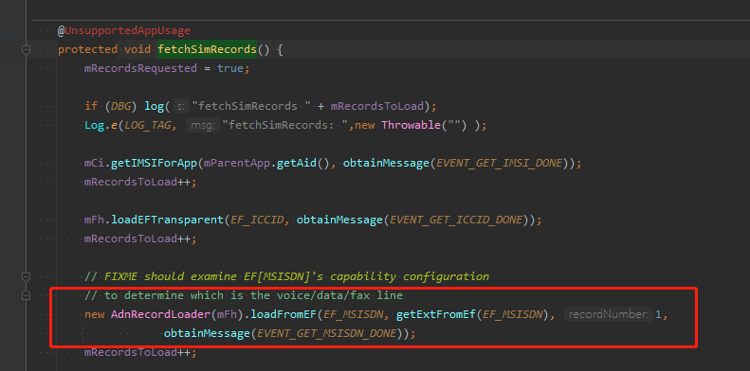
15. com.android.internal.telephony.uicc.AdnRecordLoader#loadFromEF
16. com.android.internal.telephony.uicc.IccFileHandler#loadEFLinearFixed(int, java.lang.String, int, android.os.Message) 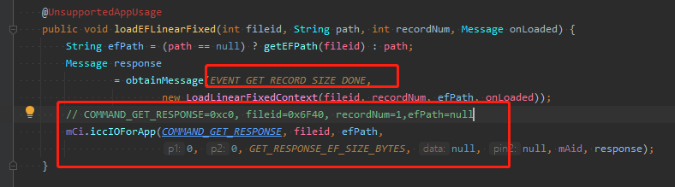
17. com.android.internal.telephony.RIL#iccIOForApp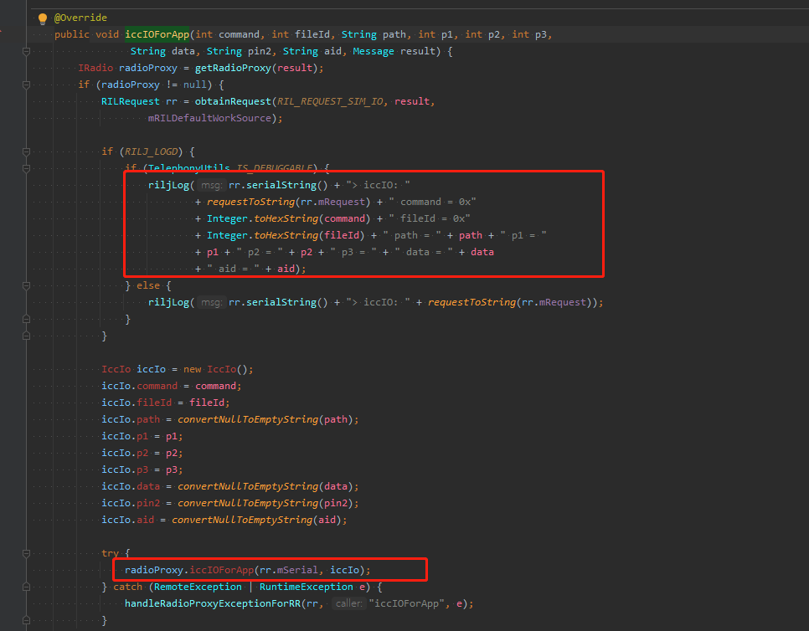
18. com.android.internal.telephony.RadioResponse#iccIOForAppResponse(Modem上报)
19. com.android.internal.telephony.uicc.IccFileHandler#handleMessage(EVENT_GET_RECORD_SIZE_DONE) 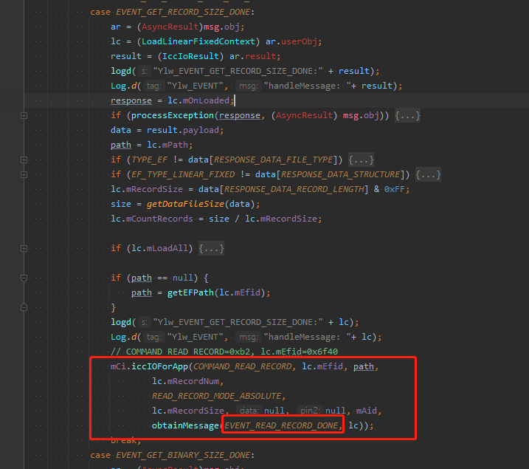
20. com.android.internal.telephony.uicc.IccFileHandler#handleMessage(EVENT_READ_RECORD_DONE) 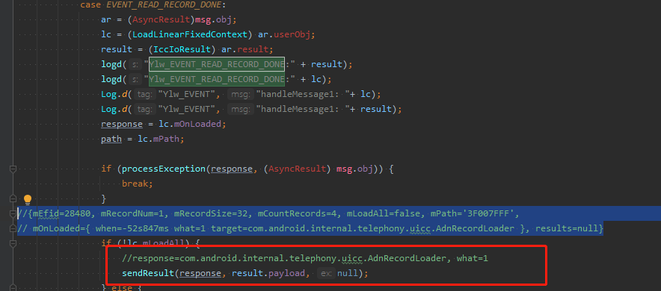
21. com.android.internal.telephony.uicc.AdnRecordLoader#handleMessage(EVENT_ADN_LOAD_DONE) 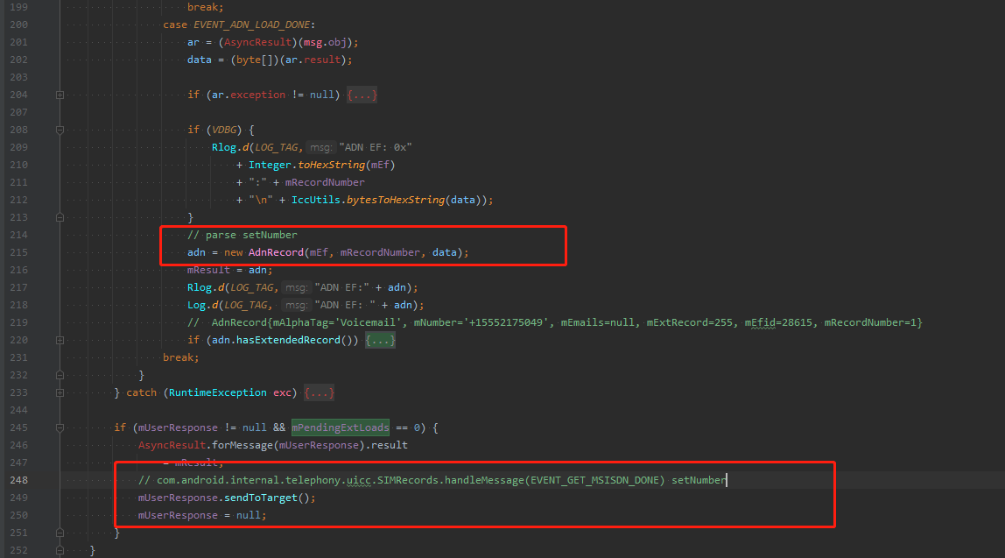
22. com.android.internal.telephony.uicc.AdnRecord#AdnRecord(int, int, byte[])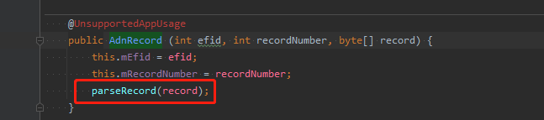
23. com.android.internal.telephony.uicc.AdnRecord#parseRecord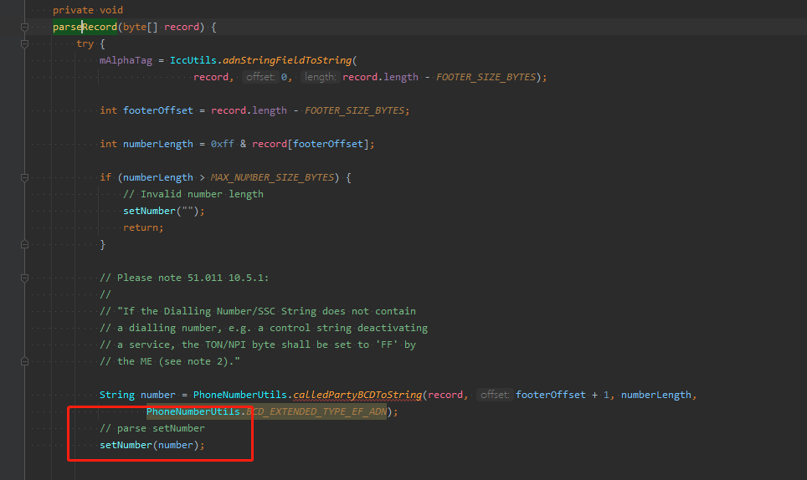
24. com.android.internal.telephony.uicc.SIMRecords#handleMessage(EVENT_GET_MSISDN_DONE) 