# DataCall

### APN

1. APN ( Access Point Name ) 是 Android 手机实现移动数据上网业务必须配置的参数,用来决定手机通过哪种接入方式来访问网络 ,其配置信息全部记录在 telephony. db的 SQLite 数据库中名为carriers 的表中.

### DataConnection

1. DataConnection (数据连接) 类在 Telephony 业务模型中管理移动数据业务,一个 DataConnection对象代表手机移动数据业务的一个数据连接。
2. 定义DcDefaultState 、DcInactiveState 、 DcActivatingState 、 DcActiveState 、DcDisconnectingState 和DcDisconnectionErrorCreatingConnection 共六个私有内部类

### 关闭数据业务

1. android.telephony.TelephonyManager#setDataEnabled
2. android.telephony.TelephonyManager#setDataEnabledForReason
3. com.android.phone.PhoneInterfaceManager#setDataEnabledForReason
4. com.android.internal.telephony.dataconnection.DataEnabledSettings#setDataEnabled
5. com.android.internal.telephony.dataconnection.DataEnabledSettings#setUserDataEnabled
6. com.android.internal.telephony.dataconnection.DataEnabledSettings#updateDataEnabledAndNotify
7. com.android.internal.telephony.dataconnection.DataEnabledSettings#notifyDataEnabledChanged
8. com.android.internal.telephony.dataconnection.DcTracker#handleMessage(DctConstants.EVENT_DATA_ENABLED_CHANGED)
9. com.android.internal.telephony.dataconnection.DcTracker#onDataEnabledChanged
10. com.android.internal.telephony.dataconnection.DcTracker#cleanUpAllConnectionsInternal
11. com.android.internal.telephony.dataconnection.DcTracker#cleanUpConnectionInternal
12. com.android.internal.telephony.dataconnection.DataConnection#tearDown
13. com.android.internal.telephony.dataconnection.DataConnection#tearDownData
14. com.android.internal.telephony.dataconnection.DataServiceManager#deactivateDataCall
15. android.telephony.data.DataService.IDataServiceWrapper#deactivateDataCall
16. android.telephony.data.DataService.DataServiceHandler#handleMessage(DATA_SERVICE_REQUEST_DEACTIVATE_DATA_CALL)
17. com.android.internal.telephony.dataconnection.CellularDataService.CellularDataServiceProvider#deactivateDataCall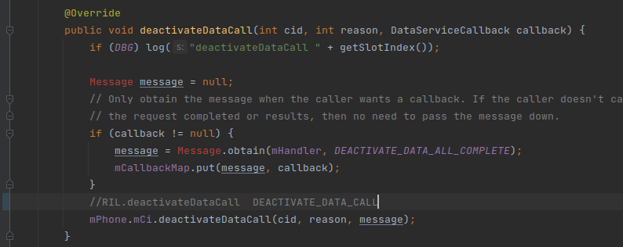

### 开启数据业务

1. android.telephony.TelephonyManager#setDataEnabled
2. android.telephony.TelephonyManager#setDataEnabledForReason
3. com.android.phone.PhoneInterfaceManager#setDataEnabledForReason
4. com.android.internal.telephony.dataconnection.DataEnabledSettings#setDataEnabled
5. com.android.internal.telephony.dataconnection.DataEnabledSettings#setUserDataEnabled
6. com.android.internal.telephony.dataconnection.DataEnabledSettings#updateDataEnabledAndNotify
7. com.android.internal.telephony.dataconnection.DataEnabledSettings#notifyDataEnabledChanged
8. com.android.internal.telephony.dataconnection.DcTracker#handleMessage(DctConstants.EVENT_DATA_ENABLED_CHANGED)
9. com.android.internal.telephony.dataconnection.DcTracker#onDataEnabledChanged
10. com.android.internal.telephony.dataconnection.DcTracker#setupDataOnAllConnectableApns
11. com.android.internal.telephony.dataconnection.DcTracker#setupDataOnConnectableApn