### 信号上报到显示

1. com.android.internal.telephony.RadioIndication#currentSignalStrength_1_4
2. com.android.internal.telephony.ServiceStateTracker#handleMessage(EVENT_SIGNAL_STRENGTH_UPDATE)
3. com.android.internal.telephony.ServiceStateTracker#onSignalStrengthResult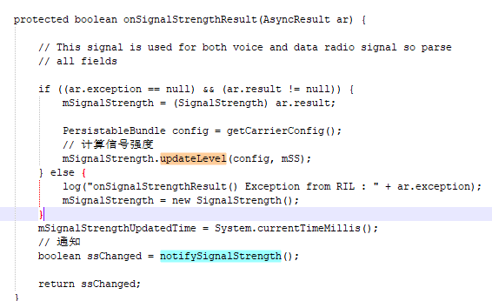
4. com.android.internal.telephony.ServiceStateTracker#notifySignalStrength
5. com.android.internal.telephony.Phone#notifySignalStrength
6. com.android.internal.telephony.DefaultPhoneNotifier#notifySignalStrength
7. android.telephony.TelephonyRegistryManager#notifySignalStrengthChanged