
Marmara University
Faculty of Engineering
CSE2025
DATA STRUCTURES

Term Project #2

Instructure: Borahan Tümer Date: 7.01.2022

Student Number:150119035
Name Surname: Batuhan Baştürk

When I tried to build an algorithm for the project for the first time, I noticed that the tree looks like an avl tree, but its maximum depth is according to the floor 3log4n formula. And in order to think and try the algorithm of this tree in more detail, I went to a site where I could do avl tree visualization and tried the inputs. When I entered the inputs as given, I realized that it did not look like a tree that what i’m looking for, so I wondered how the avl tree would be shaped when I entered from descending order or ascending order. And i saw that when i take inputs in descending order it looks similar to what i want.
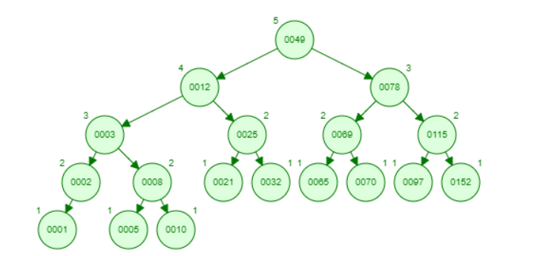
Before i insert 1 i noticed that tree would look exactly same if i insert 1 as a BST.

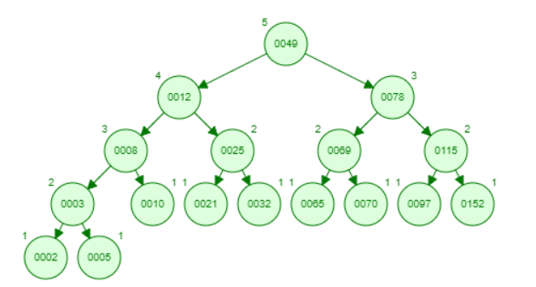
I discovered while entry input count is larger or equal than and smaller than or equal to . Until minus i will insert as AVL tree.Afterwards i need to insert remaining element as a BST.

For example: When entry input is 17
so i need to use 15 node for avl tree to make balanced after that i need to complete my depth level to 6.Currently I'm at 4th depth level.I insert remaining inputs as BST.
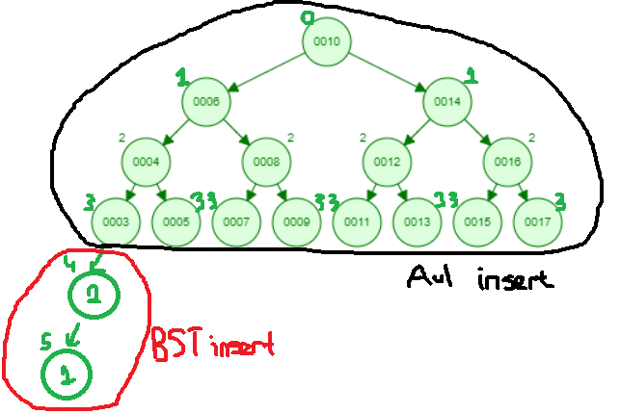
These input counts are special cases or minority input counts.
These cases are: (16 17) (64 65 66) (256 257 258 259) ...

Else part is if my node count is not in the range of upward algorithm than, that means that i inserted a node and my depth level is + 1 than before.
For example my node count is 18 in current input i can create balanced avl tree with 15 full of depth level 4.And 16th node is already in 5th depth level that means that it is enough to insert element as a BST and as an AVL tree.
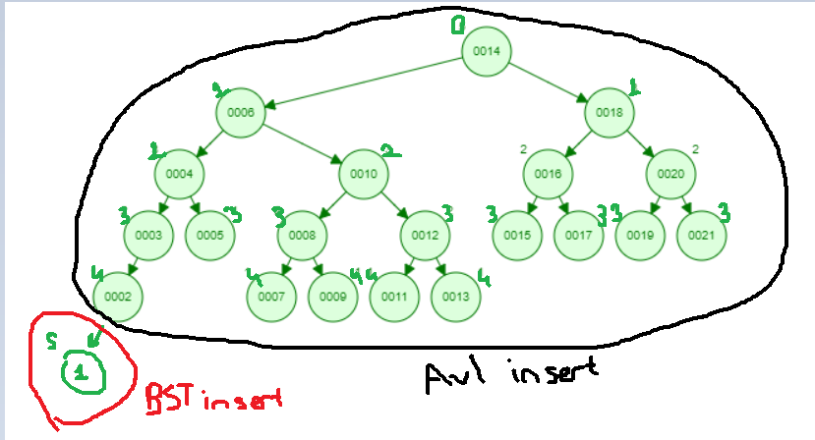

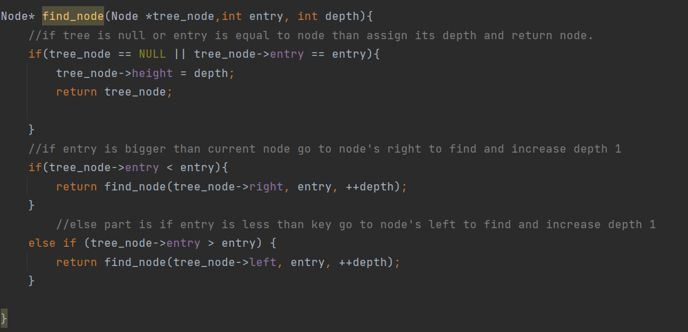
To find the depth of the point I'm looking for in the tree i need to check if my number is less than or larger than the other nodes starting from root if my tree is not null or i already find i assign depth to nodes height and return it otherwise while checking i pre increment depth by 1 and recurse the function until i node’s key is equal to key that i’m looking for.
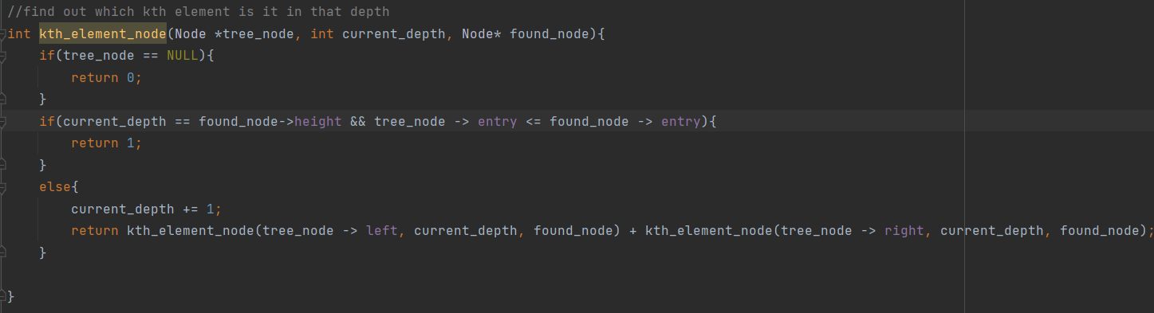
To find which kth element is in that depth i need to access nodes with the same depth level. If my node’s height is equal to depth and founded nodes value is less or equal than the key i’m looking for i return 1 as a meaning of it is 1 of the elements in that depth level. Else part is if i couldnt find the node in that depth i increase depth by 1 and recur the function look for left of node and right of node and i add up recursive functions.
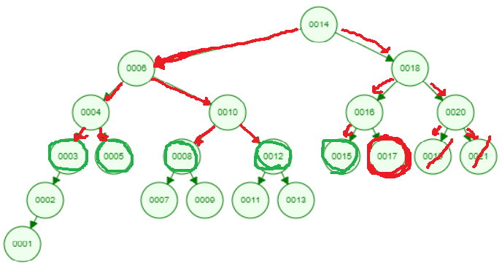
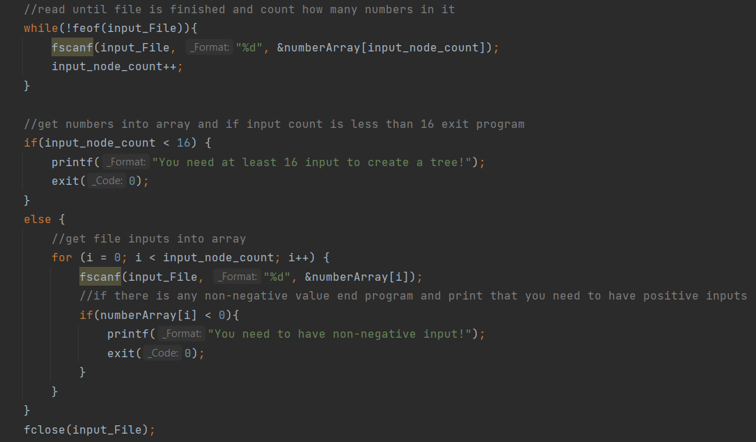
Scan numbers until end of file and get input node count if BST has less than 16 input node print info than exit program else get node values into array.If i have negative values print info that i cant have negative values than exit program.
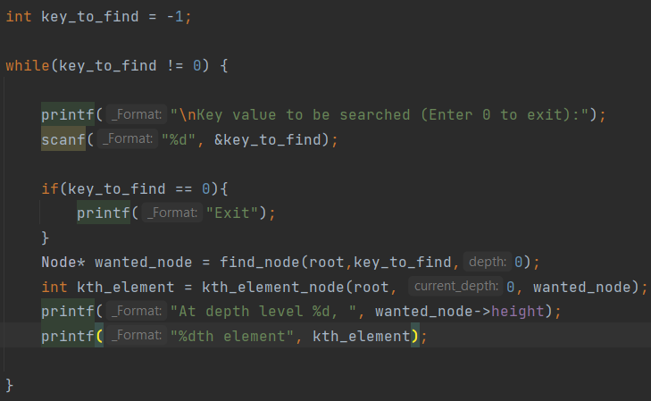
Until i enter 0 i need to get input from user for searching node which we want to know its location.Usage of functions that i created to find my key.

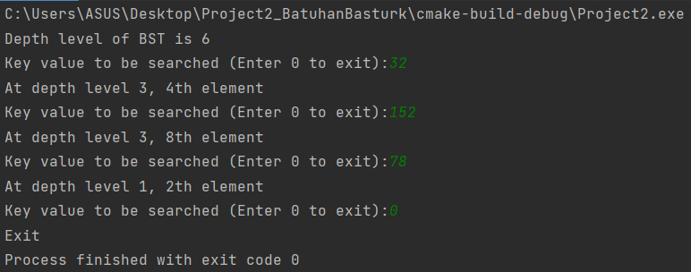
Compile works correctly.

My shortcomings, when the tree can't find it, it exits directly from the program and I couldn't print how many nodes are in each depth level.

REFERANCES:
https://www.geeksforgeeks.org/avl-tree-set-1-insertion/
Special Trees and Trees Lecture pdf’s.

