# 1. GIRIS

## 1.1. Çözülen problem ve önemi ile ilgili bir paragraf açıklama

## 1.2. Problemin cozumu surecinde veri ve analiz hakkinda aciklama

Forbes tarafindan yayinlanan ve gunluk olarak guncellenen veri seti, her bir milyarderin guncel net degerini, siralamasini, servetinin bilesenlerini, bazi demografik bilgilerini ve diger finansal bilgileri icermektedir. Veri setinin ana amaclarindan biri, dünyanın en zengin milyarderlerinin belgelenmis net degerini yillik olarak siralamaktir.

Bu odev kapsaminda milyarderlerin dagilimlari farkli endustriler, ulkeler ve bolgelere gore incelenecektir. Milyarderlerin yas, cinsiyet ve dogum yerlerinin dagılimlari incelenecektir. Milyarderlerin icindeki kendi kendine milyarder olanlarin (self made) ve servetini miras alanlarin oranlari karsilastirilacaktir. Milyarderlerin yasadigi ulkelerin GDP, TÜFE gibi ekonomik gostergeleri incelenecek, bu gostergeler arasindaki iliskiler analiz edilecektir. “Mekansal analiz” ile, milyarderlerin dunya genelinde cografi dagilimi grafikler ile ozetlenecektir.

# 2. GEREKLI PAKETLER

library(ggplot2) # grafiklerin ciziminde kullanildi  
library(stats) # t.test, prop.test gibi istatistiksel testlerin ve islemlerin uygulanmasinda kullanildi

# VERININ YUKLENMESI

Verinin cvs dosyasindan yuklenmesi:

data <- read.csv("C:/Users/Desktop/Billionaires.csv", header = TRUE)  
dim(data)

## [1] 2640 35

Veri seti 35 degisken ve 2640 gozlemden olusmaktadir.

Eklenen veri kumesinden rastgele 1000 kisi secimi:

set.seed(42)  
df <- data[sample(x = nrow(data), size = 1000, replace = FALSE), ]  
dim(df)

## [1] 1000 35

Veri setinden yerine koymadan rasgele n = 1000 gozlemlik orneklem cekilmistir, df olarak adlandirilmistir.

# 3. VERI HAZIRLAMA

## 3.1. Veriyi açıklayınız. Değişken sayısı, gözlem sayısı, değişkenlerin yapısı hakkında bilgiler veriniz.

Toplam eksik gozlem sayisi:

sum(is.na(df))

## [1] 796

Degiskenlerin tipi, eksik gozlem sayisi ve benzersiz gozlem sayilari:

# class(df$rank) # "integer"  
# class(df["rank"]) # "data.frame"  
# class(df[ ,"rank"]) # "integer"  
  
  
# unique(df$rank)  
# unique(df[, "rank"])  
# length(unique(df[, "rank"])) # 146  
  
for (j in colnames(df)){  
 cat(match(j, colnames(df)), j, "-->", class(df[ ,j]),   
 "(","missing =", sum(is.na(df[j])),  
 "/", "unique =", length(unique(df[, j])), ")", "\n")  
}

## 1 rank --> integer ( missing = 0 / unique = 146 )   
## 2 finalWorth --> integer ( missing = 0 / unique = 146 )   
## 3 category --> character ( missing = 0 / unique = 18 )   
## 4 personName --> character ( missing = 0 / unique = 1000 )   
## 5 age --> integer ( missing = 23 / unique = 75 )   
## 6 country --> character ( missing = 0 / unique = 63 )   
## 7 city --> character ( missing = 0 / unique = 399 )   
## 8 source --> character ( missing = 0 / unique = 464 )   
## 9 industries --> character ( missing = 0 / unique = 18 )   
## 10 countryOfCitizenship --> character ( missing = 0 / unique = 62 )   
## 11 organization --> character ( missing = 0 / unique = 135 )   
## 12 selfMade --> logical ( missing = 0 / unique = 2 )   
## 13 status --> character ( missing = 0 / unique = 6 )   
## 14 gender --> character ( missing = 0 / unique = 2 )   
## 15 birthDate --> character ( missing = 0 / unique = 849 )   
## 16 lastName --> character ( missing = 0 / unique = 763 )   
## 17 firstName --> character ( missing = 0 / unique = 763 )   
## 18 title --> character ( missing = 0 / unique = 57 )   
## 19 date --> character ( missing = 0 / unique = 1 )   
## 20 state --> character ( missing = 0 / unique = 37 )   
## 21 residenceStateRegion --> character ( missing = 0 / unique = 6 )   
## 22 birthYear --> integer ( missing = 28 / unique = 73 )   
## 23 birthMonth --> integer ( missing = 28 / unique = 13 )   
## 24 birthDay --> integer ( missing = 28 / unique = 32 )   
## 25 cpi_country --> numeric ( missing = 71 / unique = 55 )   
## 26 cpi_change_country --> numeric ( missing = 71 / unique = 43 )   
## 27 gdp_country --> character ( missing = 0 / unique = 56 )   
## 28 gross_tertiary_education_enrollment --> numeric ( missing = 71 / unique = 54 )   
## 29 gross_primary_education_enrollment_country --> numeric ( missing = 71 / unique = 52 )   
## 30 life_expectancy_country --> numeric ( missing = 71 / unique = 48 )   
## 31 tax_revenue_country_country --> numeric ( missing = 71 / unique = 49 )   
## 32 total_tax_rate_country --> numeric ( missing = 71 / unique = 54 )   
## 33 population_country --> integer ( missing = 64 / unique = 56 )   
## 34 latitude_country --> numeric ( missing = 64 / unique = 56 )   
## 35 longitude_country --> numeric ( missing = 64 / unique = 56 )

Bu listede “12 selfMade –> logical ( missing = 0 / unique = 2 )” satirini acarsak, selfMade degiskeni veri setinin 12. sutunudur, tipi logical’dır, eksik gozlemi yoktur, degisken 2 farkli deger almaktadir. Burada unique degerler, degiskenin aldigi farkli degerlerin sayisidir. Örneğin selfMade degiskeni dogru/yanlis olmak uzere 2 farkli deger alabilmektedir (unique = 2). Kategorik degiskenler incelenirken, degiskenin kac farklı kategorisi oldugu bilgisi gerekli olacak.

## 3.2. Veri yukleme ve duzenlemesi konusunda bilgi veriniz.

## 3.3. Verideki tum degiskenleri ozetleyip, yorumlayiniz.

### Degiskenlerin incelenmesi

rank, finalWorth, person name, lastName, firstName –> c(1, 2, 4, 16, 17)

df[1:10, c(1, 2, 4, 16, 17)]

## rank finalWorth personName lastName firstName  
## 2609 2540 1000 Tyler Perry Perry Tyler  
## 2369 2259 1200 Luc Tack Tack Luc  
## 1177 1164 2600 Maria Del Pino Del Pino Maria  
## 1098 1067 2800 Tseng Cheng Tseng Cheng  
## 1252 1217 2500 Bobby Murphy Murphy Bobby  
## 634 624 4400 Qian Dongqi & family Qian Dongqi  
## 2097 2020 1400 Boris Rotenberg Rotenberg Boris  
## 1152 1104 2700 Raj Sardana Sardana Raj  
## 1327 1312 2300 Erman Ilicak Ilicak Erman  
## 2072 2020 1400 Liu Ming Chung Liu Ming Chung

Verideki “personName” degiskeni, lastName ve firstName degiskenlerinin birlesimi.

country(unique = 63), city(unique = 399), countryOfCitizenship(unique = 62), state(unique = 37), residenceStateRegion(unique = 6) –> c(6, 7, 10, 20, 21)

df[1:6, c(6, 7, 20, 21, 10)]

## country city state residenceStateRegion countryOfCitizenship  
## 2609 United States Atlanta Georgia South United States  
## 2369 Belgium Deinze Belgium  
## 1177 Spain Madrid Spain  
## 1098 Taiwan Taiwan  
## 1252 United States Venice California West United States  
## 634 China Suzhou China

country, city, state, residenceStateRegion degiskenleri milyonerlerin **ikamet** ettigi yerlesim bolgelerine ait verilerdir.

countryOfCitizenship ise **vatandasi** oldugu ulkedir.

Yukaridaki tabloda city, state, residenceStateRegion degiskenlerinde eksik gozlemler var. Verinin ilk 21 degiskeni character tipinde degiskenler. Bu tipdeki degiskenlerin hepsinde eksik gozlem sayisi 0 gorunuyor. Numerik degiskenlerde ise eksik gozlemler var:

for (j in colnames(df)){  
 cat(match(j, colnames(df)), j, "-->", class(df[ ,j]),   
 "(","missing =", sum(is.na(df[j])), ")", "\n")  
}

## 1 rank --> integer ( missing = 0 )   
## 2 finalWorth --> integer ( missing = 0 )   
## 3 category --> character ( missing = 0 )   
## 4 personName --> character ( missing = 0 )   
## 5 age --> integer ( missing = 23 )   
## 6 country --> character ( missing = 0 )   
## 7 city --> character ( missing = 0 )   
## 8 source --> character ( missing = 0 )   
## 9 industries --> character ( missing = 0 )   
## 10 countryOfCitizenship --> character ( missing = 0 )   
## 11 organization --> character ( missing = 0 )   
## 12 selfMade --> logical ( missing = 0 )   
## 13 status --> character ( missing = 0 )   
## 14 gender --> character ( missing = 0 )   
## 15 birthDate --> character ( missing = 0 )   
## 16 lastName --> character ( missing = 0 )   
## 17 firstName --> character ( missing = 0 )   
## 18 title --> character ( missing = 0 )   
## 19 date --> character ( missing = 0 )   
## 20 state --> character ( missing = 0 )   
## 21 residenceStateRegion --> character ( missing = 0 )   
## 22 birthYear --> integer ( missing = 28 )   
## 23 birthMonth --> integer ( missing = 28 )   
## 24 birthDay --> integer ( missing = 28 )   
## 25 cpi_country --> numeric ( missing = 71 )   
## 26 cpi_change_country --> numeric ( missing = 71 )   
## 27 gdp_country --> character ( missing = 0 )   
## 28 gross_tertiary_education_enrollment --> numeric ( missing = 71 )   
## 29 gross_primary_education_enrollment_country --> numeric ( missing = 71 )   
## 30 life_expectancy_country --> numeric ( missing = 71 )   
## 31 tax_revenue_country_country --> numeric ( missing = 71 )   
## 32 total_tax_rate_country --> numeric ( missing = 71 )   
## 33 population_country --> integer ( missing = 64 )   
## 34 latitude_country --> numeric ( missing = 64 )   
## 35 longitude_country --> numeric ( missing = 64 )

Bu degiskenlerdeki eksik gozlemler tekrar incelenmeli.

state degiskenin eksik gozlemlerinin incelenmesi:

table(df$state, useNA = "always")

##   
## Arizona California Colorado   
## 699 2 74 4   
## Connecticut Florida Georgia Idaho   
## 7 41 11 1   
## Illinois Indiana Iowa Kansas   
## 10 1 1 2   
## Louisiana Maryland Massachusetts Mississippi   
## 1 3 8 1   
## Missouri Montana Nebraska Nevada   
## 3 3 2 8   
## New Hampshire New Jersey New York North Carolina   
## 1 1 54 1   
## Ohio Oklahoma Oregon Pennsylvania   
## 1 1 3 9   
## South Carolina Tennessee Texas U.S. Virgin Islands   
## 1 4 25 1   
## Utah Virginia Washington Wisconsin   
## 2 3 5 5   
## Wyoming <NA>   
## 1 0

state sutununda 699 gozlem bos. R bu eksik gozlemleri kategorik degiskenin bir sinifi olarak algiliyor. Eksik gozlemlere NA atanmali.

table() fonksiyonunda eksik veriler için belirtilebilecek 3 arguman vardir: “always”, “ifany”, “no”

sirasiyla: eksik gozlem sayisini her zaman yaz (eksik gozlem olmadiginda 0 yazar), eksik gozlem varsa yaz, eksik gozlem sayisini asla yazma

Eksik gozlemlere NA atanmasi:

eger/ifelse (state degiskenin degeri bos (df$state == "") ise, yerine NA ata, degilse kendi degerini (df$state) ata)

df$state <- ifelse(df$state == "", NA, df$state)

sum(is.na(df$state))

## [1] 699

Ilk 21 sutunun buyuk cogunlugu “chr” tipinde. 1 rank, 2 finalWorth, 5 age ve 12 selfMade sutunlari haric hepsi character tipi sutun.

1. sutun olan “age” degiskeni integer. Bu degiskendeki eksik gozlemler dogru formatta. bos olan gozlem yok:

table(df$age, useNA = "always")

##   
## 21 27 28 29 30 31 33 34 35 36 37 38 39 40 41 42   
## 1 1 1 1 2 1 1 2 3 4 4 4 4 5 10 3   
## 43 44 45 46 47 48 49 50 51 52 53 54 55 56 57 58   
## 8 3 8 12 6 9 17 12 12 26 29 21 25 22 36 24   
## 59 60 61 62 63 64 65 66 67 68 69 70 71 72 73 74   
## 29 32 40 23 22 22 28 34 36 18 24 25 21 24 30 20   
## 75 76 77 78 79 80 81 82 83 84 85 86 87 88 89 90   
## 19 22 24 20 15 15 16 10 12 6 13 7 13 6 3 5   
## 91 92 93 94 95 96 97 98 99 101 <NA>   
## 4 5 2 4 3 1 3 2 1 1 23

Veride 12. sutun olan “selfMade” degiskeni ise logical. Bu degiskenin de ayri olarak incelenmesine karar verildi. Bu degiskende de bos gozlem yok:

table(df$selfMade, useNA = "always")

##   
## FALSE TRUE <NA>   
## 273 727 0

Verinin ilk 21 sutunu icinde, 1, 2, 5 ve 12. sutunlar haric, tum sutunlar character tipinde.

apply() fonksiyonu yardimi ile character tipindeki sutunlarin eksik gozlemlerine NA atanmasi:

my.NA <- function(x) {ifelse(x == "", NA, x)}  
  
df[, c(3, 4, 6:11, 13:21)] <- apply(df[, c(3, 4, 6:11, 13:21)], 2, my.NA)

apply() fonksiyonu bir dizi, matris veya dataframe üzerinde bir işlemi tekrarli olarak yapar. Ornegin bir dataframe’in tum sutunları icin tekrarlı olarak summary() komutunu uygular. Dataframe’de 5 sutun varsa 5 tane cikti olacaktir. MARGIN islemin satira, sutuna ya da ikisine birden yapilacagini belirler.

Fonksiyonun yapisi asagidaki gibidir, kaynak: <https://r-coder.com/apply-r/>

apply fonksiyonu: apply(X = data, MARGIN = 2, FUN = Function to be applied)

MARGIN argument, which is usually set to 1, 2 or c(1, 2)

apply(X = df, MARGIN = 1, FUN = summary) # Summary for each row

apply(X = df, MARGIN = 2, FUN = summary) # Summary for each column

Verinin eksik gözlemleri:

for (j in colnames(df)){  
 cat(match(j, colnames(df)), j, "-->", class(df[ ,j]),   
 "(","missing =", sum(is.na(df[j])), ")", "\n")  
}

## 1 rank --> integer ( missing = 0 )   
## 2 finalWorth --> integer ( missing = 0 )   
## 3 category --> character ( missing = 0 )   
## 4 personName --> character ( missing = 0 )   
## 5 age --> integer ( missing = 23 )   
## 6 country --> character ( missing = 13 )   
## 7 city --> character ( missing = 28 )   
## 8 source --> character ( missing = 0 )   
## 9 industries --> character ( missing = 0 )   
## 10 countryOfCitizenship --> character ( missing = 0 )   
## 11 organization --> character ( missing = 860 )   
## 12 selfMade --> logical ( missing = 0 )   
## 13 status --> character ( missing = 0 )   
## 14 gender --> character ( missing = 0 )   
## 15 birthDate --> character ( missing = 28 )   
## 16 lastName --> character ( missing = 0 )   
## 17 firstName --> character ( missing = 1 )   
## 18 title --> character ( missing = 855 )   
## 19 date --> character ( missing = 0 )   
## 20 state --> character ( missing = 699 )   
## 21 residenceStateRegion --> character ( missing = 702 )   
## 22 birthYear --> integer ( missing = 28 )   
## 23 birthMonth --> integer ( missing = 28 )   
## 24 birthDay --> integer ( missing = 28 )   
## 25 cpi_country --> numeric ( missing = 71 )   
## 26 cpi_change_country --> numeric ( missing = 71 )   
## 27 gdp_country --> character ( missing = 0 )   
## 28 gross_tertiary_education_enrollment --> numeric ( missing = 71 )   
## 29 gross_primary_education_enrollment_country --> numeric ( missing = 71 )   
## 30 life_expectancy_country --> numeric ( missing = 71 )   
## 31 tax_revenue_country_country --> numeric ( missing = 71 )   
## 32 total_tax_rate_country --> numeric ( missing = 71 )   
## 33 population_country --> integer ( missing = 64 )   
## 34 latitude_country --> numeric ( missing = 64 )   
## 35 longitude_country --> numeric ( missing = 64 )

**Degiskenlerin incelenmesinin devami**

age, birthDate, birthYear, birthMonth, birthDay –> c(5, 15, 22, 23, 24)

df[1:10, c(5, 15, 22, 23, 24)]

## age birthDate birthYear birthMonth birthDay  
## 2609 53 9/14/1969 0:00 1969 9 14  
## 2369 61 9.01.1961 00:00 1961 9 1  
## 1177 67 3/19/1956 0:00 1956 3 19  
## 1098 61 12.01.1961 00:00 1961 12 1  
## 1252 34 7/19/1988 0:00 1988 7 19  
## 634 65 1.01.1958 00:00 1958 1 1  
## 2097 66 1.03.1957 00:00 1957 1 3  
## 1152 63 3.08.1960 00:00 1960 3 8  
## 1327 55 10.03.1967 00:00 1967 10 3  
## 2072 60 1.01.1963 00:00 1963 1 1

birthDate degiskeni birthYear, birthMonth, birthDay’ in birlesimi.

Verideki “date” isimli degisken “veri toplama tarihi”dir. Yapisi:

19 date –> character ( missing = 0 / unique = 1 )

date degiskeninin benzersiz gozlem sayisi 1’ dir. Yani odev icin cekilen orneklemin tum gozlemlerinin toplanma tarihi aynidir:

df[1:10, c(19, 5, 15)]

## date age birthDate  
## 2609 4.04.2023 05:01 53 9/14/1969 0:00  
## 2369 4.04.2023 05:01 61 9.01.1961 00:00  
## 1177 4.04.2023 05:01 67 3/19/1956 0:00  
## 1098 4.04.2023 05:01 61 12.01.1961 00:00  
## 1252 4.04.2023 05:01 34 7/19/1988 0:00  
## 634 4.04.2023 05:01 65 1.01.1958 00:00  
## 2097 4.04.2023 05:01 66 1.03.1957 00:00  
## 1152 4.04.2023 05:01 63 3.08.1960 00:00  
## 1327 4.04.2023 05:01 55 10.03.1967 00:00  
## 2072 4.04.2023 05:01 60 1.01.1963 00:00

n = 2640 gozlemden olusan ilk veride date kac fakli deger alıyor:

length(unique(data$date))

## [1] 2

unique(data$date)

## [1] "4.04.2023 05:01" "4.04.2023 09:01"

category(unique = 18), source(unique = 464), industries(unique = 18) –> c(3, 8, 9)

df[1:10, c(3, 8, 9)]

## category source  
## 2609 Media & Entertainment Movies, television  
## 2369 Manufacturing Textile, chemicals  
## 1177 Construction & Engineering Construction  
## 1098 Manufacturing Petrochemicals   
## 1252 Technology Snapchat  
## 634 Manufacturing Home-cleaning robots  
## 2097 Construction & Engineering Construction, pipes, chemicals  
## 1152 Technology Technology services  
## 1327 Construction & Engineering Construction  
## 2072 Manufacturing Paper  
## industries  
## 2609 Media & Entertainment  
## 2369 Manufacturing  
## 1177 Construction & Engineering  
## 1098 Manufacturing  
## 1252 Technology  
## 634 Manufacturing  
## 2097 Construction & Engineering  
## 1152 Technology  
## 1327 Construction & Engineering  
## 2072 Manufacturing

Iki degisken ayni veriyi iceriyor olabilir:

df[1:20, c(3, 9)]

## category industries  
## 2609 Media & Entertainment Media & Entertainment  
## 2369 Manufacturing Manufacturing  
## 1177 Construction & Engineering Construction & Engineering  
## 1098 Manufacturing Manufacturing  
## 1252 Technology Technology  
## 634 Manufacturing Manufacturing  
## 2097 Construction & Engineering Construction & Engineering  
## 1152 Technology Technology  
## 1327 Construction & Engineering Construction & Engineering  
## 2072 Manufacturing Manufacturing  
## 356 Energy Energy  
## 1625 Finance & Investments Finance & Investments  
## 165 Sports Sports  
## 2458 Automotive Automotive  
## 1903 Food & Beverage Food & Beverage  
## 899 Finance & Investments Finance & Investments  
## 601 Telecom Telecom  
## 1307 Finance & Investments Finance & Investments  
## 932 Construction & Engineering Construction & Engineering  
## 997 Finance & Investments Finance & Investments

identical {base}: iki nesnenin (vektor, matris, liste, vb.) birebir ayni olup olmadigini kontrol etmek icin kullanilir:

identical(df$category, df$industries)

## [1] TRUE

Output = TRUE yani iki degisken birebir ayni verileri iceriyor.

<https://statorials.org/tr/rdeki-iki-vektoru-karsilastirin/>

organization(unique = 135), selfMade(unique = 2), status(unique = 6), title(unique = 57) –> c(11, 12, 13, 18)

df[1:10, c(11, 12, 13, 18)]

## organization selfMade status title  
## 2609 Television TRUE E Director  
## 2369 <NA> TRUE E <NA>  
## 1177 <NA> FALSE U <NA>  
## 1098 <NA> FALSE U <NA>  
## 1252 Snap TRUE D Cofounder  
## 634 <NA> TRUE D <NA>  
## 2097 <NA> TRUE U <NA>  
## 1152 <NA> TRUE N <NA>  
## 1327 <NA> TRUE E <NA>  
## 2072 <NA> TRUE D <NA>

Sayisal degiskenler: c(25:35)

df[1:10, c(25:30)]

## cpi_country cpi_change_country gdp_country  
## 2609 117.24 7.5 $21,427,700,000,000   
## 2369 117.11 1.4 $529,606,710,418   
## 1177 110.96 0.7 $1,394,116,310,769   
## 1098 NA NA   
## 1252 117.24 7.5 $21,427,700,000,000   
## 634 125.08 2.9 $19,910,000,000,000   
## 2097 180.75 4.5 $1,699,876,578,871   
## 1152 117.24 7.5 $21,427,700,000,000   
## 1327 234.44 15.2 $754,411,708,203   
## 2072 NA NA   
## gross_tertiary_education_enrollment  
## 2609 88.2  
## 2369 79.7  
## 1177 88.9  
## 1098 NA  
## 1252 88.2  
## 634 50.6  
## 2097 81.9  
## 1152 88.2  
## 1327 23.9  
## 2072 NA  
## gross_primary_education_enrollment_country life_expectancy_country  
## 2609 101.8 78.5  
## 2369 103.9 81.6  
## 1177 102.7 83.3  
## 1098 NA NA  
## 1252 101.8 78.5  
## 634 100.2 77.0  
## 2097 102.6 72.7  
## 1152 101.8 78.5  
## 1327 93.2 77.4  
## 2072 NA NA

gdp_country degiskeni hatali olarak “chr” tipinde atanmis. Sayi formatinda da degil, dolar isareti var. Kullanilabilmesi için once dolar isaretinin kaldirilmasi ve duzenlenmesi lazim.

df[1:10, c(30:35)]

## life_expectancy_country tax_revenue_country_country total_tax_rate_country  
## 2609 78.5 9.6 36.6  
## 2369 81.6 24.0 55.4  
## 1177 83.3 14.2 47.0  
## 1098 NA NA NA  
## 1252 78.5 9.6 36.6  
## 634 77.0 9.4 59.2  
## 2097 72.7 11.4 46.2  
## 1152 78.5 9.6 36.6  
## 1327 77.4 17.9 42.3  
## 2072 NA NA NA  
## population_country latitude_country longitude_country  
## 2609 328239523 37.09024 -95.712891  
## 2369 11484055 50.50389 4.469936  
## 1177 47076781 40.46367 -3.749220  
## 1098 NA NA NA  
## 1252 328239523 37.09024 -95.712891  
## 634 1397715000 35.86166 104.195397  
## 2097 144373535 61.52401 105.318756  
## 1152 328239523 37.09024 -95.712891  
## 1327 83429615 38.96375 35.243322  
## 2072 NA NA NA

### Odevde kullanilacak degiskenler:

finalWorth, age, country(unique = 63), industries(unique = 18), selfMade(unique = 2):

df[1:10, c(2, 5, 6, 9, 12)]

## finalWorth age country industries selfMade  
## 2609 1000 53 United States Media & Entertainment TRUE  
## 2369 1200 61 Belgium Manufacturing TRUE  
## 1177 2600 67 Spain Construction & Engineering FALSE  
## 1098 2800 61 Taiwan Manufacturing FALSE  
## 1252 2500 34 United States Technology TRUE  
## 634 4400 65 China Manufacturing TRUE  
## 2097 1400 66 Russia Construction & Engineering TRUE  
## 1152 2700 63 United States Technology TRUE  
## 1327 2300 55 Turkey Construction & Engineering TRUE  
## 2072 1400 60 Hong Kong Manufacturing TRUE

**finalWorth**: Milyarderin Amerikan dolari cinsinden nihai net degeri.

**country**: Milyarderin ikamet ettigi ulke.

**industries**: Milyarderin is alanlariyla iliskilendirilen endustriler.

**selfMade**: Milyarderin servetini kendi cabasi ile kazanip kazanmadigini belirten (True/False).

status(unique = 6), gender(unique = 2), cpi_country, cpi_change_country, gdp_country:

df[1:10, c(13, 14, 25, 26, 27)]

## status gender cpi_country cpi_change_country gdp_country  
## 2609 E M 117.24 7.5 $21,427,700,000,000   
## 2369 E M 117.11 1.4 $529,606,710,418   
## 1177 U F 110.96 0.7 $1,394,116,310,769   
## 1098 U M NA NA   
## 1252 D M 117.24 7.5 $21,427,700,000,000   
## 634 D M 125.08 2.9 $19,910,000,000,000   
## 2097 U M 180.75 4.5 $1,699,876,578,871   
## 1152 N M 117.24 7.5 $21,427,700,000,000   
## 1327 E M 234.44 15.2 $754,411,708,203   
## 2072 D M NA NA

**status**: “D” kendi cabasiyla kazanilmis serveti temsil eder (Kurucular/Girisimciler), “U” ise miras veya kazanilmamis serveti gosterir.

**cpi_country**: Milyarderin ulkesinin Tuketici Fiyat Endeksi (TUFE).

**cpi_change_country**: Milyarderin ulkesindeki TUFE degisimi.

**gdp_country**: Milyarderin ulkesinin Gayri Safi Yurtici Hasilasi (GSYIH).

# 4. ANALIZ

## 4.1. Servet dagilim analizi: Milyarderlerin servetinin farkli sektorlere(industries), ulkelere(country) ve bolgelere(residenceStateRegion) dagilimini kesfedin.

Analiz edilecek degiskenlerin frekans tabloları apply() fonksiyonu yardimi ile 2 adimda olusturulmustur. Ilk adımda verilen bir kategorik degiskenin frekans tablosunu hazirlayan my.table() isimli bir fonksiyon olusturulmustur. Ikınci adimda apply() ile df’ in belirtilen sutunlarına (MARGIN = 2) bu fonksiyon tekrarlı bir sekilde uygulanmistir:

my.table <- function(x) {  
 n <- table(x, useNA = "ifany")  
 percent <- prop.table(n)*100  
 f_table <- cbind(n, percent)  
}  
  
# apply(df[c("industries", "country", "countryOfCitizenship","residenceStateRegion")], 2, my.table)  
# country(unique = 63) ve countryOfCitizenship(unique = 62) cok fazla sayida kategoriye sahip oldugundan frekans tablolarindan cikarilmistir.  
  
apply(df[c("industries", "residenceStateRegion")], 2, my.table)

## $industries  
## n percent  
## Automotive 24 2.4  
## Construction & Engineering 11 1.1  
## Diversified 68 6.8  
## Energy 36 3.6  
## Fashion & Retail 101 10.1  
## Finance & Investments 149 14.9  
## Food & Beverage 70 7.0  
## Gambling & Casinos 9 0.9  
## Healthcare 79 7.9  
## Logistics 12 1.2  
## Manufacturing 118 11.8  
## Media & Entertainment 31 3.1  
## Metals & Mining 22 2.2  
## Real Estate 82 8.2  
## Service 22 2.2  
## Sports 17 1.7  
## Technology 135 13.5  
## Telecom 14 1.4  
##   
## $residenceStateRegion  
## n percent  
## Midwest 24 2.4  
## Northeast 80 8.0  
## South 92 9.2  
## U.S. Territories 1 0.1  
## West 101 10.1  
## <NA> 702 70.2

### Milyonerlerin endustrilere gore dagilimi (industries, unique = 18):

ggplot(df, aes(x = industries)) +  
 geom_bar(fill = "blue", width = 0.7) +  
 coord_flip() + # Koordinatları çevirerek bar'ları yatay yapma (R CookBook 10.17)  
 labs(title = "Distribution of Millionaires by Industries", x = "Industries")

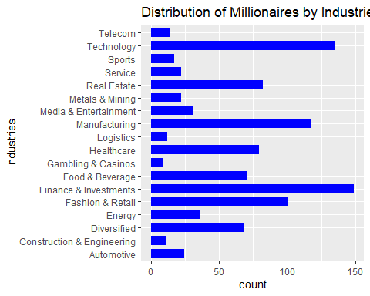

Bar grafigindeki bar’lar, milyonerlerin sayisini degilde oranlarini(percent) verirse daha okunur bir grafik olacaktir. Grafigin cizilebilmesi icin once degiskenin frekans tablosu olusturulmustur:

df_industries <- as.data.frame(my.table(df$industries)) # industries' in frekans tablosunu dataframe olarak kaydet  
  
df_industries

## n percent  
## Automotive 24 2.4  
## Construction & Engineering 11 1.1  
## Diversified 68 6.8  
## Energy 36 3.6  
## Fashion & Retail 101 10.1  
## Finance & Investments 149 14.9  
## Food & Beverage 70 7.0  
## Gambling & Casinos 9 0.9  
## Healthcare 79 7.9  
## Logistics 12 1.2  
## Manufacturing 118 11.8  
## Media & Entertainment 31 3.1  
## Metals & Mining 22 2.2  
## Real Estate 82 8.2  
## Service 22 2.2  
## Sports 17 1.7  
## Technology 135 13.5  
## Telecom 14 1.4

df_industries$industries <- rownames(df_industries) # satir isimlerini, industries sutunu olarak dataframe'e ekle  
  
df_industries

## n percent industries  
## Automotive 24 2.4 Automotive  
## Construction & Engineering 11 1.1 Construction & Engineering  
## Diversified 68 6.8 Diversified  
## Energy 36 3.6 Energy  
## Fashion & Retail 101 10.1 Fashion & Retail  
## Finance & Investments 149 14.9 Finance & Investments  
## Food & Beverage 70 7.0 Food & Beverage  
## Gambling & Casinos 9 0.9 Gambling & Casinos  
## Healthcare 79 7.9 Healthcare  
## Logistics 12 1.2 Logistics  
## Manufacturing 118 11.8 Manufacturing  
## Media & Entertainment 31 3.1 Media & Entertainment  
## Metals & Mining 22 2.2 Metals & Mining  
## Real Estate 82 8.2 Real Estate  
## Service 22 2.2 Service  
## Sports 17 1.7 Sports  
## Technology 135 13.5 Technology  
## Telecom 14 1.4 Telecom

stat = “identity” argumani ile barlarin yuksekliginin “df_industries$percent” degiskeninden alinacagi bildirilir. (R CookBook 10.10)

scale_y_continuous() fonksiyonu, y ekseninin (percent) daha sik isaretlenmesini sagladi (Cookbook for R->Graphs->Axes, <http://www.cookbook-r.com/Graphs/Axes_(ggplot2)/>)

ggplot(df_industries, aes(x = industries, y = percent)) +  
 geom_bar(stat = "identity", fill = "blue", width = 0.7) +  
 coord_flip() +  
 labs(title = "Distribution of Millionaires by Industries", x = "Industries", y = "Percent(%)") +  
 scale_y_continuous(breaks = seq(0, max(df_industries$percent), by = 1))

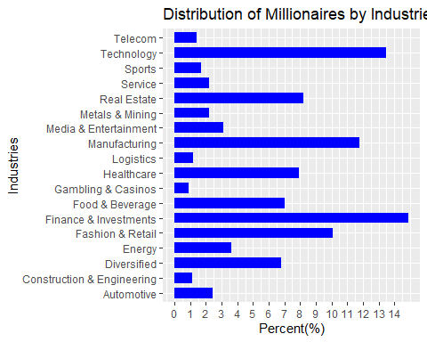

### Milyonerlerin ikamet ettigi ulkeye gore dagilimi (country, unique = 63)

Milyonerlerin ikamet ettigi ulkelerin frekans tablosu:

df_country <- as.data.frame(my.table(df$country))  
df_country$country <- rownames(df_country)  
df_country <- df_country[df_country$country != "NA.", , drop = FALSE] # eksik degerler satirini siler  
df_country

## n percent country  
## Algeria 1 0.1 Algeria  
## Argentina 2 0.2 Argentina  
## Australia 14 1.4 Australia  
## Austria 3 0.3 Austria  
## Bahamas 2 0.2 Bahamas  
## Belgium 2 0.2 Belgium  
## Bermuda 1 0.1 Bermuda  
## Brazil 13 1.3 Brazil  
## Canada 15 1.5 Canada  
## Cayman.Islands 1 0.1 Cayman.Islands  
## Chile 3 0.3 Chile  
## China 215 21.5 China  
## Colombia 1 0.1 Colombia  
## Cyprus 1 0.1 Cyprus  
## Czech.Republic 2 0.2 Czech.Republic  
## Denmark 1 0.1 Denmark  
## Egypt 1 0.1 Egypt  
## Eswatini..Swaziland. 1 0.1 Eswatini..Swaziland.  
## Finland 1 0.1 Finland  
## France 10 1.0 France  
## Germany 38 3.8 Germany  
## Greece 1 0.1 Greece  
## Hong.Kong 27 2.7 Hong.Kong  
## Hungary 2 0.2 Hungary  
## India 53 5.3 India  
## Indonesia 10 1.0 Indonesia  
## Ireland 2 0.2 Ireland  
## Israel 10 1.0 Israel  
## Italy 21 2.1 Italy  
## Japan 13 1.3 Japan  
## Kazakhstan 5 0.5 Kazakhstan  
## Lebanon 2 0.2 Lebanon  
## Luxembourg 1 0.1 Luxembourg  
## Malaysia 7 0.7 Malaysia  
## Mexico 6 0.6 Mexico  
## Monaco 7 0.7 Monaco  
## Morocco 1 0.1 Morocco  
## Nepal 1 0.1 Nepal  
## Netherlands 2 0.2 Netherlands  
## Nigeria 1 0.1 Nigeria  
## Norway 3 0.3 Norway  
## Oman 1 0.1 Oman  
## Peru 2 0.2 Peru  
## Philippines 4 0.4 Philippines  
## Poland 2 0.2 Poland  
## Qatar 1 0.1 Qatar  
## Romania 1 0.1 Romania  
## Russia 31 3.1 Russia  
## Singapore 10 1.0 Singapore  
## South.Africa 2 0.2 South.Africa  
## South.Korea 11 1.1 South.Korea  
## Spain 7 0.7 Spain  
## Sweden 9 0.9 Sweden  
## Switzerland 25 2.5 Switzerland  
## Taiwan 17 1.7 Taiwan  
## Thailand 11 1.1 Thailand  
## Turkey 6 0.6 Turkey  
## Ukraine 3 0.3 Ukraine  
## United.Arab.Emirates 7 0.7 United.Arab.Emirates  
## United.Kingdom 28 2.8 United.Kingdom  
## United.States 301 30.1 United.States  
## Vietnam 5 0.5 Vietnam

Cok fazla ulke var. Dusuk sayida milyoner olan ulkeleri bir araya toplayarak daha okunur bir grafik elde edilebilir.

**Milyonerlerin %1’inden azini barindiran ulkeler:**

low_percent_rows2 <- df_country[df_country$percent < 1, ]  
low_percent_rows2

## n percent country  
## Algeria 1 0.1 Algeria  
## Argentina 2 0.2 Argentina  
## Austria 3 0.3 Austria  
## Bahamas 2 0.2 Bahamas  
## Belgium 2 0.2 Belgium  
## Bermuda 1 0.1 Bermuda  
## Cayman.Islands 1 0.1 Cayman.Islands  
## Chile 3 0.3 Chile  
## Colombia 1 0.1 Colombia  
## Cyprus 1 0.1 Cyprus  
## Czech.Republic 2 0.2 Czech.Republic  
## Denmark 1 0.1 Denmark  
## Egypt 1 0.1 Egypt  
## Eswatini..Swaziland. 1 0.1 Eswatini..Swaziland.  
## Finland 1 0.1 Finland  
## Greece 1 0.1 Greece  
## Hungary 2 0.2 Hungary  
## Ireland 2 0.2 Ireland  
## Kazakhstan 5 0.5 Kazakhstan  
## Lebanon 2 0.2 Lebanon  
## Luxembourg 1 0.1 Luxembourg  
## Malaysia 7 0.7 Malaysia  
## Mexico 6 0.6 Mexico  
## Monaco 7 0.7 Monaco  
## Morocco 1 0.1 Morocco  
## Nepal 1 0.1 Nepal  
## Netherlands 2 0.2 Netherlands  
## Nigeria 1 0.1 Nigeria  
## Norway 3 0.3 Norway  
## Oman 1 0.1 Oman  
## Peru 2 0.2 Peru  
## Philippines 4 0.4 Philippines  
## Poland 2 0.2 Poland  
## Qatar 1 0.1 Qatar  
## Romania 1 0.1 Romania  
## South.Africa 2 0.2 South.Africa  
## Spain 7 0.7 Spain  
## Sweden 9 0.9 Sweden  
## Turkey 6 0.6 Turkey  
## Ukraine 3 0.3 Ukraine  
## United.Arab.Emirates 7 0.7 United.Arab.Emirates  
## Vietnam 5 0.5 Vietnam

**Milyonerlerin %1’inden fazlasini barindiran ulkeler:**

high_percent_rows2 <- df_country[!(df_country$percent < 1), ]  
high_percent_rows2

## n percent country  
## Australia 14 1.4 Australia  
## Brazil 13 1.3 Brazil  
## Canada 15 1.5 Canada  
## China 215 21.5 China  
## France 10 1.0 France  
## Germany 38 3.8 Germany  
## Hong.Kong 27 2.7 Hong.Kong  
## India 53 5.3 India  
## Indonesia 10 1.0 Indonesia  
## Israel 10 1.0 Israel  
## Italy 21 2.1 Italy  
## Japan 13 1.3 Japan  
## Russia 31 3.1 Russia  
## Singapore 10 1.0 Singapore  
## South.Korea 11 1.1 South.Korea  
## Switzerland 25 2.5 Switzerland  
## Taiwan 17 1.7 Taiwan  
## Thailand 11 1.1 Thailand  
## United.Kingdom 28 2.8 United.Kingdom  
## United.States 301 30.1 United.States

**Milyonerlerin %1’inden azini barindiran ulkeleri iceren “Other Countries” satirin olusturulmasi:**

total_low_percent2 <- data.frame(  
 n = sum(low_percent_rows2$n),  
 percent = sum(low_percent_rows2$percent),  
 country = "Other Countries"  
)

**Milyonerlerin %1’inden fazlasini barindiran ulkeler ile yeni satirin birlestirilmesi:**

df_country2 <- rbind(high_percent_rows2, total_low_percent2)  
df_country2

## n percent country  
## Australia 14 1.4 Australia  
## Brazil 13 1.3 Brazil  
## Canada 15 1.5 Canada  
## China 215 21.5 China  
## France 10 1.0 France  
## Germany 38 3.8 Germany  
## Hong.Kong 27 2.7 Hong.Kong  
## India 53 5.3 India  
## Indonesia 10 1.0 Indonesia  
## Israel 10 1.0 Israel  
## Italy 21 2.1 Italy  
## Japan 13 1.3 Japan  
## Russia 31 3.1 Russia  
## Singapore 10 1.0 Singapore  
## South.Korea 11 1.1 South.Korea  
## Switzerland 25 2.5 Switzerland  
## Taiwan 17 1.7 Taiwan  
## Thailand 11 1.1 Thailand  
## United.Kingdom 28 2.8 United.Kingdom  
## United.States 301 30.1 United.States  
## 1 114 11.4 Other Countries

ggplot(df_country2, aes(x = country, y = percent)) +  
 geom_bar(stat = "identity", fill = "blue", width = 0.7) +  
 coord_flip() +  
 labs(title = "The distribution of millionaires by country of residence", x = "Country of Residence", y = "Percent(%)") +  
 scale_y_continuous(breaks = seq(0, max(df_country$percent), by = 2))

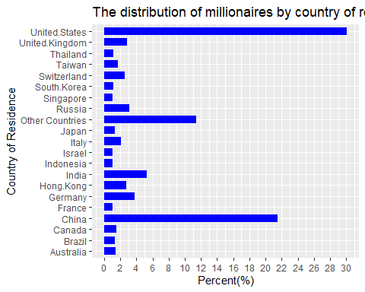

### USA’de ikamet eden milyonerlerin bolgelere gore dagilimi (residenceStateRegion, unique = 5)

df_residenceStateRegion <- as.data.frame(my.table(df$residenceStateRegion))  
df_residenceStateRegion$Region <- rownames(df_residenceStateRegion)  
df_residenceStateRegion <- df_residenceStateRegion[df_residenceStateRegion$Region != "NA.", , drop = FALSE]  
df_residenceStateRegion

## n percent Region  
## Midwest 24 2.4 Midwest  
## Northeast 80 8.0 Northeast  
## South 92 9.2 South  
## U.S..Territories 1 0.1 U.S..Territories  
## West 101 10.1 West

ggplot(df_residenceStateRegion, aes(x = Region, y = percent)) +  
 geom_bar(stat = "identity", fill = "blue", width = 0.7) +  
 labs(title = "Distribution of Millionaires by Regions of USA", x = "Region", y = "Percent(%)") +  
 scale_y_continuous(breaks = seq(0, max(df_industries$percent), by = 1))

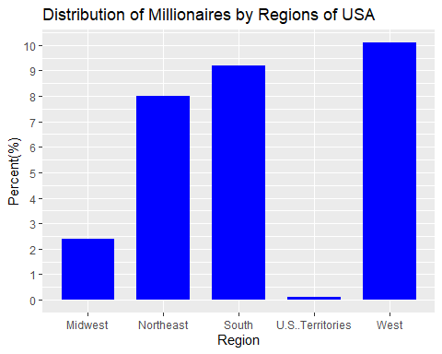

## 4.2. Demografik analiz: Milyarderlerin yasini (age), cinsiyetini (gender) ve dogum yeri (countryOfCitizenship) demografisini arastirin.

### Milyonerlerin vatandasi oldugu ulkelere gore dagilimi (countryOfCitizenship, unique = 62)

countryOfCitizenship icin frekans tablosu:

df_countryOfCitizenship <- as.data.frame(my.table(df$countryOfCitizenship))  
df_countryOfCitizenship$Citizenship <- rownames(df_countryOfCitizenship)

Cok fazla ulke var. Dusuk sayida milyoner olan ulkeleri bir araya toplayarak daha okunur bir grafik elde edilebilir.

**Milyonerlerin %1’inden azini barindiran ulkeler:**

low_percent_rows <- df_countryOfCitizenship[df_countryOfCitizenship$percent < 1, ]  
low_percent_rows

## n percent Citizenship  
## Algeria 1 0.1 Algeria  
## Argentina 2 0.2 Argentina  
## Austria 3 0.3 Austria  
## Belgium 3 0.3 Belgium  
## Belize 1 0.1 Belize  
## Chile 4 0.4 Chile  
## Colombia 2 0.2 Colombia  
## Cyprus 3 0.3 Cyprus  
## Czech Republic 3 0.3 Czech Republic  
## Denmark 1 0.1 Denmark  
## Egypt 1 0.1 Egypt  
## Eswatini (Swaziland) 1 0.1 Eswatini (Swaziland)  
## Finland 1 0.1 Finland  
## Georgia 1 0.1 Georgia  
## Greece 3 0.3 Greece  
## Hungary 2 0.2 Hungary  
## Ireland 3 0.3 Ireland  
## Israel 9 0.9 Israel  
## Kazakhstan 4 0.4 Kazakhstan  
## Lebanon 3 0.3 Lebanon  
## Mexico 6 0.6 Mexico  
## Monaco 1 0.1 Monaco  
## Morocco 1 0.1 Morocco  
## Nepal 1 0.1 Nepal  
## Netherlands 3 0.3 Netherlands  
## Nigeria 1 0.1 Nigeria  
## Norway 4 0.4 Norway  
## Oman 1 0.1 Oman  
## Panama 1 0.1 Panama  
## Peru 3 0.3 Peru  
## Philippines 4 0.4 Philippines  
## Poland 2 0.2 Poland  
## Qatar 1 0.1 Qatar  
## Romania 4 0.4 Romania  
## Singapore 7 0.7 Singapore  
## South Africa 2 0.2 South Africa  
## Spain 7 0.7 Spain  
## Turkey 6 0.6 Turkey  
## Ukraine 2 0.2 Ukraine  
## United Arab Emirates 4 0.4 United Arab Emirates  
## Vietnam 5 0.5 Vietnam  
## Zimbabwe 1 0.1 Zimbabwe

**Milyonerlerin %1’inden fazlasini barindiran ulkeler:**

high_percent_rows <- df_countryOfCitizenship[!(df_countryOfCitizenship$percent < 1), ]  
high_percent_rows

## n percent Citizenship  
## Australia 17 1.7 Australia  
## Brazil 20 2.0 Brazil  
## Canada 22 2.2 Canada  
## China 209 20.9 China  
## France 14 1.4 France  
## Germany 43 4.3 Germany  
## Hong Kong 22 2.2 Hong Kong  
## India 55 5.5 India  
## Indonesia 10 1.0 Indonesia  
## Italy 24 2.4 Italy  
## Japan 13 1.3 Japan  
## Malaysia 10 1.0 Malaysia  
## Russia 41 4.1 Russia  
## South Korea 12 1.2 South Korea  
## Sweden 13 1.3 Sweden  
## Switzerland 11 1.1 Switzerland  
## Taiwan 22 2.2 Taiwan  
## Thailand 11 1.1 Thailand  
## United Kingdom 23 2.3 United Kingdom  
## United States 290 29.0 United States

**Milyonerlerin %1’inden azini barindiran ulkeleri iceren satirin olusturulmasi:**

total_low_percent <- data.frame(  
 n = sum(low_percent_rows$n),  
 percent = sum(low_percent_rows$percent),  
 Citizenship = "Other"  
)

**Milyonerlerin %1’inden fazlasini barindiran ulkeler ile yeni satirin birlestirilmesi:**

df_countryOfCitizenship2 <- rbind(high_percent_rows, total_low_percent)  
df_countryOfCitizenship2

## n percent Citizenship  
## Australia 17 1.7 Australia  
## Brazil 20 2.0 Brazil  
## Canada 22 2.2 Canada  
## China 209 20.9 China  
## France 14 1.4 France  
## Germany 43 4.3 Germany  
## Hong Kong 22 2.2 Hong Kong  
## India 55 5.5 India  
## Indonesia 10 1.0 Indonesia  
## Italy 24 2.4 Italy  
## Japan 13 1.3 Japan  
## Malaysia 10 1.0 Malaysia  
## Russia 41 4.1 Russia  
## South Korea 12 1.2 South Korea  
## Sweden 13 1.3 Sweden  
## Switzerland 11 1.1 Switzerland  
## Taiwan 22 2.2 Taiwan  
## Thailand 11 1.1 Thailand  
## United Kingdom 23 2.3 United Kingdom  
## United States 290 29.0 United States  
## 1 118 11.8 Other

bar plot

ggplot(df_countryOfCitizenship2, aes(x = Citizenship, y = percent)) +  
 geom_bar(stat = "identity", fill = "blue", width = 0.7) +  
 coord_flip() +  
 labs(title = "Distribution of Millionaires by The Country of Citizenship", x = "Country of Citizenship", y = "Percent(%)") +  
 scale_y_continuous(breaks = seq(0, max(df_countryOfCitizenship$percent), by = 2))

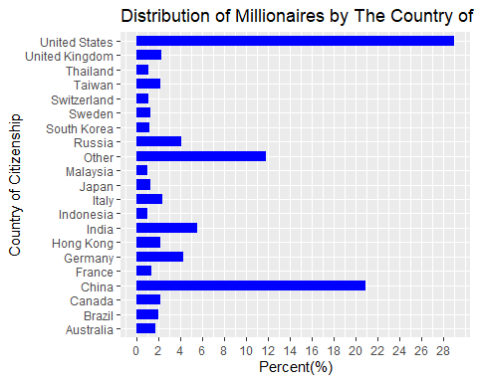

### Milyonerlerin yaslarinin dagilimi:

summary(df$age)

## Min. 1st Qu. Median Mean 3rd Qu. Max. NA's   
## 21.00 56.00 65.00 64.78 74.00 101.00 23

hist(df$age, col = "blue", main = "Histogram Graph of Millionaires' Ages", xlab = "Age")

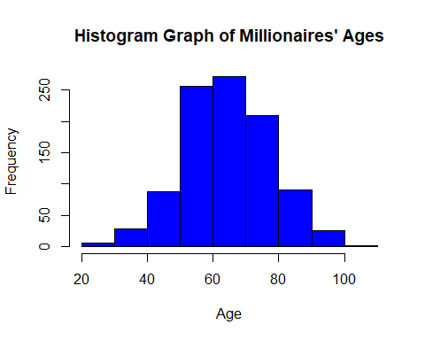

Degiskenin dagilimi normal dagilim.

### Milyonerlerin cinsiyetlerinin dagilimi:

df_gender <- as.data.frame(my.table(df$gender))  
df_gender$gender <- c("Female", "Male")  
df_gender

## n percent gender  
## F 120 12 Female  
## M 880 88 Male

Odev verisindeki milyonerlerin %88’i erkek, %12’ si kadindir.

ggplot(df_gender, aes(x = gender, y = percent)) +  
 geom_bar(stat = "identity", fill = "blue", width = 0.7)+  
 labs(title = "Distribution of Millionaires by Gender", x = "Gender", y = "Percent(%)")+  
 scale_y_continuous(breaks = seq(0, max(df_gender$percent), by = 10))

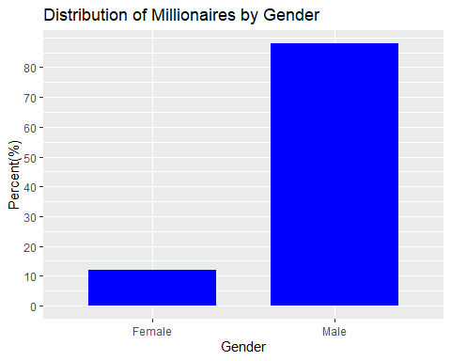

### Milyonerlerin cinsiyetlerine gore yaslarinin karsilastirilmasi

tapply(df$age, df$gender, summary)

## $F  
## Min. 1st Qu. Median Mean 3rd Qu. Max. NA's   
## 35.00 55.00 66.00 65.48 76.00 98.00 11   
##   
## $M  
## Min. 1st Qu. Median Mean 3rd Qu. Max. NA's   
## 21.00 56.00 65.00 64.69 74.00 101.00 12

Kadin milyonerlerin yas ortalamasi 65.5, erkeklerinse 64.7’ dur. Her iki grubun da yas(age) verisinde eksik gozlemler vardir.

Cinsiyetlere gore yas dagilimi histogram grafigi

par(mfrow=c(1,2))  
hist(df$age[df$gender == "F"], xlab = "Age distribution of female millionaires", main = NULL, col = "blue")  
hist(df$age[df$gender == "M"], xlab = "Age distribution of male millionaires", main = NULL, ylab = NULL, col = "blue")

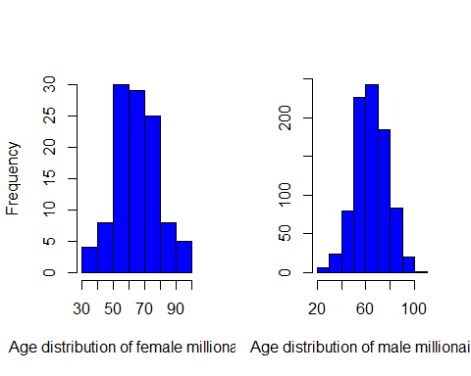

par(mfrow=c(1,1))

Age degiskeni her iki grupta da normal dagilima sahip.

Cinsiyetlere gore yas dagilimi boxplot

ggplot(df, aes(x = gender, y = age)) +  
 geom_boxplot(fill = "blue") +  
 labs(title = "Box plot of age distribution by gender",  
 x = "Gender",  
 y = "Age")

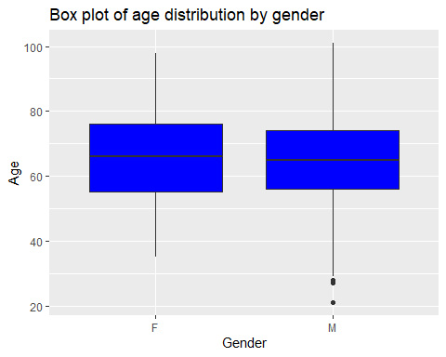

### Kadin milyonerler ile erkek milyonerlerin yas ortalamalari arasinda fark var mi?

H0: Kadinlar ile erkeklerin yas ortalamalari arasinda fark yoktur.

H1: Kadinlar ile erkeklerin yas ortalamalari arasinda fark vardir.

Student’s t test ile analiz edilir:

t.test(df$age[df$gender == "F"], df$age[df$gender == "M"], alternative = c("two.sided"))

##   
## Welch Two Sample t-test  
##   
## data: df$age[df$gender == "F"] and df$age[df$gender == "M"]  
## t = 0.56422, df = 133.52, p-value = 0.5736  
## alternative hypothesis: true difference in means is not equal to 0  
## 95 percent confidence interval:  
## -1.971797 3.545741  
## sample estimates:  
## mean of x mean of y   
## 65.47706 64.69009

Test sonucunda H0 ret edilemez (t = 0.56, p = 0.57). Kadinlar ile erkeklerin yas ortalamalari arasinda fark yoktur.

## 4.3. Kendi kendine yapilan ve miras alinan zenginlik: Kendi kendine milyarder olanlarin ve onlarin servetini miras alan kisilerin oranini analiz edin.

**status**: “D” kendi cabasiyla kazanilmis serveti temsil eder (Kurucular/Girisimciler), “U” ise miras veya kazanilmamis serveti gosterir.

status icin frekans tablosu:

df_status <- as.data.frame(my.table(df$status))  
df_status

## n percent  
## D 452 45.2  
## E 102 10.2  
## N 62 6.2  
## R 20 2.0  
## Split Family Fortune 27 2.7  
## U 337 33.7

Odevin verisindeki milyonerlerin %45.2’ si self made milyoner, %33.7’ si ise miras veya kazanilmamis servet sonucu milyonerdir.

### Oranlar arasinda fark var mi?

Iki oranin karsilastirilmasi: Binom test, prop.test()

H0: Iki oran arasinda fark yoktur.

H1: Iki oran arasinda fark vardir.

prop.test(c(df_status[1,1], df_status[6,1]), c(sum(df_status$n), sum(df_status$n)), alternative = "two.sided")

##   
## 2-sample test for equality of proportions with continuity correction  
##   
## data: c(df_status[1, 1], df_status[6, 1]) out of c(sum(df_status$n), sum(df_status$n))  
## X-squared = 27.203, df = 1, p-value = 1.832e-07  
## alternative hypothesis: two.sided  
## 95 percent confidence interval:  
## 0.07145808 0.15854192  
## sample estimates:  
## prop 1 prop 2   
## 0.452 0.337

H0 ret edilir (ki-kare test(sd = 1) = 27.203, p < 0.01), iki oran arasinda istatistiksel olarak anlamli fark vardir.

## 4.4. Ekonomik gostergeler: Milyarder serveti ile GSYIH, TUFE ve vergi oranlari gibi ekonomik gostergeler arasindaki korelasyonlarıi inceleyin.

cpi_country –> Milyarderin ulkesinin Tuketici Fiyat Endeksi (TUFE)

cpi_change_country –> Milyarderin ulkesindeki TUFE degisimi

gdp_country –> Milyarderin ulkesinin Gayri Safi Yurtici Hasilasi (GSYIH)

for (j in colnames(df[25:27])){  
 cat(match(j, colnames(df)), j, "-->", class(df[ ,j]),   
 "(","missing =", sum(is.na(df[j])),  
 "/", "unique =", length(unique(df[, j])), ")", "\n")  
}

## 25 cpi_country --> numeric ( missing = 71 / unique = 55 )   
## 26 cpi_change_country --> numeric ( missing = 71 / unique = 43 )   
## 27 gdp_country --> character ( missing = 0 / unique = 56 )

gdp_country degiskeni character tipinde. Oncelikle bu degisken incelenmeli:

df[1:10, "gdp_country"]

## [1] "$21,427,700,000,000 " "$529,606,710,418 " "$1,394,116,310,769 "   
## [4] "" "$21,427,700,000,000 " "$19,910,000,000,000 "  
## [7] "$1,699,876,578,871 " "$21,427,700,000,000 " "$754,411,708,203 "   
## [10] ""

Eksik gozlemler uygun girilmemis. Eksik gozlemlere NA atanmasi:

df$gdp_country <- ifelse(df$gdp_country == "", NA, df$gdp_country)  
  
sum(is.na(df$gdp_country))

## [1] 64

gdp_country icindeki virgul ve dolar isaretlerini kaldirma

gsub() fonksiyonu, bir karakter dizisi icinde belirli ifadeleri bulup degistirmek icin kullanilir. (R CookBook 7.5)

gsub(old, new, string) –> (old: Degistirilmek istenen desen, new: yerine konacak yeni deger, string: Deseni iceren karakter dizisi veya vektor)

df$gdp_country <- gsub("[\\$,]", "", df$gdp_country)  
df[1:20, "gdp_country"]

## [1] "21427700000000 " "529606710418 " "1394116310769 " NA   
## [5] "21427700000000 " "19910000000000 " "1699876578871 " "21427700000000 "  
## [9] "754411708203 " NA "21427700000000 " "21427700000000 "  
## [13] "21427700000000 " "5081769542380 " "19910000000000 " "2827113184696 "   
## [17] NA "703082435360 " "421142267938 " "21427700000000 "

gdp_country’yi numeric formata cevirme:

df$gdp_country <- as.numeric(df$gdp_country)

### Degiskenlerin dagilimlarinin incelenmesi

apply(df[25:27], 2, summary)

## cpi_country cpi_change_country gdp_country  
## Min. 99.5500 -1.900000 7.184844e+09  
## 1st Qu. 117.2400 1.800000 1.839758e+12  
## Median 117.2400 2.900000 1.991000e+13  
## Mean 127.5836 4.447578 1.224980e+13  
## 3rd Qu. 125.0800 7.500000 2.142770e+13  
## Max. 288.5700 53.500000 2.142770e+13  
## NA's 71.0000 71.000000 6.400000e+01

cpi_country histogram ve kutu grafigi:

Birden fazla grafige ortak ana baslik eklemek icin mtext() fonkisyonu kullanildi (<https://statisticsglobe.com/common-main-title-for-multiple-plots-in-r>).

par(mfrow=c(1,2))  
hist(df$cpi_country, col = "blue", main = NULL, xlab = NULL)  
boxplot(df$cpi_country, col = "blue", main = NULL, xlab = NULL)  
mtext("Consumer Price Index (CFI) Distribution for Billionaire's Country", line = 1, adj = 1.5)

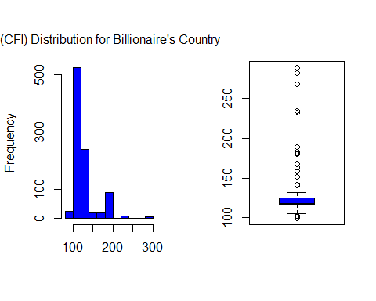

par(mfrow=c(1,1))

Dagilim normal degil, cok sayida aykiri gozlem var.

cpi_change_country histogram ve kutu grafigi:

par(mfrow=c(1,2))  
hist(df$cpi_change_country, col = "blue", main = NULL, xlab = NULL)  
boxplot(df$cpi_change_country, col = "blue", main = NULL, xlab = NULL)  
mtext("CPI Change for Billionaire's Country", line = 1, adj = 12)

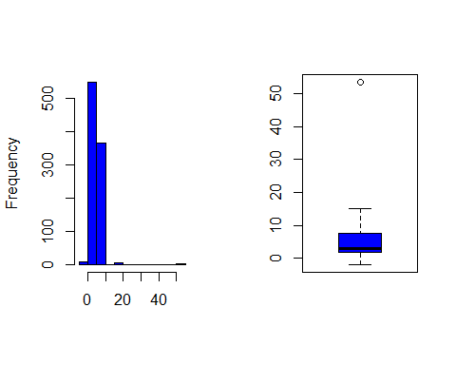

par(mfrow=c(1,1))

Dagilim normal degil, 1 tane aykiri gozlem var.

gdp_country histogram ve kutu grafigi:

par(mfrow=c(1,2))  
hist(df$gdp_country, col = "blue", main = NULL, xlab = NULL)  
boxplot(df$gdp_country, col = "blue", main = NULL, xlab = NULL)  
mtext("Gross Domestic Product (GDP) for Billionaire's Country", line = 1, adj = 2)

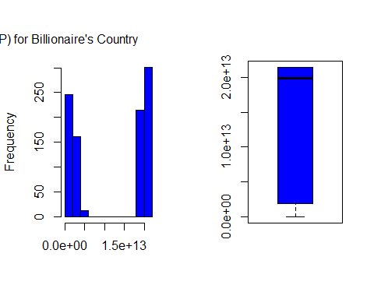

par(mfrow=c(1,1))

Dagilim normal degil, aykiri deger yok.

### Degiskenler arasi korelasyonlar

Degiskenler normal dagilim gostermediginden, Spearman korelasyon analizi ile incelendi.

H0: Degiskenler arasinda korelasyon yoktur.

H1: Degiskenler arasinda korelasyon vardir.

cpi_country ile cpi_change_country arasindaki korelasyon:

cor.test(df$cpi_country, df$cpi_change_country, method = "spearman")

## Warning in cor.test.default(df$cpi_country, df$cpi_change_country, method =  
## "spearman"): Cannot compute exact p-value with ties

##   
## Spearman's rank correlation rho  
##   
## data: df$cpi_country and df$cpi_change_country  
## S = 80030934, p-value < 2.2e-16  
## alternative hypothesis: true rho is not equal to 0  
## sample estimates:  
## rho   
## 0.4010887

H0 ret edilir (S = 80030934, p < 0.01), iki degisken arasindaki korelasyon istatistiksel olarak anlamlidir. Iki degisken arasinda pozitif yonde zayif iliski vardir (r = 0.40).

plot(df$cpi_country, df$cpi_change_country, xlab = "CPI for Billionaire's Country", ylab = "CPI Change for Billionaire's Country")

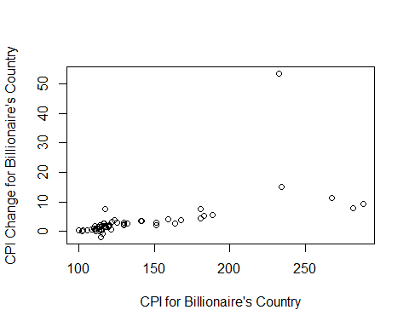

cpi_country ile gdp_country arasindaki korelasyon:

cor.test(df$cpi_country, df$gdp_country, method = "spearman")

## Warning in cor.test.default(df$cpi_country, df$gdp_country, method =  
## "spearman"): Cannot compute exact p-value with ties

##   
## Spearman's rank correlation rho  
##   
## data: df$cpi_country and df$gdp_country  
## S = 147605010, p-value = 0.00141  
## alternative hypothesis: true rho is not equal to 0  
## sample estimates:  
## rho   
## -0.1046017

H0 ret edilir (S = 147605010, p < 0.01), iki degisken arasindaki korelasyon istatistiksel olarak anlamlidir. Iki degisken arasinda negatif yonde cok zayif iliski vardir (r = -0.10).

plot(df$cpi_country, df$gdp_country, xlab = "CPI for Billionaire's Country", ylab = "GDP for Billionaire's Country")

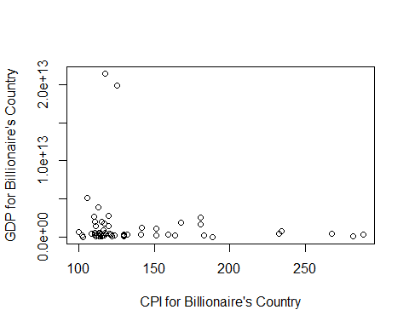

cpi_change_country ile gdp_country arasindaki korelasyon:

cor.test(df$cpi_change_country, df$gdp_country, method = "spearman")

## Warning in cor.test.default(df$cpi_change_country, df$gdp_country, method =  
## "spearman"): Cannot compute exact p-value with ties

##   
## Spearman's rank correlation rho  
##   
## data: df$cpi_change_country and df$gdp_country  
## S = 53382027, p-value < 2.2e-16  
## alternative hypothesis: true rho is not equal to 0  
## sample estimates:  
## rho   
## 0.6005157

H0 ret edilir (S = 53382027, p < 0.01), iki degisken arasindaki korelasyon istatistiksel olarak anlamlidir. Iki degisken arasinda pozitif yonde orta gucte iliski vardir (r = 0.60).

plot(df$cpi_change_country, df$gdp_country, xlab = "CPI Change for Billionaire's Country", ylab = "GDP for Billionaire's Country")

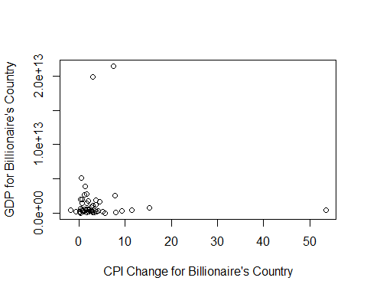

## 4.5. Mekansal analiz: Milyarderlerin cografi dagilimini(country) ve servetlerini (finalWorth) bir harita uzerinde gorsellestirin.

finalWorth degiskeninin dagilimi:

summary(df$finalWorth)

## Min. 1st Qu. Median Mean 3rd Qu. Max.   
## 1000 1500 2400 4716 4100 180000

ggplot(df) +  
 geom_histogram(aes(x = finalWorth), bins = 10, fill = "blue") +  
 scale_x_continuous(breaks = seq(0, max(df$finalWorth), by = 20000)) +  
 labs(title = "Histogram of Final Net Worth of Billionaires in U.S. Dollars", x = "Final Net Worth")

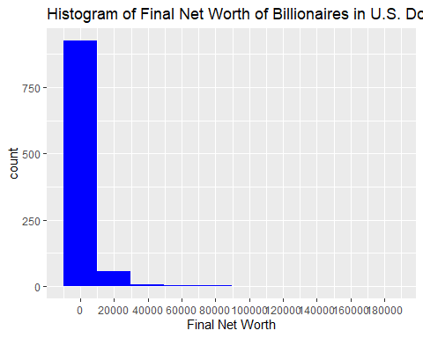

Veride bulunan az sayidaki multimilyarder, finalWorth degiskeninin dagiliminin carpik olmasina neden olmaktadir.

### Ikamet edilen ulkeye gore final net deger dagilimi

Cok fazla ulke var (unique = 62). Oncelikle dusuk sayida milyoner olan ulkeler bir araya toplanacaktir.

Milyonerlerin %1’inden fazlasini barindiran ulkeler:

high_percent_rows

## n percent Citizenship  
## Australia 17 1.7 Australia  
## Brazil 20 2.0 Brazil  
## Canada 22 2.2 Canada  
## China 209 20.9 China  
## France 14 1.4 France  
## Germany 43 4.3 Germany  
## Hong Kong 22 2.2 Hong Kong  
## India 55 5.5 India  
## Indonesia 10 1.0 Indonesia  
## Italy 24 2.4 Italy  
## Japan 13 1.3 Japan  
## Malaysia 10 1.0 Malaysia  
## Russia 41 4.1 Russia  
## South Korea 12 1.2 South Korea  
## Sweden 13 1.3 Sweden  
## Switzerland 11 1.1 Switzerland  
## Taiwan 22 2.2 Taiwan  
## Thailand 11 1.1 Thailand  
## United Kingdom 23 2.3 United Kingdom  
## United States 290 29.0 United States

Milyonerlerin %1’inden fazlasini barindiran ulkelerin listesi:

df_worth <- df[, c(2,6)]  
high_name <- rownames(high_percent_rows2)  
high_name <- gsub("[\\.]", " ", high_name)  
high_name

## [1] "Australia" "Brazil" "Canada" "China"   
## [5] "France" "Germany" "Hong Kong" "India"   
## [9] "Indonesia" "Israel" "Italy" "Japan"   
## [13] "Russia" "Singapore" "South Korea" "Switzerland"   
## [17] "Taiwan" "Thailand" "United Kingdom" "United States"

Milyonerlerin %1’inden fazlasini barindiran ulkelerin disinda kalanlarin “Other Countries” olarak atanmasi:

df_worth$new_country <- df_worth$country  
df_worth[1:5,]

## finalWorth country new_country  
## 2609 1000 United States United States  
## 2369 1200 Belgium Belgium  
## 1177 2600 Spain Spain  
## 1098 2800 Taiwan Taiwan  
## 1252 2500 United States United States

# high_name'deki ulkelerin disinda kalanlar   
for (j in seq_along(df_worth$new_country)) {  
 if (!(df_worth$new_country[j] %in% high_name)) {  
 df_worth$new_country[j] <- "Other Countries"  
 }  
}

length(unique(df_worth$country))

## [1] 63

length(unique(df_worth$new_country))

## [1] 21

ggplot(df_worth, aes(x = factor(new_country), y = finalWorth)) +  
 geom_boxplot(fill = "blue") +   
 coord_flip() +  
 labs(title = "The Distribution of Final Net Worth by Country of Residence", x = "Country of Residence", y = "Final Net Worth") +  
 scale_y_continuous(breaks = seq(0, max(df_worth$finalWorth), by = 20000))

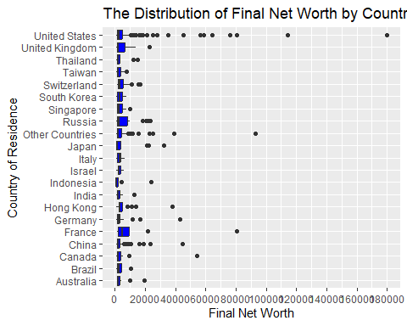

finalWorth eksenini daha kisa cizerek, boxplot’lari gorunur hale getirebiliriz.

Bunun icin scale_y_continuous() fonsiyonunda limits argumani kullanilir:

ggplot(df_worth, aes(x = factor(new_country), y = finalWorth)) +  
 geom_boxplot(fill = "blue") +   
 coord_flip() +  
 labs(title = "The Distribution of Final Net Worth by Country of Residence", x = "Country of Residence", y = "Final Net Worth") +  
 scale_y_continuous(breaks = seq(1000, 10000, by = 1000), limits = c(1000, 10000))

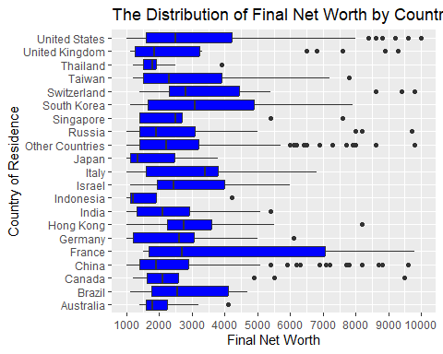

Fransa ortalamanin ustunde net degeri olan milyonerler yasamaktadir. Ilgili boxplot diger ulkelere gore oldukca genis.

Fransa’ yi South Korea, US, Taiwan, Brazil, Israel ve Italy izlemektedir. Bu ulkelerde ikamet eden milyonerlerin net degerleri, diger ulkelere gore daha yuksektir.

## 4.6. Zaman icindeki egilimler: Milyarder demografisindeki ve zenginlikteki yillar icindeki degisiklikleri izleyin.

Veride farkli zamanlarda tekrarli olculmus bir degisken yok (yillar icindeki degisiklikleri izleyin), zaman olarak kullanilmaya uygun degiskeni bulamadim. Bu nedenle milyonerlerin yaslari ile net degerleri arasindaki iliskiyi inceledim.

Yas ile net deger degiskenlerinin sacilim grafigi:

ggplot(df, aes(x = age, y = finalWorth)) +   
 geom_point(color = "blue", size=2)+  
 geom_smooth(method = "lm", formula = y ~ x, se = FALSE, color = "red") + # regresyon dogrusunu ekler  
 labs(title ="The Relationship Between Age and Networth", x = "Age", y = "Final Net Worth")

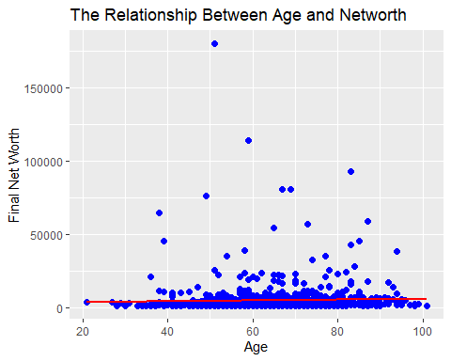

Grafikte iki degisken arasindaki korelasyonun zayif oldugu gorulebiliyor. Yasin artmasi ile birlikte net degerde de artis gorulmuyor.

cor.test(df$age, df$finalWorth, method = "spearman")

## Warning in cor.test.default(df$age, df$finalWorth, method = "spearman"): Cannot  
## compute exact p-value with ties

##   
## Spearman's rank correlation rho  
##   
## data: df$age and df$finalWorth  
## S = 130622920, p-value = 5.322e-07  
## alternative hypothesis: true rho is not equal to 0  
## sample estimates:  
## rho   
## 0.1595974

Korelasyon testinin sonuclari da degiskenler arasinda istatistiksel olarak anlamli ancak zayif korelasyon oldugunu gosteriyor (r = 0.16, p < 0.01).

Net degeri 10000 dolarin altinda olanlarin sacilim grafigi:

ggplot(df, aes(x = age, y = finalWorth)) +   
 geom_point(color = "blue", size=2)+  
 geom_smooth(method = "lm", formula = y ~ x, se = FALSE, color = "red") +  
 labs(title ="The Relationship Between Age and Networth", x = "Country of Residence", y = "Final Net Worth") +  
 scale_y_continuous(breaks = seq(1000, 10000, by = 1000), limits = c(1000, 10000))

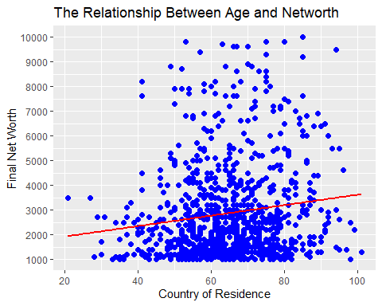

Net degeri yuksek milyonerlerin cikarilmasiyla degiskenler arasi korelasyon yukselmistir. Yas arttikca net degerde de artis goruluyor. Aralarinda dusuk/orta siddette korelasyon var.