Machine Learning Midterm Report
Breast Cancer Wisconsin and Wine Classification
I compared Decision Tree, KNN and Gaussian Naive Bayes with and without scaling. Scaled KNN had the highest mean validation macro-F1 on both datasets. I also ran K-Means on both representations and compared its test clusters with the original classes.

1 Loading the Datasets
I loaded both datasets from scikit-learn and kept the original feature names and target labels. The notebooks show the first five feature rows and the complete feature lists.
Dataset | Rows | Features | Original labels and counts
Breast Cancer | 569 | 30 | 0 malignant (212), 1 benign (357)
Wine | 178 | 13 | 0 class_0 (59), 1 class_1 (71), 2 class_2 (48)

2 Dataset Quality Checks
Both datasets had zero missing values in every column and zero duplicate rows. All 30 Breast Cancer features and all 13 Wine features are float64. Each target is an integer, and there are zero categorical features. The notebooks give counts and types for each column.
I flagged values below Q1 − 1.5 × IQR or above Q3 + 1.5 × IQR. Area error had 65 flags in Breast Cancer. In Wine, alcalinity_of_ash, magnesium and color_intensity each had four. Extreme values can dominate distance calculations and shift K-Means centres or GaussianNB estimates. I retained every row.

3 Exploratory Data Analysis
Benign is the larger Breast Cancer class, so I used macro-F1 to give both classes equal weight. Wine class_1 is the largest of the three classes. Appendix A gives the feature statistics.
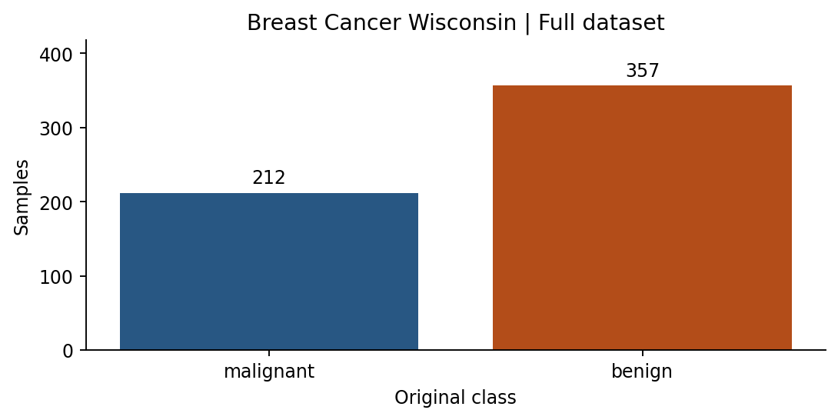 | 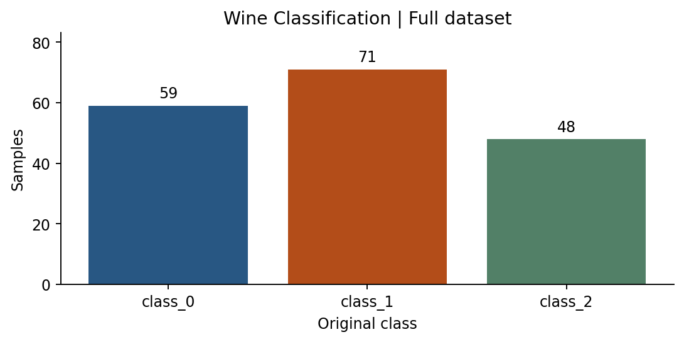

3 Pearson Correlation
The heatmaps use the full datasets. The feature numbers refer to the descriptive tables in Appendix A.
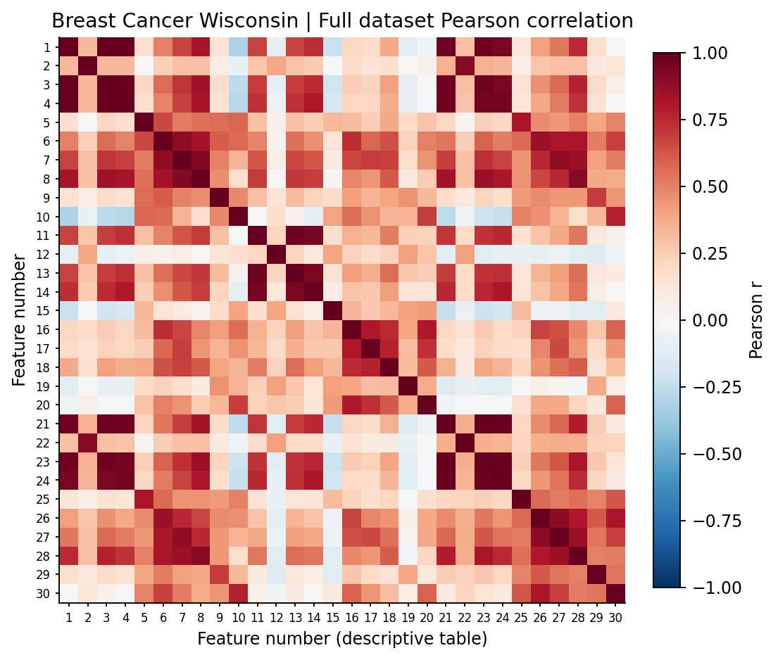 | 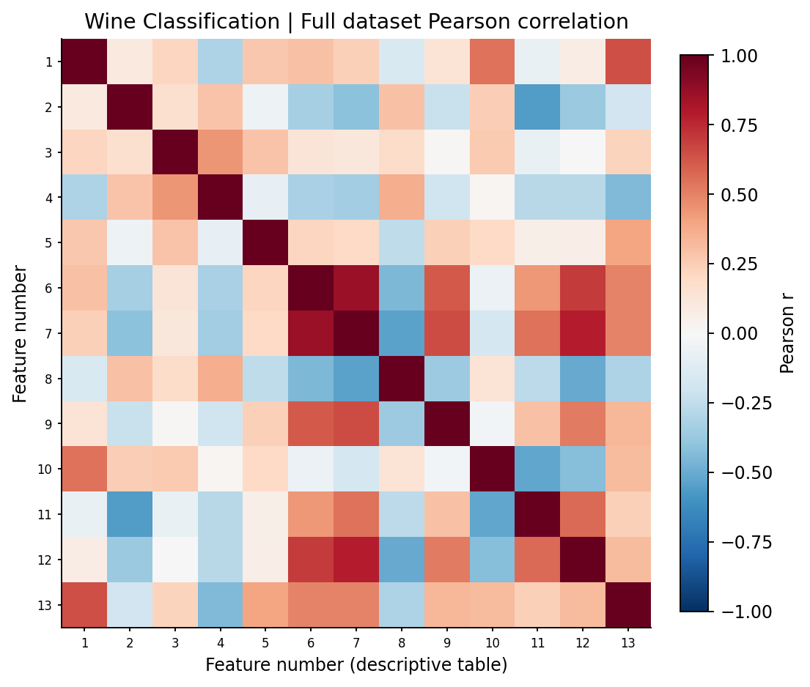
The three strongest unique feature pairs in each full dataset
Dataset | Feature A | Feature B | Pearson r
Breast Cancer | mean radius | mean perimeter | 0.998
Breast Cancer | worst radius | worst perimeter | 0.994
Breast Cancer | mean radius | mean area | 0.987
Wine | total_phenols | flavanoids | 0.865
Wine | flavanoids | od280/od315_of_diluted_wines | 0.787
Wine | total_phenols | od280/od315_of_diluted_wines | 0.700
Breast Cancer radius, perimeter and area measure related aspects of size. In Wine, flavanoids and total phenols rise together. I kept the original features and used these full-data results only to describe the datasets.

3 Breast Cancer Boxplots
Mean and worst area vary over hundreds of units, while smoothness varies by fractions of a unit. Area error has a long upper tail and many points beyond the upper whisker.
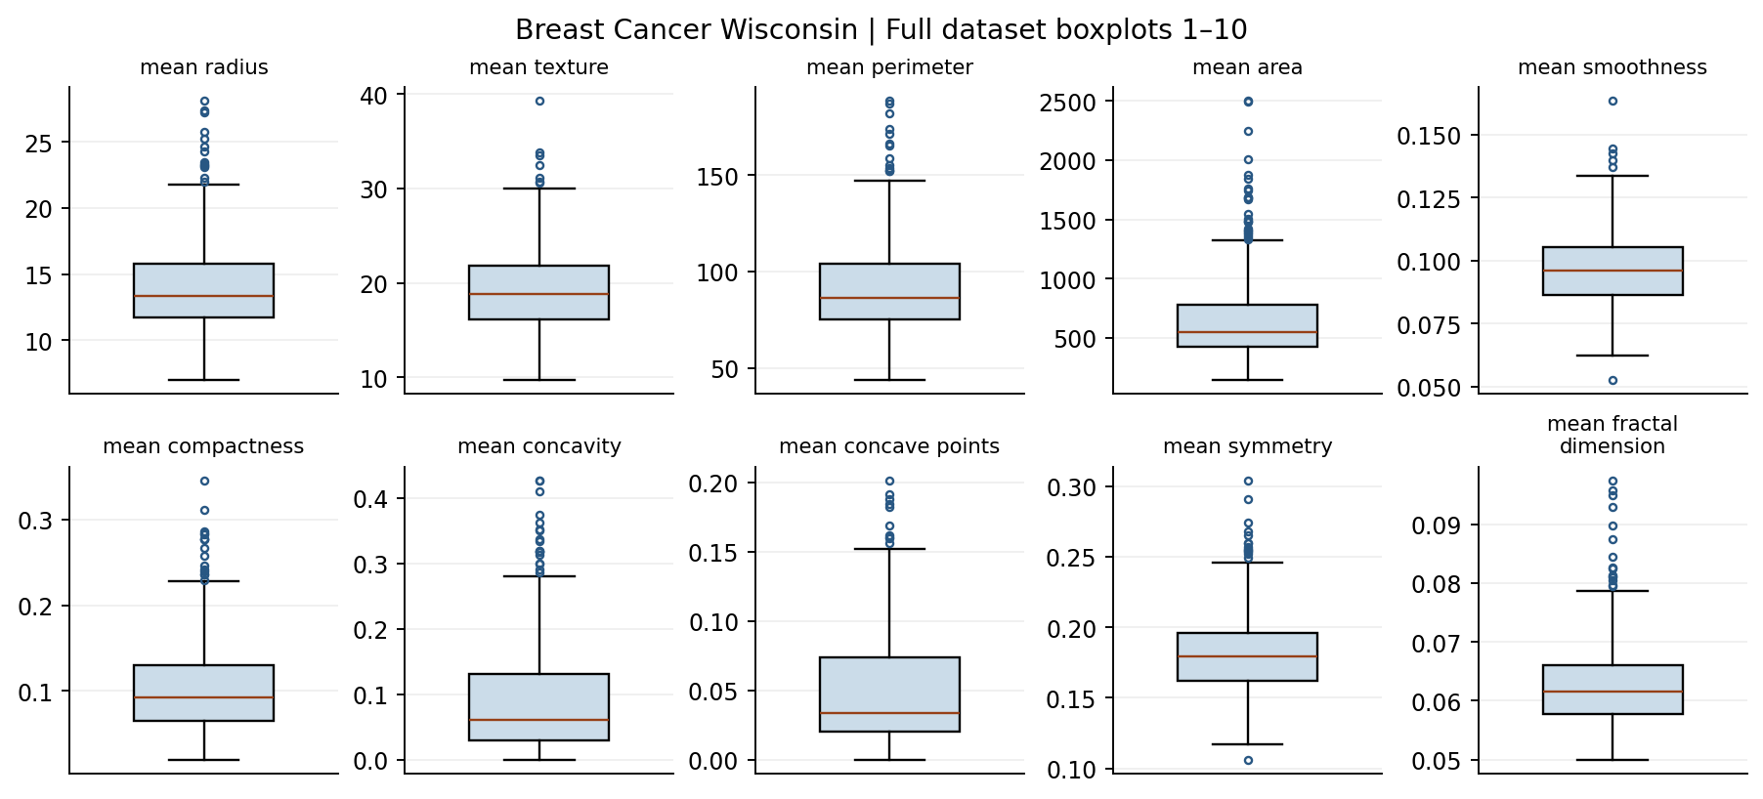 | 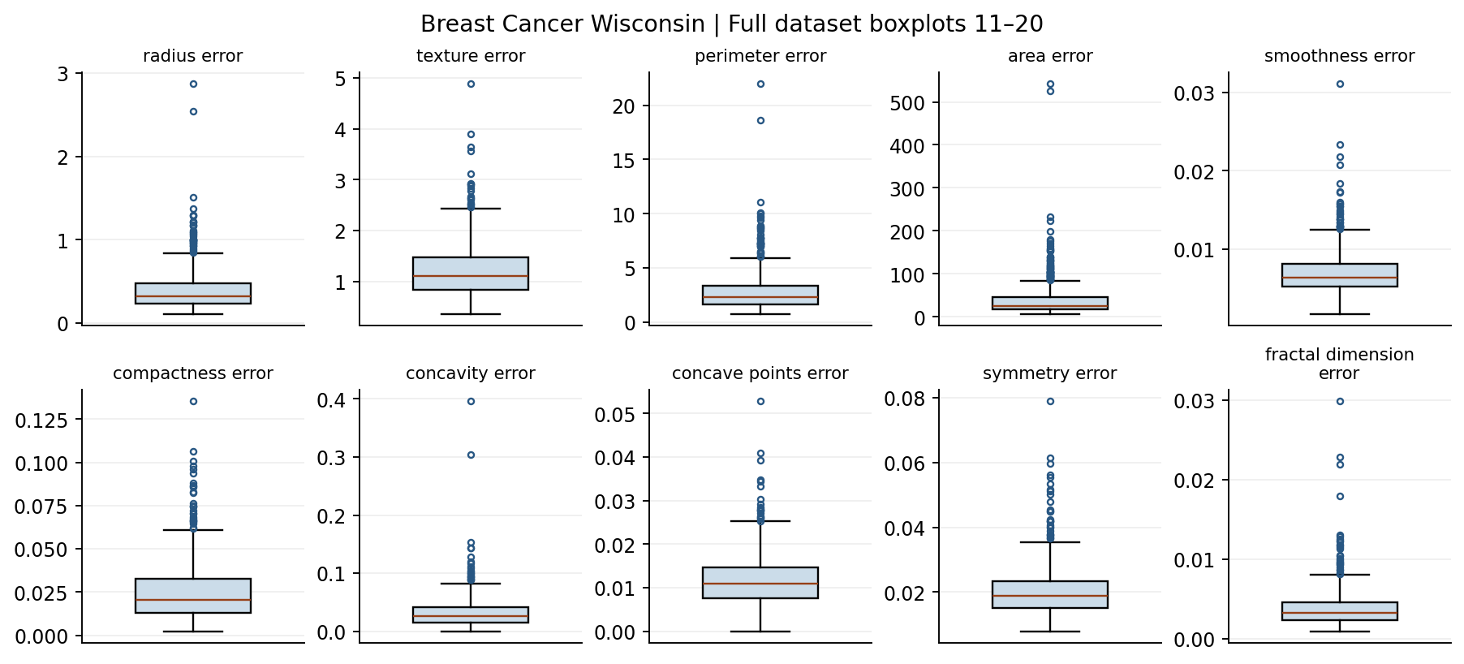
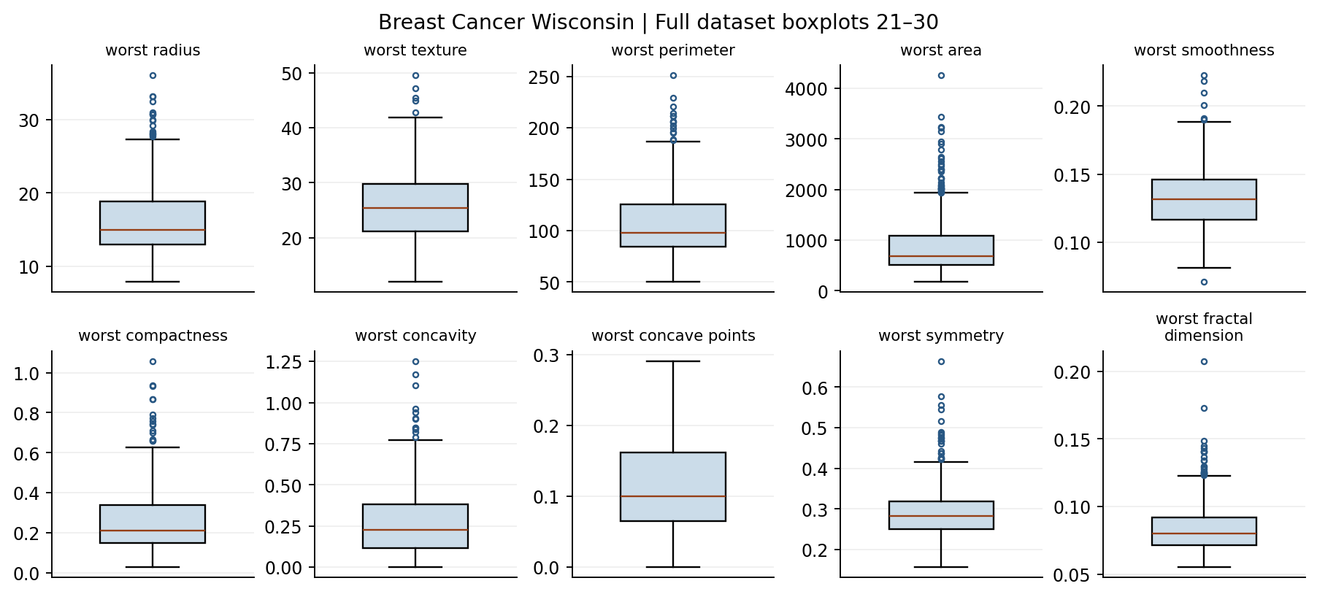

3 Wine Boxplots
Proline spans hundreds of units, while hue spans roughly one unit. Malic acid has several high values beyond its upper whisker. These differences give a reason to compare scaled and unscaled features.
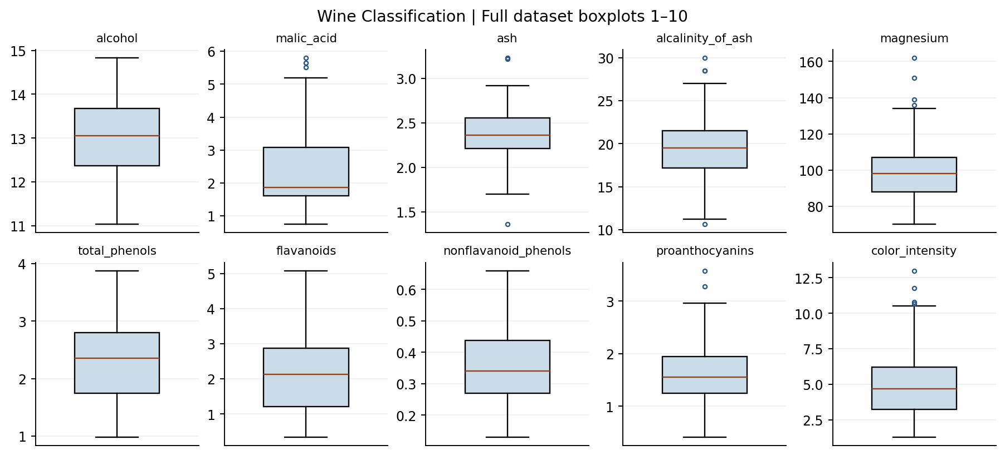 | 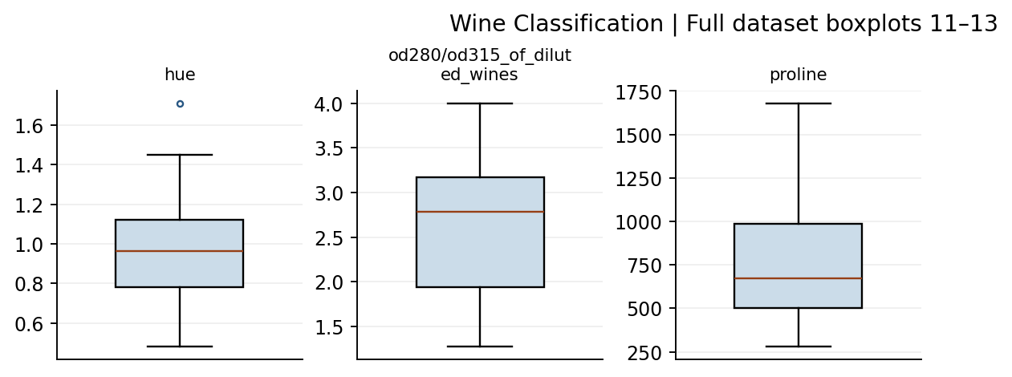

4 Splitting the Datasets
I reserved a stratified 20% test set with random state 42. For seeds 42, 52 and 62, I reserved a stratified 12.5% of the remaining rows for validation. Each repetition covered all rows without overlap and shared the same test set.
Dataset | Training | Validation | Fixed test
Breast Cancer | 398 (69.95%) | 57 (10.02%) | 114 (20.04%)
Wine | 124 (69.66%) | 18 (10.11%) | 36 (20.22%)

5 Data Preprocessing and Scaling
I fitted six StandardScalers, one on each training subset. Each subtracts the training means and divides by the training standard deviations. The notebooks show five seed-42 training rows before and after scaling. Only the seed-42 scalers transform the test features.

6 Preparing the Two Data Representations
The two representations used the same rows, labels and features within each seed.

7 Training the Classification Models
Per dataset, I fitted 30 trees at depths 2, 3, 5, 10 and None, 30 Euclidean KNNs with uniform weights at k = 1, 3, 5, 7 and 11, and six default GaussianNB models. Trees used the current seed as random state.

8 Measuring Validation Performance
I ranked configurations by mean validation macro-F1, then by higher mean accuracy, lower macro-F1 SD and alphabetical configuration ID. Wine’s scaled k = 5, 7 and 11 tied on the first three rules, so the ID ending in k11 came first. Every validation class had defined precision and recall.
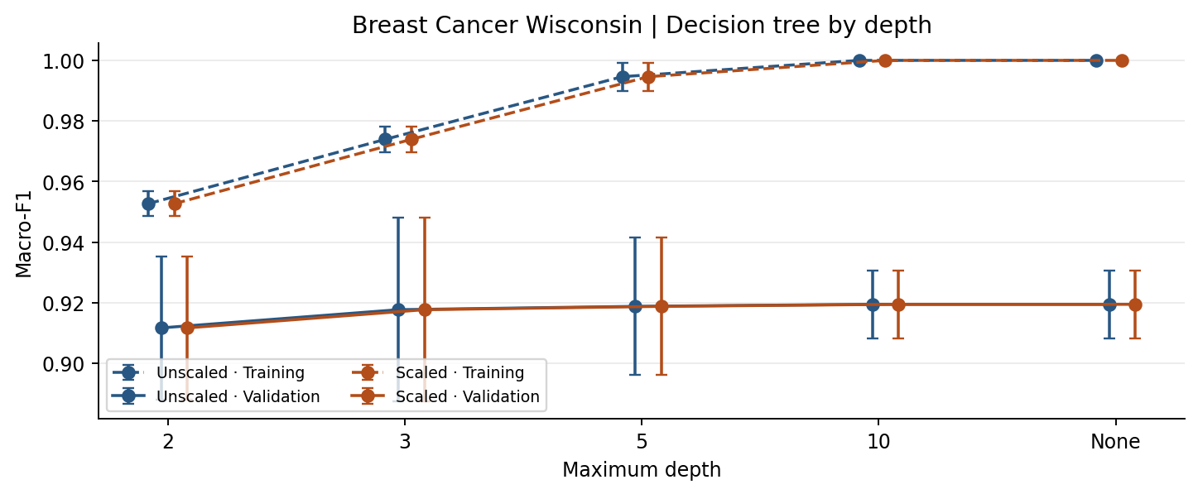 | 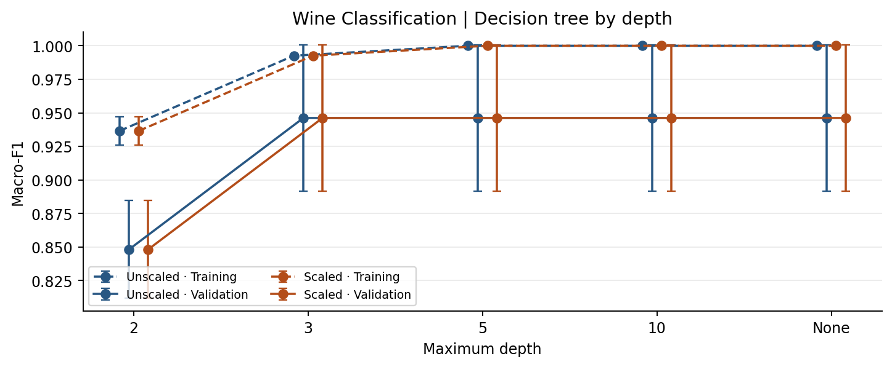
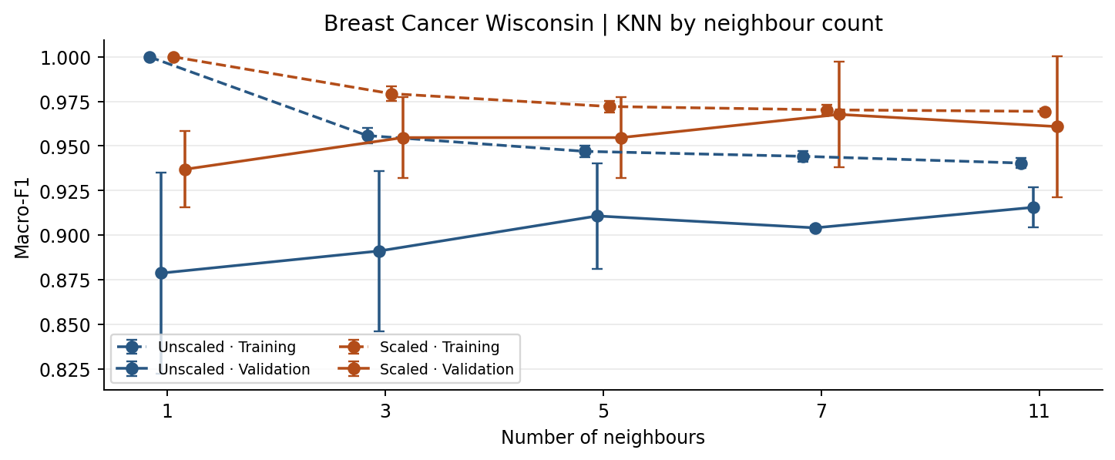 | 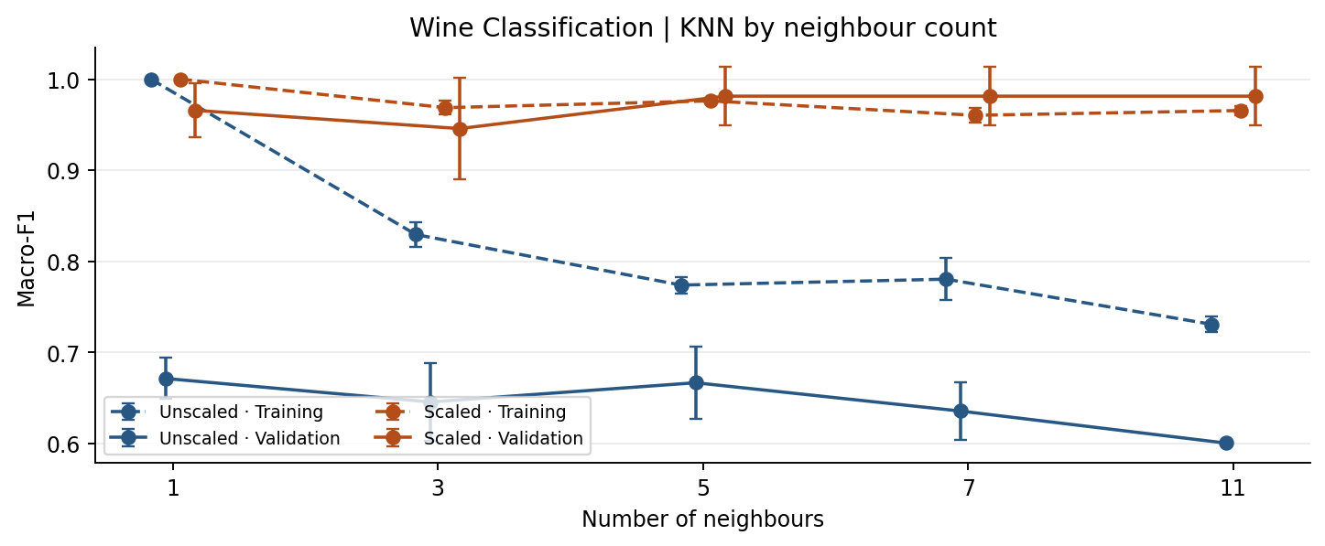
The deepest trees reached training macro-F1 of 1.000 on both datasets. Breast Cancer validation macro-F1 rose from 0.912 at depth 2 to 0.919 at depth 10. Wine reached 0.946 at depth 3 and stayed there at higher depths. Unscaled KNN with k = 1 had perfect training F1 but scored 0.879 on Breast Cancer validation and 0.671 on Wine validation. Error bars show sample SD across the three splits.

8 Breast Cancer Classifier Summary
Each entry shows mean / sample SD across seeds 42, 52 and 62. Tr means training, V means validation, and P, R and F1 are macro averages. Rows follow the selection order, with the selected configuration first.
Algorithm | Input | Depth or k | Tr acc. | Tr F1 | V acc. | V P | V R | V F1 | V AUC
KNN | scaled | 7 | 0.972/0.003 | 0.970/0.003 | 0.971/0.027 | 0.978/0.020 | 0.960/0.036 | 0.968/0.030 | 0.978/0.019
KNN | scaled | 11 | 0.972/0.001 | 0.969/0.002 | 0.965/0.035 | 0.975/0.025 | 0.952/0.048 | 0.961/0.039 | 0.994/0.005
KNN | scaled | 3 | 0.981/0.004 | 0.979/0.004 | 0.959/0.020 | 0.970/0.014 | 0.944/0.027 | 0.955/0.023 | 0.979/0.016
KNN | scaled | 5 | 0.974/0.003 | 0.972/0.003 | 0.959/0.020 | 0.970/0.014 | 0.944/0.027 | 0.955/0.023 | 0.979/0.017
KNN | scaled | 1 | 1.000/0.000 | 1.000/0.000 | 0.942/0.020 | 0.941/0.028 | 0.934/0.016 | 0.937/0.021 | 0.934/0.016
GaussianNB | unscaled | default | 0.937/0.004 | 0.932/0.005 | 0.942/0.020 | 0.938/0.016 | 0.937/0.031 | 0.937/0.023 | 0.980/0.013
GaussianNB | scaled | default | 0.936/0.005 | 0.931/0.006 | 0.930/0.018 | 0.924/0.014 | 0.928/0.029 | 0.925/0.020 | 0.976/0.015
Decision Tree | scaled | 10 | 1.000/0.000 | 1.000/0.000 | 0.924/0.010 | 0.916/0.011 | 0.927/0.017 | 0.919/0.011 | 0.927/0.017
Decision Tree | scaled | None | 1.000/0.000 | 1.000/0.000 | 0.924/0.010 | 0.916/0.011 | 0.927/0.017 | 0.919/0.011 | 0.927/0.017
Decision Tree | unscaled | 10 | 1.000/0.000 | 1.000/0.000 | 0.924/0.010 | 0.916/0.011 | 0.927/0.017 | 0.919/0.011 | 0.927/0.017
Decision Tree | unscaled | None | 1.000/0.000 | 1.000/0.000 | 0.924/0.010 | 0.916/0.011 | 0.927/0.017 | 0.919/0.011 | 0.927/0.017
Decision Tree | scaled | 5 | 0.995/0.004 | 0.995/0.005 | 0.924/0.020 | 0.917/0.018 | 0.923/0.031 | 0.919/0.023 | 0.930/0.025
Decision Tree | unscaled | 5 | 0.995/0.004 | 0.995/0.005 | 0.924/0.020 | 0.917/0.018 | 0.923/0.031 | 0.919/0.023 | 0.930/0.025
Decision Tree | scaled | 3 | 0.976/0.004 | 0.974/0.004 | 0.924/0.027 | 0.920/0.023 | 0.917/0.036 | 0.918/0.030 | 0.941/0.021
Decision Tree | unscaled | 3 | 0.976/0.004 | 0.974/0.004 | 0.924/0.027 | 0.920/0.023 | 0.917/0.036 | 0.918/0.030 | 0.941/0.021
KNN | unscaled | 11 | 0.945/0.003 | 0.940/0.003 | 0.924/0.010 | 0.935/0.015 | 0.903/0.012 | 0.916/0.011 | 0.961/0.031
Decision Tree | scaled | 2 | 0.956/0.004 | 0.953/0.004 | 0.918/0.020 | 0.913/0.016 | 0.912/0.031 | 0.912/0.024 | 0.922/0.040
Decision Tree | unscaled | 2 | 0.956/0.004 | 0.953/0.004 | 0.918/0.020 | 0.913/0.016 | 0.912/0.031 | 0.912/0.024 | 0.922/0.040
KNN | unscaled | 5 | 0.951/0.003 | 0.947/0.003 | 0.918/0.027 | 0.917/0.027 | 0.905/0.031 | 0.911/0.030 | 0.948/0.035
KNN | unscaled | 7 | 0.948/0.003 | 0.944/0.003 | 0.912/0.000 | 0.913/0.007 | 0.897/0.006 | 0.904/0.001 | 0.958/0.029
KNN | unscaled | 3 | 0.959/0.004 | 0.956/0.004 | 0.901/0.041 | 0.900/0.042 | 0.885/0.047 | 0.891/0.045 | 0.930/0.023
KNN | unscaled | 1 | 1.000/0.000 | 1.000/0.000 | 0.889/0.051 | 0.884/0.049 | 0.876/0.063 | 0.879/0.057 | 0.876/0.063

8 Wine Classifier Summary
Each entry shows mean / sample SD across seeds 42, 52 and 62. Tr means training, V means validation, and P, R and F1 are macro averages. Rows follow the selection order, with the selected configuration first.
Algorithm | Input | Depth or k | Tr acc. | Tr F1 | V acc. | V P | V R | V F1 | V AUC
KNN | scaled | 11 | 0.965/0.005 | 0.966/0.005 | 0.981/0.032 | 0.981/0.032 | 0.984/0.027 | 0.981/0.032 | 1.000/0.000
KNN | scaled | 5 | 0.976/0.000 | 0.976/0.001 | 0.981/0.032 | 0.981/0.032 | 0.984/0.027 | 0.981/0.032 | 1.000/0.000
KNN | scaled | 7 | 0.960/0.008 | 0.960/0.008 | 0.981/0.032 | 0.981/0.032 | 0.984/0.027 | 0.981/0.032 | 1.000/0.000
KNN | scaled | 1 | 1.000/0.000 | 1.000/0.000 | 0.963/0.032 | 0.968/0.027 | 0.968/0.027 | 0.966/0.030 | 0.975/0.022
GaussianNB | scaled | default | 0.984/0.000 | 0.984/0.000 | 0.963/0.032 | 0.968/0.029 | 0.966/0.030 | 0.964/0.031 | 1.000/0.000
GaussianNB | unscaled | default | 0.984/0.000 | 0.984/0.000 | 0.963/0.032 | 0.968/0.029 | 0.966/0.030 | 0.964/0.031 | 1.000/0.000
Decision Tree | scaled | 10 | 1.000/0.000 | 1.000/0.000 | 0.944/0.056 | 0.961/0.037 | 0.941/0.061 | 0.946/0.055 | 0.955/0.046
Decision Tree | scaled | 3 | 0.992/0.000 | 0.993/0.000 | 0.944/0.056 | 0.961/0.037 | 0.941/0.061 | 0.946/0.055 | 0.961/0.043
Decision Tree | scaled | 5 | 1.000/0.000 | 1.000/0.000 | 0.944/0.056 | 0.961/0.037 | 0.941/0.061 | 0.946/0.055 | 0.955/0.046
Decision Tree | scaled | None | 1.000/0.000 | 1.000/0.000 | 0.944/0.056 | 0.961/0.037 | 0.941/0.061 | 0.946/0.055 | 0.955/0.046
Decision Tree | unscaled | 10 | 1.000/0.000 | 1.000/0.000 | 0.944/0.056 | 0.961/0.037 | 0.941/0.061 | 0.946/0.055 | 0.955/0.046
Decision Tree | unscaled | 3 | 0.992/0.000 | 0.993/0.000 | 0.944/0.056 | 0.961/0.037 | 0.941/0.061 | 0.946/0.055 | 0.961/0.043
Decision Tree | unscaled | 5 | 1.000/0.000 | 1.000/0.000 | 0.944/0.056 | 0.961/0.037 | 0.941/0.061 | 0.946/0.055 | 0.955/0.046
Decision Tree | unscaled | None | 1.000/0.000 | 1.000/0.000 | 0.944/0.056 | 0.961/0.037 | 0.941/0.061 | 0.946/0.055 | 0.955/0.046
KNN | scaled | 3 | 0.968/0.008 | 0.969/0.008 | 0.944/0.056 | 0.950/0.052 | 0.952/0.048 | 0.946/0.056 | 1.000/0.000
Decision Tree | scaled | 2 | 0.935/0.008 | 0.936/0.011 | 0.852/0.032 | 0.872/0.021 | 0.849/0.049 | 0.848/0.036 | 0.905/0.022
Decision Tree | unscaled | 2 | 0.935/0.008 | 0.936/0.011 | 0.852/0.032 | 0.872/0.021 | 0.849/0.049 | 0.848/0.036 | 0.905/0.022
KNN | unscaled | 1 | 1.000/0.000 | 1.000/0.000 | 0.704/0.032 | 0.689/0.024 | 0.684/0.022 | 0.671/0.023 | 0.765/0.018
KNN | unscaled | 5 | 0.788/0.009 | 0.774/0.009 | 0.704/0.032 | 0.728/0.072 | 0.686/0.029 | 0.667/0.040 | 0.864/0.012
KNN | unscaled | 3 | 0.836/0.012 | 0.829/0.013 | 0.667/0.056 | 0.661/0.050 | 0.652/0.048 | 0.646/0.043 | 0.833/0.031
KNN | unscaled | 7 | 0.790/0.021 | 0.780/0.023 | 0.667/0.000 | 0.647/0.023 | 0.654/0.015 | 0.636/0.032 | 0.846/0.008
KNN | unscaled | 11 | 0.739/0.009 | 0.731/0.008 | 0.630/0.032 | 0.615/0.013 | 0.614/0.021 | 0.600/0.001 | 0.822/0.025

9 Evaluating the Selected Models on the Test Sets
I froze both validation selections before testing. I evaluated the already fitted seed-42 model for each dataset on its fixed test rows. Precision, recall and F1 in the first table are macro averages.
Dataset | Selection | Seed | Val F1 (SD) | Test acc. | Test P | Test R | Test F1 | Test AUC
Breast Cancer | Scaled KNN 7 | 42 | 0.968 (0.030) | 0.974 | 0.980 | 0.964 | 0.971 | 0.989
Wine | Scaled KNN 11 | 42 | 0.981 (0.032) | 1.000 | 1.000 | 1.000 | 1.000 | 1.000
Per-class classification reports on the fixed test sets
Dataset | Class | Precision | Recall | F1 | Support
Breast Cancer | malignant | 1.000 | 0.929 | 0.963 | 42
Breast Cancer | benign | 0.960 | 1.000 | 0.980 | 72
Wine | class_0 | 1.000 | 1.000 | 1.000 | 12
Wine | class_1 | 1.000 | 1.000 | 1.000 | 14
Wine | class_2 | 1.000 | 1.000 | 1.000 | 10
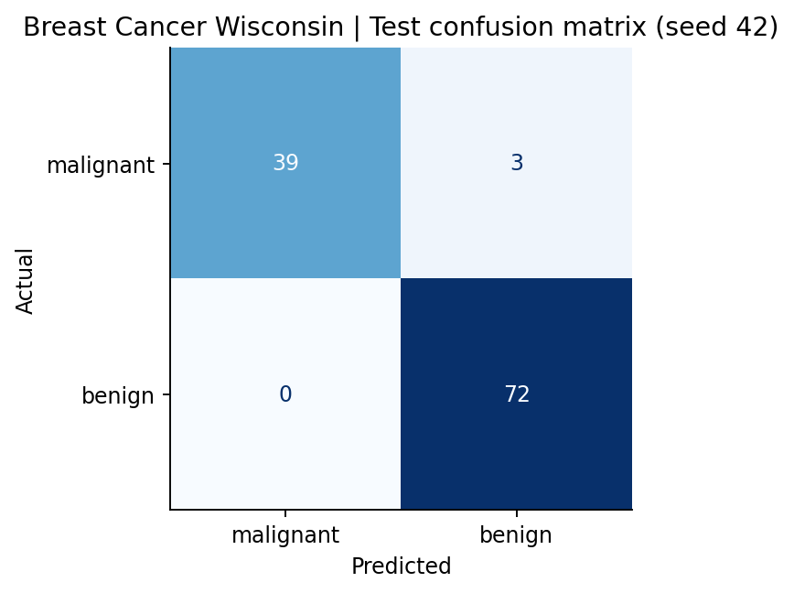 | 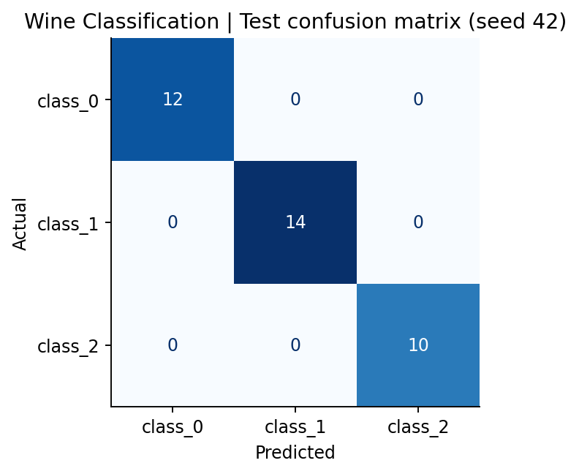

9 Manual Checks ROC Curves and Test Errors
For Breast Cancer, malignant (0) is positive. The first row gives TP = 39 and FN = 3. The second gives FP = 0 and TN = 72. Malignant precision is 39/39 = 1.000, recall is 39/42 = 0.929, and F1 is 78/81 = 0.963. These match the malignant row.
For Wine class_0 versus the other classes, TP = 12, FP = 0, FN = 0 and TN = 24. Precision is 12/12, recall is 12/12 and F1 is 24/24, all 1.000 as in the class_0 row.
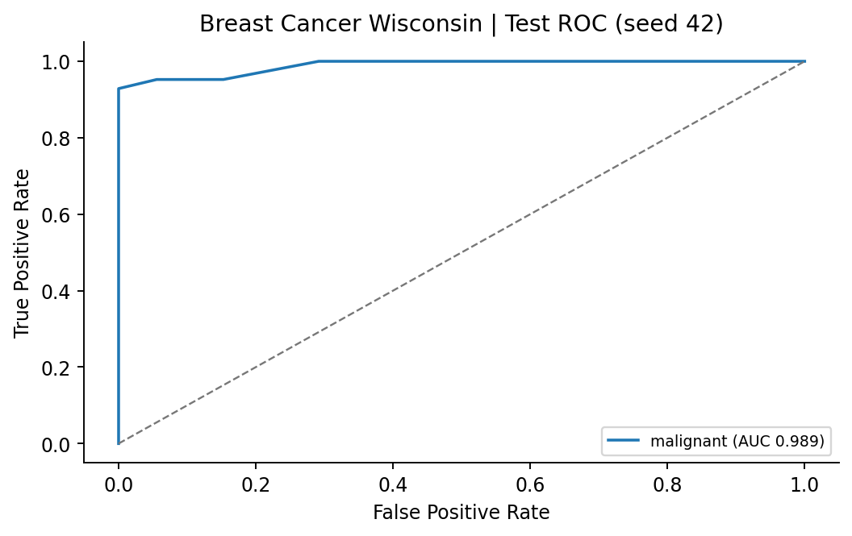 | 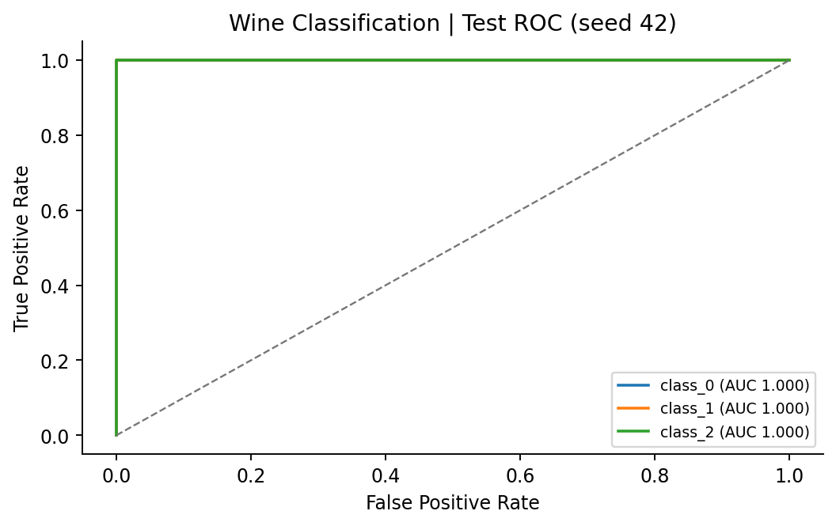
For Breast Cancer, I coded malignant as positive for ROC evaluation and used the fitted model’s probability of original class 0. Its AUC was 0.989. For Wine, I used the ordered class probabilities to draw one curve per class against the rest. Each Wine AUC and their macro average were 1.000.
A lower threshold makes it easier to call a sample positive. That can catch more actual positive cases and increase false positives. A higher threshold can reduce false positives and miss more actual positives. The test curves describe this trade-off. I kept the fitted decision rules.
Breast Cancer test macro-F1 was 0.971 versus 0.968 on average in validation. The model called original row 41 benign even though it was malignant, so it missed that case. In Wine, all off-diagonal counts were zero. Test macro-F1 was 1.000 versus 0.981 in validation. A test set of 36 samples can miss errors that would appear on a new set.
Validation sets had only 57 and 18 samples. The repetitions share many training rows, and final test scores describe a single predeclared seed for each dataset.

10 K Means Clustering
I fitted K-Means on training features without the labels, using two clusters for Breast Cancer and three for Wine. The six fits per dataset used n_init = 10 and the same seed-specific training rows as the classifiers. The classifiers use labels during fitting. I used labels for K-Means only to evaluate ARI and count classes within clusters.
Three-seed K-Means summaries in mean (sample SD) format
Dataset | Input | Training inertia | Validation ARI | Validation silhouette | Valid seeds
Breast Cancer | unscaled | 5.127e+07 (1.95e+06) | 0.504 (0.106) | 0.677 (0.033) | 3 / 3
Breast Cancer | scaled | 7948 (47.57) | 0.581 (0.142) | 0.312 (0.055) | 3 / 3
Wine | unscaled | 1.348e+06 (4.358e+04) | 0.361 (0.068) | 0.577 (0.101) | 3 / 3
Wine | scaled | 879.1 (9.861) | 1.000 (0.000) | 0.275 (0.025) | 3 / 3
Fixed test evaluations using the already fitted seed-42 models
Dataset | Input | Cluster counts by ID | Test ARI | Test silhouette
Breast Cancer | unscaled | C0 = 86, C1 = 28 | 0.558 | 0.712
Breast Cancer | scaled | C0 = 74, C1 = 40 | 0.735 | 0.325
Wine | unscaled | C0 = 14, C1 = 10, C2 = 12 | 0.373 | 0.493
Wine | scaled | C0 = 13, C1 = 13, C2 = 10 | 0.909 | 0.271
Breast Cancer test class versus cluster counts for both inputs
Actual class | Unscaled C0 | Unscaled C1 | Scaled C0 | Scaled C1
malignant | 14 | 28 | 5 | 37
benign | 72 | 0 | 69 | 3
Wine test class versus cluster counts for both inputs
Actual class | Unscaled C0 | Unscaled C1 | Unscaled C2 | Scaled C0 | Scaled C1 | Scaled C2
class_0 | 2 | 10 | 0 | 12 | 0 | 0
class_1 | 5 | 0 | 9 | 1 | 13 | 0
class_2 | 7 | 0 | 3 | 0 | 0 | 10
ARI compares the two partitions and accounts for chance. Cluster numbers can be permuted without changing ARI. Silhouette uses the corresponding feature space. Scaling changes the distance units, so raw inertia and silhouette need to be read in that context.

10 K Means Test Projections
I chose the feature pair with the smallest absolute correlation on seed-42 training data for each dataset. The axes are mean perimeter and fractal dimension error for Breast Cancer, and ash and od280/od315_of_diluted_wines for Wine. Each scatter plot shows two of the features used by the model.
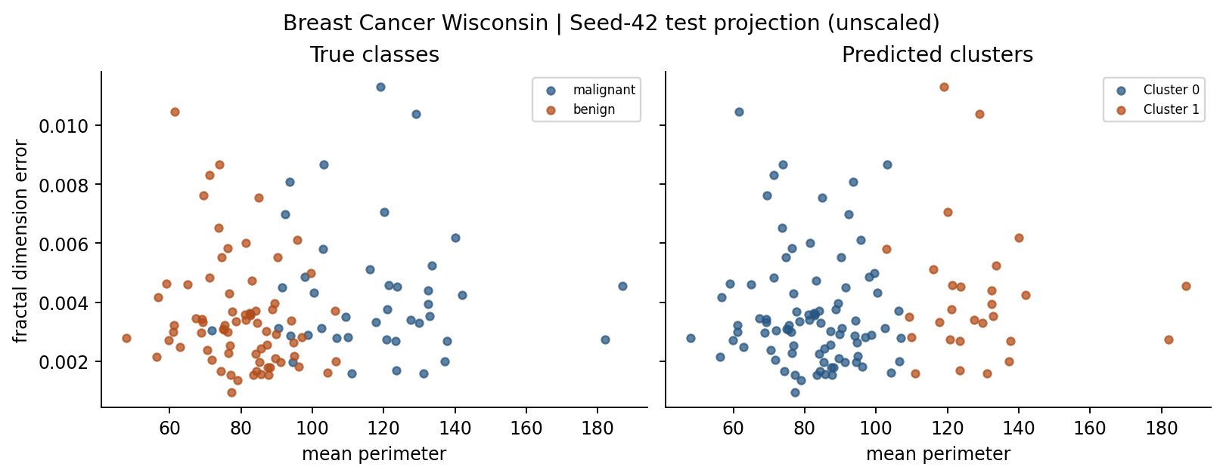 | 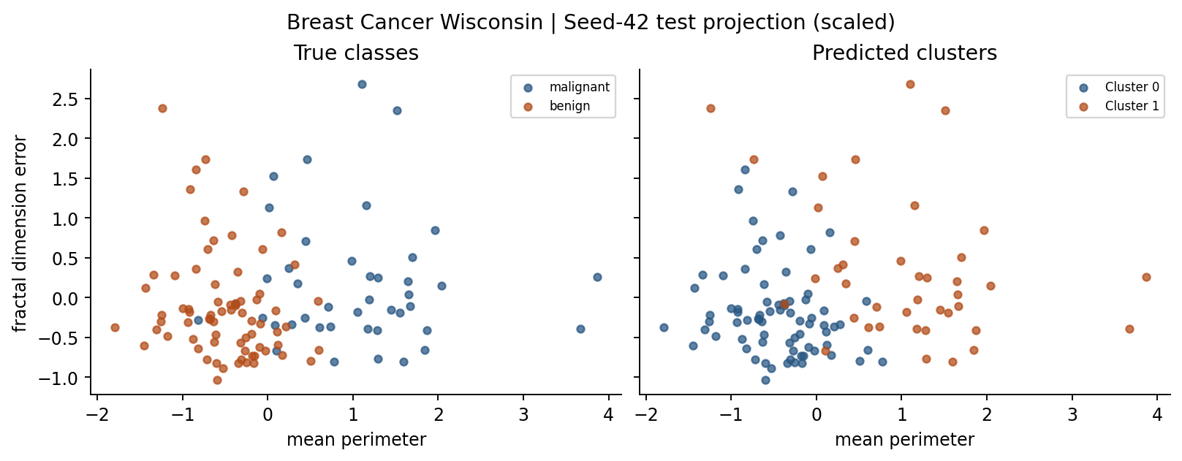
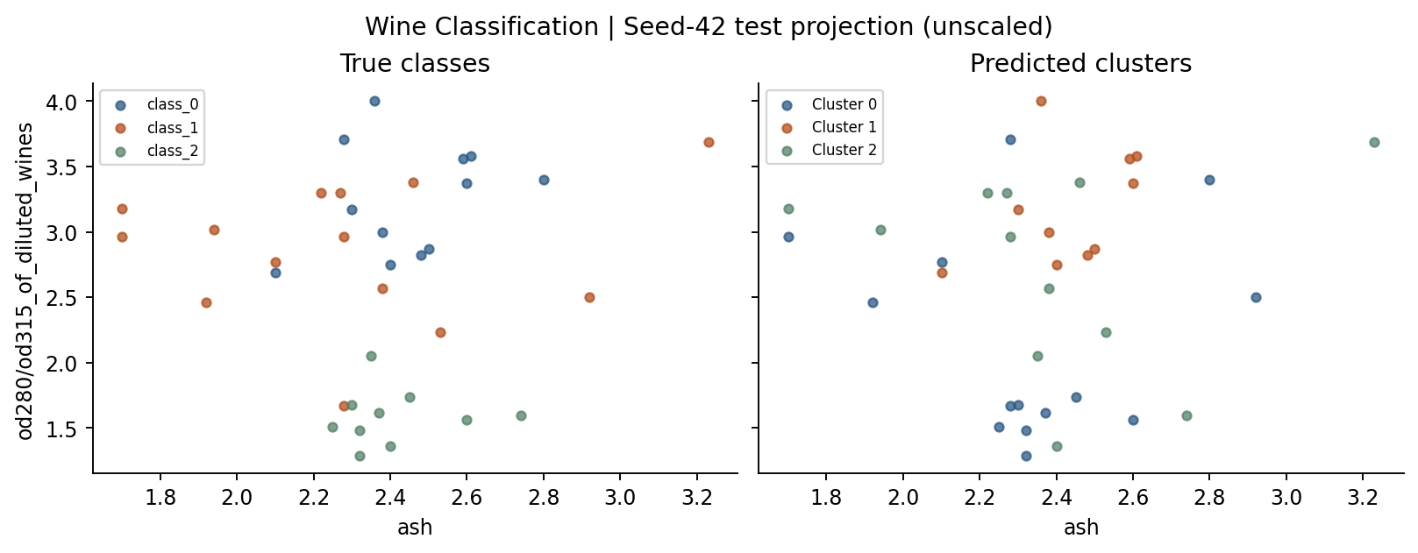 | 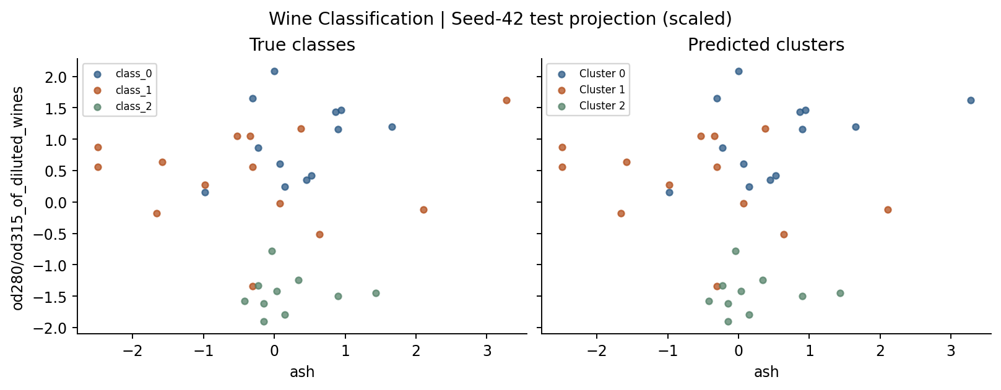
After scaling, more Breast Cancer malignant samples were grouped together in cluster 1, from 28 to 37. Wine’s unscaled cluster 0 mixed all three classes. With scaling, cluster 0 contained 12 class_0 samples and one class_1 sample, while clusters 1 and 2 each contained a single class.

11 Comparing the Two Datasets
Best classifier and representation. Both validation selections were scaled KNN. Breast Cancer selected k = 7 with mean macro-F1 0.968, and Wine selected k = 11 with 0.981. The two selected test macro-F1 scores were 0.971 and 1.000, respectively.
Scaling. KNN changed the most. For Breast Cancer at k = 7, mean validation macro-F1 rose from 0.904 to 0.968. For Wine at k = 11, it rose from 0.600 to 0.981. Tree validation F1 was the same on both representations at each depth. Scaling changes distances used by KNN. Trees split features at thresholds.
Depth, neighbours and variability. Wine trees stayed at 0.946 after depth 3. Scaled Breast Cancer KNN fell from 0.968 at k = 7 to 0.961 at k = 11. For Wine’s unscaled KNN, k = 1 scored 0.671 and k = 11 scored 0.600. Validation F1 SD ranged from 0.001 to 0.057 on Breast Cancer and 0.001 to 0.056 on Wine. The error bars show variation across these overlapping splits.
Errors. Breast Cancer missed three malignant samples and had no false malignant predictions. Wine correctly classified all 36 samples in its fixed test set.
Cluster agreement. Without scaling, Breast Cancer had higher test ARI than Wine (0.558 versus 0.373). With scaling, Wine had higher test ARI (0.909 versus 0.735). The scaled Wine table had one class_1 sample in a cluster dominated by class_0. Both scaled Breast Cancer clusters mixed the two true classes.
Future work. I would try distance-weighted KNN on new validation splits. Giving closer neighbours more weight could change borderline decisions, including malignant recall. I would compare it before a new final test.

12 Required Run and Output Inventory
Each dataset used 66 classifier fits and six K-Means fits. The total is 132 + 12 = 144 model fits. The two classifier and four clustering test evaluations reuse fitted seed-42 models.
Result CSV | Rows | Result CSV | Rows
classifier_runs.csv | 132 | kmeans_runs.csv | 12
classifier_summary.csv | 44 | kmeans_summary.csv | 4
classifier_test.csv | 2 | kmeans_test.csv | 4
The project includes both executed notebooks and 21 figures. The notebooks contain the full split indices, quality checks, before and after scaling tables, and run tables. The README lists the Python and package versions used for reproduction.
Repository URL https://github.com/batuhanomerer/machine-learning
Walkthrough video https://youtu.be/7TwU40EB4kI

Appendix A Breast Cancer Descriptive Statistics
Values describe the full dataset. Feature numbers match the correlation heatmap. SD is the sample standard deviation.
No. | Feature | Mean | Median | Min | Max | SD | Q1 | Q3
1 | mean radius | 14.127 | 13.37 | 6.981 | 28.11 | 3.524 | 11.7 | 15.78
2 | mean texture | 19.29 | 18.84 | 9.71 | 39.28 | 4.301 | 16.17 | 21.8
3 | mean perimeter | 91.969 | 86.24 | 43.79 | 188.5 | 24.299 | 75.17 | 104.1
4 | mean area | 654.89 | 551.1 | 143.5 | 2501 | 351.91 | 420.3 | 782.7
5 | mean smoothness | 0.09636 | 0.09587 | 0.05263 | 0.1634 | 0.014064 | 0.08637 | 0.1053
6 | mean compactness | 0.10434 | 0.09263 | 0.01938 | 0.3454 | 0.052813 | 0.06492 | 0.1304
7 | mean concavity | 0.088799 | 0.06154 | 0 | 0.4268 | 0.07972 | 0.02956 | 0.1307
8 | mean concave points | 0.048919 | 0.0335 | 0 | 0.2012 | 0.038803 | 0.02031 | 0.074
9 | mean symmetry | 0.18116 | 0.1792 | 0.106 | 0.304 | 0.027414 | 0.1619 | 0.1957
10 | mean fractal dimension | 0.062798 | 0.06154 | 0.04996 | 0.09744 | 0.0070604 | 0.0577 | 0.06612
11 | radius error | 0.40517 | 0.3242 | 0.1115 | 2.873 | 0.27731 | 0.2324 | 0.4789
12 | texture error | 1.2169 | 1.108 | 0.3602 | 4.885 | 0.55165 | 0.8339 | 1.474
13 | perimeter error | 2.8661 | 2.287 | 0.757 | 21.98 | 2.0219 | 1.606 | 3.357
14 | area error | 40.337 | 24.53 | 6.802 | 542.2 | 45.491 | 17.85 | 45.19
15 | smoothness error | 0.007041 | 0.00638 | 0.001713 | 0.03113 | 0.0030025 | 0.005169 | 0.008146
16 | compactness error | 0.025478 | 0.02045 | 0.002252 | 0.1354 | 0.017908 | 0.01308 | 0.03245
17 | concavity error | 0.031894 | 0.02589 | 0 | 0.396 | 0.030186 | 0.01509 | 0.04205
18 | concave points error | 0.011796 | 0.01093 | 0 | 0.05279 | 0.0061703 | 0.007638 | 0.01471
19 | symmetry error | 0.020542 | 0.01873 | 0.007882 | 0.07895 | 0.0082664 | 0.01516 | 0.02348
20 | fractal dimension error | 0.0037949 | 0.003187 | 0.0008948 | 0.02984 | 0.0026461 | 0.002248 | 0.004558
21 | worst radius | 16.269 | 14.97 | 7.93 | 36.04 | 4.8332 | 13.01 | 18.79
22 | worst texture | 25.677 | 25.41 | 12.02 | 49.54 | 6.1463 | 21.08 | 29.72
23 | worst perimeter | 107.26 | 97.66 | 50.41 | 251.2 | 33.603 | 84.11 | 125.4
24 | worst area | 880.58 | 686.5 | 185.2 | 4254 | 569.36 | 515.3 | 1084
25 | worst smoothness | 0.13237 | 0.1313 | 0.07117 | 0.2226 | 0.022832 | 0.1166 | 0.146
26 | worst compactness | 0.25427 | 0.2119 | 0.02729 | 1.058 | 0.15734 | 0.1472 | 0.3391
27 | worst concavity | 0.27219 | 0.2267 | 0 | 1.252 | 0.20862 | 0.1145 | 0.3829
28 | worst concave points | 0.11461 | 0.09993 | 0 | 0.291 | 0.065732 | 0.06493 | 0.1614
29 | worst symmetry | 0.29008 | 0.2822 | 0.1565 | 0.6638 | 0.061867 | 0.2504 | 0.3179
30 | worst fractal dimension | 0.083946 | 0.08004 | 0.05504 | 0.2075 | 0.018061 | 0.07146 | 0.09208

Appendix A Wine Descriptive Statistics
Values describe the full dataset. Feature numbers match the correlation heatmap. SD is the sample standard deviation.
No. | Feature | Mean | Median | Min | Max | SD | Q1 | Q3
1 | alcohol | 13.001 | 13.05 | 11.03 | 14.83 | 0.81183 | 12.362 | 13.678
2 | malic_acid | 2.3363 | 1.865 | 0.74 | 5.8 | 1.1171 | 1.6025 | 3.0825
3 | ash | 2.3665 | 2.36 | 1.36 | 3.23 | 0.27434 | 2.21 | 2.5575
4 | alcalinity_of_ash | 19.495 | 19.5 | 10.6 | 30 | 3.3396 | 17.2 | 21.5
5 | magnesium | 99.742 | 98 | 70 | 162 | 14.282 | 88 | 107
6 | total_phenols | 2.2951 | 2.355 | 0.98 | 3.88 | 0.62585 | 1.7425 | 2.8
7 | flavanoids | 2.0293 | 2.135 | 0.34 | 5.08 | 0.99886 | 1.205 | 2.875
8 | nonflavanoid_phenols | 0.36185 | 0.34 | 0.13 | 0.66 | 0.12445 | 0.27 | 0.4375
9 | proanthocyanins | 1.5909 | 1.555 | 0.41 | 3.58 | 0.57236 | 1.25 | 1.95
10 | color_intensity | 5.0581 | 4.69 | 1.28 | 13 | 2.3183 | 3.22 | 6.2
11 | hue | 0.95745 | 0.965 | 0.48 | 1.71 | 0.22857 | 0.7825 | 1.12
12 | od280/od315_of_diluted_wines | 2.6117 | 2.78 | 1.27 | 4 | 0.70999 | 1.9375 | 3.17
13 | proline | 746.89 | 673.5 | 278 | 1680 | 314.91 | 500.5 | 985

