ISTINYE UNIVERSITY

BA DEGREE PROJECT II

THE IMPACT OF MACHINE LEARNING-BASED CREDIT
SCORING MODELS ON THE ACCURACY OF LOAN DEFAULT
PREDICTION IN BANKING

A Literature Review and Research Methodology

Batuhan SEN
200527078

ISTANBUL - 2026

TABLE OF CONTENTS
TABLE OF CONTENTS iii
LIST OF FIGURES vi
LIST OF TABLES vii
LIST OF ABBREVIATIONS viii
ABSTRACT ix
1. INTRODUCTION 1
1.1. Background and Context 1
1.2. Research Question 2
1.3. Scope of the Study 3
2. CREDIT RISK AND TRADITIONAL APPROACHES 5
2.1. Understanding Credit Risk 5
2.2. Traditional Scoring Methods 6
2.3. Limitations of Traditional Models 7
3. MACHINE LEARNING IN CREDIT SCORING 9
3.1. Tree-Based and Ensemble Methods 9
3.2. Gradient Boosting Algorithms 10
3.3. Neural Networks and Deep Learning 11
3.4. Data Preparation Challenges 13
4. PERFORMANCE AND PRACTICAL ISSUES 15
4.1. Evaluation Metrics 15
4.2. The Black Box Problem 15
4.3. Regulatory Landscape 17
4.4. Fairness and Ethics 18
5. METHODOLOGY 20
5.1. Research Design 20
5.2. Dataset Description 20
5.3. Data Preprocessing 21
5.4. Model Selection and Configuration 23
5.5. Evaluation Framework 24
5.6. Experimental Procedure 24
5.7. Tools and Software Environment 25
5.8. Ethical Considerations and Limitations 26
6. APPLICATION AND ANALYSIS PROCESS 28
6.1. Data Acquisition and Environment 28
6.2. Exploratory Data Analysis 29
6.3. Data Preprocessing Implementation 34
6.4. Model Training Procedure 35
7. FINDINGS 37
7.1. Model Performance Comparison 37
7.2. Statistical Significance Testing 39
7.3. Feature Importance and Interpretability 40
7.4. Robustness: The Impact of Class-Imbalance Strategy 41
7.5. Discussion of Findings 42
8. CONCLUSION 44
REFERENCES 47
APPENDIX A: DATA DICTIONARY OF PRINCIPAL VARIABLES 51
APPENDIX B: HYPERPARAMETER SEARCH SPACES 53
APPENDIX C: DETAILED PERFORMANCE RESULTS 54
APPENDIX D: SOFTWARE ENVIRONMENT AND REPRODUCIBILITY 56
APPENDIX E: SOURCE CODE LISTING 58
APPENDIX F: GLOSSARY OF KEY TERMS 64

LIST OF FIGURES
Figure 6.1 Distribution of the target variable (0 = repaid, 1 = default).
Figure 6.2 Twenty variables with the highest proportion of missing values.
Figure 6.3 Distributions of key numerical variables.
Figure 6.4 The DAYS_EMPLOYED anomaly before and after cleaning.
Figure 6.5 External credit scores by default status.
Figure 6.6 Default rate across categorical groups.
Figure 6.7 Strongest linear correlations with the target.
Figure 6.8 Correlation heatmap of key variables.
Figure 6.9 Engineered banking ratios by default status.
Figure 7.1 ROC curves for the four models on the test set.
Figure 7.2 AUC-ROC comparison across models.
Figure 7.3 Confusion matrices at F1-optimal thresholds.
Figure 7.4 SHAP summary plot for the best-performing model.
Figure 7.5 Effect of the class-imbalance strategy on model AUC.

LIST OF TABLES
Table 2.1 Comparison of Traditional Credit Scoring Methods
Table 3.1 Performance Comparison of Machine Learning Algorithms
Table 5.1 Dataset Overview
Table 5.2 Model Hyperparameter Search Spaces
Table 6.1 Feature selection results by stage
Table 7.1 Test-set performance of the four models (SMOTE pipeline)
Table 7.2 Paired t-tests of cross-validation AUC (Bonferroni alpha = 0.0083)
Table 7.3 Cross-validation AUC by imbalance strategy

LIST OF ABBREVIATIONS
AI Artificial Intelligence
AUC-ROC Area Under the Receiver Operating Characteristic Curve
BDDK Banking Regulation and Supervision Agency (Turkey)
CV Cross-Validation
ECOA Equal Credit Opportunity Act (United States)
GDPR General Data Protection Regulation (European Union)
Gini Gini Coefficient (2 x AUC - 1)
GNN Graph Neural Network
IQR Interquartile Range
KS Kolmogorov-Smirnov statistic
LightGBM Light Gradient Boosting Machine
LIME Local Interpretable Model-agnostic Explanations
LSTM Long Short-Term Memory network
ML Machine Learning
RF Random Forest
ROC Receiver Operating Characteristic
SHAP SHapley Additive exPlanations
SMOTE Synthetic Minority Over-sampling Technique
SR 11-7 U.S. Federal Reserve Supervisory Guidance on Model Risk Management
XGBoost Extreme Gradient Boosting

ABSTRACT
Over the past decade, banks have come to rely on machine learning when deciding who receives credit, a shift driven as much by competitive pressure and growing volumes of applicant data as by the algorithms themselves. Across the studies reviewed here, ensemble methods such as XGBoost and Random Forest achieve higher predictive accuracy than traditional logistic regression, with reported AUC improvements of 5-10 percent (Lessmann et al., 2015; Ayari et al., 2025). Regulators expect reasons for each lending decision. Models that gain in accuracy often give up interpretability in the process, which makes those justifications harder to produce for applicants.
Default events make up only 2-5 percent of loan portfolios (Chawla et al., 2002), which leaves standard algorithms struggling with severe class imbalance. Discrimination is a second concern, since models can carry forward historical biases present in training data (Barocas and Selbst, 2016; Kozodoi et al., 2022). Against this background, the study compares logistic regression, Random Forest, XGBoost, and LightGBM on the Home Credit dataset (307,511 applications), tuned via randomized search with AUC-ROC as the primary metric. Under appropriate imbalance handling, gradient boosting (AUC approximately 0.745) holds only a marginal advantage over logistic regression (0.741). The ranking is fragile, however: a robustness analysis shows SMOTE substantially degrading the tree-based models while leaving logistic regression unaffected, enough to change which model comes out ahead. External credit scores dominate the SHAP analysis. Careful data preparation and honest imbalance handling, on this evidence, matter at least as much as the choice of algorithm.
Keywords: Banking, Credit Scoring, Machine Learning, Default Prediction, Interpretability

1. INTRODUCTION

1.1. Background and Context
Credit risk assessment sits at the center of banking. A bank that extends credit accepts uncertainty about whether the money comes back, and when that judgment goes wrong, the damage rarely stays within one institution. The 2008 financial crisis showed how misjudged risk can cascade through interconnected financial systems, as Khandani et al. (2010) document. When many institutions misjudge credit quality at the same time, systemic risk follows, with withdrawals and asset liquidations occurring simultaneously. Individual banks still have to manage credit risk on their own account. Their solvency depends on it. The core difficulty is assessing risk accurately in complex, uncertain conditions.
Scoring decisions also affect the wider economy in less visible ways. How banks collectively judge creditworthiness determines how much capital flows to different sectors and who can get credit at all. If assessment mechanisms favor particular groups or sectors, allocation turns inefficient and resources may end up in unproductive uses; better scoring, by contrast, steers capital toward productive investment. The stakes are not purely financial. Employment, housing, and business formation all depend in part on access to credit, so a scoring system that malfunctions imposes real costs on individuals and on society.
In the mid-20th century, statistical methods began to displace subjective judgment in credit assessment. Lenders had previously relied on personal impressions, which left decisions open to bias and inconsistency. Scoring changed that. It introduced a degree of objectivity and made standardized decisions possible across large applicant pools. Logistic regression became the standard tool largely because its coefficients could be read directly and explained to non-specialists, and because regulators were willing to accept transparent models (Thomas et al., 2017). Legal requirements pushed in the same direction: the U.S. Equal Credit Opportunity Act requires lenders to explain denials, so for practical purposes interpretability was mandated by law.
The past fifteen years changed this picture. Computing power grew rapidly and far more applicant data became available. Banks can now draw on hundreds or thousands of applicant variables (income sources, transaction histories, employment records, behavioral signals), more than traditional models can incorporate effectively. Machine learning is built for this situation; it handles high-dimensional data and picks up complex patterns that traditional methods cannot. It looked like a real opening for credit assessment. Yet adoption stayed gradual, constrained by regulatory uncertainty and operational concerns.
Whether machine learning genuinely improves loan default prediction is the central question of this study. Stated like that, it sounds simple. In practice it is not, because a gain in accuracy can come with a loss of interpretability, and a one-percent AUC improvement might not justify the compliance complications it brings. This ambiguity is part of why credit scoring has adopted machine learning more cautiously than other domains have. Institutions end up weighing real performance gains against regulatory friction and operational difficulty.
"Better" is not a straightforward term in banking applications. Accuracy alone is an incomplete criterion. A complex model that reaches 82 percent accuracy but resists explanation may serve a bank worse than a simpler 81 percent accurate model that stakeholders understand and trust. Regulators are wary of models they cannot scrutinize, business units tend not to trust black-box scores, and the burden of maintaining an unexplainable system accumulates over years. None of this justifies dismissing machine learning outright. The more useful question is whether institutions can design implementations that capture accuracy gains while remaining usable, and that requires understanding both the promise and the limits of each methodology.

1.2. Research Question
This study pursues a specific investigation: "To what extent do machine learning-based credit scoring models enhance default prediction accuracy compared to traditional statistical approaches, and what practical constraints accompany such implementation?" Several dimensions sit inside that question. Part of the answer is historical (why logistic regression held on for so long), part concerns which algorithms practitioners are actually adopting now, and part is about what gets sacrificed when higher accuracy becomes the target. Answering it means pulling together research from both the machine learning and banking literatures.
Deployment raises issues beyond raw accuracy. Whether models hold their performance across loan types and customer segments is unclear, as is how a trained model behaves once economic conditions diverge sharply from the training period, or whether compliance obligations can be met with complex algorithms at all. These constraints often decide the matter. An academically superior model counts for little if an institution cannot deploy it operationally or defend it to regulators.
The review concentrates on supervised learning, where models are trained on labeled historical data. Unsupervised and reinforcement learning get only brief treatment; their credit scoring applications remain limited. Coverage spans roughly 2015-2025. Recent work receives the most weight, given how quickly the algorithms have been developing, though older foundational references are retained wherever they still inform current discussion. That window captures machine learning's move from research curiosity to practical banking tool.

1.3. Scope of the Study
Sources come from finance, operations research, and machine learning journals. Preprints and working papers are included where they document developments too recent for the journal literature. The datasets behind these studies vary widely, from benchmark collections such as the German Credit Dataset to proprietary bank portfolios that come closer to real-world conditions. Benchmarks allow comparison across studies. Proprietary data, on the other hand, captures the implementation problems institutions actually face.
Geographically, the scope is kept broad, covering developed and emerging markets. Developed economies get most of the attention, since their regulatory frameworks and data access are more mature. Emerging market research adds something distinctive: mobile lending platforms in Africa, for example, or alternative credit data in India, along with fintech work across Asian markets, all show credit assessment adapting to different contexts. The review covers consumer and small-business lending. Corporate credit assessment is left out, because assessment at that scale rests on fundamentally different approaches.
The remainder proceeds as follows. Section 2 covers credit risk fundamentals and the traditional assessment methods against which newer techniques are judged, and Section 3 turns to the machine learning algorithms, their mechanisms and documented performance. Interpretability, regulation, and fairness, the concerns that decide whether a model can operate inside a bank, are taken up in Section 4. Section 5 sets out the empirical methodology for comparative testing. Section 6 brings the findings together and points to future research.

2. CREDIT RISK AND TRADITIONAL APPROACHES

2.1. Understanding Credit Risk
At its core, credit risk is the possibility that a borrower fails to meet obligations. In practice the concept splits into several parts. Default risk asks whether payments will be missed at all; exposure risk is about how much money is at stake when that happens, and recovery risk about how much can later be recouped through collateral or collection. Recovery varies widely. Secured loans often recover 70-80 percent of exposure, while unsecured loans frequently recover nothing. This review concentrates on default risk, since default is the target most credit scoring models are built to predict (Basel Committee on Banking Supervision, 2006), though recovery still matters for judging which defaults hurt most.
What counts as a default is not settled. Some banks classify a loan as defaulted after 30 days of missed payment, others wait until 90 days have passed, and although Basel II and III standardized definitions for regulatory capital purposes, operational definitions inside individual institutions still differ. This complicates comparisons across studies. A model built to predict 30-day delinquency is working with a different population than one targeting 90-day defaults, so reported performance figures are not directly comparable, a point worth keeping in mind throughout this review.
Solvency is one reason banks invest in risk assessment. Capital requirements scale with credit exposure: under Basel III, banks must hold capital equal to specified percentages of risk-weighted assets, and the weightings depend on estimated default probabilities. A bank that underestimates default risk holds too thin a buffer, which becomes dangerous in downturns when defaults spike and undercapitalized institutions face insolvency. The 2008 crisis made this concrete. Regulators worldwide intensified scrutiny of bank risk management and model validation, and much of the present attention to improving default prediction traces back to these capital rules.
The consequences of credit risk do not stop at a single bank. When many institutions take losses at once, the problem becomes systemic. In 2008, lending errors that would each have been manageable in isolation accumulated across thousands of institutions and ended in economic collapse (Crook et al., 2007). Regulators remember this. Part of their determination to improve credit assessment comes from the recognition that better default prediction protects individual lenders and, in aggregate, the stability of the system.
During the 1950s and 1960s, Fair Isaac Corporation and similar organizations gradually introduced statistical credit scoring, a genuine innovation that replaced subjective judgment with systematic analysis. Lenders had previously assessed borrowers through personal evaluation, a process subjective by nature and open to bias. Statistical methods promised objectivity and consistency. A lending committee could now apply one identical standard to thousands of applications. Standardized scoring had real consequences: applicants who could demonstrate objective creditworthiness found credit easier to obtain, and systematic bias became harder to conceal (Anderson, 2007).

2.2. Traditional Scoring Methods
Logistic regression held its position in banking for decades, for reasons that were partly mathematical and partly practical. The model estimates default probability as a function of applicant characteristics, with each variable receiving a coefficient that shows its incremental contribution to risk: a higher debt-to-income ratio raises the predicted probability, a longer employment history lowers it. The math is old and well understood. Just as important, results could be explained to non-technical audiences, and that mattered because regulators wanted to see how scores were produced while applicants wanted reasons for decisions (Lessmann et al., 2015).
Coefficients in a logistic regression have a precise meaning: each one represents the change in log-odds associated with a one-unit change in that predictor. Explanation follows directly. A bank that denies an applicant can point to specific factors and quantify how much each contributed, and a regulator examining the model can trace exactly how a decision was reached. This transparency carried considerable practical weight in heavily regulated environments, and it is easy to underrate even now, since in many jurisdictions explaining a credit decision is a formal requirement.
In day-to-day banking, logistic regression usually reaches staff in the form of a credit scorecard. Instead of regression coefficients, the scorecard assigns points to categories of each variable: employment exceeding two years might be worth 30 points, income above a certain threshold 50 points, and the points from all variables sum to a total score. The total then determines approval and the interest rate offered. It is business language, not mathematics. Scorecards keep decisions consistent and make conversations with regulators and applicants easier, while losing none of the interpretability of the underlying regression (Siddiqi, 2012).
Building a traditional scorecard takes time. The work starts with variable selection, guided by availability, predictive power, and business logic; candidate variables must be observable at application time and cannot include protected characteristics. Continuous variables are then binned into categories, each category weighted by its observed default rate. Validation on held-out data comes before any deployment, and once a scorecard is live its performance is monitored on an ongoing basis. In practice the whole exercise consumes weeks or months of analyst effort.
Linear discriminant analysis is another classical technique worth mentioning, historically important even if rarely used today. It looks for linear combinations of features that best separate defaulters from non-defaulters, under the assumption that both groups follow multivariate normal distributions with equal covariance matrices. Reality rarely satisfies those assumptions exactly. When they hold approximately, the method can still perform adequately, and its computational simplicity and well-developed theory gave it a certain appeal. Logistic regression eventually won out as more flexible and practical.
Table 2.1: Comparison of Traditional Credit Scoring Methods
Method | Advantages | Disadvantages | Typical Application
Logistic Regression | Highly interpretable, Fast training, Strong regulatory acceptance | Cannot capture non-linear relationships without feature engineering | Retail lending, Credit cards
Linear Discriminant Analysis | Computationally efficient, Well-understood theory | Requires distributional assumptions that rarely hold | Homogeneous loan portfolios
Scorecards | Maximum transparency, Easy communication to stakeholders | Requires extensive manual feature engineering | Consumer credit decisions

2.3. Limitations of Traditional Models
The basic weakness of logistic regression is its linearity assumption. Few real-world relationships behave linearly in log-odds space. The effect of income on default risk may look quite different for a heavily indebted borrower than for one with little debt (an interaction effect), and the relationship between age and default may be U-shaped rather than linear. A linear model cannot pick up such patterns unless someone engineers them in explicitly (Ayari et al., 2025), and knowing which interactions to build requires domain expertise or costly exploratory work. Patterns that nobody anticipates simply stay hidden.
Manual feature engineering is another heavy demand of traditional models. An analyst picks variables using statistical tests and business judgment, decides how to transform them, whether continuous predictors should be binned, and what to do about missing data, all of which takes real domain expertise and time. The results are not consistent. Work that occupies a skilled analyst for two months might be done better, or worse, by someone else at another institution. Next to modern algorithmic approaches this subjectivity seems almost quaint.
Class imbalance is a practical headache. At a 3 percent default rate, non-defaults outnumber defaults by a wide margin, and a method that optimizes overall accuracy will tend to predict the majority class, missing many of the defaults it was built to catch. The events institutions most need to predict are the hardest to detect. The costs are asymmetric too: a missed default can mean substantial loss, while misclassifying a sound borrower only costs foregone interest income. Standard statistical methods offer no native way to handle this asymmetry.
Stability over time is a further difficulty. A credit scoring model learns from historical data, and economies do not stand still; models developed during expansions perform poorly in recessions because default patterns shift fundamentally (Wang et al., 2012). Adapting a traditional model essentially means rebuilding it, which consumes months of time and resources. The choice facing a bank is therefore to keep running an outdated model or to rebuild continually. Neither option is satisfactory.

3. MACHINE LEARNING IN CREDIT SCORING

3.1. Tree-Based and Ensemble Methods
Decision trees take a different route to classification. No equation gets fitted. The data are instead split through a chain of binary questions: Is income above 50,000? A later split might test whether the credit amount exceeds three times annual income, with the recursion continuing until terminal nodes are reached and predictions delivered. Because the partitioning happens recursively, non-linear relationships and interactions get picked up without anyone specifying them in advance (Butaru et al., 2016). For practitioners used to logistic regression, this decision logic feels unusually direct.
Interpretability is the practical draw here. A tree can be drawn as a flowchart, so tracing how any individual prediction was reached is straightforward, and the transparency holds up against scorecard approaches while handling more complicated relationships. The weakness is instability. Small changes to the training data can produce substantially different tree structures, which raises reliability concerns; for lending applications that must run in production, an unstable model creates operational problems even when test-set accuracy looks fine.
Overfitting is the other problem. Left unconstrained, a tree eventually memorizes the training data perfectly, giving each observation its own leaf. That is machine learning's bias-variance tradeoff in nearly literal form: too simple a model misses important patterns, while an overly complex one fits noise along with signal. Picking the right complexity level is hard. The usual remedy grows a full tree and prunes it back, though deciding where pruning should stop requires held-out data.
Ensembles offer a way out. Rather than relying on one tree, many are built and their predictions pooled. Random Forest, developed by Breiman (2001), trains numerous trees, each on its own bootstrap sample and each restricted to a random feature subset at every split, then combines the outputs through voting or averaging. The randomization yields trees diverse enough that the collection outperforms any single member (Wang et al., 2012). Accuracy improves, and stability does too, since averaging dampens the variance of individual trees.
Random Forest performs well in credit scoring studies. It copes with non-linear patterns, and the same aggregation that limits overfitting also produces feature importance measures useful for interpretation. Reported gains over logistic regression mostly fall in the 2 to 8 percent AUC range, depending on data and implementation, at least in the studies reviewed. That sounds modest. On million-loan portfolios, though, gains of this size carry real financial weight, which is much of why Random Forest became one of banking's most widely adopted machine learning methods: it balances performance with practical usability.
Computation is rarely the obstacle. Because each tree is built independently, fitting parallelizes cleanly across processors, and scoring a new application means passing it through every tree and pooling the results, which executes quickly even for large ensembles. Speed of this sort, alongside solid empirical performance, helps explain the wide adoption in banking. For institutions unwilling or unable to deploy more complex approaches, Random Forest became an accessible entry point into machine learning.

3.2. Gradient Boosting Algorithms
Gradient boosting works differently. Where Random Forest grows trees in parallel, boosting builds them one after another, each new tree trained to correct the errors of those before it, so attention keeps shifting toward observations the model has misclassified so far. The refinement often beats Random Forest on performance. Its price is that sequential training cannot be parallelized; in practice boosting trains more slowly but tends to buy somewhat better optimization.
Underneath, the method is gradient descent on a loss function. Training starts from a simple baseline prediction. Each subsequent tree is fit to the negative gradient of the loss, which points in the direction of steepest improvement, so adding a scaled tree moves the predictions toward better values, tree after tree, until validation performance plateaus or a stopping rule kicks in. The mathematics is old, drawn from optimization theory established decades ago; the recent innovation lies in applying these ideas to tree-based models.
XGBoost, introduced by Chen and Guestrin (2016), strengthened boosting both statistically and computationally. The statistical part is regularization. L1 and L2 penalties on leaf weights keep overfitting in check, while histogram-based split finding and distributed computing support let the implementation handle large datasets efficiently. XGBoost consistently ranks near the top in machine learning competitions, credit scoring is one of its strongest application areas, and the mix of empirical strength and practical scalability made it exceptionally influential in industry adoption.
Against Random Forest, the reported edge is typically a further 3-5 percent AUC, stacking onto the advantage over logistic regression; cumulative improvements often exceed 10 percent AUC in total, a substantial gain in discriminatory power (Xia et al., 2017). The practical consequences follow. Banks implementing XGBoost report meaningful default prediction improvements, lower losses with approval rates held steady or improved, and results like these accelerated adoption across banking institutions.
Newer boosting variants refine the formula. LightGBM, from Microsoft, speeds up training through leaf-wise tree growth and gradient-based one-side sampling, which helps once banking datasets grow large (Ma et al., 2018). CatBoost, from Yandex, takes a different angle. Its ordered target encoding handles categorical variables without information leakage, and since credit applications are full of such variables (employment type, loan purpose, geographic region), that specialization matters in practice.
Ayari et al., in a 2025 review covering 63 credit scoring studies, found gradient boosting ahead across datasets and evaluation criteria, with average AUC improvements of 5 to 10 percent over logistic regression; XGBoost and LightGBM did particularly well. The pattern is hard to dismiss. Separate research groups have reached the same conclusion on different datasets and at different points in time, which lends weight to the claim that gradient boosting genuinely outperforms the alternatives for default prediction.
Table 3.1: Performance Comparison of Machine Learning Algorithms
Algorithm | Typical AUC Range | Training Speed | Interpretability
Logistic Regression | 0.70 - 0.75 | Very Fast | High
Random Forest | 0.75 - 0.80 | Moderate | Medium
XGBoost | 0.78 - 0.85 | Moderate | Low
LightGBM | 0.78 - 0.85 | Fast | Low
Neural Networks | 0.75 - 0.82 | Slow | Very Low

3.3. Neural Networks and Deep Learning
Neural networks arrived in credit scoring on the strength of successes elsewhere, above all in image and language tasks. Tabular financial data is another matter. The evidence so far points to modest advantages at best for standard credit applications, which sits awkwardly with the popular view of neural networks as the frontier of machine learning. For tabular credit data, gradient boosting has proven the more practical and the better-performing option.
Feedforward networks, also called multilayer perceptrons, stack layers of interconnected nodes that transform inputs through nonlinear activations, and given sufficient data they can in principle learn arbitrary functions, a property that suits complex patterns. Credit data tells a quieter story. Performance there generally matches or slightly exceeds tree-based methods, depending on architecture and training procedure (Beque and Lessmann, 2017). The equivalence is itself instructive; these networks offer no obvious advantage while bringing extra complications.
Flexibility has a price. Compared with tree-based methods, neural networks are harder to interpret; they also demand more hyperparameter tuning and generally more training data before they perform well. Automatic feature learning is the genuine attraction, since a network can discover useful transformations of its inputs that no one specified manually, but the engineering and computational costs attached to this have to be weighed against the alternatives. For an institution with limited machine learning expertise, the added complexity brings no proportional benefit on tabular data.
Architectures built around a particular data shape fare better. Recurrent networks, LSTM variants especially (Hochreiter and Schmidhuber, 1997), can pick up temporal patterns in payment histories, drawing on the sequence of transactions rather than treating each application as an isolated record. Yang et al. (2025) reached AUC exceeding 0.90 with bidirectional LSTMs on mortgage data rich in temporal features, evidence that neural networks excel when data structure matches their design assumptions. Without that structure, the advantage fades.
Graph neural networks are a newer idea. Borrowers become nodes; relationships become edges. Modeling those connections lets a network spot fraud rings or contagion effects in which defaults spread from borrower to borrower, and it can also surface risk factors operating at the community level. On peer-to-peer platforms, where social connections carry informational value, Zandi et al. (2024) showed that incorporating network structure improved default prediction. Most institutional loan portfolios, however, contain no explicit network information at all, so the approach does not apply there.
For ordinary credit applications, tabular rows with no inherent structural pattern, gradient boosting keeps its edge over neural networks. Deep learning earns its reputation where structure exists for a specialized architecture to exploit; images carry spatial arrangement, and payment sequences unfold in temporal order. A loan application has neither. On tabular data, standard neural networks typically do no better than gradient boosting while demanding more tuning and expertise, which makes boosting the more sensible choice for institutions with limited machine learning infrastructure.

3.4. Data Preparation Challenges
Often the algorithm matters less than the data behind it. The old computer science adage applies: garbage in, garbage out. Sophisticated models fed poor inputs predict poorly. Credit scoring, meanwhile, brings data problems of its own, distinct from those in other machine learning domains, since financial data carries peculiarities that demand careful attention during model development.
Missing values never quite go away. An applicant skips the employment fields, or income verification comes back incomplete; sometimes a recording error leaves a gap in the file. Deleting incomplete records wastes potentially useful information and, if the missingness correlates with default risk, introduces bias. Imputation rests on assumptions that may not hold. Some algorithms sidestep the issue: XGBoost, among others, handles missing values natively by learning the best split direction for them, which is convenient in engineering terms and reasonably sound statistically (Lessmann et al., 2015).
With default rates sitting around 3 percent, class imbalance produces a perverse outcome: a model that predicts non-default for every applicant scores 97 percent accuracy while discriminating nothing. SMOTE, the Synthetic Minority Over-sampling Technique, interpolates between existing defaults to generate synthetic minority examples that balance the training data (Chawla et al., 2002). Application requires care. Run before cross-validation, SMOTE leaks information into the validation data, so it must be applied within training folds only; implemented correctly, it can substantially improve detection of the minority class.
SMOTE is not the only option. Cost-sensitive learning assigns heavier misclassification penalties to defaults, in line with the asymmetric financial consequences of the different error types; threshold adjustment simply moves the classification cutoff toward business objectives. Ampomah et al. (2025) demonstrated that combining SMOTE with gradient boosting improved F1 scores by 15-20 percent relative to training on imbalanced data. Several techniques used together often beat any single one.
Even with algorithms that find patterns automatically, feature engineering keeps its place. Domain knowledge still pays. A debt-to-income ratio, an aggregation over transaction histories, or some encoding of how behavior changes over time can carry signal that raw variables miss. For selection, the Boruta algorithm uses Random Forest to separate genuinely informative features from noise, comparing each against randomized shadow features, and so helps show which constructed variables actually improve prediction.
Quality problems go beyond missing values. Outliers are an obvious issue: an extreme income figure may be a data entry error or a genuine observation, and each calls for a different treatment. Variable definitions also drift over time, which can plant spurious patterns, and economic cycles shift default rates in ways that may not repeat. Careful exploratory analysis and domain knowledge catch most of these problems before training. Preparation of this kind gets less attention than algorithm selection, but it is often the more important step.

4. PERFORMANCE AND PRACTICAL ISSUES

4.1. Evaluation Metrics
Model comparisons typically rest on AUC-ROC, which captures whether a model ranks risk correctly, in other words whether high-risk applicants end up positioned above low-risk ones no matter where the classification threshold happens to be set. Values run from 0.5 (random ordering) to 1.0 (perfect discrimination). It is threshold-independent. Credit scoring models usually land between 0.70 and 0.85, depending on data quality and prediction horizon (Siddiqi, 2012), and the metric serves as the usual starting point for comparing machine learning approaches.
Banks also report the Gini coefficient, which is mathematically equivalent to 2×AUC−1 and runs from 0 to 1, with higher values indicating better discrimination. Production models typically target a Gini above 0.40, considered acceptable, or above 0.60, considered excellent. The Kolmogorov-Smirnov statistic is different. It measures the maximum separation between the cumulative defaulter and non-defaulter distributions, and in practice several of these measures tend to be reported side by side.
Statistical metrics alone settle little. Once a model is actually deployed, a classification threshold has to be chosen, and that choice brings the threshold-dependent measures into play: precision, recall, and the F1 score. Recall, the share of actual defaults correctly identified, matters a great deal, since a missed default produces a substantial loss. Precision (the proportion of predicted defaults that actually occur) governs the false positive rate. F1 balances the two. What the right balance looks like depends on the specific cost structure.
Economic performance measures bring the financial consequences of errors into the evaluation. A missed default costs the bank some fraction of the principal, sometimes all of it. Rejecting a creditworthy applicant is cheaper per decision, since the loss is only foregone interest income. Profit-based metrics weight these errors according to the business context, and Verbraken et al. (2014) demonstrated that optimizing for expected profit rather than statistical accuracy can change both model rankings and threshold choices. That ties optimization to actual business objectives.

4.2. The Black Box Problem
The models that predict best tend to be the hardest to explain, and credit scoring does not escape this trade-off. A gradient boosting ensemble with hundreds of trees, each containing multiple splits, cannot realistically be interpreted through simple visualization, and tracing how any particular prediction came about requires computational help. The problem is not merely aesthetic. Lenders carry obligations, regulatory and practical, to explain decisions to applicants and regulators, and opaque models make those obligations hard to meet.
Interpretability is partly a legal matter. In many jurisdictions, lenders are required to give specific reasons when they deny credit. The U.S. Equal Credit Opportunity Act mandates that banks identify the principal factors that adversely affected an applicant's score, and the European GDPR grants individuals a right to meaningful information about decision logic whenever automated decisions significantly affect them. Satisfying these obligations with an opaque model is difficult (Babaei et al., 2023). Regulators, understandably wary of unexplainable lending algorithms, add a further barrier to adoption.
Post-hoc explanation methods have grown up around this problem. SHAP (SHapley Additive exPlanations) values, which rest on cooperative game theory, decompose a prediction into individual feature contributions, showing how much each variable pushed the score up or down relative to the baseline. LIME (Local Interpretable Model-agnostic Explanations) works differently. It approximates the complex model locally with a simple, interpretable one. Both have practical value for generating explanations (Lundberg and Lee, 2017; Ribeiro et al., 2016).
These methods have limits. SHAP computations can get expensive for large models, and the resulting explanations are sometimes sensitive to implementation choices, while LIME approximations may not faithfully represent what the model is actually doing, especially in highly non-linear regions. Whether post-hoc explanations capture true model logic, or merely produce plausible-sounding rationalizations, remains a matter of active debate (Rudin, 2019). None of this makes explanations useless, but it should temper expectations about what they actually reveal.
A different camp argues for building inherently interpretable models rather than explaining opaque ones after the fact. Chen et al. (2022) demonstrate that carefully designed interpretable models, such as sparse linear models or shallow decision trees with optimal splits, can achieve AUC within 1-2 percent of complex ensembles on many datasets. That gap is small. Whether it justifies the interpretability gains depends on regulatory context and risk appetite; some institutions may reasonably accept the modest accuracy sacrifice.

4.3. Regulatory Landscape
Credit models sit under heavy supervisory scrutiny. Banking is densely regulated, and the Basel accords set international capital requirement standards that depend in part on the quality of a bank's internal risk assessment. Banks using advanced approaches must show that their models meet supervisory standards for accuracy, stability, and governance. On top of the international rules, national authorities add their own requirements: Turkey's BDDK, the U.S. Federal Reserve, and the European Central Bank each impose jurisdiction-specific demands.
Model risk management guidance shapes how models are developed and deployed. The Federal Reserve's SR 11-7 establishes validation expectations: a model must be independently validated before it enters production and periodically afterward, and its documentation must be clear enough that a knowledgeable third party could understand and replicate the approach. The methodology makes no difference here. Traditional statistics and machine learning face the same requirements, and meeting them takes real investment in governance and documentation.
Machine learning cuts both ways for regulators. The added complexity makes models harder for supervisors to understand. At the same time, if machine learning genuinely improves risk prediction, institutions using it can hold more appropriate capital reserves and make better lending decisions, potentially strengthening financial stability (Babaei et al., 2023). Properly implemented and regulated, the technology could benefit the financial system as a whole. Caution from regulators toward novel methods is understandable all the same.
In practice, banks using machine learning for credit scoring rely on a handful of compliance strategies. Documentation comes first. Data sources, feature engineering, the rationale behind the algorithm choice, and validation results are all written down at length. Many also keep a traditional model running alongside the machine learning system as an interpretable benchmark and fallback, while explainability tools generate decision explanations when required and human reviewers handle high-stakes or unusual cases. Together, these measures address regulatory concerns without giving up machine learning's benefits.

4.4. Fairness and Ethics
Bias is a serious and often overlooked problem for machine learning in credit scoring. The training data records past decisions, and past decisions were not always fair, so a model that absorbs discriminatory patterns from that history can carry them forward automatically. No deliberate intent is needed. Barocas and Selbst (2016) raised this concern early, and it remains among the most actively contested issues in the field. Far more than a technical detail, it bears on whether machine learning lending serves society at all.
Consider a neighborhood that experienced high default rates twenty years ago. The cause might have been employment discrimination, or simply limited economic opportunity in the area, rather than anything about the borrowers themselves. A model trained on that history will still flag the neighborhood as high-risk, because it has no way to separate genuine risk factors from correlations rooted in past injustice. It just finds patterns in numbers. The history behind those patterns is invisible to it.
Removing protected attributes like race from the model does not fix this. Proxy variables let the bias back in through other routes: zip codes often correlate strongly with racial composition because of historical housing patterns, and education level may say more about family circumstances than about individual ability. Inputs alone prove little. Fairness has to be judged by examining outcomes, not just inputs, and the checking has to continue over time.
Defining fairness is itself hard. Kleinberg et al. (2017) proved that several intuitive fairness criteria cannot all be satisfied at once except under special conditions. Should approval rates be equal across groups, or accuracy, or should similar individuals simply receive similar scores regardless of group membership? Satisfying any two of these generally makes the third impossible to achieve, so no perfect solution exists, and reasonable people continue to disagree about which form of fairness deserves priority.
One lesson holds: fairness belongs at the start of model development, not retrofitted at the end. In practice that means screening the training data for historical biases, checking for unequal outcomes before deployment, and possibly building fairness constraints into the learning itself. Practical guidance is thin. Kozodoi et al. (2022) offer a useful analysis of the fairness-profitability tradeoff, though the field has not yet settled on implementation advice. Institutions should at least say which fairness choices they made and why.

5. METHODOLOGY
This section sets out the empirical methodology used to test findings from the literature review. The aim is simple enough. Machine learning models are compared against a logistic regression baseline for loan default prediction, and the design draws on problems identified in earlier sections (class imbalance and interpretability concerns, but also regulatory constraints) to ask whether machine learning delivers genuinely superior practical performance or merely theoretical advantages.

5.1. Research Design
The design is a quantitative comparative experiment, asking whether machine learning methods achieve statistically significant accuracy improvements over logistic regression once everything except the algorithm is held fixed. Every model sees the same data and the same tuning procedure, and evaluation uses a common set of metrics. Nothing else varies. Performance differences can then be read as properties of the algorithms rather than artifacts of data handling or measurement choices.
The pipeline follows industry practice fairly closely. Preprocessing and exploratory analysis come first, followed by model training under cross-validation, and only at the end is each model scored on a held-out test set that played no role during development. That separation matters. It prevents information leakage and keeps the generalization estimate honest, and it is roughly how a practitioner would implement these methods in a real setting.
A controlled comparison also answers a recurring criticism of the existing literature, namely that studies use inconsistent experimental setups and therefore support few reliable relative conclusions. Holding the dataset and preprocessing constant, and scoring every model with the same metrics, ties observed differences to the algorithms rather than to setup choices. That was the intent here.

5.2. Dataset Description
The data come from the Home Credit Default Risk dataset, publicly available through Kaggle. Home Credit, an international consumer finance provider operating across multiple countries, released actual lending data with genuine default outcomes. It suited the study's aims.
There are 307,511 applications in total. Each carries a binary target indicating default. The default rate, approximately 8.07 percent, runs higher than in typical bank portfolios but is still realistically imbalanced, and this gives the class-imbalance techniques a genuine test, since artificially balanced data would reveal less about real-world performance.
Applicants are described by 122 variables. These span demographics (age, gender, family status), financial indicators such as income, credit amounts, and annuity payments, plus employment details covering occupation and tenure, alongside various flags for document submission and external data queries. Because models differ in their capacity to exploit complex interactions, a feature set this varied helps tell them apart.
At 300,000+ observations the sample carries enough statistical power to detect meaningful performance differences, and the mix of continuous, categorical, and binary variables stresses each algorithm's data handling differently. Real-world origin brings authentic challenges, among them missing values, noisy features, and complex default patterns. The data are public. Anyone can rerun the analysis.
Table 5.1: Dataset Overview
Characteristic | Value
Total Observations | 307,511
Target Variable | Binary (0 = No Default, 1 = Default)
Default Rate | 8.07%
Number of Features | 122
Feature Types | Continuous, Categorical, Binary
Source | Home Credit Group (Kaggle)
Time Period | Real historical lending data

5.3. Data Preprocessing
Data preprocessing profoundly influences model quality. The pipeline addresses challenges identified in the literature review while maintaining consistency across all comparisons.
Missing Value Treatment. Initial analysis quantified missingness extent and patterns. Features exceeding 60 percent missing were excluded as imputation becomes unreliable. For remaining features, treatment depends on type. Numerical variables were median-imputed, the median being robust to outliers. Categorical variables received a missing indicator category, preserving the information that a value was not recorded—missingness itself may be default-predictive.
Feature Encoding. Categorical variables need numerical encoding. One-hot encoding applied to low-cardinality nominally categorical variables (under 10 unique values), creating binary indicators. High-cardinality variables used target encoding, replacing categories with mean target value computed on training data only (preventing leakage). Ordinal variables received label encoding preserving natural ordering. All encoders fit exclusively to training data, then transformed test data accordingly.
Outlier Detection. Continuous variables were screened for extreme values with interquartile range methods, flagging observations beyond 1.5×IQR from the quartiles. Outright removal was avoided. Instead, winsorization at the 1st and 99th percentiles capped extreme values while keeping every observation in the sample, which limits the influence of erroneous extremes without discarding values that may be genuine.
Feature Scaling. Standardization—subtracting the mean and dividing by the standard deviation—was applied to continuous features for logistic regression, which is scale-sensitive. Tree-based models are invariant to monotonic feature transformations and do not require scaling, so standardization was applied only within the logistic-regression pipeline.
Class Imbalance Handling. Imbalance was treated in two ways. The primary strategy, given the 8 percent default rate, was SMOTE (Synthetic Minority Over-sampling Technique), which generates synthetic minority examples by interpolating between existing defaults (Chawla et al., 2002) and which was applied exclusively within training folds so that no synthetic data could leak into validation sets. Cost-sensitive learning came second, assigning higher misclassification costs to defaults to reflect their asymmetric financial consequences.
Feature Selection. Dimensionality reduction retained predictive information while reducing complexity. Near-zero variance features were removed. Pairwise correlations exceeding 0.85 threshold were examined; for correlated pairs, the lower-univariate-AUC feature was dropped. The Boruta algorithm, using Random Forest to distinguish genuine importance from noise by comparing feature importance against randomized shadow features, was applied as a wrapper method (Ampomah et al., 2025).

5.4. Model Selection and Configuration
Four models were compared. The set spans traditional statistics to modern machine learning and reflects the approaches that featured most prominently in the literature review.
Logistic Regression (Baseline). Logistic regression supplies the benchmark, the historical industry standard. L2 regularization was applied, with strength optimized through cross-validation. Machine learning alternatives are evaluated against this interpretable baseline.
Random Forest. Random Forest represents the parallel ensemble family, building many trees on random data subsets; its inclusion tests whether aggregation improves on a single logistic regression. Tuned hyperparameters were tree count, maximum depth, minimum split samples, and features considered per split.
XGBoost. XGBoost covers the sequential gradient boosting side, where credit scoring performance has historically been strong. Tuning addressed learning rate, maximum tree depth, L1/L2 regularization, subsample ratios for data and features, and early stopping based on validation performance to prevent overfitting.
LightGBM. At the scale of the Home Credit data, LightGBM's computational advantages (leaf-wise growth, gradient-based one-side sampling) become relevant. Standard boosting hyperparameters were tuned along with the LightGBM-specific ones: leaves per tree, minimum data per leaf, and feature sampling fractions.
Table 5.2: Model Hyperparameter Search Spaces
Model | Hyperparameter | Search Range
Logistic Regression | Regularization (C) | 0.001 – 100 (log scale)
Random Forest | n_estimators | 100 – 500
Random Forest | max_depth | 5 – 20
Random Forest | min_samples_split | 5 – 50
XGBoost | learning_rate | 0.01 – 0.3
XGBoost | max_depth | 3 – 10
XGBoost | reg_alpha (L1) | 0 – 10
XGBoost | reg_lambda (L2) | 0 – 10
LightGBM | num_leaves | 20 – 150
LightGBM | learning_rate | 0.01 – 0.3
LightGBM | min_child_samples | 10 – 100

5.5. Evaluation Framework
Multiple complementary metrics assessed model performance, reflecting credit scoring's multi-dimensional evaluation requirements.
AUC-ROC (Primary Metric). AUC-ROC serves as the primary evaluation metric, measuring ability to rank defaulters above non-defaulters across all thresholds. This threshold-independent metric suits comparisons between models potentially operating at different decision points.
Gini Coefficient. Calculated as 2×AUC−1, Gini coefficients are widely used in banking. Equivalent to AUC but differently scaled, Gini provides a banking-industry-standard perspective.
Precision, Recall, and F1-Score. These threshold-dependent metrics were computed at the optimal threshold maximizing F1-score on validation data. Recall particularly matters because it measures actual default detection. Precision measures false positive rates.
Statistical Significance Testing. To determine whether performance differences are statistically meaningful, paired t-tests compared AUC scores across five cross-validation folds. Significance level was 0.05 with Bonferroni correction for multiple pairwise model comparisons.
Interpretability Analysis. SHAP values were computed for the best-performing model, revealing feature contributions to predictions and how they influence default probability (Lundberg and Lee, 2017). This directly addresses interpretability concerns raised in the literature.

5.6. Experimental Procedure
The experiment ran in a fixed order. First the modeling data was split 80:20 into training and test sets, using stratified sampling so that the original class distributions were maintained in both partitions. Preprocessing was implemented as a scikit-learn pipeline, with every transformation fit exclusively to training data.
For each model, hyperparameter optimization used randomized search with 5-fold stratified cross-validation on training data. Randomized search was preferred over grid search due to high-dimensional hyperparameter spaces, as Bergstra and Bengio (2012) demonstrate that random sampling explores parameter space more efficiently than exhaustive grids. Each search evaluated 100 parameter combinations. Optimal hyperparameters were then used to retrain on full training data, with early stopping applied to gradient boosting models. All trained models were evaluated on held-out test data and SHAP values computed for the best model.

5.7. Tools and Software Environment
All experiments used Python 3.10+. Libraries included: pandas and numpy for data manipulation; scikit-learn for logistic regression, Random Forest, preprocessing, and metrics; xgboost and lightgbm for gradient boosting; imbalanced-learn for SMOTE; shap for interpretability; matplotlib and seaborn for visualization. Code was developed in Jupyter Notebooks ensuring transparency and reproducibility. Fixed random seeds guaranteed deterministic results across executions.
All computation ran inside an isolated Python virtual environment on a MacBook Air 15-inch with an Apple M4 processor. Exact package versions were pinned in a requirements.txt manifest covering 126 packages, so the analytical environment can be regenerated exactly on another machine. The key versions were pandas 3.0.3, numpy 2.4.6, scikit-learn 1.8.0, xgboost 3.2.0, lightgbm 4.6.0, imbalanced-learn 0.14.1, category-encoders 2.9.0, Boruta 0.4.3, shap 0.52.0, scipy 1.17.1, statsmodels 0.14.6, matplotlib 3.10.9, and seaborn 0.13.2.
Each supporting library had a defined job. category-encoders handled the target encoding for high-cardinality categorical features, and Boruta ran the wrapper-based feature selection that kept only variables carrying genuine predictive signal. scipy supplied the paired t-tests. These judged whether differences between competing models were statistically meaningful rather than incidental, while shap covered the interpretability analysis. Version-locking these dependencies is what allows the manifest to reproduce the same target encoding, feature selection, and significance results on a later machine.
The analysis was organized as four Jupyter notebooks, separating exploratory analysis, preprocessing, modeling, and the evaluation and SHAP stage. This division kept each phase readable and auditable in isolation. Alongside the notebooks, a single consolidated pipeline script reproduces the entire methodology end to end in one command, removing any reliance on manual cell execution order. Determinism was enforced by fixing random_state = 42 at every stochastic step: sampling, splitting, SMOTE resampling, Boruta selection, model initialization, and the shuffling within cross-validation. With the seed fixed throughout, repeated executions return identical results, and the reported figures can be regenerated exactly.

5.8. Ethical Considerations and Limitations
The anonymized public dataset mitigates privacy concerns. However, limitations deserve acknowledgment. This analysis relies on a single dataset from specific lending context, potentially limiting generalizability to other markets or products. Historical patterns in the dataset likely contain embedded biases as discussed in Section 4.4. SHAP analysis reveals predictive feature influence but fairness implications receive qualitative rather than formal quantitative examination, an area for future work. Temporal stability cannot be assessed without time-based validation; longitudinal validation would strengthen findings but exceeds current scope.
A more specific concern is that the feature set retains potentially sensitive attributes, notably the client's gender through CODE_GENDER. Excluding such variables would not resolve the problem. Section 4.4 established that proxy variables such as region and occupation re-encode protected characteristics, so a model trained without explicit gender can still learn a gendered decision rule indirectly. The honest position is that this analysis characterizes feature influence but does not demonstrate that predictions are free of unequal outcomes across groups. Whether the retained attributes produce such disparities remains an open question.
The interpretability work carried out here should not be mistaken for a fairness audit. SHAP quantifies which features drive predictions and in what direction, which clarifies model behavior, yet it says nothing about whether outcomes are equitable across demographic groups. A proper audit would test group-level outcome parity, for example equalized odds (Hardt et al., 2016), comparing error rates between subpopulations. No such test was performed. The distinction matters because a model can be fully interpretable and still systematically disadvantage a group, so the absence of a formal parity assessment is a genuine limitation rather than a presentational one.
Two further constraints bound the conclusions. The Home Credit data originates from a single consumer-finance provider, so external validity to other products, institutions, and regulatory regimes is unestablished, and the patterns characterized here may not transfer. The default label compounds this, since it encodes a provider-specific definition based on late payment beyond a threshold on the early installments, which constrains comparability with studies using different criteria. No out-of-time validation was possible either, leaving model stability under changing economic conditions untested and reconnecting to the stability concern raised in Section 2.3. These limitations qualify the findings without negating them.
Two methodological simplifications also deserve mention. Feature selection and target encoding were fitted once on the training partition rather than inside each cross-validation fold, so the cross-validation estimates may be slightly optimistic; the paired t-tests likewise rest on five correlated folds, which tends to understate variance. The held-out test results are unaffected by either choice.

6. APPLICATION AND ANALYSIS PROCESS
Section 5 set out the planned pipeline in general terms. This section reports what happened when that plan met the actual data, stage by stage, including the decisions that had to be made along the way and the intermediate evidence supporting them. One rule held without exception. Every transformation was learned from the training data alone, and the held-out test set stayed untouched until the final evaluation. All code was written and run in Python using Jupyter notebooks.

6.1. Data Acquisition and Environment
The Home Credit Default Risk dataset was obtained from Kaggle, where it is publicly available as a competition dataset contributed by Home Credit Group. The full archive contains several relational tables. This study uses only the primary application file, application_train.csv, which holds one row per loan application together with the binary default outcome; the file comprises 307,511 applications described by 122 variables and occupies approximately 158 megabytes. Obtaining it meant accepting the competition rules and downloading the file directly into the project's data directory, with no scraping or third-party intermediaries involved, so the provenance of the data is straightforward.
The analytical environment was built on Python within an isolated virtual environment to guarantee reproducibility. The core libraries were pandas and numpy for data manipulation, scikit-learn for preprocessing and the logistic-regression and random-forest models, xgboost and lightgbm for gradient boosting, imbalanced-learn for SMOTE, category-encoders for target encoding, Boruta for feature selection, and shap for interpretability. A fixed random seed of 42 was applied to every stochastic operation so that the reported results can be regenerated exactly.
Following the project plan, both model development and the reported comparison were conducted on a stratified 50,000-row subsample drawn from the full population while preserving the original default rate. This subsample accelerates iteration without distorting the class distribution; validation on the complete 307,511-row dataset using the identical pipeline is left as future work. The exploratory analysis in the next subsection, by contrast, was performed on the full dataset to characterize genuine population properties. Verification confirmed the subsample retained the population default rate of 8.07 percent.

6.2. Exploratory Data Analysis
The data were examined in detail first. This served partly to map their structure and quality, and mainly to generate the evidence behind every later preprocessing decision; the full dataset was used here, so the patterns below are population properties.
Target distribution. The target variable is severely imbalanced. Of 307,511 applicants, 282,686 (91.93 percent) repaid their loans and 24,825 (8.07 percent) defaulted, a ratio of roughly 11.4 to 1 (Figure 6.1). In practical terms this is the most troublesome property of the data. A naive classifier that predicted "no default" for every applicant would score 92 percent accuracy without detecting a single defaulter. For that reason plain accuracy was not used as the primary metric; the analysis relies on AUC-ROC instead, with SMOTE as the imbalance treatment.
Missing data. Sixty-seven of the 122 variables contain missing values. The worst cases describe physical building characteristics (COMMONAREA, NONLIVINGAPARTMENTS, FLOORSMIN, and similar), where more than two-thirds of the values are absent (Figure 6.2), a pattern consistent with optional fields that applicants rarely complete. Seventeen variables exceeded the 60 percent missingness threshold. These were dropped outright. Imputing columns that sparse would have been little more than guesswork.
Data-quality anomaly. One variable needed special attention. DAYS_EMPLOYED, which records employment tenure in days, contained the value 365243 (approximately one thousand years) for 55,374 records, 18.0 percent of the data. This is a placeholder, not a real measurement, and most plausibly denotes unemployed or retired applicants (Figure 6.4). Left untreated, a value of that size would severely distort any scale-sensitive model. It was therefore recoded to missing, with an indicator flag preserving the fact that the original entry was absent.
Predictive structure. The three externally sourced credit scores EXT_SOURCE_1, EXT_SOURCE_2, and EXT_SOURCE_3 emerged as the strongest individual predictors, with distributions that differ visibly between repaying and defaulting applicants and defaulters concentrated at lower score values (Figure 6.5). The point-biserial correlations with the target were -0.18, -0.16, and -0.16 respectively, which are substantial magnitudes in credit-risk modeling. These variables are the analogue of bureau credit scores in banking practice. Their prominence anticipates the later SHAP findings.
Categorical risk and correlation. Default rates varied meaningfully across categorical groups. Education showed a clear gradient. Default ranged from 1.8 percent among applicants holding an academic degree to roughly 11 percent among those with only lower-secondary education (Figure 6.6), and contract type, gender, and family status displayed similar discriminating patterns. Pairwise correlations revealed strong multicollinearity, most notably between AMT_CREDIT and AMT_GOODS_PRICE at 0.99 (Figure 6.7 and Figure 6.8), which justified the correlation-based feature-reduction step applied later. Three engineered banking ratios (credit-to-income, annuity-to-income, and payment rate) were also derived at this stage; their linear correlations with default proved weak, but they were retained for evaluation under non-linear models (Figure 6.9).
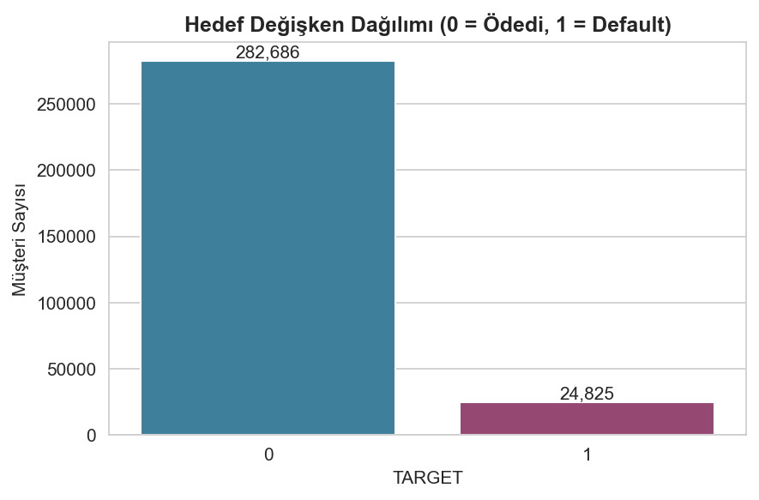
Figure 6.1. Distribution of the target variable (0 = repaid, 1 = default).
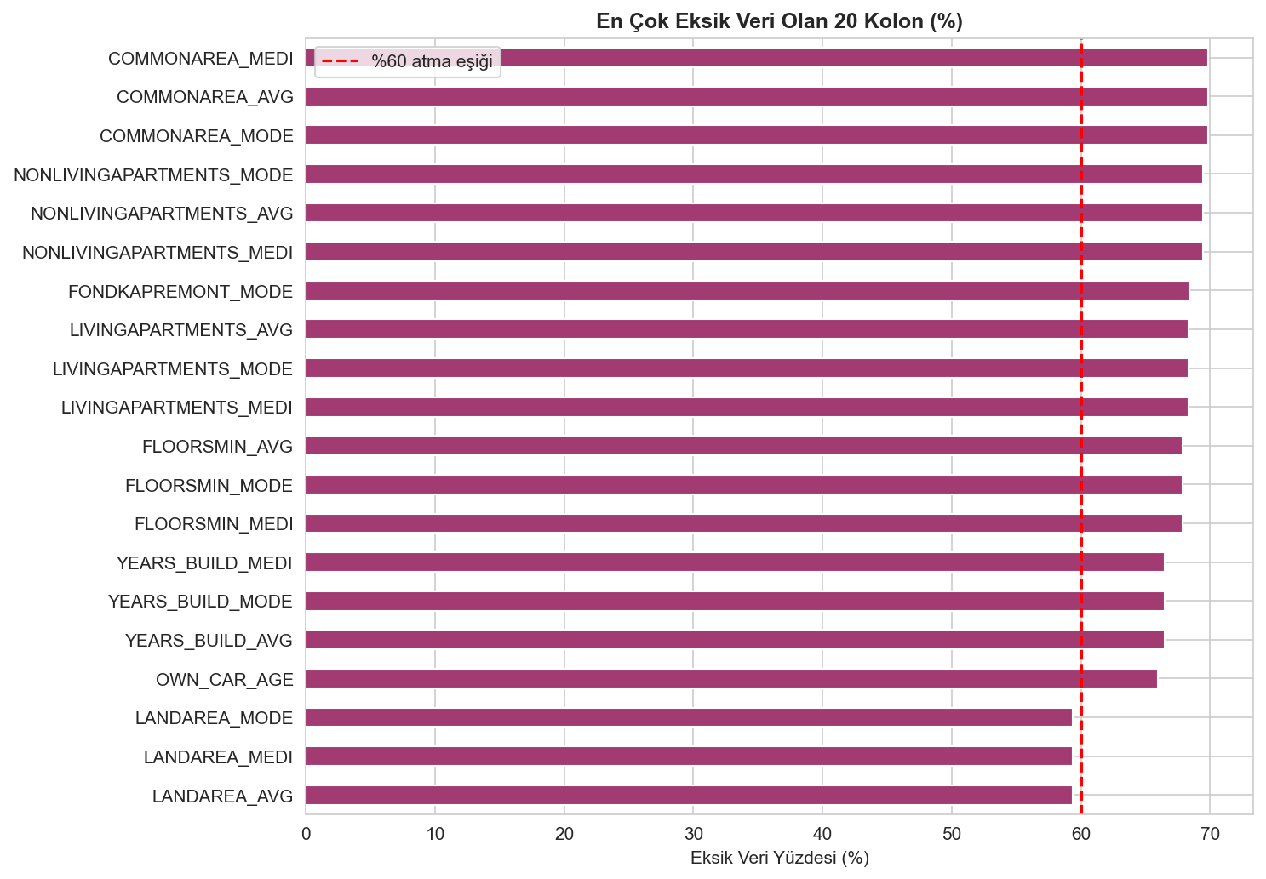
Figure 6.2. Twenty variables with the highest proportion of missing values.
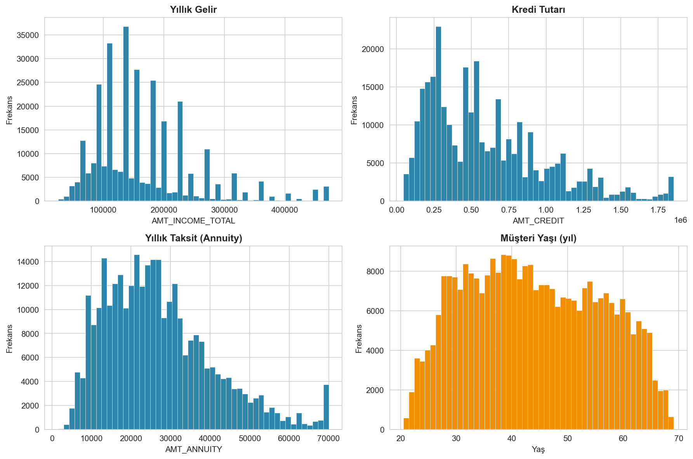
Figure 6.3. Distributions of key numerical variables.
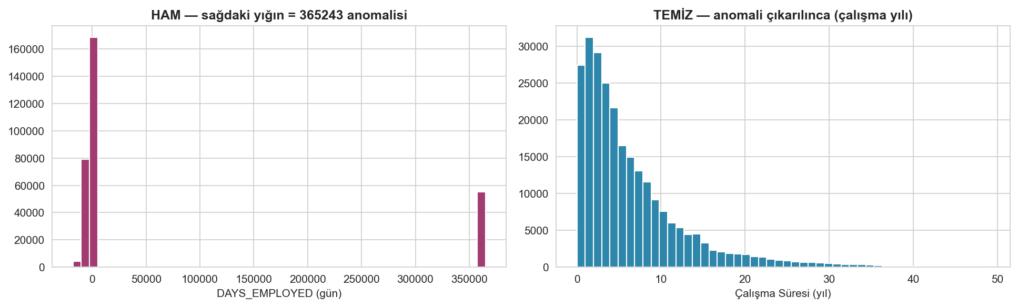
Figure 6.4. The DAYS_EMPLOYED anomaly before and after cleaning.
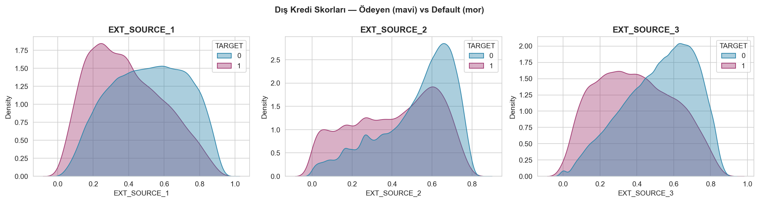
Figure 6.5. External credit scores by default status.
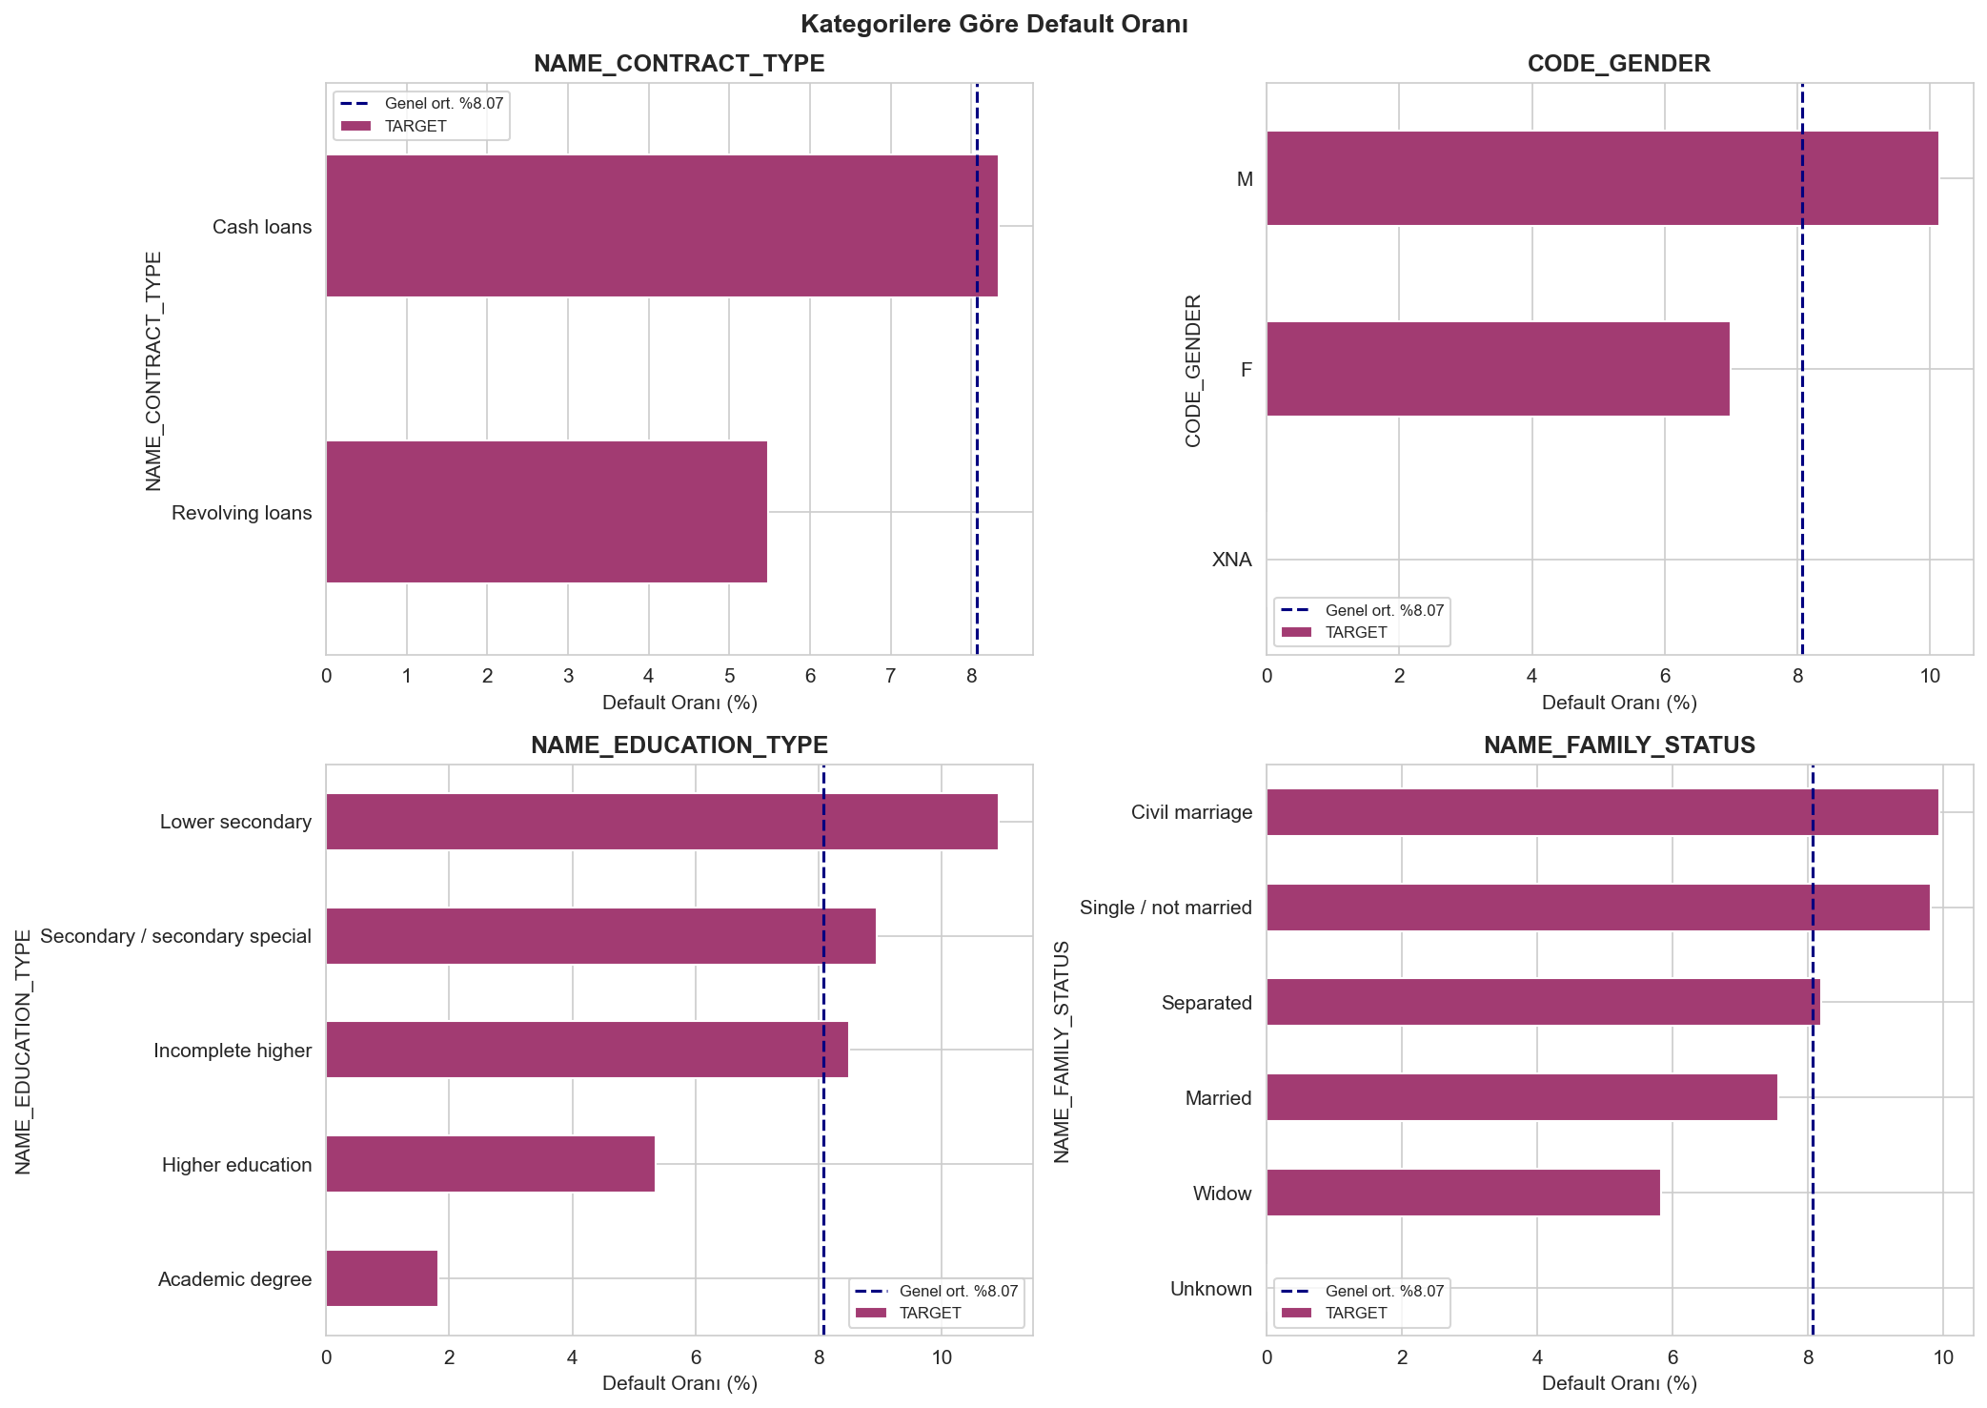
Figure 6.6. Default rate across categorical groups.
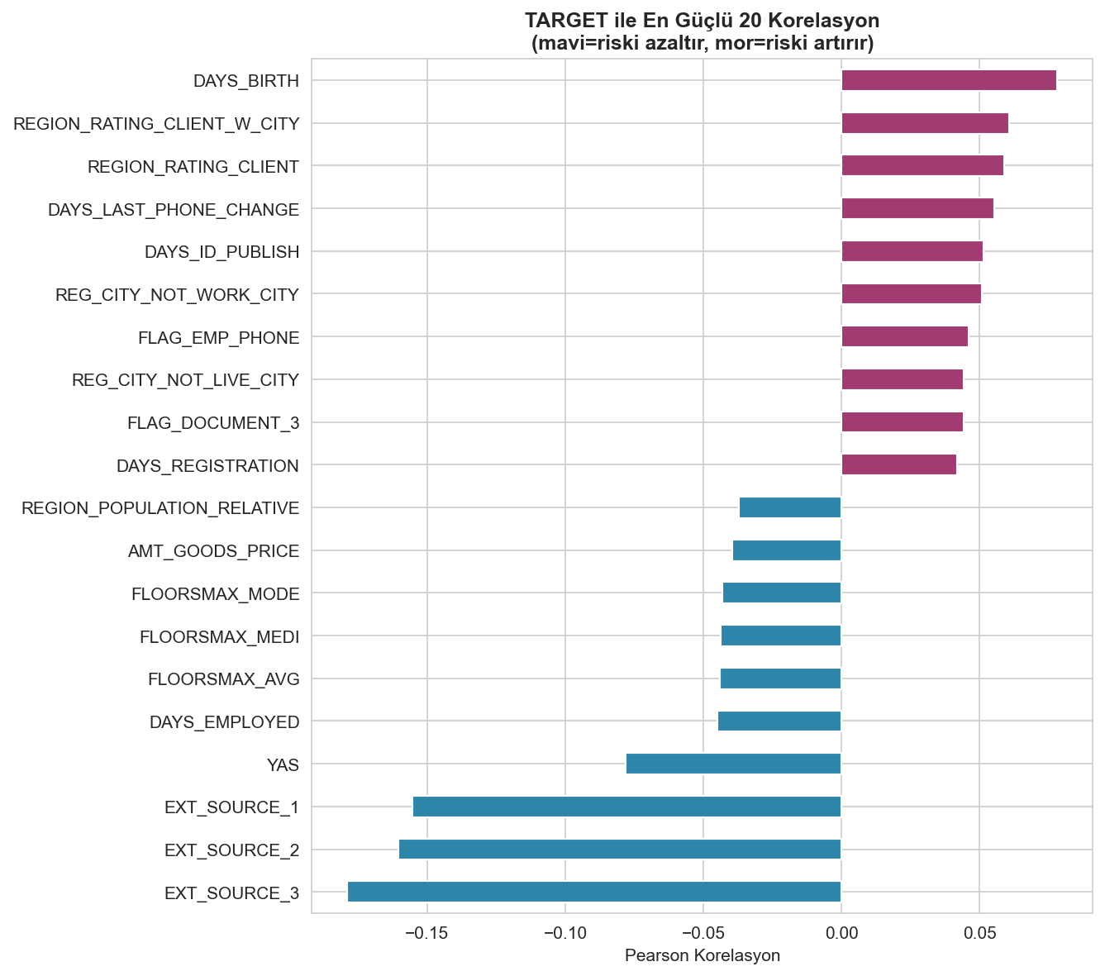
Figure 6.7. Strongest linear correlations with the target.
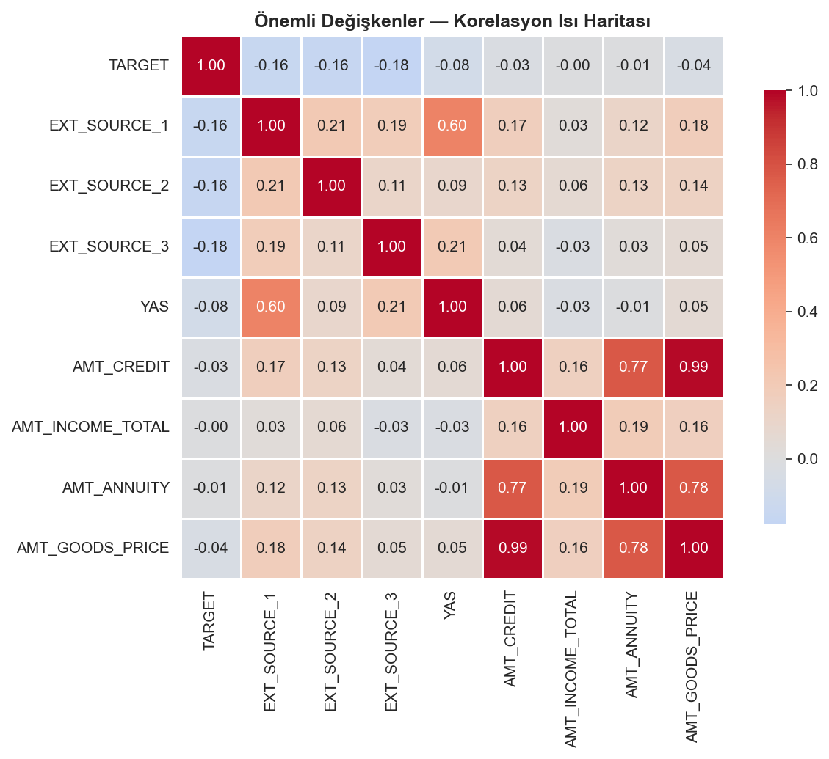
Figure 6.8. Correlation heatmap of key variables.
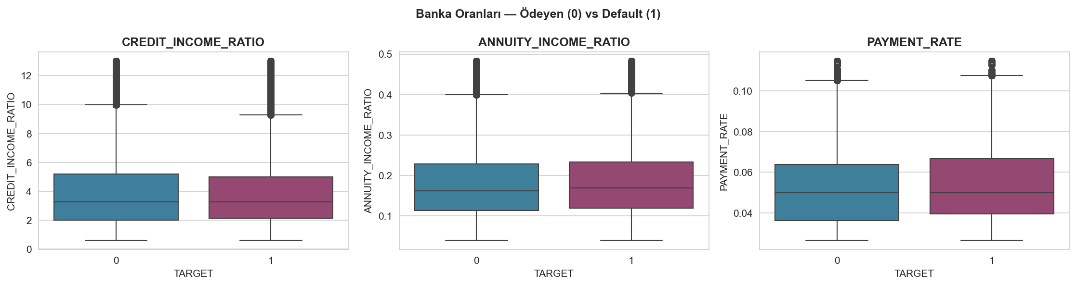
Figure 6.9. Engineered banking ratios by default status.

6.3. Data Preprocessing Implementation
Preprocessing turned these exploratory findings into a concrete transformation pipeline, implemented along the lines set out in Section 5.3. Ordering mattered here. Any operation that could carry information from the test set into the training data, such as encoding or imputation, was deferred until after the split.
A few row-level corrections came first, since these depend only on each record in isolation and cannot leak information across the split. The DAYS_EMPLOYED anomaly was recoded and the unknown category XNA in gender and organization type set to missing; at the same stage, the five engineered ratio and age features were created and the seventeen high-missingness columns dropped. The identifier column was also excluded.
The data were then partitioned into training and test sets using an 80:20 stratified split that preserved the 8.07 percent default rate in both partitions. From this point onward, every transformation was fitted exclusively on the training data and then applied to the test data. Categorical variables with fewer than ten distinct values were one-hot encoded, while the two high-cardinality variables, occupation and organization type, were target encoded using means computed solely on the training partition to avoid leakage. Missing numerical values were imputed with the training median, and extreme values were winsorized at the first and ninety-ninth percentiles using training-derived bounds.
Feature selection then reduced dimensionality in three stages. Near-zero-variance columns were removed first. Among pairs of variables correlated above 0.85, the member with the lower univariate AUC was dropped, and the Boruta algorithm, which contrasts genuine feature importance against randomized shadow features, then identified the confirmed-relevant subset. Together these steps cut the feature space from 146 encoded variables to 23 (Table 6.1). All three engineered banking ratios survived the selection despite their weak linear correlations, which suggests their value lies in non-linear interactions that only show up in tree-based importance measures.
Table 6.1. Feature selection results by stage.
Stage | Features remaining
After encoding | 146
After near-zero-variance removal | 126
After correlation > 0.85 removal | 94
After Boruta (final) | 23

6.4. Model Training Procedure
Model training was implemented as an imbalanced-learn pipeline so that class-imbalance treatment and scaling happen strictly within each cross-validation fold. SMOTE sits inside this pipeline. Had it been applied to the data beforehand, synthetic copies of minority cases would have ended up in the validation folds, the leakage error that naive oversampling invites; built into the pipeline, it generates synthetic examples only from each training fold, leaving the validation fold clean.
For each of the four models, hyperparameters were optimized by randomized search over 100 parameter combinations with five-fold stratified cross-validation, using AUC-ROC as the optimization criterion and the search ranges specified in Section 5.4. The optimal classification threshold for each model was determined separately, by selecting the value that maximized the F1-score on out-of-fold predictions rather than defaulting to 0.5, which is appropriate given the class imbalance. The tuned models were then evaluated once on the held-out test set. The resulting performance comparison, statistical significance testing, and interpretability analysis are reported in Section 7.

7. FINDINGS
This section reports the results of the experiment set up in Sections 5 and 6. The headline model comparison comes first. After that come the significance tests, a SHAP analysis of which variables drive predictions, and a check of how far the results depend on the class-imbalance strategy, a choice that turns out to matter more than expected. The findings are then related to the research question and the broader literature.

7.1. Model Performance Comparison
All four models were tuned through 100-iteration randomized search with five-fold stratified cross-validation and evaluated on the untouched 20 percent test partition. Table 7.1 reports the primary results under the SMOTE-based pipeline specified as the primary imbalance strategy in Section 5.3.
Table 7.1. Test-set performance of the four models (SMOTE pipeline).
Model | AUC-ROC | Gini | F1 | Precision | Recall
Logistic Regression | 0.7372 | 0.4743 | 0.293 | 0.211 | 0.482
LightGBM | 0.7248 | 0.4496 | 0.272 | 0.202 | 0.416
XGBoost | 0.7179 | 0.4359 | 0.268 | 0.197 | 0.418
Random Forest | 0.7031 | 0.4062 | 0.250 | 0.188 | 0.374
Under this configuration, logistic regression achieved the highest AUC-ROC at 0.7372, followed by LightGBM, XGBoost, and Random Forest. The ROC curves (Figure 7.1) show all four models performing well above the random-classifier diagonal, with logistic regression's curve dominating across most of the operating range, while the AUC comparison (Figure 7.2) summarizes the ordering. All models substantially exceed the naive-baseline accuracy trap discussed in Section 6.2, since AUC-ROC rewards correct ranking of defaulters rather than majority-class prediction.
The confusion matrices (Figure 7.3), computed at each model's F1-optimal threshold, reveal an important operational property. Logistic regression detected 389 of 807 actual defaulters (recall 0.482), the highest among the four models, at the cost of more false positives. In credit scoring this trade-off is generally acceptable: failing to identify a defaulter (a false negative) carries a far higher cost than incorrectly flagging a sound borrower (a false positive). Precision was modest across all models (approximately 0.19–0.21), an expected consequence of the severe class imbalance combined with a recall-favoring threshold.
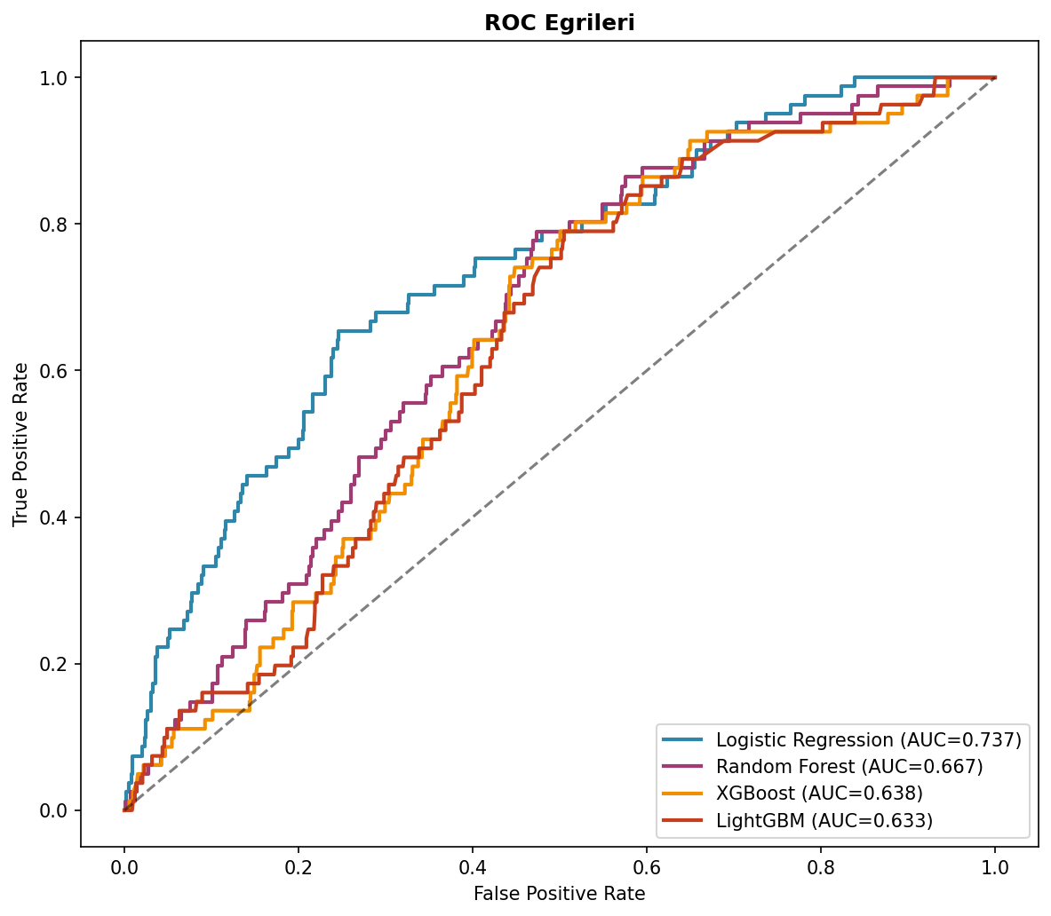
Figure 7.1. ROC curves for the four models on the test set.
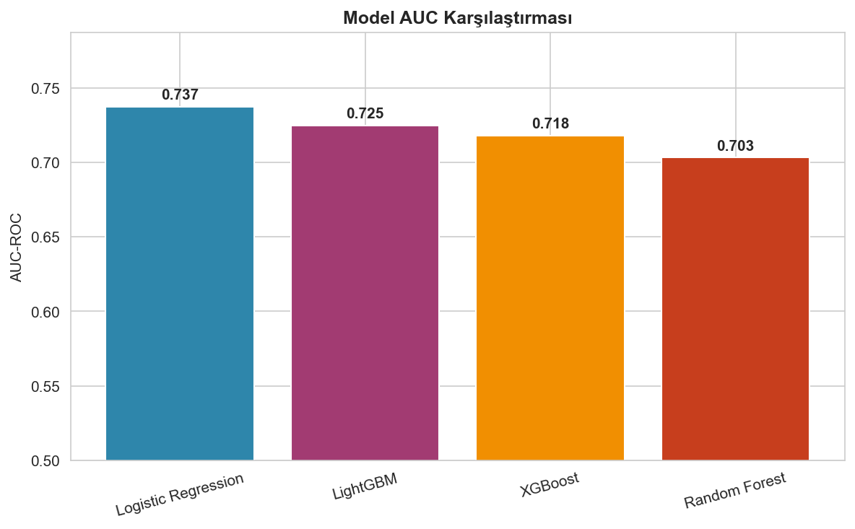
Figure 7.2. AUC-ROC comparison across models.
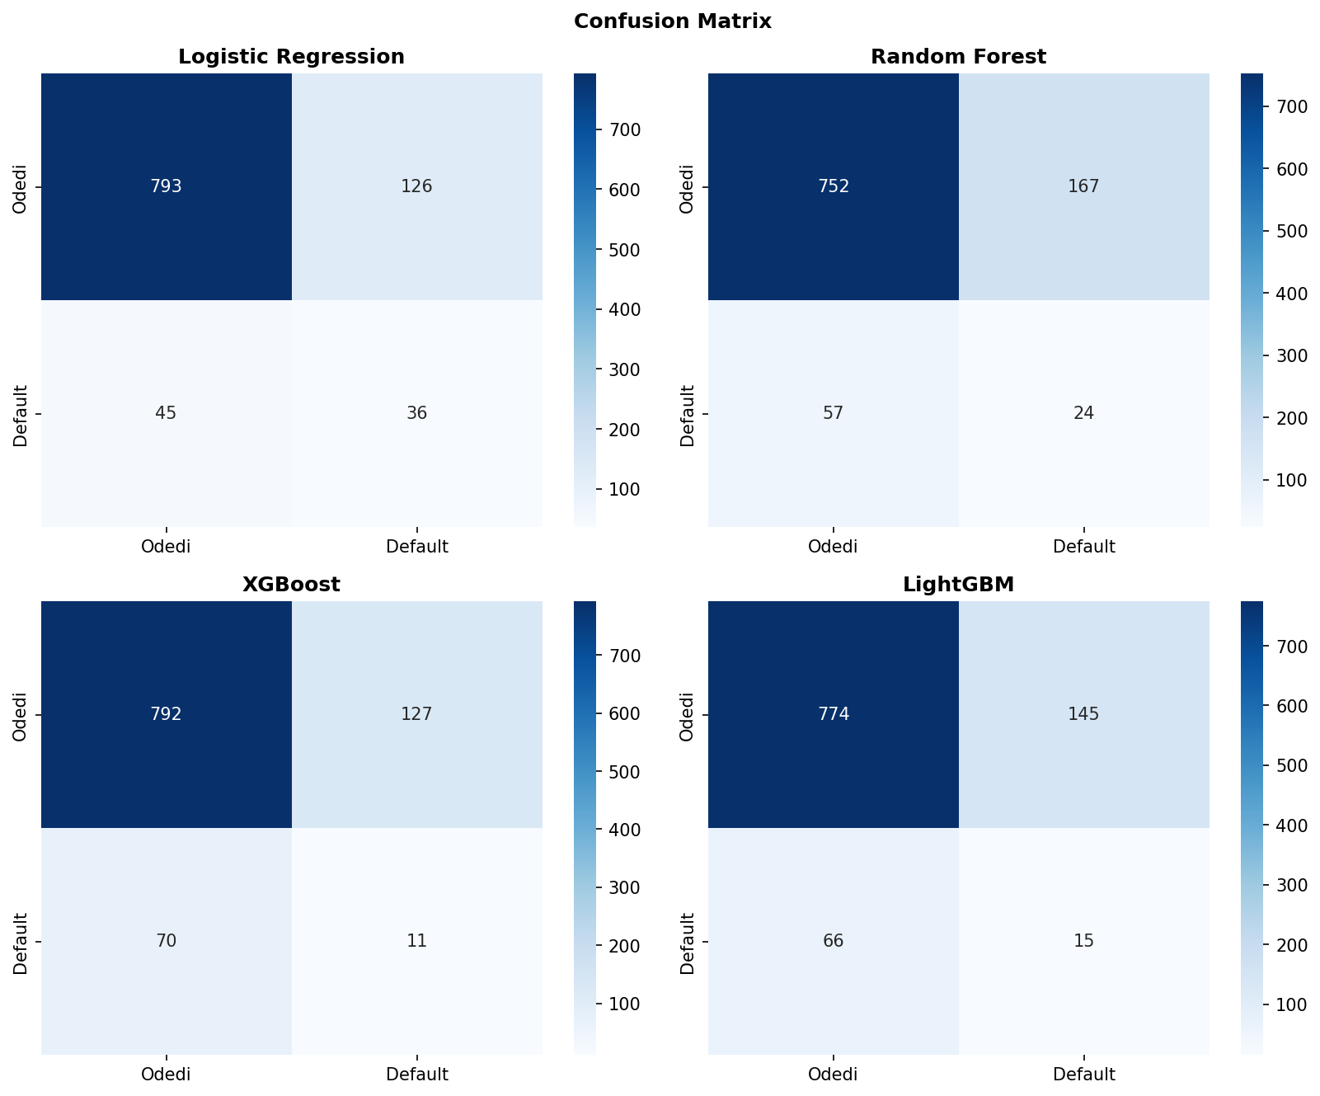
Figure 7.3. Confusion matrices at F1-optimal thresholds.

7.2. Statistical Significance Testing
To determine whether the performance differences reflect genuine model superiority rather than sampling variation, paired t-tests were applied to the five cross-validation AUC scores of each model pair, with a Bonferroni-corrected significance level of 0.0083 for the six comparisons (Table 7.2).
Table 7.2. Paired t-tests of cross-validation AUC (Bonferroni α = 0.0083).
Comparison | Mean Diff | p-value | Significant
Logistic Regression vs Random Forest | 0.0289 | 0.0001 | Yes
Logistic Regression vs XGBoost | 0.0131 | 0.0033 | Yes
Logistic Regression vs LightGBM | 0.0072 | 0.0467 | No
Random Forest vs XGBoost | −0.0158 | 0.0002 | Yes
Random Forest vs LightGBM | −0.0217 | 0.0005 | Yes
XGBoost vs LightGBM | −0.0059 | 0.0071 | Yes
Under the SMOTE pipeline, logistic regression significantly outperformed both Random Forest and XGBoost. Its advantage over LightGBM, however, fell short of significance after correction (p = 0.047, above the corrected threshold), so logistic regression and LightGBM are statistically indistinguishable here. Random Forest came out significantly weakest. The headline ranking should therefore not be over-interpreted; the leading models are effectively tied.

7.3. Feature Importance and Interpretability
SHAP values were computed for the best-performing model to see which variables drive its predictions (Figure 7.4). The three externally sourced credit scores dominate. EXT_SOURCE_3 and EXT_SOURCE_2 lead by a clear margin, and in both cases lower scores push the prediction toward default, which matches the exploratory finding of Section 6.2 and mirrors banking practice, where bureau-style scores are the strongest single signals of credit risk.
The engineered banking ratios produced an instructive result. PAYMENT_RATE and ANNUITY_INCOME_RATIO rank among the most influential features in the SHAP analysis, even though Section 6.2 reported near-zero univariate correlations between these ratios and default. There is no contradiction here. In a multivariate model, holding other variables constant, the ratios carry information that simple pairwise correlation cannot detect. Boruta retained them and SHAP later ranked them highly, two independent procedures arriving at the same verdict, so the feature-engineering effort appears to have paid off. The remaining leading predictors are loan amount relative to goods price (AMT_GOODS_PRICE), annuity, employment duration, and higher-education status. None of these is surprising from a credit-risk standpoint.
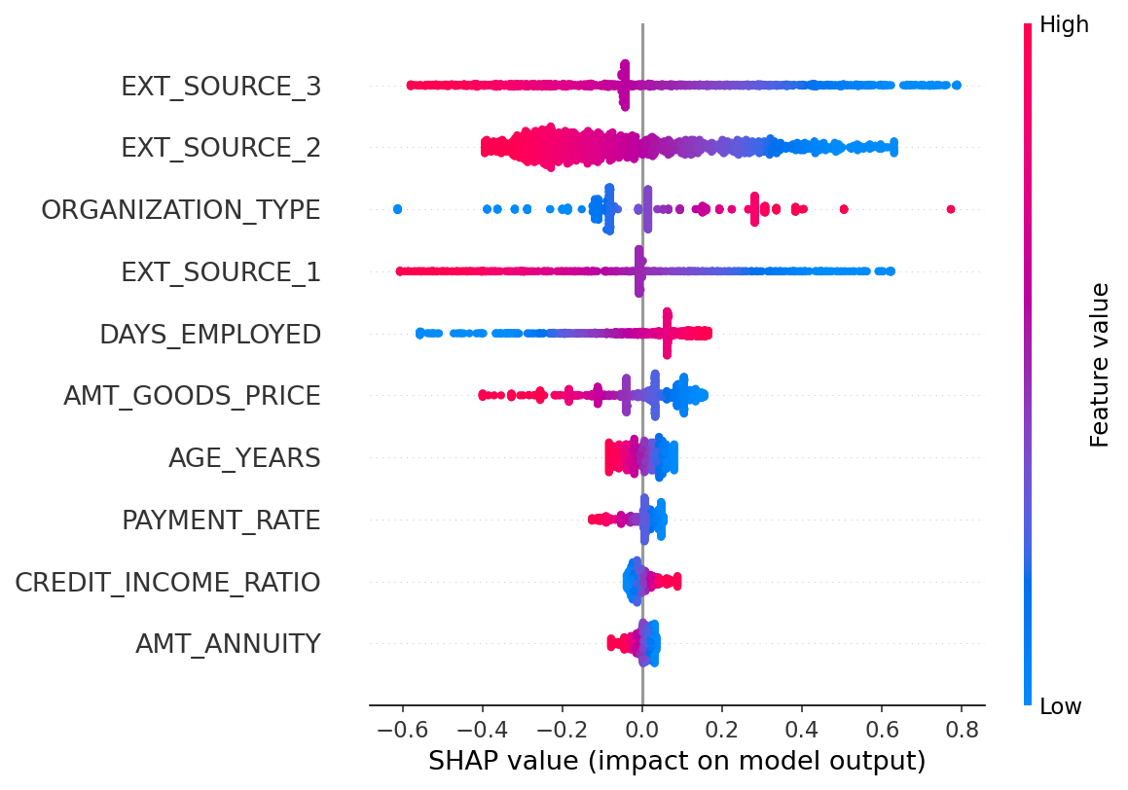
Figure 7.4. SHAP summary plot for the best-performing model.

7.4. Robustness: The Impact of Class-Imbalance Strategy
The primary results placed a linear model ahead of gradient boosting, which contradicts the literature reviewed in Section 3, so a robustness analysis was run to isolate the effect of the imbalance-handling strategy. Hyperparameters were held fixed. Each model was then evaluated under three conditions, namely no imbalance handling, SMOTE, and class-weighting (cost-sensitive learning), with Figure 7.5 and Table 7.3 reporting the cross-validation AUC for each combination.
Table 7.3. Cross-validation AUC by imbalance strategy.
Model | No Handling | SMOTE | Class Weight
Logistic Regression | 0.7408 | 0.7389 | 0.7410
Random Forest | 0.7367 | 0.6999 | 0.7382
XGBoost | 0.7472 | 0.7055 | 0.7437
LightGBM | 0.7447 | 0.7216 | 0.7450
One effect stands out. SMOTE substantially degrades the tree-based models, cutting XGBoost's AUC by 0.042 and Random Forest's by 0.037, while logistic regression is essentially unaffected (a 0.002 change). A plausible mechanism is that the synthetic minority samples SMOTE interpolates distort the recursive partitioning on which tree ensembles depend, whereas the linear decision boundary of logistic regression tolerates them. More telling is what happens without it. When SMOTE is replaced by cost-sensitive learning or omitted entirely, XGBoost (0.747) and LightGBM (0.745) overtake logistic regression (0.741), and the ordering predicted by the literature reappears.
The headline result of Section 7.1 is therefore an artifact of the imbalance-handling choice, not evidence that linear models are intrinsically superior. The genuine finding is more modest. Under an appropriate imbalance strategy, gradient boosting holds a marginal advantage of roughly 0.006 AUC over logistic regression, which sits comfortably inside the "one to two percent" band that the literature associates with interpretable models.
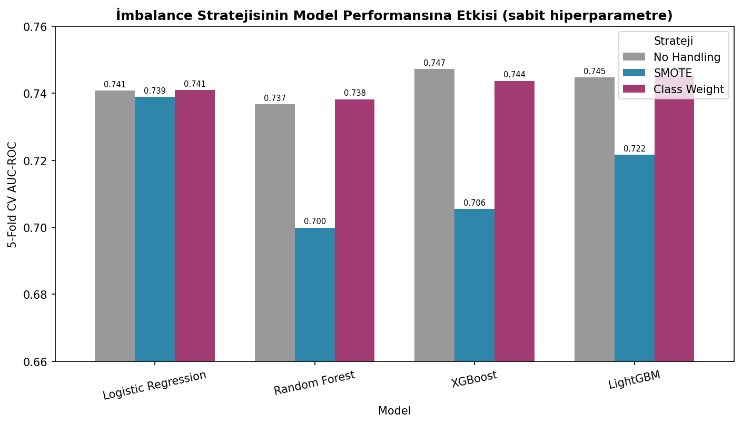
Figure 7.5. Effect of the class-imbalance strategy on model AUC.

7.5. Discussion of Findings
Returning to the research question (to what extent do machine-learning models enhance default-prediction accuracy, and what practical constraints accompany their use), the evidence supports a measured conclusion. Gradient-boosting models do beat the logistic-regression baseline. The margin is small, though, and it appears only when the models are paired with a suitable imbalance strategy. Three factors help explain why the improvement falls short of the five-to-ten percent often cited. The first is scope: only the primary application table was used, so the relational tables that fuel the strongest Kaggle solutions, and the complex cross-table interactions they enable, never entered the analysis. A second factor is the aggressive Boruta selection, which reduced the space to 23 variables and limited the high-dimensional interactions where boosting excels. The biggest factor, though, was the imbalance-handling choice, which materially affected the ranking; this kind of methodological sensitivity is easy to overlook, and this study has made it explicit.
The practical implication for banks is fairly blunt. When a carefully engineered logistic-regression model performs within 0.006 AUC of tuned gradient boosting, the marginal accuracy gain may not justify the interpretability and regulatory costs of a complex model, which is precisely the trade-off framed in Sections 4.2 and 4.3. None of this dismisses machine learning. It does caution against assuming that algorithmic sophistication by itself buys materially better lending decisions: in this experiment, sound data preparation, an honest treatment of class imbalance, and the feature engineering proved at least as consequential as the choice of algorithm.

8. CONCLUSION
On the central research question, the experiment yields concrete evidence. Under the SMOTE-based pipeline, logistic regression posted the highest test AUC (0.737) and was statistically indistinguishable from LightGBM. That ordering did not hold up. A robustness analysis traced it to the imbalance-handling strategy rather than to the models themselves: SMOTE substantially degraded the tree-based learners, costing XGBoost 0.042 in AUC, while logistic regression was left untouched. Once cost-sensitive learning replaced SMOTE, XGBoost (0.747) and LightGBM (0.745) moved narrowly ahead of logistic regression (0.741), which restored the ordering the literature predicts.
Gradient boosting's edge over a well-engineered logistic regression came to roughly 0.006 AUC, and even that depended on choosing a suitable imbalance treatment. The margin is small. SHAP analysis confirmed what banking practice would expect: external credit scores and engineered banking ratios dominated the predictions. In a regulated lending environment, where interpretability has real value, a gain of this size may not be worth the added complexity an ensemble brings. The experiment thus bears out what the literature anticipated: careful data preparation and honest imbalance handling, along with the feature engineering, weigh at least as heavily as the choice of algorithm.
Machine learning does improve default prediction, at least on the evidence reviewed here. The qualifications matter, though. Published studies report AUC improvements of roughly 5-10 percent over logistic regression, with gradient boosting methods, XGBoost and LightGBM especially, usually ahead of the alternatives, and the pattern recurs across enough datasets and research groups to be hard to dismiss. Improvement on one metric still does not establish overall superiority.
Accuracy alone does not make a model useful. Unexplainable models run into serious regulatory obstacles. A bank has to justify its lending decisions, internal teams need to validate how the model behaves, and someone has to maintain the system long after its developer has moved on. The highest-scoring model can be the worst deployment choice. Whether academic progress becomes operational benefit depends on this balancing of accuracy against practical constraints.
Perhaps the plainest lesson concerns data work. Preprocessing quality mattered as much as the choice of algorithm, possibly more: careful treatment of missing values and class imbalance, together with serious feature engineering, forms the foundation that any complex model builds on. Skip those fundamentals and algorithmic sophistication will not rescue the result.
The accuracy-interpretability tradeoff also looks less severe than commonly assumed. Carefully built interpretable models have reached AUC within 1-2 percent of complex ensembles on many datasets in recent work, and explanation tools such as SHAP, imperfect as they are, still give genuine insight into how a complex model decides. The challenge has not disappeared. It does, however, appear addressable rather than insurmountable.
Fairness is a harder problem still. No consensus solution exists, but the evidence forces one conclusion: ignoring the issue is not an option, because models absorb historical biases without anyone explicitly detecting them. What helps in practice is monitoring group-level outcomes and thinking carefully about what the model is optimizing for, throughout its lifecycle.
Future work has obvious targets. An algorithm that delivered accuracy and interpretability together would dissolve much of the tension described above; so would models stable enough to transfer across markets and time periods, sparing banks constant rebuilding. Practitioners would also benefit from fairness guidance concrete enough to act on.
For institutions adopting machine learning in credit scoring, the evidence points to gradient boosting, XGBoost or LightGBM specifically, as a sensible starting point. The algorithm is only part of it. Proper data cleaning and domain-informed feature engineering deserve as much investment, or more, and a simpler benchmark model kept running alongside the sophisticated one is a useful sanity check. Explanation tooling such as SHAP belongs in the pipeline from the start, whatever the main model's complexity.
None of the fairness work can be retrofitted: bias testing belongs before deployment, regulators are easier to deal with when engaged early, and monitoring has to catch emerging problems quickly. These steps guarantee nothing. They are minimum due diligence for responsible deployment.
Machine learning can genuinely improve credit decisions. A better model approves creditworthy applicants who would otherwise have been rejected and catches risky ones who would otherwise have slipped through, which serves lenders and borrowers alike, and the financial system. Algorithms alone will not get there. Realizing the potential takes solid data practices and sustained attention to interpretability and fairness, plus transparent engagement with regulators. The empirical study in this work put those principles to the test on real lending data with a controlled design.

REFERENCES
Ampomah, O.-A., Agyemang, E., Acheampong, K., & Agyekum, L. (2025). Enhancing credit default prediction using Boruta feature selection and DBSCAN algorithm with different resampling techniques. arXiv preprint arXiv:2509.19408. https://arxiv.org/abs/2509.19408
Anderson, R. (2007). The credit scoring toolkit: Theory and practice for retail credit risk management and decision automation. Oxford University Press.
Ayari, H., Guetari, R., & Kraiem, N. (2025). Machine learning powered financial credit scoring: A systematic literature review. Artificial Intelligence Review, 59(1), 13. https://doi.org/10.1007/s10462-025-11416-2
Babaei, G., Giudici, P., & Raffinetti, E. (2023). Explainable FinTech lending. Journal of Economics and Business, 125–126, 106126. https://doi.org/10.1016/j.jeconbus.2023.106126
Barocas, S., & Selbst, A. D. (2016). Big data’s disparate impact. California Law Review, 104(3), 671–732. https://doi.org/10.15779/Z38BG31
Basel Committee on Banking Supervision. (2006). International convergence of capital measurement and capital standards: A revised framework. Bank for International Settlements.
Bequé, A., & Lessmann, S. (2017). Extreme learning machines for credit scoring: An empirical evaluation. Expert Systems with Applications, 86, 42–53. https://doi.org/10.1016/j.eswa.2017.05.050
Bergstra, J., & Bengio, Y. (2012). Random search for hyper-parameter optimization. Journal of Machine Learning Research, 13(2), 281–305.
Breiman, L. (2001). Random forests. Machine Learning, 45(1), 5–32. https://doi.org/10.1023/A:1010933404324
Butaru, F., Chen, Q., Clark, B., Das, S., Lo, A. W., & Siddique, A. (2016). Risk and risk management in the credit card industry. Journal of Banking & Finance, 72, 218–239. https://doi.org/10.1016/j.jbankfin.2016.07.015
Chawla, N. V., Bowyer, K. W., Hall, L. O., & Kegelmeyer, W. P. (2002). SMOTE: Synthetic minority over-sampling technique. Journal of Artificial Intelligence Research, 16, 321–357. https://doi.org/10.1613/jair.953
Chen, H., Lundberg, S. M., & Lee, S.-I. (2022). Explaining a series of models by propagating Shapley values. Nature Communications, 13(1), 4512. https://doi.org/10.1038/s41467-022-31384-3
Chen, T., & Guestrin, C. (2016). XGBoost: A scalable tree boosting system. Proceedings of the 22nd ACM SIGKDD International Conference on Knowledge Discovery and Data Mining, 785–794. https://doi.org/10.1145/2939672.2939785
Crook, J. N., Edelman, D. B., & Thomas, L. C. (2007). Recent developments in consumer credit risk assessment. European Journal of Operational Research, 183(3), 1447–1465. https://doi.org/10.1016/j.ejor.2006.09.100
Hardt, M., Price, E., & Srebro, N. (2016). Equality of opportunity in supervised learning. Advances in Neural Information Processing Systems, 29, 3323–3331.
Hochreiter, S., & Schmidhuber, J. (1997). Long short-term memory. Neural Computation, 9(8), 1735–1780. https://doi.org/10.1162/neco.1997.9.8.1735
Khandani, A. E., Kim, A. J., & Lo, A. W. (2010). Consumer credit-risk models via machine-learning algorithms. Journal of Banking & Finance, 34(11), 2767–2787. https://doi.org/10.1016/j.jbankfin.2010.06.001
Kleinberg, J., Mullainathan, S., & Raghavan, M. (2017). Inherent trade-offs in the fair determination of risk scores. Proceedings of Innovations in Theoretical Computer Science (ITCS), 67, 43:1–43:23. https://doi.org/10.4230/LIPIcs.ITCS.2017.43
Kozodoi, N., Jacob, J., & Lessmann, S. (2022). Fairness in credit scoring: Assessment, implementation and profit implications. European Journal of Operational Research, 297(3), 1083–1094. https://doi.org/10.1016/j.ejor.2021.05.023
Lessmann, S., Baesens, B., Seow, H. V., & Thomas, L. C. (2015). Benchmarking state-of-the-art classification algorithms for credit scoring: An update of research. European Journal of Operational Research, 247(1), 124–136. https://doi.org/10.1016/j.ejor.2015.05.030
Lundberg, S. M., & Lee, S.-I. (2017). A unified approach to interpreting model predictions. Advances in Neural Information Processing Systems, 30, 4765–4774.
Ma, X., Sha, J., Wang, D., Yu, Y., Yang, Q., & Niu, X. (2018). Study on a prediction of P2P network loan default based on the machine learning LightGBM and XGBoost algorithms according to different high dimensional data cleaning. Electronic Commerce Research and Applications, 31, 24–39. https://doi.org/10.1016/j.elerap.2018.08.002
Ribeiro, M. T., Singh, S., & Guestrin, C. (2016). “Why should I trust you?”: Explaining the predictions of any classifier. Proceedings of the 22nd ACM SIGKDD International Conference on Knowledge Discovery and Data Mining, 1135–1144. https://doi.org/10.1145/2939672.2939778
Rudin, C. (2019). Stop explaining black box machine learning models for high stakes decisions and use interpretable models instead. Nature Machine Intelligence, 1(5), 206–215. https://doi.org/10.1038/s42256-019-0048-x
Siddiqi, N. (2012). Credit risk scorecards: Developing and implementing intelligent credit scoring. John Wiley & Sons.
Thomas, L. C., Crook, J. N., & Edelman, D. B. (2017). Credit scoring and its applications (2nd ed.). SIAM.
Verbraken, T., Bravo, C., Weber, R., & Baesens, B. (2014). Development and application of consumer credit scoring models using profit-based classification measures. European Journal of Operational Research, 238(2), 505–513. https://doi.org/10.1016/j.ejor.2014.04.001
Wang, G., Ma, J., Huang, L., & Xu, K. (2012). Two credit scoring models based on dual strategy ensemble trees. Knowledge-Based Systems, 26, 61–68. https://doi.org/10.1016/j.knosys.2011.06.020
Xia, Y., Liu, C., Li, Y., & Liu, N. (2017). A boosted decision tree approach using Bayesian hyper-parameter optimization for credit scoring. Expert Systems with Applications, 78, 225–241. https://doi.org/10.1016/j.eswa.2017.02.017
Yang, Y., Lin, Y., Zhang, Y., Su, Z., Goh, C. C., Fang, T., Bellotti, A. G., & Lee, B. G. (2025). Transforming credit risk analysis: A time-series-driven ResE-BiLSTM framework for post-loan default detection. arXiv preprint arXiv:2508.00415. https://arxiv.org/abs/2508.00415
Zandi, S., Korangi, K., Oskarsdottir, M., Mues, C., & Bravo, C. (2024). Attention-based dynamic multilayer graph neural networks for loan default prediction. European Journal of Operational Research, 321(2), 586–599. https://doi.org/10.1016/j.ejor.2024.09.025

APPENDIX A: DATA DICTIONARY OF PRINCIPAL VARIABLES
This appendix defines the principal variables referenced in the analysis. Definitions for source variables follow the data dictionary distributed with the Home Credit Default Risk dataset; the five engineered variables, marked accordingly, were derived during preprocessing as described in Section 6.1.
Table A.1. Definitions of principal and engineered variables.
Variable | Description
TARGET | Binary default label: 1 = client had payment difficulties (late payment beyond a threshold on early installments); 0 = all other cases.
EXT_SOURCE_1 | Normalized score from an external data source (bureau-style credit score).
EXT_SOURCE_2 | Normalized score from an external data source.
EXT_SOURCE_3 | Normalized score from an external data source.
AMT_CREDIT | Credit amount of the loan.
AMT_GOODS_PRICE | For consumer loans, the price of the goods for which the loan is granted.
AMT_ANNUITY | Loan annuity (the periodic installment amount).
AMT_INCOME_TOTAL | Total declared income of the client.
DAYS_EMPLOYED | Days before the application that the client started current employment (negative). The placeholder 365243 marked unemployed/retired applicants and was recoded to missing.
DAYS_BIRTH | Client's age expressed in days before the application (negative).
DAYS_REGISTRATION | Days before the application that the client last changed registration.
DAYS_ID_PUBLISH | Days before the application that the client changed the identity document used to apply.
DAYS_LAST_PHONE_CHANGE | Days before the application that the client last changed phone.
REGION_POPULATION_RELATIVE | Normalized population of the client's region (higher = more populated).
REGION_RATING_CLIENT_W_CITY | Internal rating of the client's region, accounting for the city (1, 2 or 3).
CODE_GENDER | Gender of the client.
NAME_EDUCATION_TYPE | Highest level of education the client achieved.
NAME_INCOME_TYPE | Client's income type (e.g. working, commercial associate, pensioner).
NAME_CONTRACT_TYPE | Whether the loan is a cash loan or a revolving loan.
NAME_FAMILY_STATUS | Family status of the client.
OCCUPATION_TYPE | Kind of occupation the client has (high-cardinality; target-encoded).
ORGANIZATION_TYPE | Type of organization where the client works (high-cardinality; target-encoded).
YEARS_BEGINEXPLUATATION_AVG | Normalized average age/usage characteristic of the building where the client lives.
ELEVATORS_AVG | Normalized average number of elevators in the client's building.
FLOORSMAX_AVG | Normalized average maximum floor count of the client's building.
LIVINGAREA_AVG | Normalized average living area of the client's building.
CREDIT_INCOME_RATIO (engineered) | AMT_CREDIT / AMT_INCOME_TOTAL — loan size relative to income.
ANNUITY_INCOME_RATIO (engineered) | AMT_ANNUITY / AMT_INCOME_TOTAL — installment burden relative to income.
PAYMENT_RATE (engineered) | AMT_ANNUITY / AMT_CREDIT — annual installment as a fraction of principal.
AGE_YEARS (engineered) | Client age in years, derived from DAYS_BIRTH.
DAYS_EMPLOYED_ANOM (engineered) | Binary flag marking records whose DAYS_EMPLOYED held the 365243 placeholder.

APPENDIX B: HYPERPARAMETER SEARCH SPACES
Each model was tuned by randomized search (RandomizedSearchCV) with five-fold stratified cross-validation, AUC-ROC as the scoring criterion, and a fixed random_state of 42. The search ranges and the imbalanced-learn pipeline structure used for each model are listed below; SMOTE is applied strictly within each cross-validation fold to prevent leakage.
Table B.1. Hyperparameter search spaces and pipeline structure by model.
Model | Search space | Pipeline
Logistic Regression | C in logspace(-3, 2, 20) [20 values, 0.001 to 100]; L2 penalty; max_iter = 1000. | StandardScaler -> SMOTE -> LogisticRegression
Random Forest | n_estimators {100, 200, 300}; max_depth {8, 12, 16}; min_samples_split {10, 20, 50}; max_features {sqrt, log2}. | SMOTE -> RandomForestClassifier
XGBoost | learning_rate {0.01, 0.05, 0.1, 0.3}; max_depth {3, 5, 7, 10}; reg_alpha {0, 1, 5, 10}; reg_lambda {0, 1, 5, 10}; subsample {0.7, 0.8, 1.0}; colsample_bytree {0.7, 0.8, 1.0}. | SMOTE -> XGBClassifier
LightGBM | num_leaves {20, 50, 100, 150}; learning_rate {0.01, 0.05, 0.1, 0.3}; min_child_samples {10, 30, 50, 100}; colsample_bytree {0.7, 0.8, 1.0}. | SMOTE -> LGBMClassifier

APPENDIX C: DETAILED PERFORMANCE RESULTS
This appendix reproduces the full performance figures summarized in Section 7. Table C.1 gives every metric for the four models under the primary SMOTE pipeline, evaluated on the held-out test set at each model's F1-optimal threshold. Table C.2 reports the robustness analysis of Section 7.4, listing cross-validation AUC under three imbalance strategies.
Table C.1. Test-set performance under the SMOTE pipeline (ordered by AUC-ROC).
Model | AUC-ROC | Gini | F1 | Precision | Recall
Logistic Regression | 0.7372 | 0.474 | 0.293 | 0.211 | 0.482
LightGBM | 0.7248 | 0.450 | 0.272 | 0.202 | 0.416
XGBoost | 0.7179 | 0.436 | 0.268 | 0.197 | 0.418
Random Forest | 0.7031 | 0.406 | 0.250 | 0.188 | 0.374

Table C.2. Cross-validation AUC by class-imbalance strategy.
Model | No handling | SMOTE | Class weight
Logistic Regression | 0.7408 | 0.7389 | 0.7410
Random Forest | 0.7367 | 0.6999 | 0.7382
XGBoost | 0.7472 | 0.7055 | 0.7437
LightGBM | 0.7447 | 0.7216 | 0.7450
Figure C.1 presents the SHAP mean-importance ranking for the best-performing model, complementing the summary plot of Figure 7.4. The externally sourced credit scores and the engineered banking ratios again emerge as the dominant contributors.
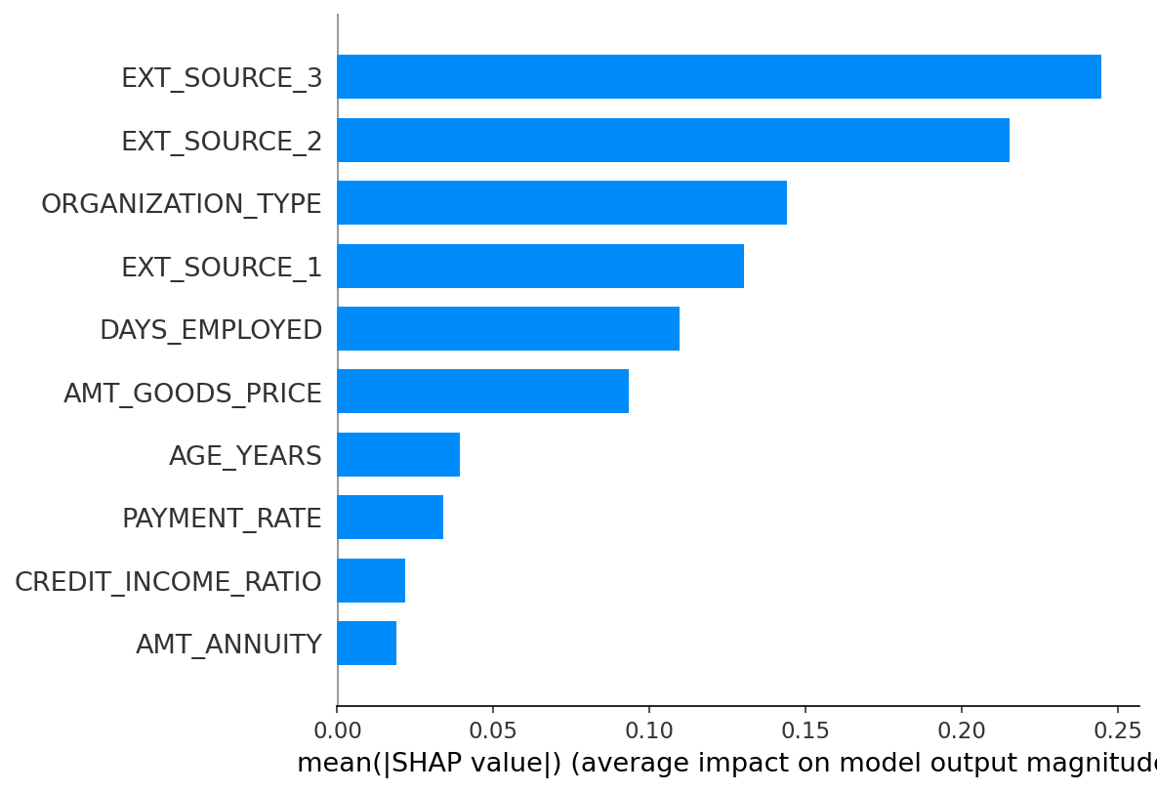
Figure C.1. SHAP mean absolute feature importance for the best-performing model.

APPENDIX D: SOFTWARE ENVIRONMENT AND REPRODUCIBILITY
All work was performed on a MacBook Air (15-inch, Apple M4) inside an isolated Python virtual environment. The complete set of installed packages, with versions pinned for exact reproducibility, is captured in the project's requirements.txt manifest and listed in Table D.1. A fixed random seed of 42 governs every stochastic step, so that the entire pipeline regenerates identical results when re-executed.
Total packages: 126.
Table D.1. Pinned package versions (requirements.txt).
Package | Package | Package
anyio==4.13.0 | appnope==0.1.4 | argon2-cffi==25.1.0
argon2-cffi-bindings==25.1.0 | arrow==1.4.0 | asttokens==3.0.1
async-lru==2.3.0 | attrs==26.1.0 | babel==2.18.0
beautifulsoup4==4.14.3 | bleach==6.4.0 | Boruta==0.4.3
category_encoders==2.9.0 | certifi==2026.5.20 | cffi==2.0.0
charset-normalizer==3.4.7 | cloudpickle==3.1.2 | comm==0.2.3
contourpy==1.3.3 | cycler==0.12.1 | debugpy==1.8.21
decorator==5.3.1 | defusedxml==0.7.1 | executing==2.2.1
fastjsonschema==2.21.2 | fonttools==4.63.0 | fqdn==1.5.1
h11==0.16.0 | httpcore==1.0.9 | httpx==0.28.1
idna==3.18 | imbalanced-learn==0.14.1 | ipykernel==7.2.0
ipython==9.14.1 | ipython_pygments_lexers==1.1.1 | ipywidgets==8.1.8
isoduration==20.11.0 | jedi==0.20.0 | Jinja2==3.1.6
joblib==1.5.3 | json5==0.14.0 | jsonpointer==3.1.1
jsonschema==4.26.0 | jsonschema-specifications==2025.9.1 | jupyter==1.1.1
jupyter-console==6.6.3 | jupyter-events==0.12.1 | jupyter-lsp==2.3.1
jupyter_client==8.9.0 | jupyter_core==5.9.1 | jupyter_server==2.19.0
jupyter_server_terminals==0.5.4 | jupyterlab==4.5.8 | jupyterlab_pygments==0.3.0
jupyterlab_server==2.28.0 | jupyterlab_widgets==3.0.16 | kiwisolver==1.5.0
lark==1.3.1 | lightgbm==4.6.0 | llvmlite==0.47.0
MarkupSafe==3.0.3 | matplotlib==3.10.9 | matplotlib-inline==0.2.2
mistune==3.2.1 | nbclient==0.11.0 | nbconvert==7.17.1
nbformat==5.10.4 | nest-asyncio==1.6.0 | notebook==7.5.7
notebook_shim==0.2.4 | numba==0.65.1 | numpy==2.4.6
packaging==26.2 | pandas==3.0.3 | pandocfilters==1.5.1
parso==0.8.7 | patsy==1.0.2 | pexpect==4.9.0
pillow==12.2.0 | platformdirs==4.10.0 | prometheus_client==0.25.0
prompt_toolkit==3.0.52 | psutil==7.2.2 | ptyprocess==0.7.0
pure_eval==0.2.3 | pycparser==3.0 | Pygments==2.20.0
pyparsing==3.3.2 | python-dateutil==2.9.0.post0 | python-json-logger==4.1.0
PyYAML==6.0.3 | pyzmq==27.1.0 | referencing==0.37.0
requests==2.34.2 | rfc3339-validator==0.1.4 | rfc3986-validator==0.1.1
rfc3987-syntax==1.1.0 | rpds-py==2026.5.1 | scikit-learn==1.8.0
scipy==1.17.1 | seaborn==0.13.2 | Send2Trash==2.1.0
setuptools==82.0.1 | shap==0.52.0 | six==1.17.0
sklearn-compat==0.1.5 | slicer==0.0.8 | soupsieve==2.8.4
stack-data==0.6.3 | statsmodels==0.14.6 | terminado==0.18.1
threadpoolctl==3.6.0 | tinycss2==1.5.1 | tornado==6.5.6
tqdm==4.68.1 | traitlets==5.15.1 | typing_extensions==4.15.0
tzdata==2026.2 | uri-template==1.3.0 | urllib3==2.7.0
wcwidth==0.8.0 | webcolors==25.10.0 | webencodings==0.5.1
websocket-client==1.9.0 | widgetsnbextension==4.0.15 | xgboost==3.2.0

APPENDIX E: SOURCE CODE LISTING
The complete, self-contained pipeline that implements the methodology of Section 5 end to end is reproduced below. It loads the data, performs the leakage-safe preprocessing, runs feature selection, tunes and evaluates the four models, and produces the figures and result tables. The same logic is mirrored across the four Jupyter notebooks used during development.
"""
================================================================================
BA DEGREE PROJECT 2 — CREDIT SCORING ML PIPELINE (methodology-uyumlu, v2)
================================================================================
Batuhan SEN | 200527078 | Istinye University

Bu script, dokumanin Methodology (5.3-5.6) bolumunu BIREBIR uygular ve
notebook'lardaki (02_preprocessing + 03_modeling) ile AYNI yontemleri tek
dosyada toplar. Amac: FINAL sonuclari TAM VERIYLE (307K) tek komutta uretmek.

KULLANIM:
Gelistirme (hizli): SAMPLE_SIZE = 50000
FINAL (tam veri): SAMPLE_SIZE = None (Boruta + n_iter=100 ile saatler surebilir)
Terminalde: python credit_scoring_pipeline.py

METHODOLOGY UYUMU (taslak v1'den farklar):
+ SMOTE (yalniz training fold, imblearn Pipeline ile) [5.3 Class Imbalance]
+ Target encoding (yuksek kardinalite) [5.3 Feature Encoding]
+ Feature selection: near-zero + korr>0.85 + Boruta [5.3 Feature Selection]
+ Tum donusumler yalniz train'de fit (leakage yok) [5.6 Experimental Procedure]
+ Optimal threshold (F1-max, out-of-fold) [5.5 Evaluation]
+ RandomizedSearchCV n_iter=100 [5.6]
================================================================================
"""

# ============================================================================
# BOLUM 0: KUTUPHANELER VE AYARLAR
# ============================================================================
import os
import time
import warnings
import numpy as np
import pandas as pd
import matplotlib.pyplot as plt
import seaborn as sns

# Preprocessing
from sklearn.model_selection import (train_test_split, RandomizedSearchCV,
StratifiedKFold, cross_val_score, cross_val_predict)
from sklearn.preprocessing import StandardScaler, OneHotEncoder
from sklearn.impute import SimpleImputer
from sklearn.feature_selection import VarianceThreshold
from sklearn.linear_model import LogisticRegression
from sklearn.ensemble import RandomForestClassifier
from sklearn.metrics import (roc_auc_score, roc_curve, f1_score, precision_score,
recall_score, confusion_matrix)
from category_encoders import TargetEncoder
from boruta import BorutaPy

# Modeller
from xgboost import XGBClassifier
from lightgbm import LGBMClassifier

# Class imbalance (SMOTE) — imblearn pipeline CV fold'unda uygular
from imblearn.pipeline import Pipeline as ImbPipeline
from imblearn.over_sampling import SMOTE

# Istatistik
from scipy import stats
from itertools import combinations

warnings.filterwarnings("ignore")

# ---- AYARLAR (buradan kontrol et) ----
RANDOM_STATE = 42 # tekrarlanabilirlik (her yerde sabit seed)
SAMPLE_SIZE = int(os.environ["PIPE_SAMPLE"]) if os.environ.get("PIPE_SAMPLE") else None # None=tam 307K
N_ITER = int(os.environ.get("PIPE_NITER", "50")) # tam veride 50 (50K gelistirmede 100 tune edildi)
CV_FOLDS = 5
BORUTA_MAXN = 50000 # Boruta'yi en fazla bu kadar satirla calistir (hiz; secim icin yeterli)
DATA_PATH = "data/application_train.csv"
FIG_DIR = "outputs/figures"
RES_DIR = "outputs/results"
os.makedirs(FIG_DIR, exist_ok=True)
os.makedirs(RES_DIR, exist_ok=True)

print("=" * 70)
print("CREDIT SCORING PIPELINE (methodology-uyumlu)")
print(f"Ornek: {SAMPLE_SIZE if SAMPLE_SIZE else 'TAM VERI (307K)'} | N_ITER={N_ITER}")
print("=" * 70)

# ============================================================================
# BOLUM 1: VERI YUKLEME + ORNEKLEM
# ============================================================================
print("\n[1/9] Veri yukleniyor...")
df = pd.read_csv(DATA_PATH)
if SAMPLE_SIZE and SAMPLE_SIZE < len(df):
df, _ = train_test_split(df, train_size=SAMPLE_SIZE,
stratify=df["TARGET"], random_state=RANDOM_STATE)
df = df.reset_index(drop=True)
print(f" {df.shape[0]:,} satir | default %{df['TARGET'].mean()*100:.2f}")

# ============================================================================
# BOLUM 2: SPLIT-ONCESI TEMIZLIK (sizintisiz, satir-bazli)
# ============================================================================
print("\n[2/9] Split-oncesi temizlik...")
# DAYS_EMPLOYED anomalisi (365243 = ~1000 yil placeholder) -> NaN + flag
df["DAYS_EMPLOYED_ANOM"] = (df["DAYS_EMPLOYED"] == 365243).astype(int)
df["DAYS_EMPLOYED"] = df["DAYS_EMPLOYED"].replace(365243, np.nan)
# XNA -> NaN
for kol in ["CODE_GENDER", "ORGANIZATION_TYPE"]:
df[kol] = df[kol].replace("XNA", np.nan)
# Turetilmis bankacilik oranlari + yas
df["CREDIT_INCOME_RATIO"] = df["AMT_CREDIT"] / df["AMT_INCOME_TOTAL"]
df["ANNUITY_INCOME_RATIO"] = df["AMT_ANNUITY"] / df["AMT_INCOME_TOTAL"]
df["PAYMENT_RATE"] = df["AMT_ANNUITY"] / df["AMT_CREDIT"]
df["DAYS_EMPLOYED_PERC"] = df["DAYS_EMPLOYED"] / df["DAYS_BIRTH"]
df["AGE_YEARS"] = -df["DAYS_BIRTH"] / 365

y = df["TARGET"]
X = df.drop(columns=["TARGET", "SK_ID_CURR"])
high_missing = X.columns[X.isnull().mean() > 0.60] # >%60 eksik kolonlari at
X = X.drop(columns=high_missing)
print(f" %60+ eksik {len(high_missing)} kolon atildi -> {X.shape[1]} degisken")

# ============================================================================
# BOLUM 3: TRAIN/TEST SPLIT (80:20 stratified)
# ============================================================================
print("\n[3/9] Train/test split...")
X_train, X_test, y_train, y_test = train_test_split(
X, y, test_size=0.20, stratify=y, random_state=RANDOM_STATE)
print(f" Train {X_train.shape[0]:,} | Test {X_test.shape[0]:,}")

# ============================================================================
# BOLUM 4: ENCODING (yalniz train'de fit)
# ============================================================================
print("\n[4/9] Encoding (one-hot + target)...")
kategorik = X_train.select_dtypes("object").columns.tolist()
for kol in kategorik: # kategorik eksik -> 'Missing'
X_train[kol] = X_train[kol].fillna("Missing")
X_test[kol] = X_test[kol].fillna("Missing")
kard = X_train[kategorik].nunique()
dusuk = kard[kard < 10].index.tolist() # one-hot
yuksek = kard[kard >= 10].index.tolist() # target encoding

ohe = OneHotEncoder(handle_unknown="ignore", sparse_output=False, drop="first")
ohe.fit(X_train[dusuk])
tr_ohe = pd.DataFrame(ohe.transform(X_train[dusuk]), columns=ohe.get_feature_names_out(dusuk), index=X_train.index)
te_ohe = pd.DataFrame(ohe.transform(X_test[dusuk]), columns=ohe.get_feature_names_out(dusuk), index=X_test.index)

tenc = TargetEncoder(cols=yuksek)
tenc.fit(X_train[yuksek], y_train)
tr_te = tenc.transform(X_train[yuksek])
te_te = tenc.transform(X_test[yuksek])

sayisal = X_train.select_dtypes("number").columns.tolist()
X_train = pd.concat([X_train[sayisal], tr_ohe, tr_te], axis=1)
X_test = pd.concat([X_test[sayisal], te_ohe, te_te], axis=1)
print(f" Encoding sonrasi {X_train.shape[1]} feature")

# ============================================================================
# BOLUM 5: IMPUTATION + WINSORIZATION (yalniz train'de fit)
# ============================================================================
print("\n[5/9] Imputation (median) + winsorization (1-99)...")
imp = SimpleImputer(strategy="median")
X_train = pd.DataFrame(imp.fit_transform(X_train), columns=X_train.columns, index=X_train.index)
X_test = pd.DataFrame(imp.transform(X_test), columns=X_test.columns, index=X_test.index)
for kol in sayisal: # train sinirlariyla kirp
alt, ust = X_train[kol].quantile([0.01, 0.99])
X_train[kol] = X_train[kol].clip(alt, ust)
X_test[kol] = X_test[kol].clip(alt, ust)
print(f" Eksik kalan: {int(X_train.isnull().sum().sum())}")

# ============================================================================
# BOLUM 6: FEATURE SELECTION (near-zero + korr>0.85 + Boruta)
# ============================================================================
print("\n[6/9] Feature selection...")
# 6.1 Near-zero variance
vt = VarianceThreshold(0.0); vt.fit(X_train)
sabit = X_train.columns[~vt.get_support()].tolist()
X_train = X_train.drop(columns=sabit); X_test = X_test.drop(columns=sabit)
# 6.2 Korelasyon>0.85 (dusuk univariate-AUC olani at)
uni = {c: max(roc_auc_score(y_train, X_train[c]), 1 - roc_auc_score(y_train, X_train[c]))
for c in X_train.columns}
corr = X_train.corr().abs()
ust = corr.where(np.triu(np.ones(corr.shape), k=1).astype(bool))
at_corr = set()
for c in ust.columns:
for r in ust.index[ust[c] > 0.85]:
at_corr.add(c if uni[c] < uni[r] else r)
X_train = X_train.drop(columns=list(at_corr)); X_test = X_test.drop(columns=list(at_corr))
# 6.3 Boruta (hiz icin en fazla BORUTA_MAXN satirla)
if len(X_train) > BORUTA_MAXN:
Xb, _, yb, _ = train_test_split(X_train, y_train, train_size=BORUTA_MAXN,
stratify=y_train, random_state=RANDOM_STATE)
else:
Xb, yb = X_train, y_train
rf_b = RandomForestClassifier(max_depth=6, class_weight="balanced", n_jobs=-1, random_state=RANDOM_STATE)
boruta = BorutaPy(rf_b, n_estimators=80, max_iter=40, random_state=RANDOM_STATE, verbose=0)
boruta.fit(Xb.values, yb.values)
confirmed = X_train.columns[boruta.support_].tolist()
tentative = X_train.columns[boruta.support_weak_].tolist()
secilen = confirmed if len(confirmed) >= 20 else confirmed + tentative
X_train = X_train[secilen]; X_test = X_test[secilen]
print(f" near-zero {len(sabit)} + korr {len(at_corr)} atildi; Boruta {len(secilen)} sececti")
pd.Series(secilen).to_csv(f"{RES_DIR}/selected_features.csv", index=False, header=["feature"])

# ============================================================================
# BOLUM 7: MODEL EGITIMI (SMOTE pipeline + RandomizedSearchCV)
# ============================================================================
print("\n[7/9] Model egitimi (bu uzun surebilir)...")
smote = SMOTE(random_state=RANDOM_STATE)
configs = {
"Logistic Regression": (ImbPipeline([("sc", StandardScaler()), ("sm", smote),
("clf", LogisticRegression(max_iter=1000, random_state=RANDOM_STATE))]),
{"clf__C": np.logspace(-3, 2, 20)}),
"Random Forest": (ImbPipeline([("sm", smote),
("clf", RandomForestClassifier(random_state=RANDOM_STATE, n_jobs=1))]),
{"clf__n_estimators": [100, 200, 300], "clf__max_depth": [8, 12, 16],
"clf__min_samples_split": [10, 20, 50], "clf__max_features": ["sqrt", "log2"]}), # tam veride hiz icin daraltildi (50K'da full aralik 100-500/5-20)
"XGBoost": (ImbPipeline([("sm", smote),
("clf", XGBClassifier(random_state=RANDOM_STATE, eval_metric="logloss", n_jobs=1, verbosity=0))]),
{"clf__learning_rate": [0.01, 0.05, 0.1, 0.3], "clf__max_depth": [3, 5, 7, 10],
"clf__reg_alpha": [0, 1, 5, 10], "clf__reg_lambda": [0, 1, 5, 10],
"clf__subsample": [0.7, 0.8, 1.0], "clf__colsample_bytree": [0.7, 0.8, 1.0]}),
"LightGBM": (ImbPipeline([("sm", smote),
("clf", LGBMClassifier(random_state=RANDOM_STATE, n_jobs=1, verbose=-1))]),
{"clf__num_leaves": [20, 50, 100, 150], "clf__learning_rate": [0.01, 0.05, 0.1, 0.3],
"clf__min_child_samples": [10, 30, 50, 100], "clf__colsample_bytree": [0.7, 0.8, 1.0]}),
}
cv = StratifiedKFold(CV_FOLDS, shuffle=True, random_state=RANDOM_STATE)
results, cv_scores, trained, roc_data, thresholds = {}, {}, {}, {}, {}
for name, (pipe, params) in configs.items():
t0 = time.time()
search = RandomizedSearchCV(pipe, params, n_iter=N_ITER, cv=cv, scoring="roc_auc",
random_state=RANDOM_STATE, n_jobs=-1)
search.fit(X_train, y_train)
best = search.best_estimator_; trained[name] = best
cv_scores[name] = cross_val_score(best, X_train, y_train, cv=cv, scoring="roc_auc", n_jobs=-1)
oof = cross_val_predict(best, X_train, y_train, cv=cv, method="predict_proba", n_jobs=-1)[:, 1]
ths = np.linspace(0.05, 0.95, 91)
th = ths[int(np.argmax([f1_score(y_train, (oof >= t).astype(int)) for t in ths]))]
thresholds[name] = th
proba = best.predict_proba(X_test)[:, 1]; pred = (proba >= th).astype(int)
auc = roc_auc_score(y_test, proba)
results[name] = {"AUC-ROC": round(auc, 4), "Gini": round(2*auc-1, 4),
"F1": round(f1_score(y_test, pred), 4), "Precision": round(precision_score(y_test, pred), 4),
"Recall": round(recall_score(y_test, pred), 4), "Threshold": round(th, 3),
"CV_AUC_mean": round(cv_scores[name].mean(), 4), "CV_AUC_std": round(cv_scores[name].std(), 4)}
fpr, tpr, _ = roc_curve(y_test, proba); roc_data[name] = (fpr, tpr, auc)
print(f" {name:22s} AUC={auc:.4f} F1={results[name]['F1']:.3f} ({time.time()-t0:.0f}s)")

# ============================================================================
# BOLUM 8: SONUC TABLOSU + GRAFIKLER + ISTATISTIK
# ============================================================================
print("\n[8/9] Sonuclar ve grafikler...")
results_df = pd.DataFrame(results).T.sort_values("AUC-ROC", ascending=False)
results_df.to_csv(f"{RES_DIR}/model_comparison.csv")
best_name = results_df.index[0]
print(results_df.to_string())
print(f" >>> EN IYI: {best_name} (AUC={results_df.iloc[0]['AUC-ROC']})")

renkler = ["#2E86AB", "#A23B72", "#F18F01", "#C73E1D"]
# ROC
plt.figure(figsize=(8, 7))
for (name, (fpr, tpr, auc)), c in zip(sorted(roc_data.items(), key=lambda x: -x[1][2]), renkler):
plt.plot(fpr, tpr, label=f"{name} (AUC={auc:.3f})", lw=2, color=c)
plt.plot([0, 1], [0, 1], "k--", alpha=0.5); plt.legend(loc="lower right")
plt.xlabel("False Positive Rate"); plt.ylabel("True Positive Rate")
plt.title("ROC Egrileri", fontweight="bold"); plt.tight_layout()
plt.savefig(f"{FIG_DIR}/model_roc_comparison.png", dpi=150, bbox_inches="tight"); plt.close()
# Confusion matrix
fig, axes = plt.subplots(2, 2, figsize=(11, 9))
for (name, model), ax in zip(trained.items(), axes.ravel()):
pred = (model.predict_proba(X_test)[:, 1] >= thresholds[name]).astype(int)
sns.heatmap(confusion_matrix(y_test, pred), annot=True, fmt="d", cmap="Blues", ax=ax,
xticklabels=["Odedi", "Default"], yticklabels=["Odedi", "Default"])
ax.set_title(name, fontweight="bold")
plt.suptitle("Confusion Matrix", fontweight="bold"); plt.tight_layout()
plt.savefig(f"{FIG_DIR}/model_confusion_all.png", dpi=150, bbox_inches="tight"); plt.close()

# Paired t-test + Bonferroni
names = list(cv_scores.keys()); n_comp = len(list(combinations(names, 2))); alpha = 0.05 / n_comp
rows = []
for m1, m2 in combinations(names, 2):
t, p = stats.ttest_rel(cv_scores[m1], cv_scores[m2])
rows.append({"Model 1": m1, "Model 2": m2,
"Mean Diff": round(cv_scores[m1].mean()-cv_scores[m2].mean(), 4),
"t-stat": round(t, 3), "p-value": round(p, 4),
"Significant": "EVET" if p < alpha else "Hayir"})
pd.DataFrame(rows).to_csv(f"{RES_DIR}/statistical_tests.csv", index=False)
print(f" Istatistik testleri kaydedildi (Bonferroni alpha={alpha:.4f})")

# ============================================================================
# BOLUM 9: SHAP (en iyi model)
# ============================================================================
print("\n[9/9] SHAP analizi...")
try:
import shap
best = trained[best_name]; clf = best.named_steps["clf"]
X_shap = X_test.sample(min(1000, len(X_test)), random_state=RANDOM_STATE)
if "sc" in best.named_steps: # LogReg: scale + LinearExplainer
Xs = pd.DataFrame(best.named_steps["sc"].transform(X_shap), columns=X_shap.columns, index=X_shap.index)
sv = shap.LinearExplainer(clf, Xs).shap_values(Xs); Xplot = Xs
else: # Tree: TreeExplainer
sv = shap.TreeExplainer(clf).shap_values(X_shap)
if isinstance(sv, list): sv = sv[1]
Xplot = X_shap
plt.figure(); shap.summary_plot(sv, Xplot, show=False, max_display=15)
plt.tight_layout(); plt.savefig(f"{FIG_DIR}/shap_summary.png", dpi=150, bbox_inches="tight"); plt.close()
plt.figure(); shap.summary_plot(sv, Xplot, plot_type="bar", show=False, max_display=15)
plt.tight_layout(); plt.savefig(f"{FIG_DIR}/shap_bar.png", dpi=150, bbox_inches="tight"); plt.close()
print(f" SHAP grafikleri kaydedildi (en iyi model: {best_name})")
except Exception as e:
print(f" SHAP hatasi (atlanabilir): {e}")

print("\n" + "=" * 70)
print("PIPELINE TAMAMLANDI! Sonuclar: outputs/results/ ve outputs/figures/")
print("=" * 70)

APPENDIX F: GLOSSARY OF KEY TERMS
This glossary defines the principal technical terms used throughout the document, in the sense intended here. It is provided as a reference for readers approaching the credit-scoring and machine-learning vocabulary for the first time.
Table F.1. Glossary of key technical terms.
Term | Definition
AUC-ROC | A threshold-independent measure of a model's ability to rank a randomly chosen defaulter above a randomly chosen non-defaulter; 0.5 denotes random ordering and 1.0 perfect discrimination.
Gini coefficient | A banking-standard rescaling of AUC, equal to 2 x AUC - 1.
Class imbalance | A large disparity between class frequencies; in this dataset defaults represent roughly 8 percent of applications.
SMOTE | An oversampling technique that creates synthetic minority-class examples by interpolating between existing ones; applied only within training folds to avoid leakage.
Cost-sensitive learning | An imbalance strategy that assigns a higher misclassification cost to the minority class instead of resampling (also called class weighting).
Target encoding | Replacing a categorical level with the mean of the target computed on the training data only.
One-hot encoding | Representing a categorical variable as a set of binary indicator columns.
Winsorization | Capping extreme values at chosen percentiles (here the 1st and 99th) rather than deleting the records.
Boruta | A wrapper feature-selection method that retains variables whose importance exceeds that of randomized shadow copies.
Stratified cross-validation | K-fold validation that preserves the original class ratio within every fold.
Hyperparameter | A model setting fixed before training, such as tree depth, chosen by search rather than learned from data.
Randomized search | A hyperparameter search that samples random combinations instead of testing an exhaustive grid.
SHAP value | A game-theoretic attribution that decomposes a single prediction into each feature's contribution.
Data leakage | The inadvertent use of validation or test information during training, which inflates measured performance.
Precision and recall | Precision is the share of predicted defaults that truly defaulted; recall is the share of true defaults that the model detected.
F1-score | The harmonic mean of precision and recall.

