**Considerations for Finite Element Modeling of the Bosphorus Suspension Bridge**

**Selcuk Bas1,2 Nurdan M. Apaydin3 and Necati Catbas4**

**Abstract** This study is aimed at establishing the finite element-FE model of the Bosphorus Bridge and at discussing the specifications, considerations and idealiza- tions upon modeling. The Bosphorus Bridge is the first long-span suspension bridge in Turkey and has been carrying the majority part of Istanbul’s heavy traffic along with the Fatih Sultan Mehmet Bridge. Due to its critical function for the city of Istanbul, reliably understanding the structural behavior of the bridge under various loading events, such as wind, earthquake and heavy traffic becomes important issue for the bridge authority of KGM and structural bridge engineers. For this objective, relatively advanced shell element type is considered in this study to develop FE model of the bridge. In order to indicate the accuracy of 3-D full-scale shell model, the dynamic characteristics from the recently-developed FE model are compared with those obtained from the previous numerical and experimental studies. A good comparison is obtained for the established FE model, and the model and its specifi- cations are concluded to be utilized for further analyses of the bridge.

# 1 Introduction

In civil engineering structures, bridges are special structures in many aspects. Apart from their critical functions in transportation systems of metro cities, they have also presented visual appearance that lead to being more popular in their locations. The aforementioned features are much more valid for suspension bridge. The need for maintenance, safety, rehabilitation and management requirements becomes high for suspension bridges. Therefore, almost all transportation department of countries or states have paid special attention to suspension bridges.

1. Res. Assist. Civil Engineering Department, Bartin University, Bartin, Turkey
2. PhD Cand. Structural Engineering Department, Istanbul Technical University, Istanbul, Turkey 3 Assoc. Prof. Director of Bridge Engineering, General Directorate of Turkish State Highways, Ankara, Turkey

4 Prof. Civil, Environmental and Constructional Engineering Department, University of Central Florida, Orlando, USA

For suspension bridges, many researchers have conducted different studies from structural behavior under extreme events to life-cycle assessment. In addition to numerical studies, the advances in sensing and testing technology enable to make various experimental testing and to easily monitor structural changes in suspension bridges under operational and unpredicted load events. Structural Health Monitor- ing system (SHMs) provides an integrated solution to tracking the changes in the structural behavior of suspension bridges. Since monitoring requirements change from bridge to bridge, SHM system cannot be installed according to a commonly accepted SHM guide. Collected data from SHM system provides also a valuable opportunity to improve and update numerical model. Due to the limitations to ac- cess and limitations in monitoring system, experimental studies may not possible in many cases. Therefore, sophisticated FE model presents complementary tool for further analyses of suspension bridges. Concerning long-span cable-supported bridges in literature, two type techniques of spine-beam and multi-scale modeling have been considered for developing FE model. The spine-beam approach is used for determining global behavior of suspension bridges while for obtaining local and more elaborate results the multi-scale modeling technique is taken into account. The 3-D FE spine-beam model of the Kap Shui Mun Bridge in Hong Kong was devel- oped for updating the bridge using SHM data [1]. In that study, beam elements for the tower and the deck, truss elements for cables and link elements for connections were used. The spine-beam model approach was utilized for the Tsing Ma Bridge in Hong Kong for fatigue investigations [2]. With the help of SHM data, modal analysis of the developed FE model of the bridge was verified. The Roebling Sus- pension was modeled for static and dynamic analysis [3]. All cables were modeled as tension-only truss element and the deck was considered as truss element whereas elastic beam was assigned for the towers of the bridge. In [4, 5], recently new in- vestigations for the spine-beam technique were also conducted for the New Car- quinez Bridge (NCB), newly-built suspension bridge in California in USA and Ta- tara Bridge in Japan, respectively. The main outcome obtained from all these studies was that the spine-beam approach could be used efficiently for global behavior ex- traction and model updating of long-span cable-supported bridges. Much more de- tailed study was carried out for the Tsing Ma Bridge (TMB) Bridge using the multi- scale approach [6]. In that study, different element types of beam, shell and solid was considered for different aims of global and local analysis of the bridge. The proposed model showed a good performance, especially for fatigue estimation. Structural Health Monitoring-based multi-scale FE modeling approach was achieved for the Tsing Ma Bridge [7]. For this aim, all components from foundation to tower saddle were modeled using advanced FE elements to develop much more detailed 3-D full-scale FE model of the bridge. This study addressed that FE model has to be established taking the design requirements for SHM system of long-span bridges into account.

A limited investigations were made in literature for numerical modeling of the sus- pension bridges in Turkey, the Bosphorus and Fatih Sultan Mehmet Suspension

Bridges in Istanbul, and also ongoing bridge projects of Yavuz Sultan Selim Bridge in Istanbul and Osman Gazi Bridge in Izmit. All efforts to develop FE model of the existing suspension bridges of Bosphorus and Fatih Sultan Mehmet Bridges were made utilizing the spine-beam concept [8-12]. In these studies, global behavior of the bridges were focused to be obtained and to make a comparison based on the SHM data from the bridges. In the current study, relatively elaborate FE model is aimed to be established for the Bosphorus Bridge due to the lack of the pertinent studies to the bridge in literature. For this objective, the bridge is modeled as 3-D full-scale considering shell element for all structural components. In addition, link element is utilized for the connections of tower-deck, side span-tower and portal beam-tower. The results obtained from dynamic analysis of the developed 3-D full- scale FE model of the bridge indicated closure agreement with those from the stud- ies in literature. The present study also enables to reliably utilize the established FE model to better understand the behavior of the bridge for operational and extreme events.

# General features of the bridge

The Bosphorus Bridge is one of the suspension bridges in Istanbul connecting two continents, the European and the Asian. Steel orthotropic hollow deck and box tow- ers as well as steel girder approach viaducts are indicators for being modern sus- pension bridge of the Bosphorus Bridge. As shown in Fig. 1, the bridge has a main span length of 1074 m. The approaching spans at the European and Asian side are

EUROPEAN SIDE ASIAN SIDE



X

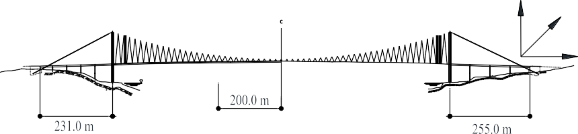

Z

Y

+0.000 Mean Sea Level

Fig.1 General Arrangement of the Bosphorus Bridge [13]

supported at the base instead of suspenders. The span length of Ortakoy and Beylerbeyi approach viaducts are 231 m and 255 m, respectively. The width of the deck with six lanes is 33 m and the height of the towers from the sea level is 165 m. Elaborate FE model including shell elements adopted for the all structural compo- nents of the bridge was established since the former models in literature [11, 12, 16] were modeled only for determining global behavior of the bridge. With the help of the recent FE model, performing detailed analyses and simulations will be possible.

# Finite element modeling of the bridge

All structural components of the bridge were made of steel thin plate. Internal dia- phragms were also used to provide additional stiffness for these components. Based on its project drawings, the bridge was modeled using shell element. Besides, link element was considered for deck-tower and side span-tower connections. Consid- ering cable sag effect, cable element features were assigned to the main cable, back- stay cable and hangers. The cross girder I beams with tapered section and the circu- lar box columns of the approach viaducts were modeled as frame element. The es- tablished FE model is shown in Fig.2. In this model, 4121 points, 263 frame ele- ments, 387 cable elements and 3996 shell elements were used. For all efforts, SAP2000 [14] software was utilized.

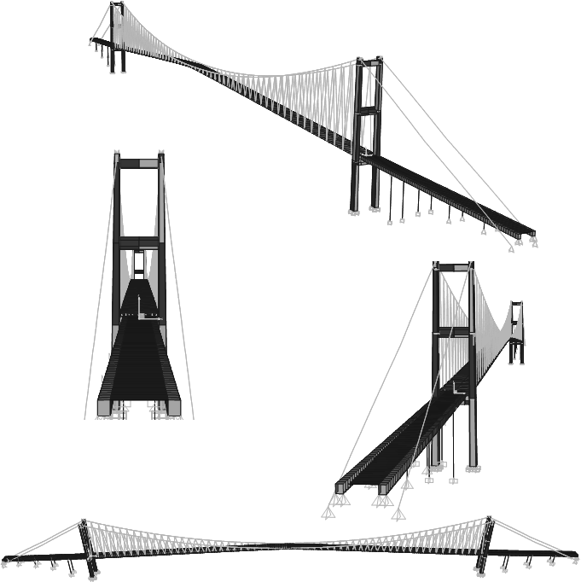

Fig.2 The 3-D full-scale FE model of the Bosphorus Bridge

# Dynamic analysis of the bridge

The modal analysis provides a powerful tool to detect the problems relevant to the geometrical and loading assignments of FE models. After completion of the FE model, the modal analysis of the bridge was performed whether to determine local modes resulting from element connection and link assignment problems. The FE model was improved through the modal analysis, and total number of 50 mode fre- quencies and corresponding mode shapes were obtained. As expected, the first ef- fective mode shape frequency is in transvers direction. In Fig. 3, the first 5 modes are shown. These results are then compared with those recently-obtained. As given in Table 1, the obtained results in the current study are compatible with those from

Mode 2 f=0.102 Hz

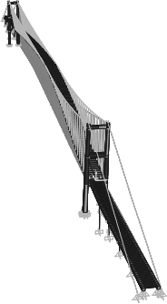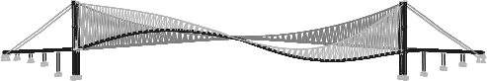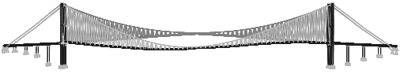

Mode 3 f=0.136 Hz

Mode 1

f=0.068 Hz

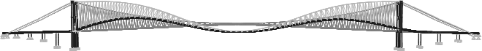Mode 4 f=0.125 Hz

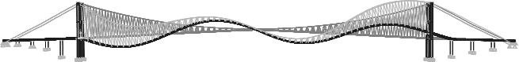Mode 5 f=0.179 Hz

Fig.3 The first 5 mode frequencies and corresponding mode shapes

the previous studies. Thus, the developed model and the considered idealizations are proved to be used for further analysis and simulations of the bridge.

Table 1. Comparison of the results from the current study.

Frequency

Mode Number

Mode Shape

(Hz) [15] [16] [11] [12] Current

|  |  |  |  |  |  |  |
| --- | --- | --- | --- | --- | --- | --- |
|  | | | | | | study |
| Mode-1 | 1st Lsym | 0.073 | 0.072 | 0.069 | 0.074 | 0.068 |
| Mode-2 | 1st Vasym | 0.126 | 0.144 | 0.125 | 0.120 | 0.102 |
| Mode-3 | 1st Vsym | 0.165 | 0.202 | 0.190 | 0.158 | 0.136 |
| Mode-4 | 2nd Vsym | 0.180 | 0.225 | 0.223 | 0.210 | 0.125 |
| Mode-5 | 3rd Vasym | 0.218 | 0.323 | 0.273 | 0.262 | 0.179 |

Lsym: Lateral symmetric, Vsym: Vertical symmetric, Vasym: Vertical asymmetric

# Results and conclusions

The 3-D full-scale finite element model of the Bosphorus Suspension Bridge is es- tablished using shell element. Besides, fame element and link element are also con- sidered. In order to verify the model and to solve the problems with geometry of the bridge, mode shapes and frequencies are obtained by the modal analysis. A close relation between the results from the present study and formerly conducted studies in literature is determined. Consequently, the findings from this study indicate that the established 3-D full-scale FE model can be used effectively for detailed analysis and simulations of the bridge and that the modeling specifications and idealizations for this model can be easily considered for the advanced FE modeling of long-span bridges.

# References

1. Zhang Q, Chang T, and Chang C. (2001). Finite-Element Model Updating for the Kap Shui Mun Cable-Stayed Bridge. Journal of Bridge Engineering, 6(4), 285-293.
2. Chan TH T, Guo L, and Li Z X (2003). Finite element modelling for fatigue stress analysis of large suspension bridges. Journal of Sound and Vibration, 261(3), 443-464.
3. Ren W, Blandford G, and Harik I. (2004). Roebling Suspension Bridge. I: finite-element model and free vibration response. Journal of Bridge Engineering, 9(2), 110-118.
4. Hong A, Ubertini F, and Betti R. (2011). Wind analysis of a suspension bridge: identification and finite-element model simulation. Journal of Structural Engineering, 137(1), 133-142.
5. Asgari B, Osman S A, and Adnan A. (2013). Three-dimensional finite element modelling of long-span cable-stayed bridges. The IES Journal Part A: Civil & Structural Engineering, 6(4), 258-269.
6. Li ZX, Zhou TQ, Chan THT. et al (2007). Multi-scale numerical analysis on dynamic response and local damage in long-span bridges. Engineering Structures, 29(7), 1507-1524.
7. Duan Y F, Xu Y L, Fei QG. et al (2011). Advanced finite element model of Tsing Ma Bridge for. International Journal of Structural Stability and Dynamics, 11(02), 313-344.
8. Apaydin NM, Bas S, and Harmandar E. (2016). Response of the Fatih Sultan Mehmet Suspen- sion Bridge under spatially varying multi-point earthquake excitations. Soil Dynamics and Earthquake Engineering, 84, 44-54.
9. Apaydin NM, Kaya Y, Safak E, and Alcik H (2012). Vibration characteristics of a suspension bridge under traffic and no traffic conditions. Earthquake Engineering & Structural Dynamics, 41(12), 1717-1723.
10. Bas S. (2011). Dynamic analysis and seismic performance evaluation of two approach viaducts of the Bosphorus Suspension Bridge. MSc, Istanbul Technical University, Istanbul, Turkey.
11. Kosar U. (2003). System identiﬁcation of Bogazici Suspension Bridge. MSc, Bosphorus Uni- versity, Istanbul, Turkey.
12. Apaydın NM. (2010). Earthquake performance assessment and retrofit investigations of o suspension bridges in Istanbul. Soil Dynamics and Earthquake Engineering, 30(8), 702-710.
13. Bosporus Bridge towers, suspended structures, cables, anchorage drawings, (1968). Consulting Engineers. Freeman, Fox and Partners, Westminster, London, UK.
14. Integrated structural ﬁnite element analysis and design of structures (SAP2000) (2011). Com- puters and Structures, Inc., Berkeley, CA, USA.
15. Brownjohn JM., Dumanoglu AA, Severn RT et al. (1989). Ambient vibration survey of the Bosporus Suspension Bridge. Earthquake Engineering and Structural Dynamics 18, 263–83.
16. Erdik M, Uckan E. (1989). Ambient vibration survey of the Bogazici Suspension Bridge, Re- port No: 89-5. Istanbul-Turkey: Department of Earthquake Engineering Kandilli Observatory and Earthquake Research Institute, Bogazici University.