Name: Batuhan Yalçın

Student ID: 64274

Course: MECH 411 Fluid Mechanics

Instructor: Assoc. Prof. Ipek Basdogan

Date: 19.01.2021

**Vibration Analyses of a Home Standing Fan**

1. **Introduciton:**

Investigated part

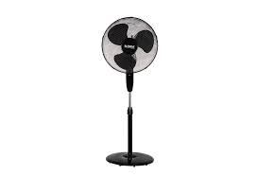

Figure 1: A conventional home standing fan [1]

The using home standing fan is old fashioned and cheaper method the, feeling cool in summer. The most common feedback received by users is the noise of the fans. After the literature review, I found that the most common reason of these noise of the fan due to the vibration of the propellers. After the literature review, I found that there is 4 way to control of the vibration of the fan system. First way is the controlling the number of the propellers in the fan. The second way is the controlling of the rotation speed of the fan. Third way is changing the material. Fourth way is the geometry of the propellers for the geometry of the propellers found as the quadratic edge line of the propellers gives the best result of the decreasing vibration and the reducing the noise. As I will explained below decreasing the vibration frequency will not create the reasons with the system rotation speed for almost most of the case rotation frequency is much lower than the system frequency. For a typical home standing fan geometry I found the geometries as : dp=315 [mm] corresponding to a duct radius rp=157.5 [mm]. The fan (tip) diameter is dt=300 [mm], therefore the fan radius is r=150 [mm]. The hub diameter is dh=94[mm], therefore the hub radius is rh=47 [mm]. The tip clearance was g=7.5 [mm] uniformly along the circumference [2]. The below figures shows the geometry.

 

Figure 2: Literature search geometry for the home standing fan.

1. **Simulation Procedure**

For the simulation firstly I decided the type of the vibration. Since the fan is rotating at 1430 RPM which is given from the literature [2]. so, there should be Coriolis effect and there should be damped which is controlled by the Ansys. For the simulation after the import model I choose the Material property as Structural Steel. From literature revies I found that the material of the propeller is mostly polymer plastic. However, my comparison geometry which I explain in upper was the Structural Steel at young modules 200GPa [2] so, I choose the aluminum to get more close result with given data. For the meshing I used the element size as 15mm for the upper in the article it was chose 10mm however my student version limit doesn’t allow to me more than 15mm, so I choose 15mm and it create the 15237 nodes and 7931 element a which create. The mesh of the geometry given:

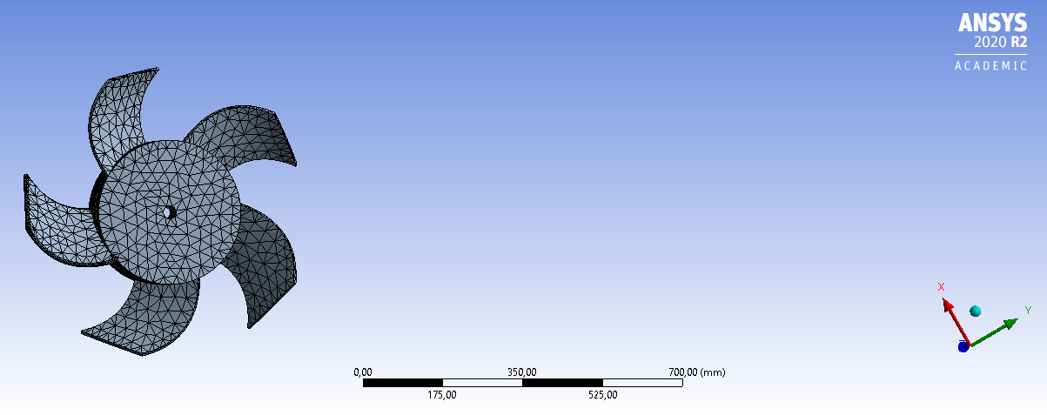

Figure 3: The meshes of the design geometry 15237 nodes and 7931 elements.

For the fixed support I chose the center of the force and for the rotating I choose the z axis and 1430 rpm. The boundary conditions are in the below:

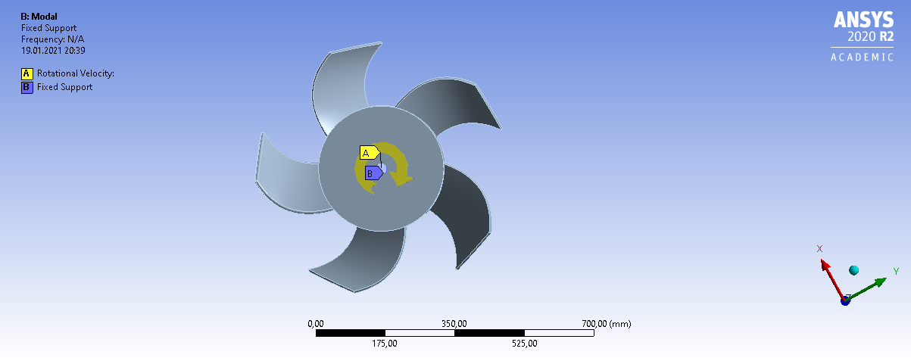

Figure 4: Boundary conditions of the fan.

**Discussion:**

**The Effects of the blade number in modal analysis:**

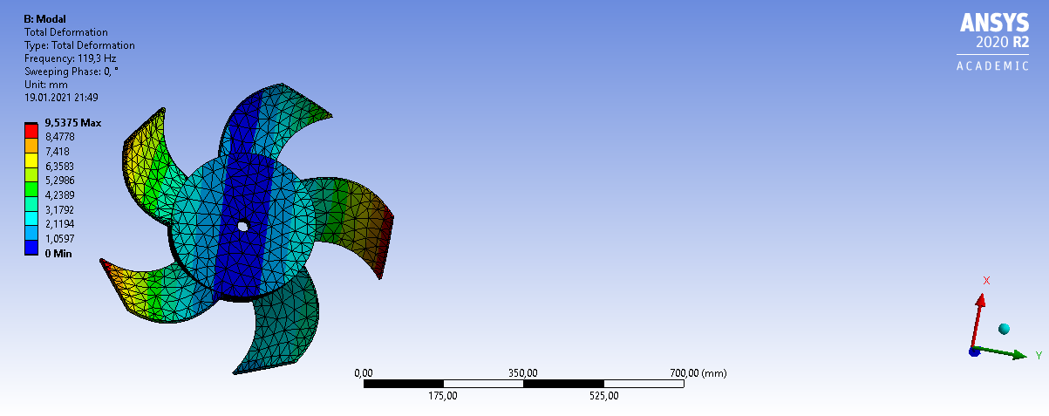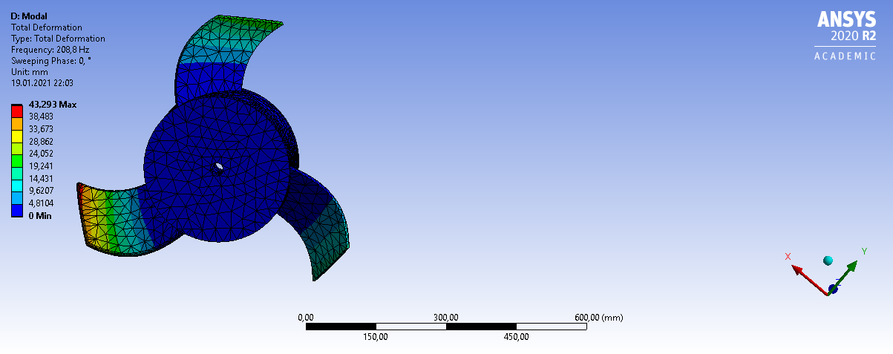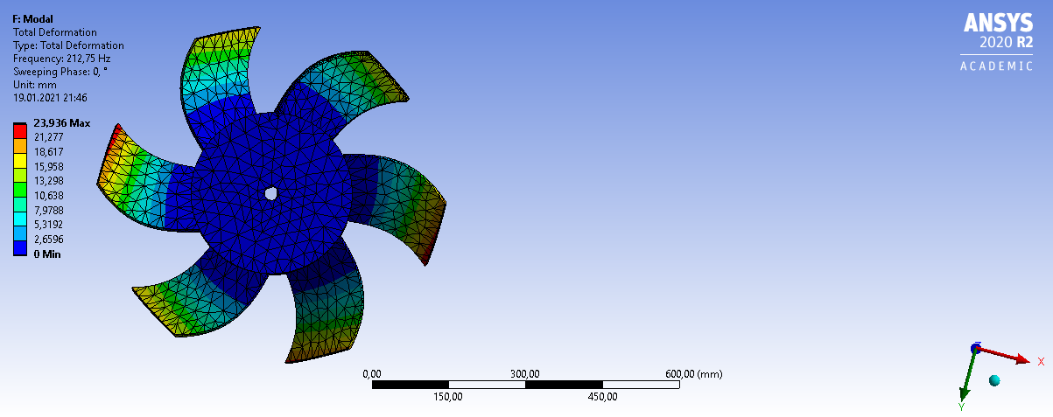

Blade number 6

Blade number 3

Blade number 5

Figure 5: Different Blade numbers for the fan system 3,5,6 blade number

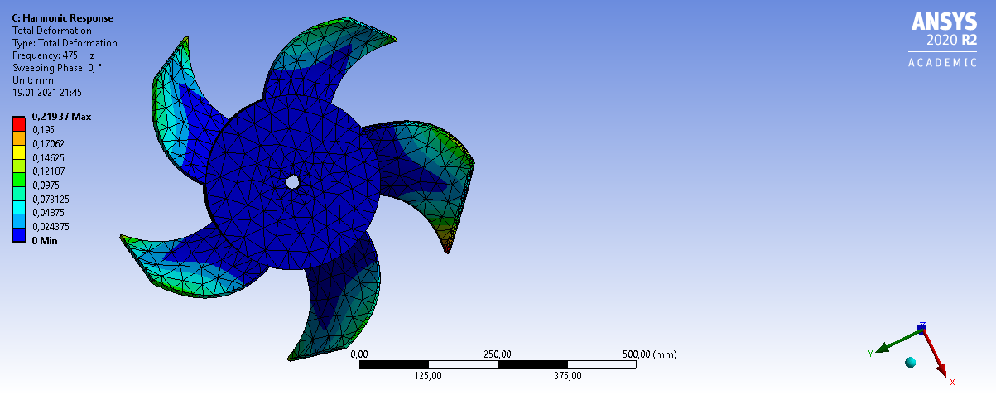

Figure 6: Harmonic response of the 5 blade there is no any critical deformation

|  |  |  |  |  |  |
| --- | --- | --- | --- | --- | --- |
| Modes | Blade Number 5 (Hz.) | | Blade Number 3 (Hz.) | Blade Number 6 | Blade 5 Harmonic frequency applied (Hz.) |
| 1 | 119,3 | | 208,8 | 208,3 | 47,5 |
| 2 | | 145,95 | 209,25 | 208,8 | 95 |
| 3 | 160,87 | | 209,53 | 209,3 | 142,5 |
| 4 | 211,33 | | 462,84 | 209,61 | 190 |
| 5 | 212,87 | | 468,24 | 214,69 | 237,5 |
| 6 | 230,73 | | 470,27 | 214,88 | 285 |
| 7 | 233,22 | | 632,25 | 460,12 | 332,5 |
| 8 | 239,84 | | 1069,3 | 468,21 | 380 |
| 9 | 465,2 | | 1093,5 | 470,1 | 427,5 |
| 10 | 467,83 | | 1257,2 | 470,71 | 475 |

Table 1: Modal analysis on the different number of blades and the harmonic response of the best case under the centrifugal force due to rotation speed

The comparison between the blade numbers shows that the there is no linear relation for between the blade number and the vibration response. I founded that when blade number get decrease from the 5-blade vibration response increase and the difference between the modes also increase. In addition to due that when the number of blades increased from the 5 blade the vibration response also increases however in terms of the differences between the modes number and respect frequency there were fewer changes comparing the blade decreasing case. When the looking effect of the material chosen, I will stay in more that. When the vibration response comparing the min and average value 5 blade number founded as the best case.

**The Effects of the Material in modal analysis:**

 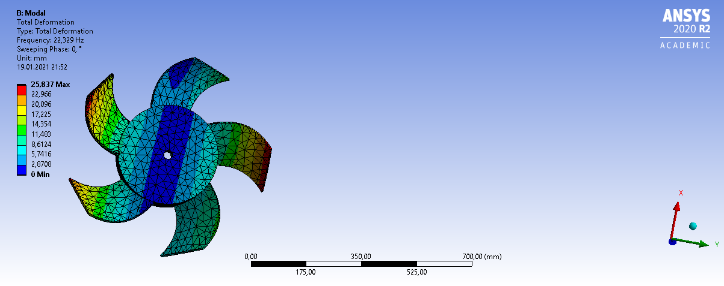

Plastic ABS

Structural Steel

Figure 7: Structural steel blade and the Plastic ABS blades

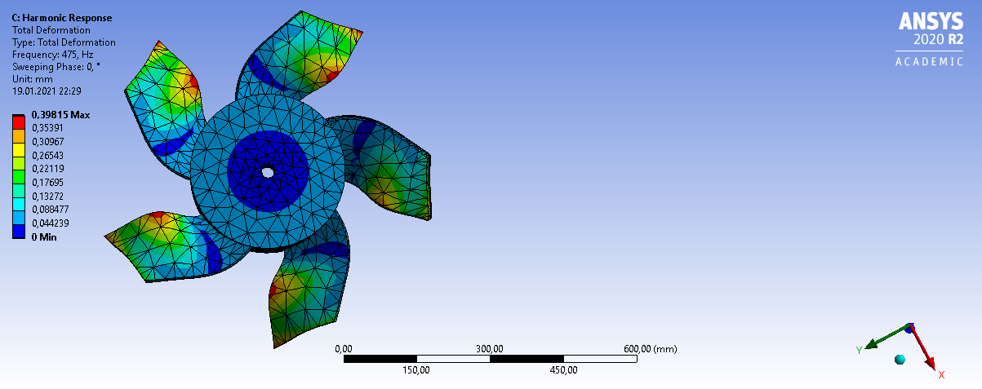

Figure 8: Harmonic response of the ABS there is more deformation then the steel but acceptable

|  |  |  |  |  |
| --- | --- | --- | --- | --- |
| Modes | Structural Steel (Hz.) | | Plastic ABS (Hz) | Blade 5 Harmonic frequency applied (Hz.) |
| 1 | 119,3 | | 22,329 | 47.5 |
| 2 | | 145,95 | 39,734 | 95 |
| 3 | 160,87 | | 45,384 | 142,5 |
| 4 | 211,33 | | 52,145 | 190 |
| 5 | 212,87 | | 59,836 | 237,5 |
| 6 | 230,73 | | 61,262 | 285 |
| 7 | 233,22 | | 62,03 | 332,5 |
| 8 | 239,84 | | 141,64 | 380 |
| 9 | 465,2 | | 141,98 | 427,5 |
| 10 | 467,83 | | 45,384 | 475 |

Table 2: Modal analysis on the different material of blades and the harmonic response of the best case under the centrifugal force due to rotation speed

When the comparing the comparing the vibration case of the Structural Steel and the Plastic ABS, Plastic ABS founded as a giving less vibration response, it is supporting that the why in almost every home standing fan blades Plastic ABS is used. The deformation on the harmonic response were much then the Structural Steel however differences is in the acceptable ratio so Plastic ABS is the best material for using in the home standing fan in terms of the vibration response.

**Conclusion:**

My purpose was decreasing of the vibration response to obstacle to noise of the home standing fan. The vibration of the home standing can be controlled by some changes, in the terms of the effects of followings: the number of the blade, the material chosen, the geometry of the blade, and the Revolution of the fan in terms of the RPM. I founded best geometry for the fan blades are quadratic for the performance of the fan there is no doubt on that and almost all fans produce according to do that. For the revolution of the fan there were not too much effect on the vibration response of the blade with the conventional range of using and it was interesting. I founded that the in terms number of the blade vibration response hast a lot changes and I found the best number of blade 5 however 6 was also acceptable. The changing the material created the most changes on the vibration response, and I found that the Plastic ABS is the best material for the fan blades. However, for the revolution 1430 rpm we have 23.833 Hz frequency which is very close the first mode of the Plastic ABS vibration response as shown in the table 2, so to get obstacle to any resonance between the revolution speed and the blade vibration response instead of the 5 blade we can use the 6 blade or 3 blades. In the scope of this to reducing the noise of the fan and the vibration response, for best case we can use the 6 blade and the Plastic ABS, however, in terms of the long usage and the safety 3 blade or 4 blade and the Plastic ABS material can be optimal for the home standing fan.

Reference:

[1]. Kalmar-Nagy, Tamas & Bak, Bendegúz & Benedek, Tamás & Vad, János. (2015). Vibration and Noise of an Axial Flow Fan. Periodica Polytechnica Mechanical Engineering. 59. 10.3311/PPme.7948.