**Batuhan Yalçın**

**64274**

**Mech 411**

**Project Proposal**

**My first Project is First Bosphorus Bridge under the earthquake**

First Bosphorus Bridge simple support multi support vibration analysis and earthquake analysis

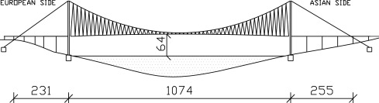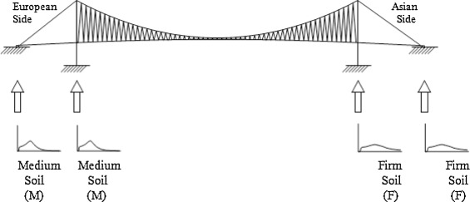

Figure 1: Dimensions of the First Borborues gate [1]

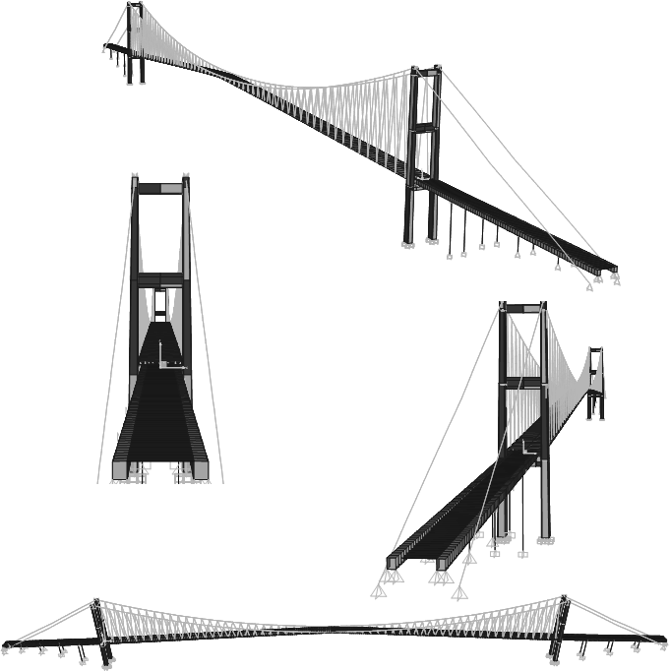The reason for me to choose these Project the earthquake being a certainty for the Istanbul so I want to understand the effect of the earthquake to First Bosphorus Bridge which can be very important to transit needs for the earthquake victims.

Figure 2 Modeling of the gate [2]

| **Mode Number** | **Frequency (Hz)** | **Period (sec)** |
| --- | --- | --- |
| **1** | 0.121 | 8.286 |
| **2** | 0.161 | 6.215 |
| **3** | 0.220 | 4.538 |
| **4** | 0.277 | 3.617 |
| **5** | 0.365 | 2.738 |
| **6** | 0.449 | 2.230 |
| **7** | 0.554 | 1.805 |
| **8** | 0.574 | 1.741 |
| **9** | 0.661 | 1.513 |
| **10** | 0.771 | 1.297 |
| **11** | 0.896 | 1.116 |
| **12** | 1.026 | 0.975 |
| **13** | 1.033 | 0.968 |
| **14** | 1.036 | 0.966 |
| **15** | 1.174 | 0.852 |

Table 1. Frequency modeling of the First Bosphorus Bridge without the earthquake response [1]

In these project additions to earthquake effect, I want to look the effect of the support members to bridge also design parameters in upper part. If I couldn’t find the force and the vibrations of a Istanbul earthquake for the First Bosphorus Bridge I will look for the Fatih Sultan Mehmet bridge:

**My second project is Fatih Sultan Mehmet bridge**

Fatih Sultan Mehmet gate simple support multi support vibration analysis and earthquake analysis

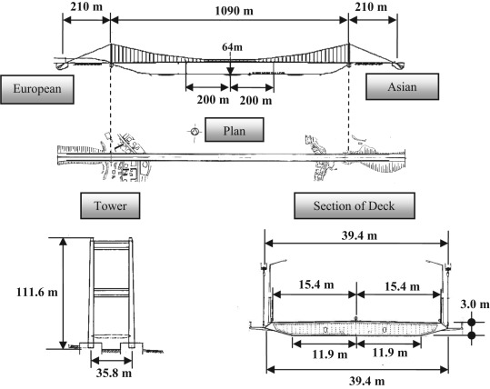

Figure 3: Dimensions of the Fatih Sultan Mehmet bridge [3]

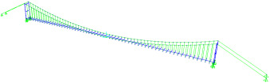

| **Mode number** | **Mode shape** | **Period** | **Frequency** |
| --- | --- | --- | --- |
| **s** | **Cyc/s** |
| **1** | 1st Lsym | 15.15 | 0.066 |
| **2** | 1st Vasym Long | 10.23 | 0.098 |
| **3** | 2nd Vasym Long | 6.75 | 0.148 |
| **4** | 1st Vsym Long | 6.58 | 0.152 |
| **5** | 1st Lasym | 5.20 | 0.192 |

Lsym: Lateral symmetric; Vasym: Vertical asymmetric; Vsym: Vertical symmetric; Long: Longitudinal.[3]

Figure 4: Modeling frequencies and the modeling of the Fatih Sultan Mehmet bridge

If I will also fail on the founding of the Earthquake response of the Fatih Sultan Mehmet bridge I will change my project to home standing fan:

**My third Project home standing fan**

Purpose of the analysis is the effects of the number of the blades to vibration which main cause of the sound.

 

Figure 5: The real geometry and the modeling geometry of the Fan blades [4]

|  |  |
| --- | --- |
| Measured Frequency [Hz] | Computed Frequency [Hz] |
| 101.5 | 104.6 |
| 103.8 | 104.6 |
| 110.5 | 112.5 |
| 123.0 | 126.3 |
| 125.1 | 126.3 |
| 156.6 | 156.6 |
| 160.4 | 156.8 |
| 167.4 | 166.9 |
| 171.6 | 167.1 |
| 192.7 | 189.5 |

Table 2. measured vibration response of the home standing fans after the Ansys analyses [4].

The table 2 data for a structural steel blade.

I want to look at these projects to predict how the number of the blades effect the vibration which cause sound in a home standing fan and the rotation speed. The noise of this fans is main problem from the consumer feedbacks so, my target is solving this problem. The most efficient way to solve this problem is the decreasing the vibration response of the sytem.

Referances

[1]. Süleyman Adanur, Ahmet Can Altunişik, Kurtuluş Soyluk, Alemdar Bayraktar, A. Aydın Dumanoğlu,Multiple-support seismic response of Bosporus Suspension Bridge for various random vibration methods,Case Studies in Structural Engineering,Volume 5,2016,Pages 54-67,ISSN 2214-3998, <https://doi.org/10.1016/j.csse.2016.04.001>.

[2]. Bas, Selcuk & Aypadin, Nurdan & Harmandar, Ebru & Catbas, Necati. (2018). Multi-point earthquake response of the Bosphorus Bridge to site-specific ground motions. Steel and Composite Structures. 26. 197-211. 10.12989/scs.2018.26.2.197.

[3]. Nurdan Memisoglu Apaydin, Selcuk Bas, Ebru Harmandar,Response of the Fatih Sultan Mehmet Suspension Bridge under spatially varying multi-point earthquake excitations,Soil Dynamics and Earthquake Engineering,Volume 84,2016,Pages 44-54,ISSN 0267-7261, <https://doi.org/10.1016/j.soildyn.2016.01.018>.

[4]. Kalmar-Nagy, Tamas & Bak, Bendegúz & Benedek, Tamás & Vad, János. (2015). Vibration and Noise of an Axial Flow Fan. Periodica Polytechnica Mechanical Engineering. 59. 10.3311/PPme.7948.