Machine Learning

DAT-5303

Course Case

Apprentice Chef, Inc.

Classification Model

Instructor  
Prof. Chase Kusterer

Cohort

FMSBA2

Student

Baturalp Topcu

4905507

**Apprentice Chef, Inc Classification Write Up**

Apprentice Chef, Inc. makes cross-selling promotions where subscribers receive a bottle of wine in the mid of every week. The team believes that this is their competitive advantage because they offer exclusive local wines. They want to reach more audiences and increase their number of subscribers for this wine service.

Since we know, only new customers are registering with the mobile number, and they get a one-time code to confirm their phone number. When the number of mobile numbers increases one-unit, cross-sell success increases by 76%. In other words, a new customer tends to subscribe to cross-sell promotion than an old customer. The number of new customers get higher, cross-sell success gets higher. In addition to that, this data shows that most of the new customers’ age is above 21 and registered with their ID.

The customers who selected tastes and preferences in terms of cuisine, cuisine characteristic, food allergies, and any dietary restriction, they increase the success in cross-sell promotion by 59%. Because all of this information helps the company to promote to the target customer. According to our model, we predicted that 107 of our customers would subscribe to the service, and they did it. However, we forecasted to reach 47 of our customers, but we didn’t contact them. One of the reasons for this is that some of our customers are registered with their unused email, in other words, junk email. They might not see our emails about cross-sell promotion because the junk email registration affects our success in cross cell promotion quite negatively.

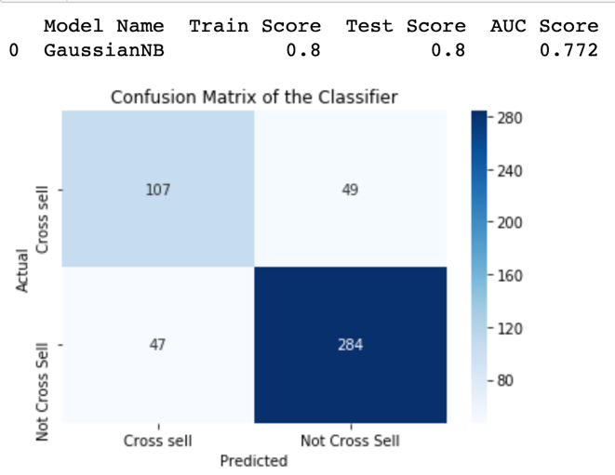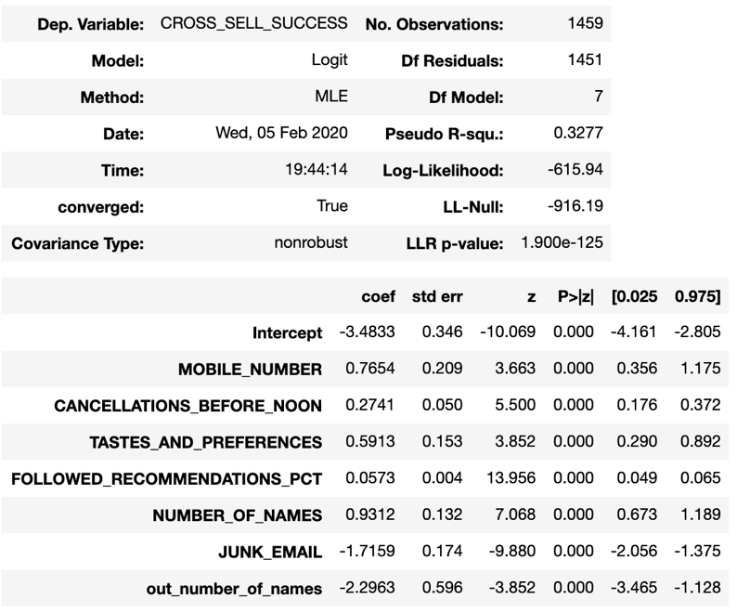

According to our confusion matrix, our aim is to increase top-left corner which shows that we predicted right, and we succeeded actually. To do this, the company should target people who are above 21 and who could prefer drinking wine. Uber Eats started online alcohol delivery in Australia. They first checked the ID of the customer during the registration (Lieu, J., 2017). DoorDash also started selling some breweries, but for this, customer needs to sign up with the ID (PYMNTS.com, 2016). It might increase our bounce rate and decrease our new customer acquisition—another problem which is junk email issues. Apprentice Chef, Inc. can use email verification or offer a secure registration method like sign up with Facebook or Google and following social media integrations. The decrease in registration with a junk email domain will increase cross-sell success. The increase in sign up with Facebook and Google account will affect the success in cross-sell because our company can get more information about our customer profile. This gives them a chance to understand their customer’s age, interests, and preferences. This action will solve many problems as Sushrut Padhye says, “You Should Integrate Social Media Platforms into Your App” because it provides in-app social sharing, accessibility. It improves functionality, data quality, and forecast (Padhye, S., 2015).

**Reference**

* Padhye,S., (2015, Jan 19). “You Should Integrate Social Media Platforms into Your App”. Retrieved from <https://www.socialmediatoday.com/content/why-you-should-integrate-social-media-platforms-your-app>
* PYMNTS.com, (2016, June 30). “DoorDash Dashes Into Booze Delivery”. Retrieved from <https://www.pymnts.com/news/mobile-commerce/2016/doorcash-alcohol-delivery/>
* Lieu,J., (2017,March 22)“UberEATS is delivering alcohol now, but probably not in the way you were hoping”. Retrieved from <https://mashable.com/2017/03/22/uber-eats-alcohol-delivery-melbourne/>