ASSIGNMENT #5
COMPUTATIONAL MODELS WITH POLYNOMIALS
CS4720 INTRODUCTION TO COMPUTATIONAL SCIENCE
FALL 2014

Baturay Daylak
bdaylak@students.kennesaw.edu

October 4th , 2014
College of Science and Mathematics
Kennesaw State University
Assignment Description:

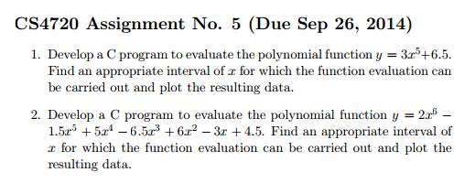
Solution Details:
All solutions are developed on Kennesaw State University Computer Science Department's CS3 server, and compiled with gcc on the server. Solution utilizes gsl_poly_eval function from GSL's gsl_poly.h. GNU Plot outputs are generated with gnuplot v4.6.5 on Windows 8.1.

Solution to Problem 1)
For the solution of the problem, the given polynomial's coefficients have been supplied to the gsl_poly_eval function as an array. The coefficient array is <6.5,0,0,0,0,3>, and the interval for evaluation is (-5,5).

Source:
00000001 //Program: CS4720 Assignment 5 Program 1
00000002 //C program for evaluating a polynomial using GSL
00000003 //Original program by J.M.Garrido, Feb 23 2013
00000004 //Modified by Baturay Daylak, September 2014
00000005
00000006 #include <stdio.h>
00000007 #include <gsl/gsl_poly.h>
00000008 #include "basic_lib.h"
00000009
00000010 #define N 6
00000011 #define M 20
00000012
00000013 void polyeval(double p[], double x[], double y[], int n, int m)
00000014 {
00000015 int j;
00000016 y[0] = gsl_poly_eval(p, N, x[0]);
00000017 for(j=1; j<M; j++)
00000018 y[j] = gsl_poly_eval(p, N, x[j]);
00000019 return;
00000020 }
00000021
00000022 int main()
00000023 {
00000024 int i, j;
00000025 double xi, xf, x[M], y[M];
00000026 double coefs[N] = {6.5,0,0,0,0,3};
00000027 printf("Evaluating polynomial with coefficients: \n");
00000028 for(i=0;i<N;i++)
00000029 printf("%f ",coefs[i]);
00000030 printf("\n");
00000031 xi = -5;
00000032 xf = 5;
00000033 linspace(x, xi, xf, M);
00000034 polyeval(coefs, x, y, N, M);
00000035 printf("\nData points calculated of the polynomial x y \n");
00000036 for(j=0;j<M;j++)
00000037 printf("%+.18f %+.18f \n", x[j], y[j]);
00000038 return 0;
00000039 }

Output
Evaluating polynomial with coefficients:
6.500000 0.000000 0.000000 0.000000 0.000000 3.000000
Data points calculated of the polynomial x y
-5.000000000000000000 -9368.500000000000000000
-4.473684210526315930 -5369.359113468404757441
-3.947368421052631859 -2868.643774542133542127
-3.421052631578947789 -1399.288651826926752619
-2.894736842105263719 -603.270903748194768923
-2.368421052631579649 -217.071179908396572955
-1.842105263157895578 -57.134622444417757947
-1.315789473684211508 -5.331867384947090116
-0.789473684210527327 +5.579953992146511332
-0.263157894736843145 +6.496213802436816565
+0.263157894736841036 +6.503786197563182547
+0.789473684210525217 +7.420046007853476233
+1.315789473684209288 +18.331867384946992416
+1.842105263157893358 +70.134622444417374254
+2.368421052631577428 +230.071179908395521352
+2.894736842105261498 +616.270903748192495186
+3.421052631578945569 +1412.288651826922432519
+3.947368421052629639 +2881.643774542125356675
+4.473684210526314153 +5382.359113468392934010
+4.999999999999998224 +9381.499999999983629095
Graph of the polynomial
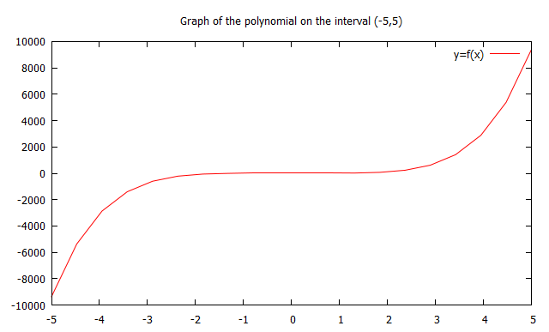
Solution to Problem 2)
For the solution of the problem, the given polynomial's coefficients have been supplied to the gsl_poly_eval function as an array. The coefficient array is <4.5,-3,6,-6.5,5,1.5>, and the interval for evaluation is (-5,5).

Source:
00000001 //Program: CS4720 Assignment 5 Program 1
00000002 //C program for evaluating a polynomial using GSL
00000003 //Original program by J.M.Garrido, Feb 23 2013
00000004 //Modified by Baturay Daylak, September 2014
00000005
00000006 #include <stdio.h>
00000007 #include <gsl/gsl_poly.h>
00000008 #include "basic_lib.h"
00000009
00000010 #define N 6
00000011 #define M 20
00000012
00000013 void polyeval(double p[], double x[], double y[], int n, int m)
00000014 {
00000015 int j;
00000016 y[0] = gsl_poly_eval(p, N, x[0]);
00000017 for(j=1; j<M; j++)
00000018 y[j] = gsl_poly_eval(p, N, x[j]);
00000019 return;
00000020 }
00000021
00000022 int main()
00000023 {
00000024 int i, j;
00000025 double xi, xf, x[M], y[M];
00000026 double coefs[N] = {4.5,-3,6,-6.5,5,1.5};
00000027 printf("Evaluating polynomial with coefficients: \n");
00000028 for(i=0;i<N;i++)
00000029 printf("%f ",coefs[i]);
00000030 printf("\n");
00000031 xi = -5;
00000032 xf = 5;
00000033 linspace(x, xi, xf, M);
00000034 polyeval(coefs, x, y, N, M);
00000035 printf("\nData points calculated of the polynomial x y \n");
00000036 for(j=0;j<M;j++)
00000037 printf("%+.18f %+.18f \n", x[j], y[j]);
00000038 return 0;
00000039 }

Output:
Evaluating polynomial with coefficients:
4.500000 -3.000000 6.000000 -6.500000 5.000000 1.500000
Data points calculated of the polynomial x y
-5.000000000000000000 -580.500000000000000000
-4.473684210526315930 +34.827343535132996521
-3.947368421052631859 +286.004182587206685184
-3.421052631578947789 +327.212963011575936889
-2.894736842105263719 +267.322918227421496340
-2.368421052631579649 +177.159568539060956027
-1.842105263157895578 +96.774220457259701789
-1.315789473684211508 +42.713466020542867341
-0.789473684210527327 +15.288682116506683073
-0.263157894736843145 +5.845529803129850599
+0.263157894736841036 +4.033453630085066521
+0.789473684210525217 +5.075180960050458268
+1.315789473684209288 +17.036221290021060781
+1.842105263157893358 +68.094365572620262128
+2.368421052631577428 +213.809185537411224232
+2.894736842105261498 +544.391533012208469700
+3.421052631578945569 +1191.973039244389156011
+3.947368421052629639 +2337.875614222205058468
+4.473684210526314153 +4219.880945996093942085
+4.999999999999998224 +7139.499999999988176569

Graph of the polynomial
