ASSIGNMENT #1
INTRODUCTION TO C LANGUAGE
CS3540 SYSTEM PROGRAMMING WITH C AND LINUX
SPRING 2015

Baturay Daylak
bdaylak@students.kennesaw.edu

January 14th , 2015
College of Science and Mathematics
Kennesaw State University
Assignment Description:

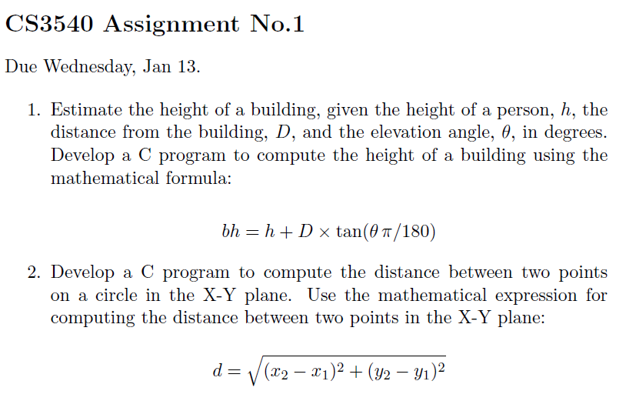
Solution Details:
All solutions are developed on Debian 7 running within VirtualBox 4.3.20 hosted by Windows 8.1 environment. Debian 7's default GNU Compiler is used to compile the source files.

Solution to Problem 1)
Solution assumes user would input the data required correctly. There are no input validations at the moment. (Not specified by the assignment.) Solution uses tan function from C's standard math library. Therefore, source code is compiled with math module.

Source:
00000001 // Spring 2015 - CS3540 - Systems Programming w/ C
00000002 // Assignment 1 Question 1
00000003 // Baturay Daylak
00000004
00000005 #include<stdio.h>
00000006 #include<math.h>
00000007 int main()
00000008 {
00000009 float bh, h, D, theta;
00000010 printf("\n--------------------------------------------------\n");
00000011 printf("Assignment 1 Question 1 - CS3540 - Baturay Daylak\n");
00000012 printf("--------------------------------------------------\n");
00000013 printf("Please enter the height of the person: ");
00000014 scanf("%f", &h);
00000015 printf("Please enter the distance from the building: ");
00000016 scanf("%f", &D);
00000017 printf("Please enter the elevation angle: ");
00000018 scanf("%f", &theta);
00000019 bh = h + D * tan(M_PI*theta/180.0);
00000020 printf("--------------------------------------------------\n");
00000021 printf("Height of the building is %.2f\n", bh);
00000022 printf("--------------------------------------------------\n\n");
00000023 return 0;
00000024 }

Output
Script started on Mon 12 Jan 2015 04:41:33 PM EST
baturay@debian:~/CS3540/Assignments/1$ ./a1

--------------------------------------------------
Assignment 1 Question 1 - CS3540 - Baturay Daylak
--------------------------------------------------
Please enter the height of the person: 5
Please enter the distance from the building: 10
Please enter the elevation angle: 45
--------------------------------------------------
Height of the building is 15.00
--------------------------------------------------

baturay@debian:~/CS3540/Assignments/1$ exit
exit
Script done on Mon 12 Jan 2015 04:41:40 PM EST
Solution to Problem 2)
Solution assumes user would input the data required correctly. There are no input validations at the moment. (Not specified by the assignment.) Solution uses pow and sqrt functions from C's standard math library. Therefore, source code is compiled with math module.

Source:
00000001 // Spring 2015 - CS3540 - Baturay Daylak
00000002 // Assignment 1 Question 2
00000003
00000004 #include<stdio.h>
00000005 #include<math.h>
00000006
00000007 int main()
00000008 {
00000009 float d, x1, x2, y1, y2;
00000010 printf("\n--------------------------------------------------");
00000011 printf("\nAssignment 1 Question 2 - CS3540 - Baturay Daylak");
00000012 printf("\n--------------------------------------------------\n");
00000013 printf("Please enter first X coordinate: ");
00000014 scanf("%f", &x1);
00000015 printf("Please enter second X ccoordinate: ");
00000016 scanf("%f", &x2);
00000017 printf("Please enter first Y coordinate: ");
00000018 scanf("%f", &y1);
00000019 printf("Please enter second Y coordinate: ");
00000020 scanf("%f", &y2);
00000021
00000022 d = sqrt( pow(x2-x1, 2) + pow(y2-y1, 2) );
00000023
00000024 printf("--------------------------------------------------\n");
00000025 printf("Distance between two points is %.3f\n", d);
00000026 printf("--------------------------------------------------\n\n");
00000027 return 0;
00000028 }

Output:
Script started on Mon 12 Jan 2015 04:42:36 PM EST
baturay@debian:~/CS3540/Assignments/2$ ./a2

--------------------------------------------------
Assignment 1 Question 2 - CS3540 - Baturay Daylak
--------------------------------------------------
Please enter first X coordinate: 10
Please enter second X ccoordinate: 5
Please enter first Y coordinate: 10
Please enter second Y coordinate: 4
--------------------------------------------------
Distance between two points is 7.810
--------------------------------------------------

baturay@debian:~/CS3540/Assignments/2$ exit
exit
Script done on Mon 12 Jan 2015 04:42:45 PM EST

