ASSIGNMENT #2
INTRODUCTION TO ARRAYS IN C LANGUAGE
CS3540 SYSTEM PROGRAMMING WITH C AND LINUX
SPRING 2015

Baturay Daylak
bdaylak@students.kennesaw.edu

January 20th , 2015
College of Science and Mathematics
Kennesaw State University
Assignment Description:
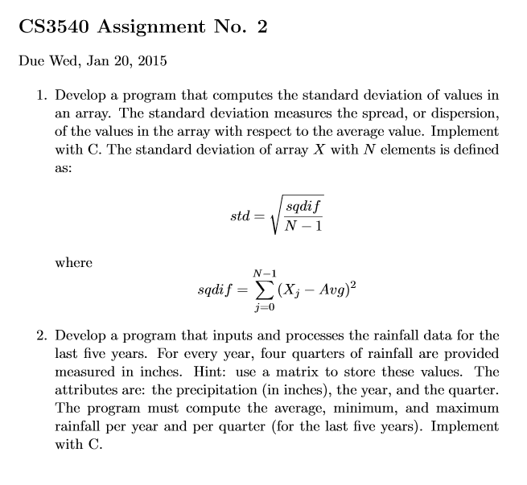
Solution Details:
All solutions are developed on Debian 7 running within VirtualBox 4.3.20 hosted by Windows 8.1 environment. Debian 7's default GNU Compiler is used to compile the source files.

Solution to Problem 1)
Solution assumes a function to be called in order to randomly fill up an array structure. Solution also uses std_dev function from basic_lib.h to calculate the standard deviation of the array values.

Source:
00000001 /*
00000002 * Program: assignment2_1.c
00000003 * Author: Baturay Daylak, January 14, 2015
00000004 * Class: CS3540 Spring '15 - System Programing with Linux and C
00000005 * Description: Calculates standard deviation for an N element array.
00000006 * Comments: randouble function has been gathered from a GNU source.
00000007 */
00000008 #include <stdio.h>
00000009 #include <stdlib.h>
00000010 #include <math.h>
00000011 #include "basic_lib.h"
00000012
00000013 double randouble(double min, double max)
00000014 {
00000015 double range = (max - min);
00000016 double div = RAND_MAX / range;
00000017 return min + (rand()/div);
00000018 }
00000019
00000020 int main()
00000021 {
00000022 //Assignment information
00000023 print_assignment_header(2,1);
00000024
00000025 srand(time(NULL)); //This will make rand function generate unique output at each program run.
00000026 int i = 0;
00000027 int n = 50;
00000028 double values[n];
00000029
00000030 printf("\nInput values for std_dev calculation:\n");
00000031 for(i = 0; i<n; i++)
00000032 {
00000033 values[i] = randouble(0.0,100.0); //random double between 0 and 100
00000034 printf("%f\n",values[i]);
00000035 }
00000036 print_separator();
00000037 printf("\nStandard deviation of values: %f\n",std_dev(values,n));
00000038 print_separator();
00000039 print_newline();
00000040 return 0;
00000041 }
Output
Script started on Wed 14 Jan 2015 05:14:13 PM EST
baturay@debian:~/CS3540/Assignments/2/src$ ./a1
-----------------------------------------------------
Assignment 2 - Question 1 - CS3540 - Baturay Daylak
-----------------------------------------------------

Input values for std_dev calculation:
72.506369
35.309785
43.661690
43.663136
43.864286
23.105020
74.238713
30.783506
21.820930
53.730926
9.412201
14.647858
76.090986
59.624315
5.975324
48.064173
0.202343
37.402051
95.095053
24.685482
75.740842
76.958029
40.729994
47.626104
8.238333
17.535922
73.741477
77.939194
46.615356
13.073561
96.738601
19.121726
48.383346
40.400290
62.784862
92.247632
63.505311
37.023575
23.031138
85.326241
90.754501
32.443339
99.974099
66.845487
92.067654
5.949423
14.909660
92.269997
43.351474
10.004712
-----------------------------------------------------
Standard deviation of values: 29.178037
-----------------------------------------------------

baturay@debian:~/CS3540/Assignments/2/src$ exit
exit
Script done on Wed 14 Jan 2015 05:14:20 PM EST
Solution to Problem 2)
Solution assumes user would input the data required correctly. There are no input validations at the moment. (Not specified by the assignment.) Solution uses pow and sqrt functions from C's standard math library. Therefore, source code is compiled with math module.

Source:
00000001 /*
00000002 * Program: assignment2_2.c
00000003 * Author: Baturay Daylak, January 14, 2015
00000004 * Class: CS3540 Spring '15 - System Programing with Linux and C
00000005 * Description: Calculates standard deviation for an N element array.
00000006 * Comments: randouble function has been gathered from a GNU source.
00000007 */
00000008 #include <stdio.h>
00000009 #include <stdlib.h>
00000010 #include "basic_lib.c"
00000011
00000012 int main()
00000013 {
00000014 double values[5][4] = {
00000015
00000016 {213.2, 564.3, 485.0, 321.5},
00000017 {301.2, 523.2, 468.6, 352.4},
00000018 {200.2, 510.2, 435.3, 408.4},
00000019 {276.5, 543.1, 432.4, 453.3},
00000020 {298.5, 456.6, 478.2, 300.7}
00000021
00000022 };
00000023
00000024 int i;
00000025 int j;
00000026
00000027 //Assignment information
00000028 print_assignment_header(2,2);
00000029
00000030 printf("\nInput data for annual quarterly rain fall: \n");
00000031 for(i=0;i<5;i++)
00000032 {
00000033 printf("%d data: ",2010+i);
00000034 for(j=0;j<4;j++)
00000035 printf("%f\t",values[i][j]);
00000036 printf("\n");
00000037 }
00000038
00000039 print_separator();
00000040 print_newline();
00000041
00000042 for(i=0;i<5;i++)
00000043 {
00000044
00000045 printf("Minimum rainfall for %d: %f\n", 2010+i,min(values[i],4));
00000046 printf("Maximum rainfall for %d: %f\n", 2010+i,max(values[i],4));
00000047 printf("Average rainfall for %d: %f\n\n", 2010+i,ave_magn(values[i],4));
00000048
00000049 }
00000050 }

Output:
Script started on Wed 14 Jan 2015 06:34:10 PM EST
baturay@debian:~/CS3540/Assignments/2/src$ ./a1
-----------------------------------------------------
Assignment 2 - Question 2 - CS3540 - Baturay Daylak
-----------------------------------------------------

baturay@debian:~/CS3540/Assignments/2/src$ exit
exit
Script done on Wed 14 Jan 2015 06:34:13 PM EST

