ASSIGNMENT #1
CS 4401 ALGORITHM ANALYSIS & DESIGN
SPRING 2015

Baturay Daylak
bdaylak@students.kennesaw.edu

January 19th , 2015
College of Science and Mathematics
Kennesaw State University
Assignment Description:
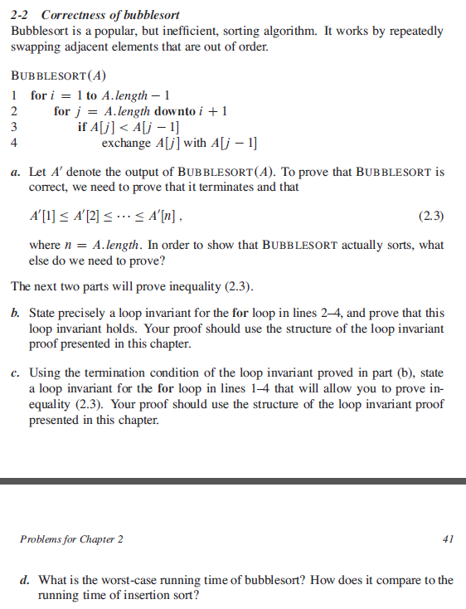
Solution to Problem
a) In addition to the output sequence to be sorted, it is also necessary that the output sequence is a permutation of the original sequence for the algorithm to be correct. (Output must contain the same elements as the input, however in sorted order.) No element of the sequence should be missing.

b) Let the input data be a sequence S with n elements. Before each iteration of the inner loop in line 2-4, there exists a subsetwhere is smaller than or equal to any element of the L. This leads the smaller element of the subset to be in subset .

Initialization
At the initialization, j is equal to the size of set S, which is n. Then, subset L only has one element, and subsets M and N are equal. Therefore, subset N surely holds the smallest element of subset M.

Maintenance
In each iteration of inner loop, the smallest element of subset L is swapped with the (j-1)th element of the set S, therefore the leftmost element, namely , of the subset L is also the smallest of the subset L prior to each iteration.

Termination
At the last iteration, j equals to i, which means the leftmost element indexed by is actually . Therefore, the smallest element of subset M is placed on after termination.

c) Termination condition of the loop invariant gives a direct insight about the structure of the sequence after each iteration of the outside loop: the subset contains smallest i elements and is sorted.

Initialization:
Before the initial loop, i equals to 1, which results in a subset from to , which is trivially sorted.

Maintenance:
In each iteration of outer loop, inner loop swaps the next smallest element of the set S into without manipulating upon its termination. Therefore, the subset R is sorted before each iteration of outer loop.

Termination:
During the loop before termination, inner loop j replaces the last smallest element on , if any, with . At the point, subset R is from to , and it is sorted.

d) Worst-case running time for bubble sort is In comparison, bubble sort and insertion sort has similar worst-case running times; however, bubble sort performs move swaps then insertion sort.

