Astana IT University

Software Design Patterns
Report

Group: SE-2503
Student name: Uvayev Batyrkhan
Date: 20.09.2026

Introduction
This project demonstrates two creational design patterns: Factory Method and Abstract Factory.
The chosen topic is GamingPCBuilder. A gaming PC can have different configurations and different component families. Because of this, the Factory Method and Abstract Factory patterns are useful for organizing object creation.
The Factory Method is used to create different types of Gaming PCs, such as Budget and High-End Gaming PCs. The factory interface defines the creation method, while concrete factories decide which Gaming PC should be created.
The Abstract Factory is used to create families of related Gaming PC components. In this project, there are two families: Budget and High-End. Each family contains a CPU, GPU, RAM, and Storage.
The implementation follows the structure of the examples from Lecture 2. Factory Method is used for one product, while Abstract Factory is used for a family of related products.

Factory Method | Abstract Factory
Creates one product | Creates a family of products
BudgetGamingPC/ HighEndGamingPC | Budget components / High-end components
Creates a GamingPC | Creates CPU + GPU + RAM + Storage
One creation method | Several creation methods

Factory Method
The Factory Method provides a common method for creating an object while allowing concrete factories to decide which concrete product will be created.
In this project, the product is a Gaming PC.
The structure contains:
- Product - GamingPC
- Concrete Products - BudgetGamingPC and HighEndGamingPC
- Factory Interface - GamingPCFactory
- Concrete Factories - BudgetPCFactory and HighEndPCFactory
- Client - GamingPCClient
Product
The GamingPC class is the common Product.
public abstract class GamingPC {

public abstract void showPC();
}
It defines the common operation that all Gaming PCs must provide.

Concrete Products
There are two concrete products.
BudgetGamingPC
public class BudgetGamingPC extends GamingPC {
@Override
public void showPC() {
System.out.println("Budget Gaming PC");
System.out.println("CPU: AMD Ryzen 5");
System.out.println("GPU: NVIDIA RTX 4060");
System.out.println("RAM: 16GB");
System.out.println("Storage: 1TB SSD");
}
}
HighEndGamingPC
public class HighEndGamingPC extends GamingPC {
@Override
public void showPC() {
System.out.println("High-End Gaming PC");
System.out.println("CPU: AMD Ryzen 7");
System.out.println("GPU: NVIDIA RTX 5090");
System.out.println("RAM: 64GB");
System.out.println("Storage: 2TB NVMe SSD");
}
}
Both classes implement the common GamingPC product.
Factory Interface
The factory interface is GamingPCFactory.
public interface GamingPCFactory {

GamingPC createGamingPC();
}
The method createGamingPC() is the Factory Method.
The interface does not specify which concrete Gaming PC will be created.
Concrete Factories
There are two concrete factories.
BudgetPCFactory creates BudgetGamingPC:
public class BudgetPCFactory implements GamingPCFactory {

@Override
public GamingPC createGamingPC() {
return new BudgetGamingPC();
}
}
HighEndPCFactory creates HighEndGamingPC:
public class HighEndPCFactory implements GamingPCFactory {

@Override
public GamingPC createGamingPC() {
return new HighEndGamingPC();
}
}
This separates object creation from the client code.

Client
The GamingPCClient receives a GamingPCFactory.
public class GamingPCClient {
private GamingPC pc;
public GamingPCClient(GamingPCFactory factory) {
pc = factory.createGamingPC();
}
public void showPC() {
pc.showPC();
}
}
The client does not directly create BudgetGamingPC or HighEndGamingPC.
The client works through the factory interface.
Factory Method UML
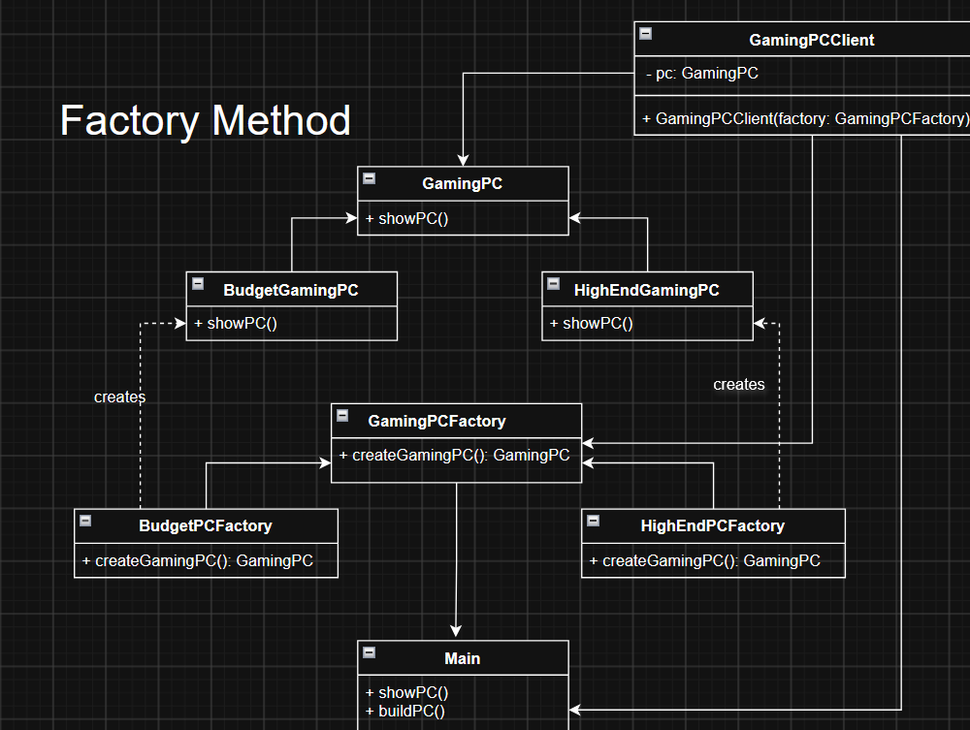

Abstract Factory
The Abstract Factory pattern is used to create families of related objects without directly specifying their concrete classes.
In this project, a Gaming PC consists of several components:
CPU,GPU,RAM and Storage
There are two component families: Budget and High-End
The Abstract Factory guarantees that the components come from the same family.

Abstract Products
The project has four Abstract Product interfaces.
CPU
public interface CPU {
String getName();
}
GPU
public interface GPU {
String getName();
}
RAM
public interface RAM {
String getName();
}
Storage
public interface Storage {
String getName();
}
These interfaces hide the implementation details of the concrete components.

Budget Product Family
The Budget family contains: BudgetCPU,BudgetGPU,BudgetRAM and BudgetStorage
For example:
public class BudgetCPU implements CPU {
@Override
public String getName() {
return "AMD Ryzen 5";
}
}
The other Budget components follow the same structure.
The complete family is:
BudgetComponentFactory
|
+-- BudgetCPU
+-- BudgetGPU
+-- BudgetRAM
+-- BudgetStorage

High-End Product Family
The High-End family contains: HighEndCPU,HighEndGPU,HighEndRAM and HighEndStorage
For example:
public class HighEndCPU implements CPU {
@Override
public String getName() {
return "AMD Ryzen 7";
}
}
The complete family is:
HighEndComponentFactory
|
+-- HighEndCPU
+-- HighEndGPU
+-- HighEndRAM
+-- HighEndStorage

Abstract Factory
The Abstract Factory interface is:
public interface GamingPCComponentFactory {
CPU createCPU();
GPU createGPU();
RAM createRAM();
Storage createStorage();
}
It defines one creation method for each product type.
The factory does not specify whether the products are Budget or High-End.

Concrete Factories
BudgetComponentFactory
public class BudgetComponentFactory implements GamingPCComponentFactory {
@Override
public CPU createCPU() {
return new BudgetCPU();
}

@Override
public GPU createGPU() {
return new BudgetGPU();
}

@Override
public RAM createRAM() {
return new BudgetRAM();
}

@Override
public Storage createStorage() {
return new BudgetStorage();
}
}
This factory creates only Budget components.
HighEndComponentFactory
public class HighEndComponentFactory implements GamingPCComponentFactory {
@Override
public CPU createCPU() {
return new HighEndCPU();
}

@Override
public GPU createGPU() {
return new HighEndGPU();
}

@Override
public RAM createRAM() {
return new HighEndRAM();
}

@Override
public Storage createStorage() {
return new HighEndStorage();
}
}
This factory creates only High-End components.

Client
The client is GamingPCAssembler.
public class GamingPCAssembler {
public void buildPC(GamingPCComponentFactory factory) {
CPU cpu = factory.createCPU();
GPU gpu = factory.createGPU();
RAM ram = factory.createRAM();
Storage storage = factory.createStorage();

System.out.println("Gaming PC");
System.out.println("CPU: " + cpu.getName());
System.out.println("GPU: " + gpu.getName());
System.out.println("RAM: " + ram.getName());
System.out.println("Storage: " + storage.getName());
}
}
The client works only with the Abstract Factory and Abstract Product interfaces.
For example, the client does not contain:
new BudgetCPU(); or: new HighEndGPU();
This keeps the client independent from concrete component classes.

Abstract Factory UML
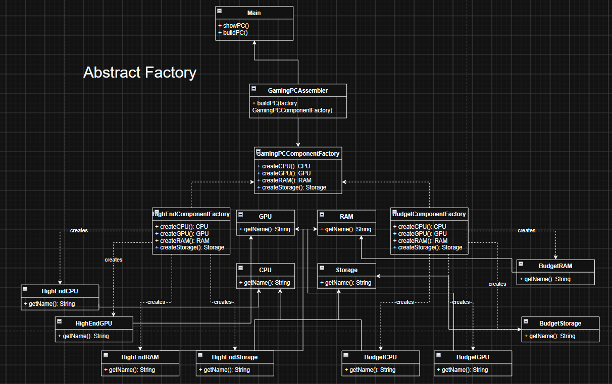

Clean Code
Chapter 4: Comments
4.1 Explanation of Intent
In Main.java, comments explain which part of the program demonstrates each pattern:
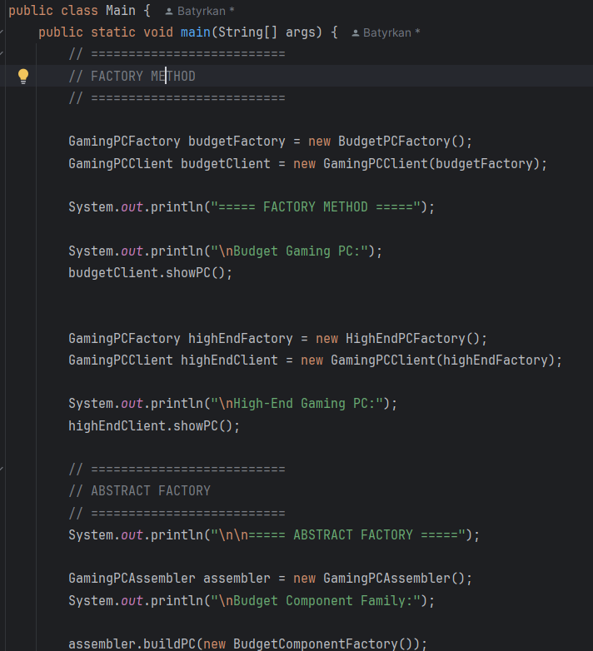
These comments explain the intention of the code. They help the reader quickly understand where the Factory Method and Abstract Factory examples start.

4.3 Comments Do Not Replace Good Code
We avoid using comments to explain complicated code. Instead, we use clear class and method names.
For example:
GamingPCFactory budgetFactory = new BudgetPCFactory();
The names GamingPCFactory, BudgetPCFactory, and budgetFactory clearly show their purpose. Therefore, we do not need a comment such as:
// Create a factory that creates budget gaming PCs
This follows the Clean Code idea that code should explain itself when possible.

Chapter 6: Data Abstraction
6.1 Data Abstraction with Interfaces
In the Abstract Factory part, we use interfaces for PC components:
public interface CPU {
String getName();
}
The client does not need to know how a concrete CPU is implemented.
For example, the client works with:
CPU cpu = factory.createCPU();
It does not directly create:
new BudgetCPU();
or:
new HighEndCPU();
This hides the concrete implementation from the client.
6.2 Data/Object Anti-Symmetry
The project mainly follows the object-oriented approach described in Chapter 6. Objects expose behavior while hiding their internal data.
For example, the CPU interface provides behavior through the getName() method:
public interface CPU {
String getName();
}
The client uses the method:
CPU cpu = factory.createCPU();
System.out.println("CPU: " + cpu.getName());
The client does not directly access the internal data of the concrete CPU object.
For example, we do not use:
cpu.name;
Instead, the object provides behavior through a method:
cpu.getName();
This follows the idea:
Objects: expose behavior, hide data.
The project uses objects and interfaces because the system needs different types of components. For example, we can have BudgetCPU and HighEndCPU that implement the same CPU interface.

6.3 Law of Demeter
The project also follows the idea of the Law of Demeter, which means that a method should mainly communicate with objects that it directly receives, creates, or owns.
For example, GamingPCAssembler directly works with the factory:
CPU cpu = factory.createCPU();
GPU gpu = factory.createGPU();
RAM ram = factory.createRAM();
Storage storage = factory.createStorage();
The project does not use long method chains such as:
factory.getSomething().getAnotherObject().getName();
This makes the code easier to understand and reduces unnecessary dependencies between classes.

Conclusion
Factory Method is useful when the system needs to create one type of product with different concrete implementations.
Abstract Factory is useful when the system needs to create several related products as a consistent family.
In this project, Factory Method creates different Gaming PCs, while Abstract Factory creates compatible component families.
The main difference is that Factory Method focuses on one product, while Abstract Factory creates a family of related products.
GitHub Repository

