Astana IT University

Software Design Patterns
Report

Group: SE-2503
Student name: Uvayev Batyrkhan
Date: 26.10.2026

Introduction
The purpose of this project is to implement the Strategy behavioral design pattern in Java.
The chosen domain is a calculator that performs four mathematical operations: addition, subtraction, multiplication, and division.
The main problem solved by the Strategy Pattern is how to support different algorithms without placing all their implementations inside one class. Instead of using a long chain of conditional statements, the project encapsulates each mathematical operation in a separate strategy class.
The project contains an OperationStrategy interface, four concrete strategy classes, a Calculator context, and a Main client class.
The calculator can change its selected strategy at runtime using the setStrategy() method.

UML Diagram
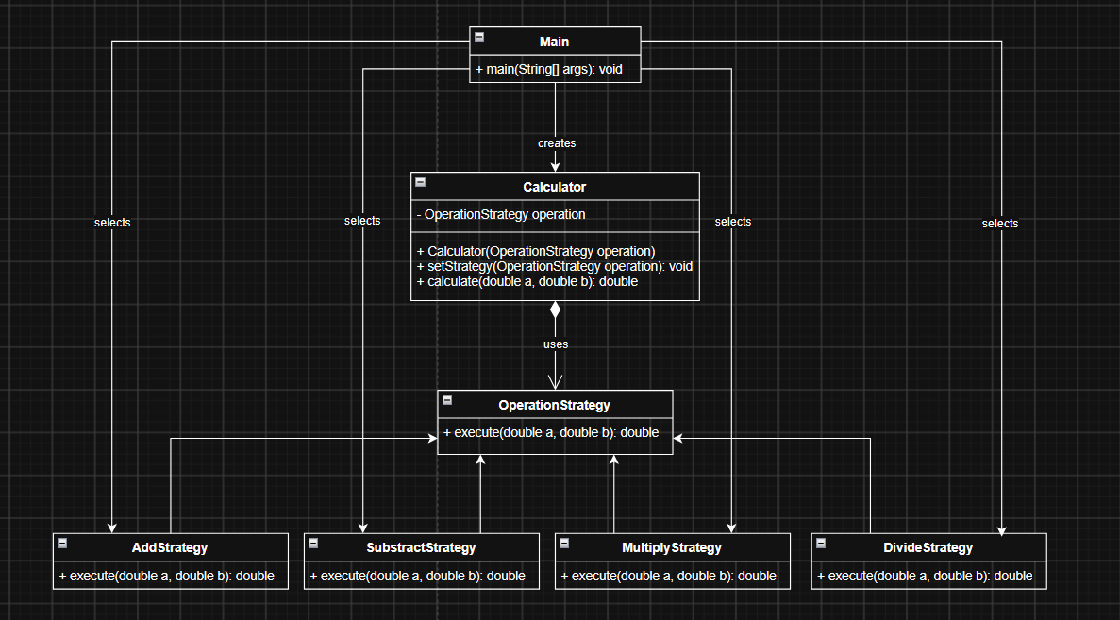
Strategy Interface: OperationStrategy defines the common execute() method.
Concrete Strategies: AddStrategy, SubtractStrategy, MultiplyStrategy, and DivideStrategy implement the interface.
Context: Calculator stores the selected strategy and delegates calculations to it.
Client: Main creates the calculator and selects the strategy.

Clean Code
Chapter 9
Single Concept per Test
A test should focus on one concept and verify one specific behavior. Small, focused tests are easier to understand and debug.
For example, a test for addition should check only whether the calculator returns the correct sum.
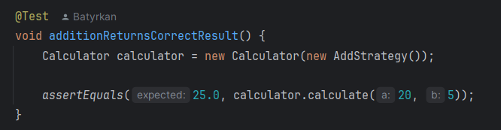
This test has a clear purpose: it verifies the addition behavior. Separate tests can verify subtraction, multiplication, division, and division by zero.
Benefit: Focused tests make it easier to identify which behavior fails when a problem occurs.
Chapter 10
Classes Should Be Small
Robert C. Martin explains that classes should be small and have a clear responsibility.
In this project, every concrete strategy performs only one mathematical operation.
For example:
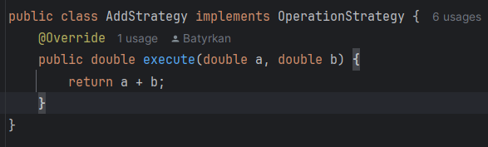
AddStrategy is responsible only for addition. It does not handle subtraction, multiplication, division, or user interaction.
Benefit: Small classes are easier to understand, maintain, and modify.
Single Responsibility Principle
A class should have one main responsibility.
The Calculator class manages the selected strategy and delegates the calculation. The concrete strategy classes contain the actual mathematical algorithms.
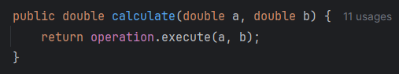
The Calculator does not implement every mathematical operation itself. It delegates the work to the selected strategy.
Benefit: Responsibilities are separated, so changes to one mathematical algorithm do not require changes to the Calculator class.
Organizing for Change
A design should make future changes easier. The Strategy Pattern achieves this by allowing new algorithms to be introduced through a common interface.
For example, a new power operation can be implemented as a separate class:
public class PowerStrategy implements OperationStrategy {
@Override
public double execute(double a, double b) {
return Math.pow(a, b);
}
}
The new strategy can be selected using:
calculator.setStrategy(new PowerStrategy());
The existing Calculator class does not need to be modified.
Benefit: The project is easier to extend because new operations can be added independently.
Chapter 11
Separate Construction from Use
The existing Calculator class does not need to be modified.
Benefit: The project is easier to extend because new operations can be added independently.
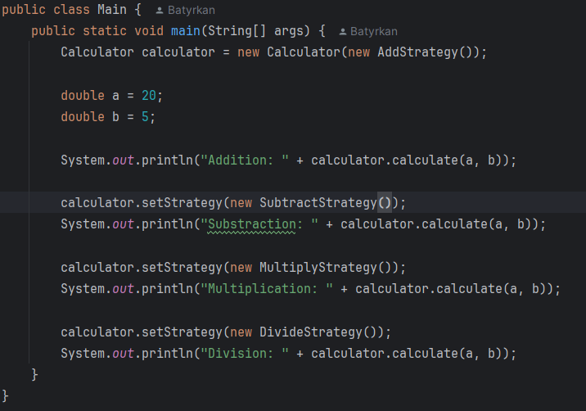
The existing Calculator class does not need to be modified.
Benefit: The project is easier to extend because new operations can be added independently.
Conclusion
The project demonstrates how the Strategy Pattern can make a calculator more flexible and maintainable.
The main advantage is that the calculator can switch between different algorithms at runtime. Each operation is encapsulated in its own class, and all strategies follow the same interface.
The main trade-off is the increased number of classes. However, this additional structure makes the project easier to extend and maintain as new operations are introduced.
The project also demonstrates important Clean Code ideas from Chapters 9, 10, and 11, including focused unit tests, small classes, single responsibility, organization for change, and separation of construction from use.
Github Repository

