GIT:

Differences between local, centralized and distributed version control systems.

Version control is a system that records changes to a file or set of files over time so that you can recall specific versions later

Local version control system: works by keeping patch sets (that is, the differences between files) in a special format on disk; it can then re-create what any file looked like at any point in time by adding up all the patches.

Centralized version control system: These systems (such as CVS, Subversion, and Perforce) have a single server that contains all the versioned files, and a number of clients that check out files from that central place. For many years, this has been the standard for version control.

Distributed version control system: In a DVCS (such as Git, Mercurial, Bazaar or Darcs), clients don’t just check out the latest snapshot of the files; rather, they fully mirror the repository, including its full history. Thus, if any server dies, and these systems were collaborating via that server, any of the client repositories can be copied back up to the server to restore it. Every clone is really a full backup of all the data.

There are three type of states your data can be at:

Modified: This means that you have changed the file but have not committed it to your database yet.

Staged: This means that you have marked a modified file in its current version to go into your next commit snapshot.

Committed: This means that the data is safely stored in your local database.

The working tree is a single checkout of one version of the project. These files are pulled out of the compressed database in the Git directory and placed on disk for you to use or modify.
The staging area is a file, generally contained in your Git directory, that stores information about what will go into your next commit. Its technical name in Git parlance is the “index”, but the phrase “staging area” works just as well.
The Git directory is where Git stores the metadata and object database for your project. This is the most important part of Git, and it is what is copied when you clone a repository from another computer.

The basic Git workflow goes something like this:

You modify files in your working tree.

You selectively stage just those changes you want to be part of your next commit, which adds only those changes to the staging area.

You do a commit, which takes the files as they are in the staging area and stores that snapshot permanently to your Git directory.
If a particular version of a file is in the Git directory, it’s considered committed. If it has been modified and was added to the staging area, it is staged. And if it was changed since it was checked out but has not been staged, it is modified

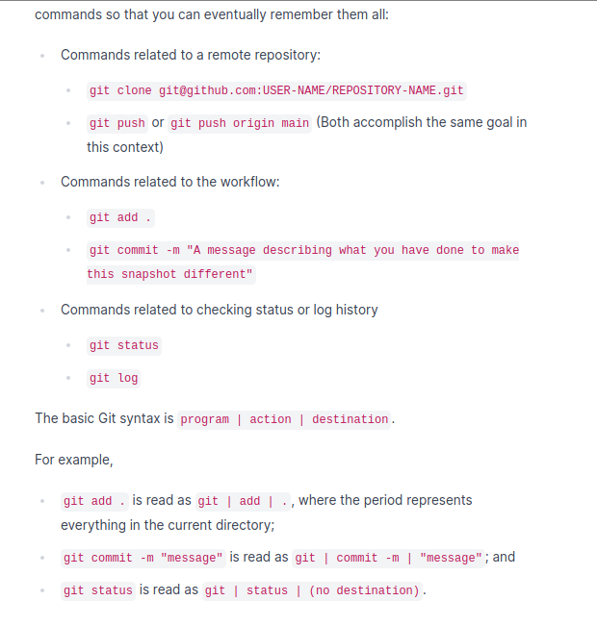
Git is a Distributed version control system.

Git saves your work on snapshots, so you can come back to each different snapshot and see the history of your project. Git saves when it detects differences in the files and keeps a historical track of each save.
On the other hand, a simple text editor just saves all the words and everything in just a single file and you are only given one copy of the file unless you make several copies of it and name them to keep track.

Git works at a Local level, allowing you to access the history of your project super fast and even being offline or with a VPN.

Github is a remote storage facility, allowing you to showcase your git work on Github.

Git is useful to a single developer because of how easy you can keep track of all the versions of a project. Git and Github are awesome too for teams of developers because they can all see who made changes, when they did them and when things started to go wrong as they all work together.

To create a new repository, you have to go to Github and on the top right corner, click on the arrow and create a new repository, give it a name and check the “add a readme file” box.

To copy a repository from Github to your local machine you have to click on code on your repository, go to the SSH key tab and copy that link to clipboard. Once you have that link, you can go to your terminal and type git clone and paste what you have on your billboard, and that’s it!

Origin stands for the name of your remote connection. The name “origin” is both the default and the convention for the remote repository.

Main stands for the default branch name.

Git adds your file to the staged area when you give it the command to do it. This doesn’t mean its already saved, you still have to commit it. When you commit it, you confirm your snapshot and you give a little description to that snapshot, and it also shows who did it and when.

To check the status of your current repositories you can type git status on your terminal/text editor.

You can add files to the staging area with the line “git add *name file*”

You can commit your files with the line “git commit -m “here goes the description with your file name”.

You can push them with “git push” if its just one branch, ore “git push origin main” if you want to be more specific.

You can check your commits log with the line “git log”.

